DEVELOPING A GRADUATE STUDENT LIFECYCLE MONITORING AND ANALYTICS PLATFORM FOR THE UNIVERSITY OF ST. LA SALLE GRADUATE SCHOOL

A Capstone Project Proposal Presented to the
Department of Information Technology
College of Computer Studies
De La Salle University

In Partial Fulfillment of the Requirements for the Degree of
Bachelor of Science in Information Technology

Prepared and Submitted By:

Mendoza, Natalie U.
Oseña, Khloe Cassandra M.
Sanson, Miguel Joaquin A.
Tumbaga, Myrine Rena Princess B.

Submitted to:

_________________________
Mr. Malabanan, Oliver A.

July 28, 2026

ABSTRACT

Graduate schools manage complex academic and research activities that require continuous coordination among students, advisers, academic coordinators, and Graduate School personnel across multiple lifecycle stages. However, in many institutions, including the University of St. La Salle – Bacolod Graduate School, monitoring graduate student progress relies on spreadsheets, email communication, and distributed document files, making it difficult to verify student status, identify pending requirements, and determine responsibility for the next action. This study proposes the development of a Graduate Student Lifecycle Monitoring and Analytics Platform that consolidates lifecycle records, milestone events, scheduling activities, and document submissions into a centralized monitoring environment to improve visibility of graduate student progression from admission to graduation. The platform organizes lifecycle events into structured workflow states and timestamps that support role-based monitoring, task ownership tracking, and analytics-ready reporting for Graduate School stakeholders. The system is designed using workflow modeling and root-cause analysis to examine existing operational practices and identify coordination gaps. The development approach integrates stakeholder validation, process modeling using BPMN, Ishikawa root-cause analysis, and iterative system prototyping guided by an Agile development methodology. The expected outcome is a web-based monitoring platform that provides dashboards, lifecycle status views, milestone tracking, and operational analytics to support timely follow-ups, reduce coordination delays, and improve decision-making in Graduate School operations.

Keywords: Graduate student lifecycle, milestone tracking, academic monitoring, Agile development, workflow modeling, Graduate School operations, lifecycle analytics, task ownership tracking, monitoring platform.

TABLE OF CONTENTS
ABSTRACT 1
TABLE OF CONTENTS 2
LIST OF FIGURES 16
LIST OF TABLES 18
Chapter 1 – Project Background 19
1.1 Introduction 19
1.2 Organizational Profile 20
1.2.1 Key Stakeholders 21
1.2.2 Ownership Mapping 24
Table 1. Ownership Mapping 26
1.2.3 Graduate School Research Protocol Forms 27
Table 2. Graduate School Research Protocol Forms and Their Purpose 28
1.2.4 Important Stakeholder Documents 29
Table 3. Source-to-mapping 29
1.3 Description of Existing Systems 30
1.3.1 Admission 31
Figure 1. BPMN Diagram – Admission 32
1.3.2 Enrollment 33
Figure 1.1 BPMN Diagram – Enrollment 33
Figure 1.2 BPMN Diagram – Course Adjustments 35
Figure 1.3 BPMN Diagram – Coursework 36
1.3.5 Leave of Absence and Readmission 37
Figure 1.4 BPMN Diagram – Leave of Absence and Readmission 37
1.3.6 Title Defense 39
Figure 1.5 BPMN Diagram – Title Defense 39
1.3.7 Advisor Designation 41
Figure 1.6 BPMN Diagram – Advisor Designation 43
1.3.7 Defense Scheduling and Rescheduling 44
Figure 1.7 BPMN Diagram – Defense Scheduling and Rescheduling 44
1.3.9 Defense and Revisions 46
Figure 1.8 BPMN Diagram – Defense and Revisions 46
1.3.10 Practicum 47
Figure 1.9 BPMN Diagram – Practicum 48
1.3.11 Withdrawal 49
Figure 1.10 BPMN Diagram – Withdrawal 50
1.3.12 Graduation 50
Figure 1.11 BPMN Diagram – Graduation 51
1.4 Statement of the Problem 52
Figure 2. Ishikawa Diagram – Root Causes of Difficulty in Monitoring and Processing Graduate Student Progress 55
1.5 Objectives of the Study 57
1.5.1 SDG Alignment (Sustainable Development Goals): 57
1.6 Conceptual Framework/Design Architecture 59
1.6.1 Conceptual Framework 59
Figure 3. Conceptual Framework Diagram 59
Figure 3.1 Module 1: Student Progress Management 61
Figure 3.2 Module 2: Case Status and Action Tracking 62
Figure 3.3 Module 3:Defense Scheduling Management 63
Figure 3.4 Module 4: Case Monitoring and Follow Up 65
Figure 3.5 Module 5: Analytics and Decision Support 66
Figure 3.6 Module 6:Policy and Case Guidance 68
Figure 3.7 Module 7: Reporting and Dashboards 70
1.6.2 Design Architecture 71
Figure 4. High-Level System Architecture Diagram 71
1.7 Scope and Limitations 74
1.7.1 Scope 74
1.7.1.1 User Scope 74
1.7.1.2 Process Scope 75
1.7.1.3 Data Scope 76
1.7.1.4 Key Performance Indicators (KPIs) of the Conceptual Framework 77
Table 3.1 User and Access Management KPI 78
Table 3.2 Audit Trail and Accountability KPI 79
Table 3.3 Module 1: Student Progress Management KPI 79
Table 3.4 Module 2: Case Status and Action Tracking KPI 80
Table 3.5 Module 3: Defense Scheduling Management KPI 80
Table 3.6 Module 4: Case Monitoring and Follow-Up KPI 81
Table 3.7 Module 5: Monitoring and Follow-ups KPI 82
Table 3.8 Module 6: Policy and Case Guidancet KPI 82
Table 3.9 Module 6: Reporting and Dashboards KPI 83
Table 4. Reference labels used in the KPI table 84
1.7.1.2 Existing (AS-IS) vs Proposed (TO-BE) System 85
Table 5. Existing system (as-is) vs proposed system (to-be) 86
1.7.2 Limitations 87
1.8 Significance of the Study 89
Chapter 2 – Review of Related Literature 91
2.1 Review of Related Concepts 91
2.1.1 Key Terms/Scope Labels 91
2.1.2 Graduate Student Lifecycle Tracking and Milestone-Centric Progress 92
2.1.3 Thesis/Dissertation Pipeline as an Operational Workflow 93
2.1.4 Time-to-Degree, Residency, Delay, and Attrition as Monitoring Measures 93
2.1.5 Academic Operations Analytics and Decision Support 94
2.1.6 Data Privacy, and Role-Based Access in Higher Education Systems 95
2.1.7 Retrieval-Augmented Generation for Policy-Grounded AI Systems 95
2.1.8 API-Based System Integration in Academic Information Systems 96
2.2 Review of Related Systems/Infrastructure 97
2.2.1 Thesis/Dissertation Management Portals and Scheduling Systems 98
2.2.2 Workflow-Based Approval Systems for Graduate Submissions 98
2.2.3 Institutional Policies and Handbooks as Operational Infrastructure 98
2.2.4 Sector Digital Transformation and Data Platform Context 99
2.3 Review of Related Methodologies 99
2.3.1 BPMN for Workflow Modeling and Analysis 99
2.3.2 Ishikawa (Fishbone) Analysis for Root Cause Identification 99
2.3.3 Decision Support, Dashboards, and Process/Operations Analytics 100
2.4 Conflicting Arguments, Context Differences, and Monitoring Implications 101
2.4.1 Normative Timelines vs. Policy Ceilings 101
2.4.2 Milestone-Centric Progress vs. Enrollment-Centric Status 101
2.4.3 Manual Operational Reality vs. Analytics Expectations 102
Chapter 3 – Methodology 103
Figure 5.1 Methodology Flow of the Study with Scrum-Based Prototype Development 104
3.1 Proposed System Development 106
Figure 5.2 Proposed System Development Approach 106
Figure 5.3. Proposed System Development Overview Using Agile Scrum 109
3.2 Phases 111
Figure 5.4. Specification Phases for the Proposed Graduate School Monitoring and Decision Support Platform 112
3.2.1 Data Requirements 113
Table 5. Data to be collected and sources 118
3.2.2 Milestone Gate Criteria 118
Table 6. Milestone Gate Criteria explaining definition of completion 123
3.2.3 Functional Requirements 124
Table 7. Functional Requirements of the modules 125
3.2.4 Non-Functional Requirements 126
Table 8. Non-Functional Requirements of the modules 126
3.2.5 Technology Stack and Tools 127
3.2.5.1 Summary of IT Tools 128
Table 9. IT tools to be used 131
3.2.5.2 Platform Approach 131
3.2.5.3 Database and Reporting 131
3.2.5.4 Prescriptive Analysis for Decision Support 132
3.2.5.5 RAG-Based Decision Support Assistant 134
Figure 6. RAG-Based Decision Support Assistant Architecture 135
3.2.5.6 Authentication, RBAC, and Audit Logging Tools 137
3.2.5.7 Reporting, Dashboards, and Analytics Tools 137
3.2.5.8 Notifications and Alerts Tools 138
3.2.5.9 Development, Collaboration, and Documentation Tools 139
3.2.6 Database Design 139
3.2.6.1 Core Entities/Tables 140
Table 10. Core tables and their purpose 143
3.2.6.2 Key Relationships and Integrity Rules 143
Table 11. Key relationships (high-level PK/FK design) 145
3.2.6.3 Entity-Relationship Diagram (ERD) and Table Group Overview 147
Figure 7. Full ERD of the proposed platform database (grouped) 147
Figure 7.1 Group A. Student and Program Context 148
Figure 7.2 Group B. Identity, Roles, and Assignments 149
Figure 7.3 Group C. Lifecycle & Milestones 150
Figure 7.4 Group D. Workflow Tasks & Decisions 152
Figure 7.5 Group E. Documents & Revisions 154
Figure 7.6 Group F. Scheduling & Coordination 155
Figure 7.7 Group G. Monitoring, Alerts, and Interventions 156
Figure 7.8 Group H. Auditability 157
3.2.6.4 Computed Indicators for Prescriptive Analytics and Decision Support 158
Table 13. Computed indicators from event history used for prescriptive analytics and decision support 159
3.2.6.5 Resource Planning 160
Table 14. Cost table for on-site premises 162
3.3 Workplan 163
3.3.1 Target Accomplishment for CAP-IT1 (80% of IT development) 163
3.3.2 Target Accomplishment for CAP-IT2 (20% of IT development) 163
3.3.3 CAP-IT1 Work Timeline 164
Table 15.1. CAP-IT1 Work Timeline (80% target) 169
3.3.4 CAP-IT2 Work Timeline 169
Table 15.2. CAP-IT2 Work Timeline (20% target) 171
CHAPTER 4 – The Existing System 173
4.1 Organization Profile 173
Table 16. Graduate School programs by cluster and practicum requirement 174
4.1.1 Stakeholders and Their Present Responsibilities 174
Table 17. Existing stakeholders and present responsibilities 174
4.2 Description of the Existing System 175
4.2.1 AIMS as the Official Academic Information System 175
4.2.2 The Manual Monitoring Workbook 176
Table 18. Structure of the existing monitoring workbook 176
4.2.3 Forms, Documents, and Email Coordination 177
4.2.4 Classification of the Existing Processes 177
Table 19. Classification of existing processes by locus of authority 177
4.2.5 The Existing Lifecycle Processes in Detail 178
4.2.5.1 Admission Handoff 178
4.2.5.2 Course Offering and Enrollment 179
4.2.5.3 Coursework and Subject Status 179
4.2.5.4 Leave of Absence, Readmission, AWOL, and Residency 179
4.2.5.5 Research Milestones and Defense Coordination 180
4.2.5.6 Practicum 180
4.2.5.7 Subject Withdrawal 181
4.2.5.8 Graduation Endorsement 181
4.2.6 Current State of Technology 182
4.2.6.1 Traditional Methods 182
4.2.6.2 Modern Methods 182
4.3 Problem Areas 182
4.3.1 Machine 183
4.3.2 Method 183
4.3.3 Man 184
4.3.4 Summary of Problem Areas 184
Table 20. Problem areas mapped to their operational consequence 184
4.4 Opportunities 185
4.4.1 Opportunities for the Graduate School 185
4.4.2 Opportunities for Graduate Students 185
4.4.3 Opportunities for Faculty and Other Offices 186
4.4.4 Constraints on Any Proposed Solution 186
CHAPTER 5 – The Proposed System 187
5.1 System Description 187
5.2 System Objectives 188
5.2.1 General Objective 188
5.2.2 Specific Objectives 188
5.3 System Modules 189
5.3.1 Student Handoff and Monitoring Import 189
5.3.2 Course Adjustments and Course Offering Setup 189
5.3.3 Enrollment 190
5.3.4 Monitoring Sheet 190
5.3.5 Research Gate 190
5.3.6 Panel Matching 190
5.3.7 Defense Scheduling 191
5.3.8 Practicum 191
5.3.9 Graduation 191
5.3.10 Leave of Absence and Readmission 191
5.3.11 AWOL and Residency 192
5.3.12 Subject Withdrawal 192
5.3.13 Work Queue, Activity Log, and Recommendations 192
5.3.14 Policy Assistant 193
5.3.15 Student, Faculty, and Dean Portals 193
5.3.16 Mapping to the Conceptual Framework 193
Table 21. Conceptual framework modules mapped to implemented modules 193
5.4 System Scope 194
5.4.1 User Scope 194
Table 22. Account types and access 194
5.4.2 Process Scope 195
5.4.3 Data Scope 195
5.4.4 Exclusions 195
5.5 System Assumptions 195
5.6 System Feasibility 196
5.6.1 Developmental Feasibility 196
5.6.2 Economic Feasibility 196
5.6.3 Operational Feasibility 197
5.7 Technical Requirements 197
5.7.1 For the Developers 197
Table 23. Development environment requirements 197
5.7.2 For the Users 198
5.7.3 For the Server 198
5.8 Non-Technical Requirements 198
5.8.1 Data Security and Integrity 198
5.8.2 System Performance 199
5.8.3 User Interface 199
5.9 Data Specifications 199
5.9.1 Entity Relationship Diagram 199
5.9.2 Tables and File Layouts 200
5.9.2.1 program 200
5.9.2.2 student 200
5.9.2.3 user_account 201
5.9.2.4 course 201
5.9.2.5 curriculum_offering 201
5.9.2.6 course_record 202
5.9.2.7 withdrawal_application 202
5.9.2.8 practicum_record 203
5.9.2.9 graduation_endorsement 204
5.9.2.10 research_case 204
5.9.2.11 faculty 204
5.9.2.12 schedule_request 205
5.9.2.13 task 206
5.9.2.14 transaction_log 206
5.10 Screen Specifications 207
5.10.1 Login Screen 207
Figure 8. Login screen 208
5.10.2 Dashboard 208
Figure 9. Graduate School overview dashboard 209
5.10.3 Monitoring Sheet 209
Figure 10. Monitoring sheet 210
5.10.4 Student Handoff 210
Figure 11. Student handoff 210
5.10.5 Course Adjustments 210
Figure 12. Course adjustments and subject needs 211
5.10.6 Course Offering Setup 211
Figure 13. Course offering setup 212
5.10.7 Enrollment 212
Figure 14. Enrollment 213
5.10.8 Enrollment Class List 213
Figure 15. Enrollment class list 214
5.10.9 Research Gate 214
Figure 16. Research gate 215
5.10.10 Panel Matching 215
Figure 17. Panel matching 216
5.10.11 Defense Scheduling 216
Figure 18. Defense scheduling 217
5.10.12 Practicum 217
Figure 19. Practicum monitoring 218
5.10.13 Graduation 218
Figure 20. Graduation endorsement 219
5.10.14 Leave of Absence 219
Figure 21. Leave of absence 220
5.10.15 Readmission 220
Figure 22. Readmission 221
5.10.16 AWOL and Residency 221
Figure 23. AWOL and residency 222
5.10.17 Withdrawal Requests 222
Figure 24. Subject withdrawal 223
5.10.18 Work Queue 223
Figure 25. Work queue 224
5.10.19 Activity Log 224
Figure 26. Activity log 225
5.10.20 Recommendations 225
Figure 27. Recommendations 226
5.10.21 Policy Assistant 226
Figure 28. Policy assistant 227
5.10.22 Reports 227
Figure 29. Reports 228
5.10.23 Students and Student Detail 228
Figure 30. Student detail 229
5.10.24 Faculty 229
Figure 31. Faculty records 230
5.10.25 Academic Semesters 230
Figure 32. Academic semester settings 231
5.10.26 Dean Approvals 231
Figure 33. Dean approvals queue 232
5.10.27 Student Portal 232
Figure 34. Student portal 233
5.10.28 Faculty Portal 233
Figure 35. Faculty portal 234
5.10.29 Role-Scoped Views 234
Figure 36. Academic Coordinator view of the monitoring sheet 235
5.11 Report Specifications 236
Table 24. Report specifications 236
5.11.1 Generated Documents and Exports 236
Table 25. Generated documents and exports 237
5.12 System Architecture 237
5.13 Infrastructure 238
5.13.1 Front End 238
5.13.2 Back End 238
5.13.3 Database 238
5.13.4 Deployment 239
CHAPTER 6 – System Testing 240
6.1 Testing Approach 240
Table 26. Testing levels 240
6.2 Test Environment 241
Table 27. Test environment 241
6.3 Automated Workflow Test Suite 241
6.3.1 Coverage 241
Table 28. Automated test coverage by module 242
6.3.2 Execution Results 242
Table 29. Automated test execution summary 242
6.3.3 Defect Identified 243
Table 30. Defect record DEF-001 243
6.3.4 Results by Module 243
Subject Withdrawal 243
Practicum 244
Graduation 244
Leave of Absence, Readmission, AWOL and Residency 244
Research, Panel Matching and Defense Scheduling 244
Policy Assistant and Document Retrieval 245
Monitoring and Data Integrity 245
Enrollment and Course Offering 245
Access Control, Messaging and Audit 246
6.4 Functional and Scenario Testing 246
Table 31. Scenario test results 246
6.5 Role-Based Access Verification 247
Table 32. Observed access by role 247
6.6 Observations and Limitations 247
6.7 User Acceptance Testing Plan 248
6.7.1 Respondents 248
6.7.2 Evaluation Criteria 248
Table 33. User acceptance evaluation criteria 248
6.7.3 Procedure 249
6.8 Summary of Testing Results 249
REFERENCES 250
GLOSSARY OF TERMS 259
LIST OF ACRONYMS 269
APPENDICES 271
Appendix A. BPMN Workflows 271
Appendix A.1. Admission 271
Appendix A.2. : Enrollment 272
Appendix A.3. Course Adjustments 273
Appendix A.4. Coursework 274
Appendix A.5. Leave of Absence and Readmission 275
Appendix A.6. Title Defense 276
Appendix A.7. Advisor Designation 277
Appendix A.8. Thesis/Dissertation Pipeline (Milestone Workflow) 279
Appendix B. Ishikawa Diagram – Root Causes of Difficulty in Monitoring and Processing Graduate Student Progress 283
Appendix C. Conceptual Framework Diagram 283
Appendix D. High-Level System Architecture Diagram 285
Appendix E. Key Performance Indicators (KPIs) of the Conceptual Framework 286
Appendix E.1. User and Access Management KPI 286
Appendix E.2. Audit Trail and Accountability KPI 286
Appendix E.3. Student Progress Management KPI 286
Appendix E.4. Case Status and Action Tracking KPI 287
Appendix E.5. Defense Scheduling Management KPI 287
Appendix E.6. Case Monitoring and Follow-Up KPI 287
Appendix E.7.Analytics and Decision Support KPI 288
Appendix E.8. RAG-Based Decision Support Assistant KPI 288
Appendix E.9. Reporting and Dashboards KPI 288
Appendix F. Reference labels used in the KPI table 288
Appendix G. Existing (AS-IS) vs Proposed (TO-BE) System 289
Appendix H. Methodology 291
Appendix H.1. Methodology Flow of the Study with Scrum-Based Prototype Development 291
Appendix H.2. Proposed System Development Approach 292
Appendix H.3. Proposed System Development Overview Using Agile Scrum 292
Appendix H.4. Specification Phases for the Proposed Graduate School Monitoring and Decision Support Platform 293
Appendix I. Data Requirements 293
Appendix I.1. Data to be collected and sources 293
Appendix J. Milestone Gate Criteria 298
Appendix J.1 Milestone Gate Criteria explaining definition of completion 298
Appendix K. Functional Requirements 303
Appendix L. Non-Functional Requirements 305
Appendix M. IT tools to be used 306
Appendix N. Core tables and their purpose 308
Appendix O. Key relationships (high-level PK/FK design) 312
Appendix P. RAG-Based Decision Support Assistant Architecture 314
Appendix Q. Entity-Relationship Diagram (ERD) and Table Group Overview 315
Appendix Q.1. Group A. Student and Program Context 316
Appendix Q.2. Group B. Identity, Roles, and Assignments 316
Appendix Q.3. Group C. Lifecycle & Milestones 317
Appendix Q.4. D. Workflow Tasks & Decisions 319
Appendix Q.5. Group E. Documents & Revisions 320
Appendix Q.6. Group F. Scheduling & Coordination 320
Appendix Q.7. Group G .Monitoring, Alerts, and Interventions 322
Appendix Q.8. Group H. Auditability 323
Appendix R. Computed indicators from event history used for prescriptive analytics and decision support 323
Appendix S. Cost table for on-site premises 325
Appendix T. Workplan 326
Appendix T.1. CAP-IT1 Work Timeline (80% target) 326
Appendix T.2. CAP-IT2 Work Timeline (20% target) 332
Appendix U. System Screenshots 335
Appendix U.1. Login screen 335
Figure U.1. Login screen (full screen) 336
Appendix U.2. Dashboard — Graduate School overview 336
Figure U.2. Dashboard — Graduate School overview (visible window; the screen continues below) 337
Appendix U.3. Reports 337
Figure U.3. Reports (full screen) 338
Appendix U.4. Academic semesters 338
Figure U.4. Academic semesters (full screen) 339
Appendix U.5. Students 339
Figure U.5. Students (visible window; the screen continues below) 340
Appendix U.6. Faculty records 340
Figure U.6. Faculty records (visible window; the screen continues below) 341
Appendix U.7. Monitoring sheet 341
Figure U.7. Monitoring sheet (full screen) 342
Appendix U.8. Enrollment class list 342
Figure U.8. Enrollment class list (full screen) 343
Appendix U.9. Student handoff 343
Figure U.9. Student handoff (full screen) 344
Appendix U.10. Course adjustments and subject needs 344
Figure U.10. Course adjustments and subject needs (visible window; the screen continues below) 345
Appendix U.11. Course offering setup 345
Figure U.11. Course offering setup (full screen) 346
Appendix U.12. Enrollment 346
Figure U.12. Enrollment (full screen) 347
Appendix U.13. Research gate 347
Figure U.13. Research gate (full screen) 348
Appendix U.14. Panel matching 348
Figure U.14. Panel matching (full screen) 349
Appendix U.15. Defense scheduling 349
Figure U.15. Defense scheduling (full screen) 350
Appendix U.16. Practicum monitoring 350
Figure U.16. Practicum monitoring (visible window; the screen continues below) 351
Appendix U.17. Graduation endorsement 351
Figure U.17. Graduation endorsement (full screen) 352
Appendix U.18. Leave of absence 352
Figure U.18. Leave of absence (full screen) 353
Appendix U.19. Readmission 353
Figure U.19. Readmission (full screen) 354
Appendix U.20. AWOL and residency 354
Figure U.20. AWOL and residency (visible window; the screen continues below) 355
Appendix U.21. Subject withdrawal requests 355
Figure U.21. Subject withdrawal requests (full screen) 356
Appendix U.22. Work queue 356
Figure U.22. Work queue (visible window; the screen continues below) 357
Appendix U.23. Activity log 357
Figure U.23. Activity log (full screen) 358
Appendix U.24. Recommendations 358
Figure U.24. Recommendations (visible window; the screen continues below) 359
Appendix U.25. Policy assistant 359
Figure U.25. Policy assistant (full screen) 360
Appendix U.26. Form 1 endorsements 360
Figure U.26. Form 1 endorsements (visible window; the screen continues below) 361
Appendix U.27. Student detail 361
Figure U.27. Student detail (full screen) 362
Appendix U.28. Dean approvals queue 362
Figure U.28. Dean approvals queue (visible window; the screen continues below) 363
Appendix U.29. Student portal 363
Figure U.29. Student portal (full screen) 364
Appendix U.30. Faculty portal 364
Figure U.30. Faculty portal (full screen) 365
Appendix U.31. Academic Coordinator view of the monitoring sheet 365
Figure U.31. Academic Coordinator view of the monitoring sheet (full screen) 366
Appendix U.32. Research Coordinator view of graduation 366
Figure U.32. Research Coordinator view of graduation (full screen) 367
Appendix U.33. Graduate School Staff dashboard 367
Figure U.33. Graduate School Staff dashboard (visible window; the screen continues below) 367
Appendix V. Automated Test Case Matrix 368
Appendix W. Automated Test Execution Record 371
Appendix X. User Acceptance Testing Instrument 372
Appendix X.1. Respondent Profile 372
Appendix X.2. Rated Items 372
Appendix X.3. Per-Module Items 373
Appendix X.4. Free-Response Items 373
Appendix Y. As-Built API Endpoint Inventory 375
Appendix Z. As-Built Database Table Inventory 379

LIST OF FIGURES

Figure 1. BPMN Diagram – Admission
Figure 1.1 BPMN Diagram – Enrollment
Figure 1.2 BPMN Diagram – Course Adjustments
Figure 1.3 BPMN Diagram – Coursework
Figure 1.4 BPMN Diagram – Leave of Absence and Readmission
Figure 1.5 BPMN Diagram – Title Defense
Figure 1.6 BPMN Diagram – Advisor Designation
Figure 1.7 BPMN Diagram – Thesis/Dissertation Pipeline (Milestone Workflow)
Figure 1.8 BPMN Diagram – Defense and Revisions
Figure 1.9 BPMN Diagram – Practicum
Figure 1.10 BPMN Diagram – Withdrawal
Figure 1.11 BPMN Diagram – Graduation
Figure 2. Ishikawa Diagram – Root Causes of Difficulty in Monitoring and Processing Graduate Student Progress
Figure 3. Conceptual Framework Diagram
Figure 3.1 Module 1: Student Progress Management
Figure 3.2 Module 2: Case Status and Action Tracking
Figure 3.3 Module 3: Defense Scheduling Management
Figure 3.4 Module 4: Case Monitoring and Follow-Up
Figure 3.5 Module 5: Analytics and Decision Support
Figure 3.6 Module 6: Policy and Case Guidance
Figure 3.7 Module 7: Reporting and Dashboards
Figure 4. High-Level System Architecture Diagram (Appendix D)
Figure 5.1 Methodology Flow of the Study with Scrum-Based Prototype Development
Figure 5.2 Proposed System Development Approach
Figure 5.3. Proposed System Development Overview Using Agile Scrum
Figure 5.4. Specification Phases for the Proposed Graduate School Monitoring and Decision Support Platform
Figure 6. RAG Architecture
Figure 7. Full ERD of the proposed platform database (grouped)
Figure 7.1 Group A. Student and Program Context
Figure 7.2 Group B. Identity, Roles, and Assignments
Figure 7.3 Group C. Lifecycle & Milestones
Figure 7.4 Group D. Workflow Tasks & Decisions
Figure 7.5 Group E. Documents & Revisions
Figure 7.6 Group F. Scheduling & Coordination
Figure 7.7 Group G. Monitoring, Alerts, and Interventions
Figure 7.8 Group H. Auditability

LIST OF TABLES

Table 1. Ownership Mapping
Table 2. Modules, in-scope features, and measurable KPIs (Prototype)
Table 3.1 User and Access Management KPI
Table 3.2 Audit Trail and Accountability KPI
Table 3.3 Module 1: Student Progress Management KPI
Table 3.4 Module 2: Case Status and Action Tracking KPI
Table 3.5 Module 3: Defense Scheduling Management KPI
Table 3.6 Module 4: Case Monitoring and Follow-Up KPI
Table 3.7 Module 5: Analytics and Decision Support KPI
Table 3.8 Module 6: Policy and Case Guidance
Table 3.9 Module 7: Reporting and Dashboards KPI
Table 4. Reference labels used in the KPI table
Table 5. Existing system (as-is) vs proposed system (to-be)
Table 6. Data to be collected and sources
Table 7. Milestone Gate Criteria explaining definition of completion
Table 8. Functional Requirements of the modules
Table 9. Non-Functional Requirements of the modules
Table 10. IT tools to be used
Table 11. Core tables and their purpose
Table 12. Key relationships (high-level PK/FK design)
Table 13. Computed indicators from event history used for prescriptive analytics and decision support
Table 14. Cost table for on-site premises
Table 15.1. CAP-IT1 Work Timeline (80% target)
Table 15.2. CAP-IT2 Work Timeline (20% target)

Chapter 1 – Project Background

1.1 Introduction
Graduate education involves long-term academic and research work that requires continued coordination among graduate students, advisers, panel members, coordinators, and Graduate School offices. Unlike many undergraduate processes that often move in more synchronized batches, graduate students may progress at different speeds across admission, enrollment, coursework, leave of absence and readmission, practicum where applicable, research milestones, withdrawal, and graduation endorsement. Students may move forward at different times depending on reviews, approvals, revisions, and scheduling. Because of this, student progress is not only about completing requirements. It also depends on passing milestone stages, getting approvals, and coordinating with different roles. In this kind of setting, the practical question, “Where is the student right now?” becomes difficult to answer when records and updates are scattered across different tools, offices, and communication channels.
In graduate school operations, milestone-based tracking is important for maintaining visibility and consistency across programs. Young et al. (2024) explain that graduate progress is often centered on milestones and may not fit the same kind of dashboards used for undergraduate monitoring. This suggests that institutions need tracking approaches that reflect different program rules and non-linear progress patterns. In the same way, doctoral monitoring literature shows that progress oversight depends on structured signals and not only on informal judgment (Brooks, 2023). When progress evidence is divided across admissions records, enrollment records, monitoring sheets, forms, decisions, and schedules spread across email threads, shared drives, and spreadsheets, status visibility often becomes a best-guess reconstruction instead of a clear and reliable record.
In response to this need, the proposed capstone is an AI-enhanced business system in the form of a web-based Graduate Student Lifecycle Monitoring and Analytics Platform. As an AI system, it is designed to support Graduate School work by bringing student monitoring, milestone tracking, document tracking, scheduling, follow-ups, and reporting into one platform. It also includes an AI-supported feature that uses Retrieval-Augmented Generation (RAG) through NotebookLM. This allows the system to provide answers and guidance based on Graduate School policies, guidelines, and related records, instead of relying only on general AI responses. The AI feature is meant to assist staff and administrators in reviewing cases and understanding the next steps, while final decisions remain with the proper offices and authorized personnel. In this way, the capstone combines the functions of a business system for daily Graduate School processes with AI support that improves monitoring and decision support.

1.2 Organizational Profile
This project is situated in the higher education sector, specifically in graduate school administration and student lifecycle operations in the Philippine context. Graduate schools need to coordinate many roles involved in academic decisions, such as curriculum alignment, subject planning, title approval, proposal acceptance, defense outcomes, and graduation endorsement, as well as operational tasks such as routing documents, scheduling panels, tracking compliance requirements, and monitoring student status across different stages of the lifecycle. These processes are shaped by institutional policies, program-level differences, and role restrictions related to privacy and academic records.
The main organizational setting of this project is the University of St. La Salle Graduate School in Bacolod City. The Graduate School offers programs in several academic areas, including Arts and Sciences, Business, Education, Engineering and Technology, and Nursing. Because of this, Graduate School processes must support multiple disciplines that may differ in curriculum structure, documentation requirements, practicum needs, research milestones, and review or scheduling practices.

In terms of admissions, the Graduate School follows a structured set of steps and requirements. Applicants are asked to submit requirements through the Graduate School admissions email, create an AIMS applicant account, pay the required processing and examination fees through the approved channels, and proceed through the examination and interview stages before acceptance is confirmed. These published steps show that Graduate School administration already relies on a mix of digital tools and coordination across multiple offices. This reflects the same kind of operational complexity that also appears later in enrollment monitoring, coursework tracking, leave of absence and readmission, research milestones, and graduation endorsement.
The Graduate School also operates within a defined administrative structure. The Graduate School overview identifies the academic officers of the unit, including the Dean, Academic Coordinators, Research Coordinators, and other related contact references. This is important because it helps clarify where decision-making authority and oversight may be located across Graduate School processes, policy interpretation, and escalation.

1.2.1 Key Stakeholders
Graduate School operations involve several stakeholders with different responsibilities and information needs across the full graduate student lifecycle. The process is not limited to thesis or dissertation stages alone. It also includes admission handoff, enrollment monitoring, curriculum alignment, coursework tracking, leave of absence and readmission, practicum for applicable programs, research milestones, withdrawal, and graduation endorsement. These activities are carried out through a series of handoffs among students, faculty, coordinators, administrative staff, and decision-making offices. Because of this, monitoring and process support must reflect both the academic side of decisions, such as subject completion, defense outcomes, and graduation readiness, and the operational side of coordination, such as routing, scheduling, document completeness, status updates, and approvals. The following stakeholders represent the main roles involved in the graduate student lifecycle and its related monitoring processes.
- Graduate Students. Graduate students move through both academic and research-related stages of the graduate lifecycle. These may include admission onboarding, enrollment, coursework completion, leave of absence or readmission when applicable, practicum for certain programs, title defense, proposal and final defense, revisions, and graduation endorsement. Their main need is clear visibility of their current stage, required documents, next steps, deadlines, and realistic time expectations. Students also need to know what is still pending and who is responsible for the next action to reduce repeated follow-ups and uncertainty.
- Research Adviser(s). Advisers guide manuscript development, provide technical and academic supervision, endorse readiness for proposal and final defense stages, and confirm revision completion when needed. Their monitoring needs include visibility of assigned students, pending review tasks, correct document versions, revision status, and upcoming or requested schedule windows.
- Academic Coordinator. The Academic Coordinator supports program compliance and day-to-day process flow by reviewing study plans, confirming curriculum alignment, identifying subject needs, endorsing required forms, and providing inputs related to panel nomination or research-stage requirements depending on institutional practice. Their monitoring needs include visibility of student status across the program, exception handling, and queues of pending endorsements, validation checks, or subject-related concerns
- Research Coordinator. The Research Coordinator supports research-stage coordination, such as panel nomination, defense scheduling, and routing of research-related decisions and requirements. Their monitoring needs include visibility of milestone status, compliance checks, adviser and panel assignments, and indicators that help identify cases needing follow-up or escalation.
- Graduate School Office Staff. Administrative staff coordinate schedules, track documents, route submissions, and maintain day-to-day visibility of student progress across different stages of the lifecycle. This may include onboarding support, enrollment-related monitoring, leave of absence and readmission records, defense-related coordination, and graduation endorsement preparation. In many cases, this role also maintains monitoring artifacts such as spreadsheets or email-based tracking. For example, the interview discussion referenced Ms. Lyra as an administrative support role for monitoring, which shows how visibility can become person-dependent when tracking relies on manual practices. Their monitoring needs include counts per stage, pending items, overdue cases, scheduling status, and turnaround-time signals that help identify bottlenecks.
- Dean. The Dean serves as a decision-making and approval authority in key parts of the graduate lifecycle. This may include leave of absence decisions, withdrawal requests, onboarding review, adviser designation, and graduation endorsement review. The Dean’s monitoring needs include visibility of cases awaiting approval, supporting documents, exception cases, and summary views that help support timely decisions.
- Faculty. Faculty members support the academic side of the graduate student lifecycle, particularly in coursework delivery, grade submission, and subject-related academic requirements. In the current process, faculty encode grades that students later view through the existing system, while the Graduate School uses the resulting signals mainly for completion and monitoring rather than detailed grade management. Their monitoring needs include visibility of class lists, assigned teaching loads, submitted grade status, and any subject-related information that affects Student Progress Management.

1.2.2 Ownership Mapping
Process Area | Sub-area | Accountable Office/Role (AS-IS) | Student View (AS-IS) | Current System (AS-IS) | In System Scope? (Yes/No)
Admission | Requirements submission | Admission Office | AIMS / admissions email | AIMS and email | No
 | Admission status confirmation | Graduate School Staff / Academic Coordinator | Graduate School | AIMS status and email | No
 | Program onboarding | Graduate School Staff / Academic Coordinator | Graduate School | Manual onboarding steps, email, and forms | Yes
Enrollment | Enrollment status confirmation | Graduate School Staff / Academic Coordinator | AIMS / Graduate School | Existing enrollment system and spreadsheets | Yes
 | Monitoring of enrolled classes | Academic Coordinator / Graduate School Staff | Graduate School |  | Yes
 | Monitoring of class changes | Academic Coordinator / Graduate School Staff | Graduate School | Enrollment platform + spreadsheets | Yes
 | Subject needs and class offering planning | Academic Coordinator | Graduate School | Manual planning, spreadsheets, and monitoring sheets | Yes
 | Academic progress tracking (course audit) | Academic Coordinator | Graduate School | AC-Student-Monitoring template / Excel | Yes
Coursework | Planned class schedule visibility | Academic Coordinator / Graduate School Staff | CANVAS / Graduate School | Existing student portal / CANVAS | Yes
 | Grade and standing summary signals | Faculty / Academic Coordinator | Graduate School | Registrar-side grade system | No
LOA & Readmission | LOA application tracking | Dean / Graduate School Staff | Graduate School | Email-based routing | Yes
 | Residency pause tracking | Graduate School Staff | Graduate School | Manual tracking and AIMS reports | Yes
 | Readmission application tracking | Graduate School Staff / Dean | Graduate School | Email and manual tracking | Yes
Thesis/Dissertations | Research milestone tracking | Research Coordinator / Graduate School Staff / Adviser | Graduate School | Research monitoring sheets and protocol forms | Yes
Practicum | Practicum hours and document tracking | Academic Coordinator / Program Coordinator | Graduate School | Manual logs, certificates, and paper submissions | Yes
Withdrawal | Withdrawal request tracking | Dean / Academic Coordinator | Graduate School | Email and manual tracking | Yes
 | Withdrawal status confirmation | Academic Coordinator / Graduate School Staff | Graduate School |  | Yes
Graduation | Graduation candidate review | Graduate School Staff / Academic Coordinator / Research Coordinator | Graduate School | Manual checklist and endorsement preparation | Yes
 | Graduation endorsement list review | Dean | Graduate School | Manual endorsement list | Yes
 | Graduation status output | Registrar |  | Registrar process and output | No

Table 1. Ownership Mapping
Table 1 shows the ownership mapping of each graduate student lifecycle process area and sub-area by identifying the accountable office or role in the current process, where the student usually refers for the transaction, the current system or document used, and whether the item is within the scope of the proposed system. This mapping helps define scope boundaries and supports the role lanes used in the AS-IS process diagrams and access control design. The mapping also reflects the confirmed setup that the proposed system is for monitoring and support, and does not replace official admissions, Registrar, or Accounting processes.

1.2.3 Graduate School Research Protocol Forms
Form ID | Form Name | Purpose | Key Monitoring Signal
Form 1 | Application for Title Defense | Title Defense Application | “Title defense application submitted” (date/time)
Form 2 | Report of Title Defense | Title Defense Outcome | “Approved title selected / disapproved” (outcome + date)
Form 3 | Application for Designation of Research Adviser | Adviser Designation Request | “Adviser designation requested”
Form 3.1 | Appointment for Research Adviser | Adviser Confirmed | “Adviser appointed” (date)
Form 3.2 | Research Timetable | Advising Setup | “Timetable submitted/approved”
Form 3.3 | Thesis/Dissertation Advising Contract | Advising Setup | “Advising contract completed”
Form 3.4 | Request for Change of Title of the Study | Exception / Change Control | “Title change requested/approved”
Form 3.1.1 | Request for Change of Research Adviser | Exception / Change Control | “Adviser change requested/approved”
Form 4 | Endorsement for Proposal/Final Defense | Defense Readiness Endorsement | “Endorsed for defense” (date)
Form 4.1 | Statistical Consultation Form | Conditional (Quantitative) | “Stat consultation completed”
Form 4.2 | Co-authorship Information for Publication | Conditional (Publication-related) | “Co-authorship declared”
Form 4.3 | Endorsement for Public Defense | Public Defense Readiness | “Endorsed for public defense”
Form 5 | Comments Sheet for Proposal Defense | Proposal Defense Outcome | “Proposal comments consolidated” (date)
Form 5.1 | Technical Review Certificate | Proposal Post-Revision Gate | “Technical review cleared”
Form 5.2 | Application for Ethics Review | Ethics Review | “Ethics submitted / cleared” (status + date)
Form 6 | Comments Sheet for Final Defense | Final Defense Outcome | “Final defense comments issued”
Form 7 | Evaluation Sheet for Final Defense | Final Defense Evaluation | “Final rating recorded” (pass/minor/major)
Form 8 | Settlement of Provisional Thesis/Dissertation Approval | Provisional Pass Handling | “Provisional settlement recorded”
Form 9 | Editor Certification | Manuscript Finalization | “Editor certified”
Form 10 | Approval Sheet | Completion Evidence | “Approval sheet complete” / readiness for endorsement

Table 2. Graduate School Research Protocol Forms and Their Purpose
Table 2 shows the Graduate School Research Protocol forms used in thesis and dissertation monitoring. These forms mark key process events such as applications, endorsements, comments, clearances, evaluations, and completion evidence. For monitoring purposes, each form can be linked to a milestone, owner, status, and timestamp.

1.2.4 Important Stakeholder Documents
Output | Relevance
AC-STUDENT-MONITORING-Template.xlsx | Academic year entry, student identifiers, program or track, course list, unit totals, completion markers, and AY/Sem taken fields
Student-Research-Monitoring.xlsx | Adviser assignment, milestone dates, defense outcomes, required certifications such as Turnitin, editor certification, and approval sheet, and exception notes
Graduate School Research Protocol (AY 2024–2025) | Title, proposal, and final defense stages, form flow, required documents, and conditional requirements
2nd Meeting Transcript Confirmation w/ Sir Eddie De Paula | Confirmed AS-IS process details, role ownership, scope boundaries, current monitoring practices, and key lifecycle requirements discussed with and signed by Sir Eddie De Paula.

Table 3. Source-to-mapping
Table 3 shows how key stakeholder documents support monitoring across the graduate student lifecycle. The AC-STUDENT-MONITORING template supports coursework and study plan tracking, while the student research monitoring sheet supports milestone tracking, defense outcomes, and completion evidence. The Graduate School Research Protocol provides the required forms, stages, and document requirements used in research-related processes. Together, these documents serve as practical sources for status tracking, milestone recording, and completion checking.

1.3 Description of Existing Systems
Graduate student lifecycle tracking is currently handled through a mix of existing institutional systems and manual coordination. Official records such as enrollment status and grades are kept in institutional systems, primarily AIMS, while Graduate School processes such as checking requirements, scheduling, and endorsements are often handled through email, spreadsheets, person-to-person follow-ups, the AC-Student-Monitoring template, the STUDENT-MONITORING spreadsheet, and Graduate School research protocol forms.

1.3.1 Admission
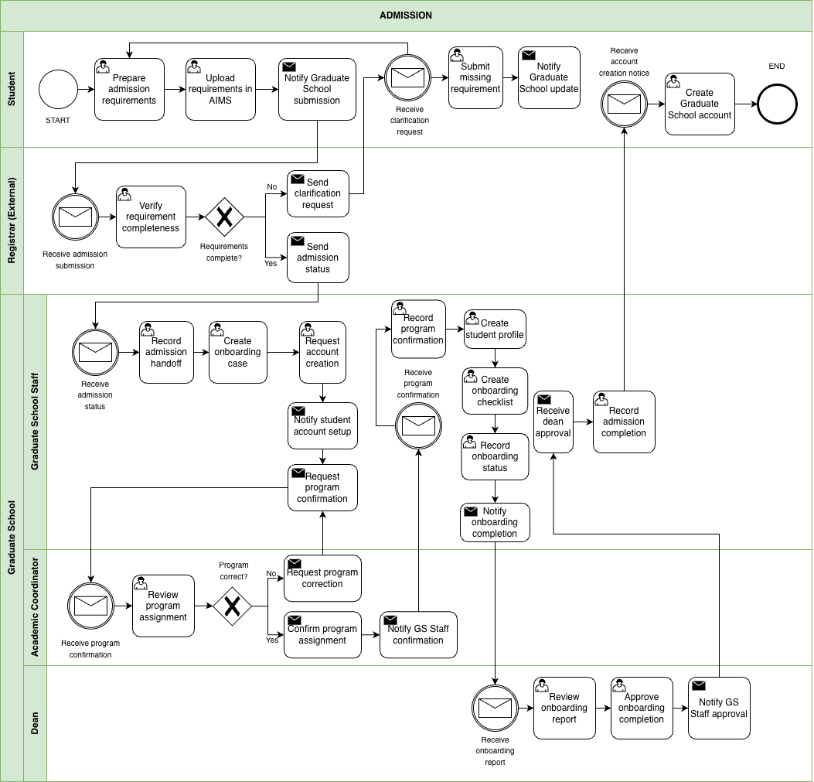

Figure 1. BPMN Diagram – Admission
This figure shows the admission monitoring handoff from AIMS to the Graduate School. The student uploads requirements in AIMS, and the Registrar checks completeness. If something is missing, a clarification request is sent and the student submits the missing items. Once admission status is confirmed, Graduate School Staff begin onboarding activities such as creating an onboarding case, requesting account creation, confirming the program assignment, and preparing an onboarding checklist. The Dean reviews onboarding completion before the Graduate School records admission completion.

1.3.2 Enrollment
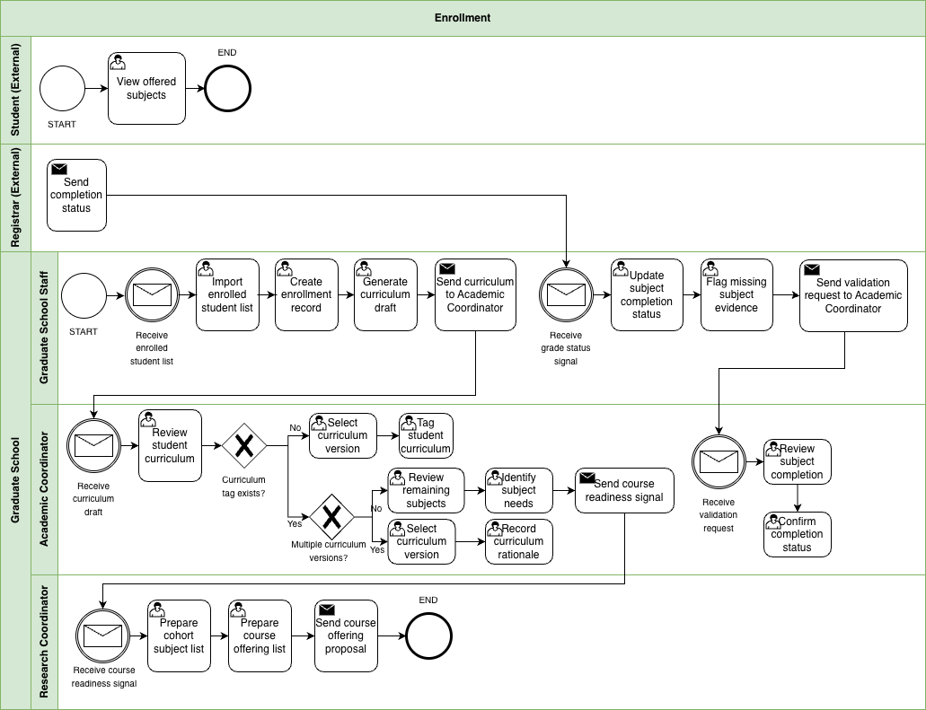

Figure 1.1 BPMN Diagram – Enrollment
This figure shows how the Graduate School takes enrollment signals and turns them into monitoring actions. Graduate School Staff receive the enrolled student list and create basic enrollment records and a curriculum draft. The Academic Coordinator reviews the curriculum, confirms or assigns the correct curriculum version, and tags the student to that curriculum. This monitoring view is based on records such as the AC-Student-Monitoring template and the STUDENT-MONITORING spreadsheet. When there are multiple curriculum versions, extra checking is needed to make sure the student is aligned correctly. After tagging, the Academic Coordinator identifies the remaining subjects and subject needs. When grade or completion signals arrive, Graduate School Staff update subject completion status, flag missing evidence, and send validation requests when needed.

1.3.3 Course Adjustments
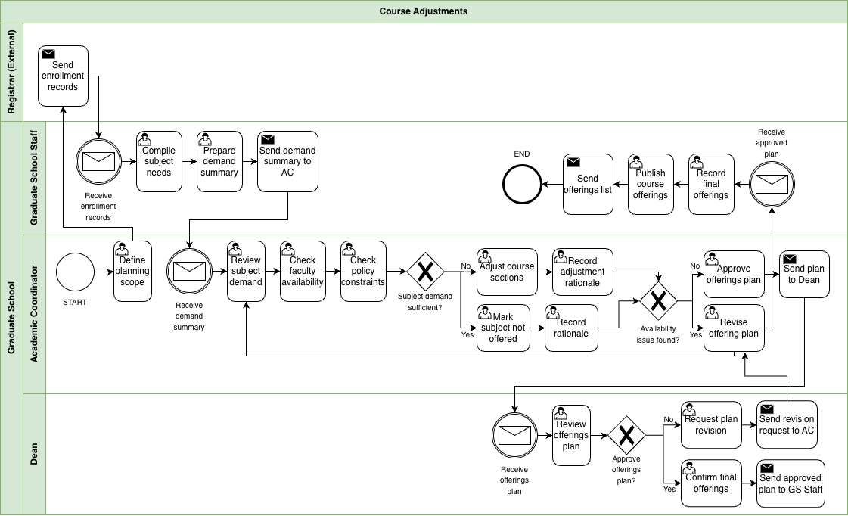

Figure 1.2 BPMN Diagram – Course Adjustments
This figure shows how the Graduate School reviews subject demand and adjusts planned course offerings before publication. Graduate School Staff compile subject needs from enrollment records and prepare a demand summary for the Academic Coordinator. The Academic Coordinator reviews subject demand, checks faculty availability and policy constraints, and decides whether to adjust course sections or mark a subject as not offered. If availability issues occur, the offering plan is revised before being sent to the Dean for approval. Once approved, Graduate School Staff record the final offerings and publish the course list. This reflects the current practice where the Academic Coordinator prepares course offerings based on student subject needs and curriculum requirements near the end of each term.

1.3.4 Coursework
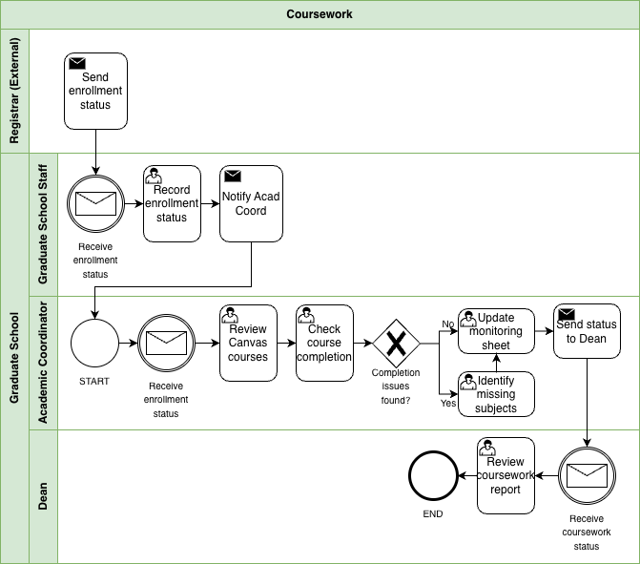

Figure 1.3 BPMN Diagram – Coursework
This figure shows how the Graduate School monitors coursework completion after enrollment. Enrollment status is received from existing institutional records, and Graduate School Staff record the status and notify the Academic Coordinator. The Academic Coordinator reviews coursework and checks subject completion to identify missing subjects or remaining requirements. Monitoring records are updated and the coursework status is sent to the Dean for review. This process reflects how Graduate School monitoring focuses on completion status and remaining subjects rather than exact grade values while official academic records remain within the Registrar’s system.

1.3.5 Leave of Absence and Readmission
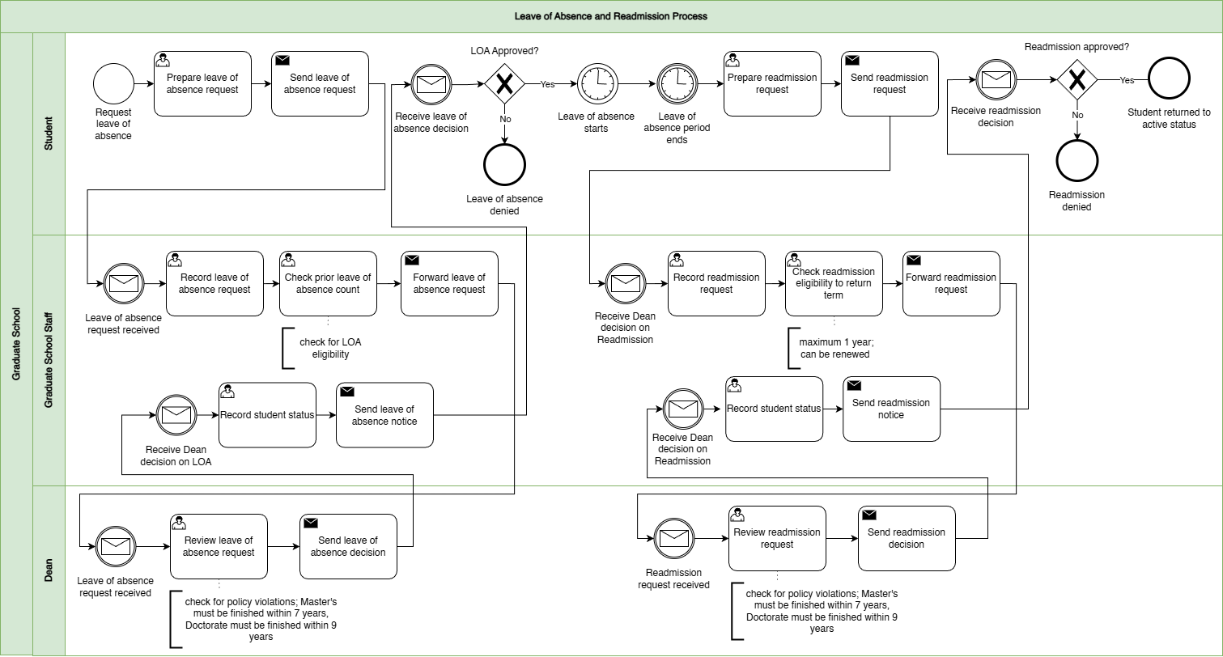

Figure 1.4 BPMN Diagram – Leave of Absence and Readmission
This figure shows leave of absence and readmission as a stop and start process. The student submits a leave of absence request, usually through email, and Graduate School Staff record it, check eligibility including prior leave of absence count, and forward it to the Dean for approval. Once the Dean decides, Graduate School Staff record the student’s status and send the decision notice. The stop and start part is important because leave of absence has an approved period, and readmission happens later when the student is ready to return. When the student requests readmission, staff record the request, check eligibility to return for the target term, and forward it again to the Dean. After the Dean’s decision, staff update the status and notify the student.

1.3.6 Title Defense
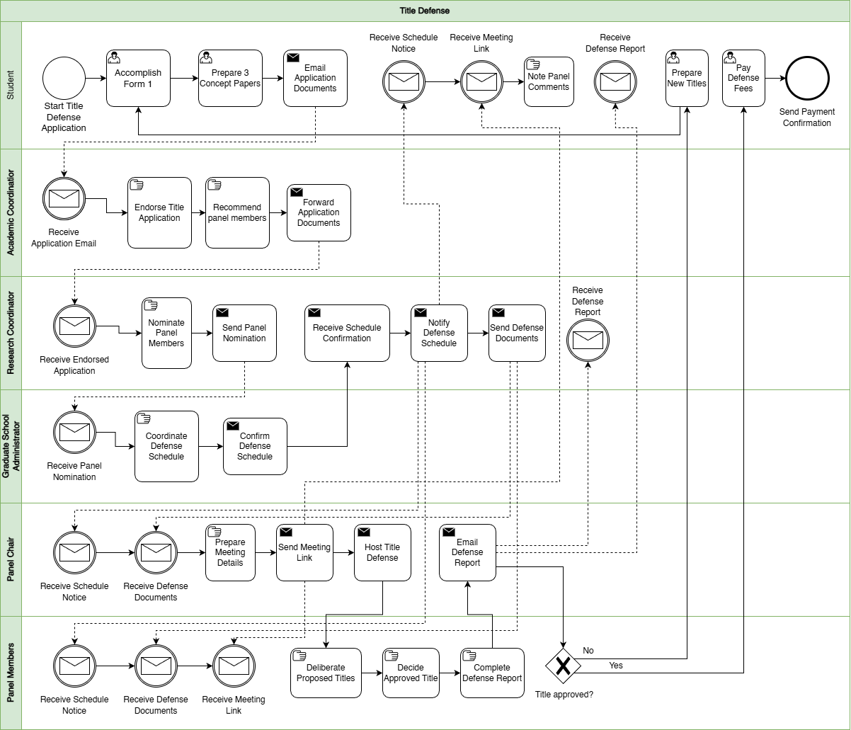

Figure 1.5 BPMN Diagram – Title Defense
This figure shows how the title defense application and decisions are coordinated. The student prepares and submits the required documents, including the concept papers, Form 1 Application for Title Defense, and the related application materials. The Academic Coordinator receives the submission, endorses it, and helps recommend panel members. The Research Coordinator handles panel nomination. Graduate School administration coordinates the schedule and sends notices. The Panel Chair prepares the meeting details, sends the meeting link, hosts the title defense, and sends the defense report through Form 2 Report of Title Defense. The Panel Members deliberate and decide whether the proposed title is approved. If the title is not approved, the student revises and prepares new titles for re-evaluation. If approved, the student proceeds with the next required actions, including payment, which is usually given in cash to the panel on the day of the defense.

1.3.7 Advisor Designation
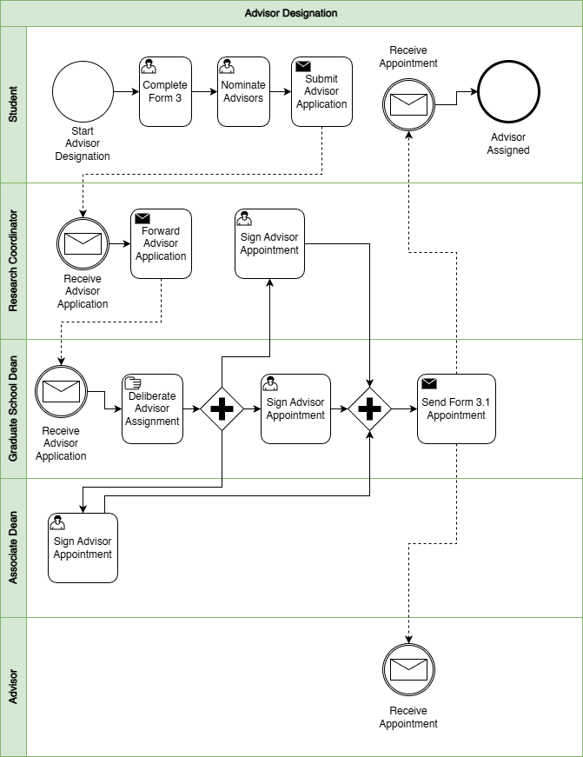

Figure 1.6 BPMN Diagram – Advisor Designation
This figure shows the adviser assignment process from student nomination to official appointment. The student completes Form 3 Application for Designation of Research Adviser and nominates advisers, then submits the adviser application. The Research Coordinator receives and forwards the application. The Graduate School Dean reviews and deliberates adviser assignment, and the appointment is signed and confirmed. After signing, Form 3.1 Appointment for Research Adviser is sent out, and both the student and adviser receive the appointment. After the adviser is confirmed, related advising setup documents such as Form 3.2 Research Timetable and Form 3.3 Thesis/Dissertation Advising Contract may also be completed as part of the advising setup.

1.3.7 Defense Scheduling and Rescheduling
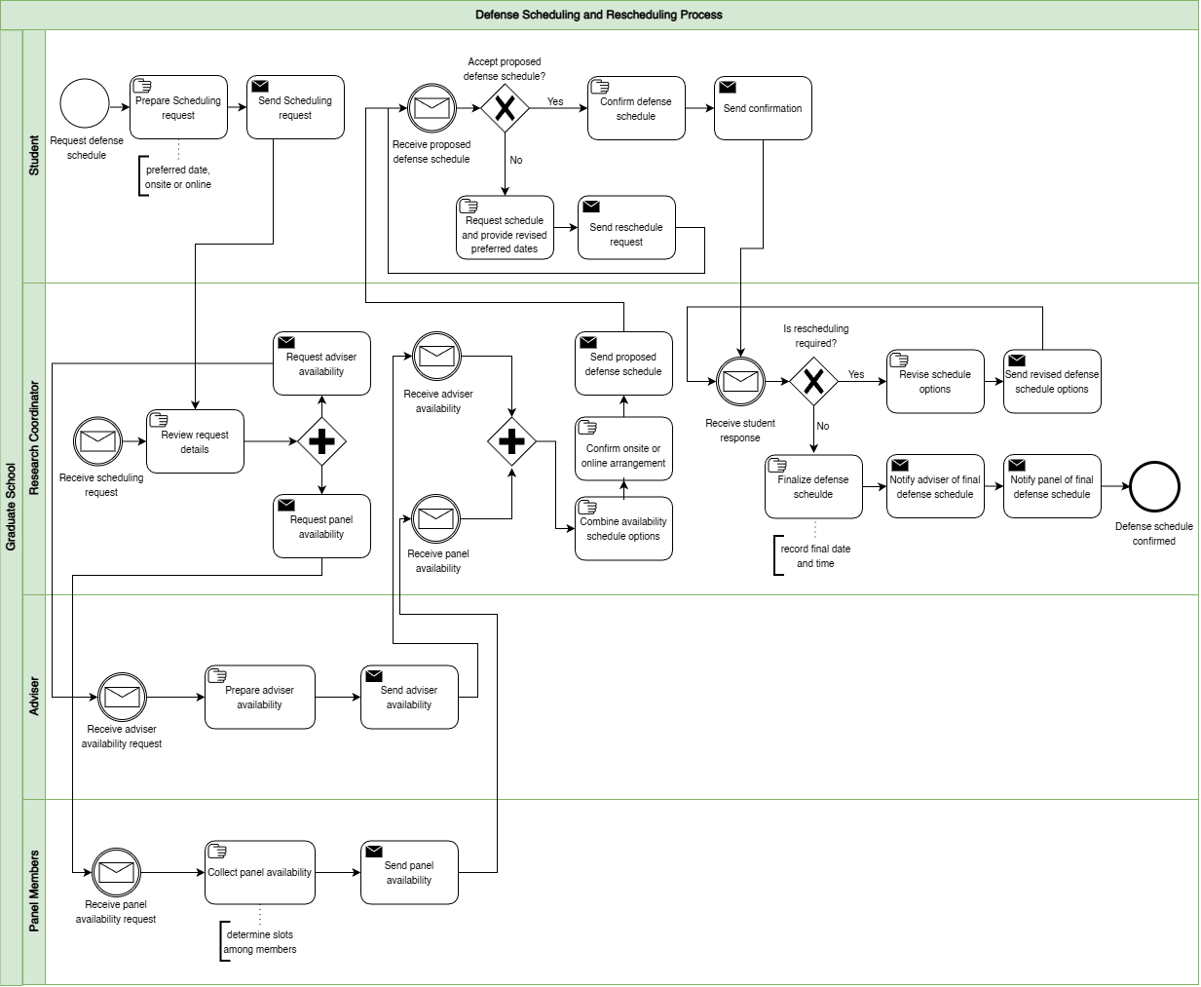

Figure 1.7 BPMN Diagram – Defense Scheduling and Rescheduling
This figure isolates defense scheduling as a coordination loop. The student submits a schedule request with a preferred date window and mode, either onsite or online. The Research Coordinator reviews the request and collects availability from the adviser and panel members. Once availability is received, the Research Coordinator combines it into schedule options, confirms the venue or online arrangement, and sends a proposed schedule to the student. The student either confirms or requests a reschedule with revised preferred dates. If rescheduling is required, the Research Coordinator revises options and the loop repeats. If confirmed, the schedule is finalized and notifications are sent to the adviser and panel. In the wider research process, this scheduling stage usually happens alongside defense readiness documents such as Form 4 Endorsement for Proposal/Final Defense and, when applicable, Form 4.3 Endorsement for Public Defense.

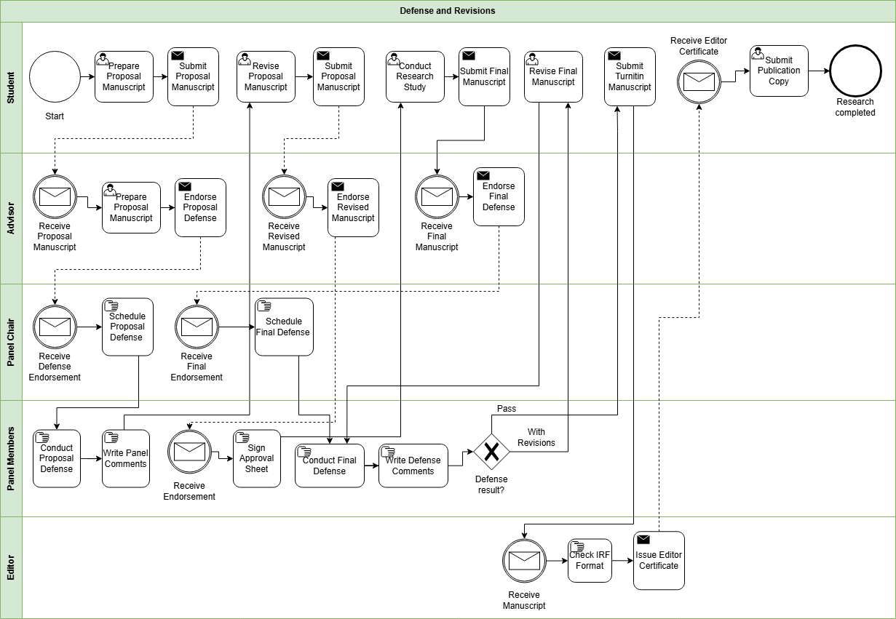
1.3.9 Defense and Revisions

Figure 1.8 BPMN Diagram – Defense and Revisions
This figure focuses on what happens after a defense decision and how revisions are handled. After the defense, panel comments and required revisions are captured and routed back to the student. Depending on the stage, this may involve documents such as Form 5 Comments Sheet for Proposal Defense, Form 6 Comments Sheet for Final Defense, and Form 7 Evaluation Sheet for Final Defense. If there is a provisional pass or conditional approval, Form 8 Settlement of Provisional Thesis/Dissertation Approval may also be used. The student revises and resubmits until the required changes are confirmed as complete. If revisions are incomplete or unclear, the process loops back for further updates. Related completion and clearance documents may also appear in this stage, including Form 5.1 Technical Review Certificate, Form 5.2 Application for Ethics Review, Form 9 Editor Certification, and Form 10 Approval Sheet.

1.3.10 Practicum
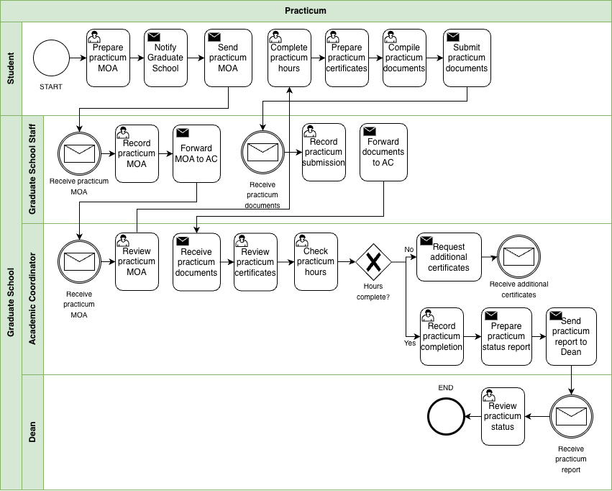

Figure 1.9 BPMN Diagram – Practicum
This figure shows how the Graduate School monitors practicum requirements for programs that require field hours. Practicum currently applies only to the Psychology and Master of Science in Guidance and Counseling (MSGC) programs, so this workflow functions as a conditional process that activates only when practicum is required. The student first notifies the Graduate School and submits the practicum MOA before completing the required practicum hours. After completing the hours, the student submits practicum certificates and supporting documents. Graduate School Staff record the submission and forward the documents to the Academic Coordinator. The Academic Coordinator reviews the certificates and checks whether the required practicum hours are completed. Because hours may be completed across multiple companies, several certificates may need to be reviewed. Once the requirement is satisfied, the Academic Coordinator records completion and sends a practicum status report to the Dean for review.

1.3.11 Withdrawal
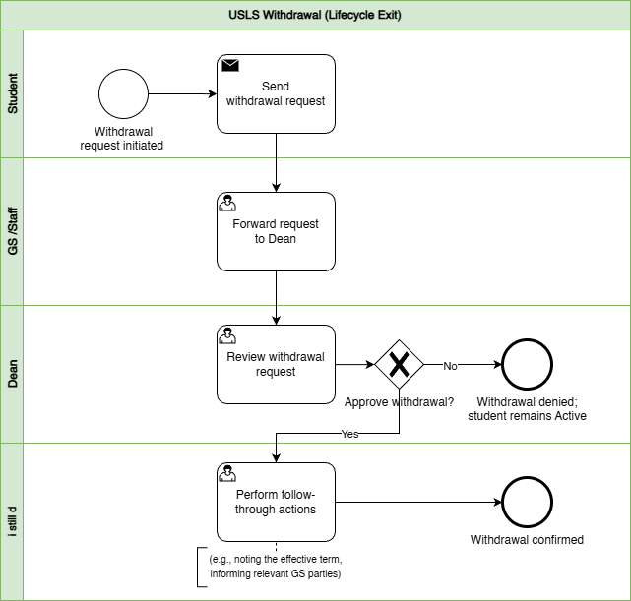

Figure 1.10 BPMN Diagram – Withdrawal
This figure shows withdrawal as a controlled exit process. The student submits a withdrawal request, Graduate School Staff forward it to the Dean, and the Dean approves or denies the request. If denied, the student remains active. If approved, follow-through actions are performed, such as noting the effective term and informing relevant Graduate School parties, and the withdrawal is confirmed.

1.3.12 Graduation
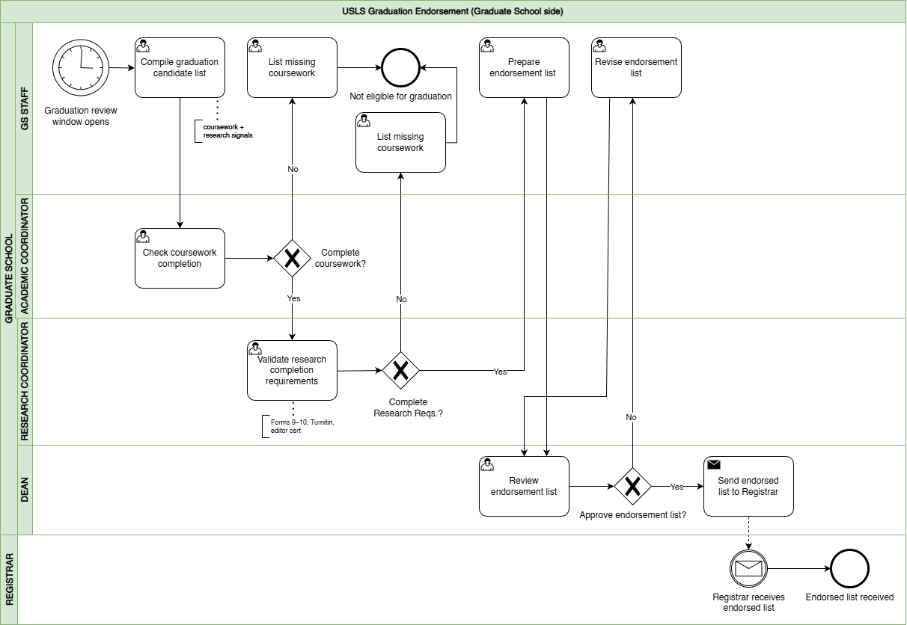

Figure 1.11 BPMN Diagram – Graduation
This figure shows graduation as an endorsement process on the Graduate School side, separate from Registrar graduation processing. Graduate School Staff compile a candidate list during the graduation review window. The Academic Coordinator checks coursework completion, and the Research Coordinator validates research completion requirements. This validation may include completion evidence drawn from the research protocol documents, especially Form 9 Editor Certification and Form 10 Approval Sheet, together with other credited subject and requirement checks. If requirements are missing, the student is marked not eligible and is placed under missing requirements tracking so the issue is visible instead of being lost in follow-ups. If complete, an endorsement list is prepared and sent to the Dean for review. If approved, the endorsed list is sent to the Registrar and the receipt is acknowledged.

1.4 Statement of the Problem
Graduate schools must maintain oversight of graduate student progression across the full graduate student lifecycle to support academic decisions, compliance monitoring, and timely intervention for delayed cases. This includes admission handoff, enrollment monitoring, coursework tracking, leave of absence and readmission, practicum for applicable programs, research milestones, withdrawal, and graduation endorsement. In current practice, however, graduate student lifecycle monitoring and processes are performed through manual coordination using multiple records and documents.
Information needed to verify a student’s standing is distributed across different files and tools maintained by various Graduate School stakeholders. For example, admissions results are recorded in spreadsheets, enrollment and coursework progress are tracked in monitoring sheets, and research-related requirements such as Form 4 (Research Protocol Submission Form) are reviewed by the academic coordinator and faculty advisers. Other supporting records, such as practicum documents and email coordination, are also used in monitoring. Because each stage of the process is recorded separately, confirming a student’s progress requires checking several files and communicating with multiple stakeholders.
As a result, stakeholders cannot easily determine key monitoring information such as the current lifecycle stage of a student, pending requirements, the responsible person for the next action, or which cases may already be delayed. Confirming this information often requires manual checking of records, reviewing forms, and coordinating through email or follow-ups.
This concern was also raised during the second confirmed meeting with Sir Eddie De Paula, documented in the review and sign-off file titled 2nd Meeting Transcript Confirmation w/ Sir Eddie De Paula. In that meeting, the Graduate School identified the need for reports such as subject needs for class planning, lists of graduating students, LOA monitoring, and residency tracking. The notes also confirm that staff sometimes generate reports from AIMS and still manually compute residency by counting the student’s start and end years, which takes more time and effort. In addition, the current monitoring view is often kept per student in spreadsheets rather than in one consolidated group view, so reporting still requires manual consolidation before it can support decisions. This shows that the issue is not simply solved by adding more manpower. Even if more people are assigned to do the work, the process remains manual, slower, more costly, and still prone to encoding errors, missed updates, and inconsistent results.
Main Problem Statement: “Graduate student status is recorded across multiple sources, and the Graduate School does not have one consolidated view. Because monitoring and processing rely on manual checking and encoding, status confirmation is slow and prone to human error.”
This means:
- Difficulty in maintaining a clear view of student progress. Graduate School tracking covers many stages of the student lifecycle and research milestones. Stakeholders need a clear view of where a student stands to support term decisions, compliance checks, and early intervention for delayed cases.
- Difficulty in receiving updates and supporting evidence on time. Status details come from different sources such as admissions signals, monitoring sheets, protocol forms, and email coordination. Because updates rely on manual checking and encoding, some updates may be delayed, missed, or recorded incorrectly.
- Difficulty in combining records into one status view. Even when the needed information exists, it is stored in separate tools and records. Staff often need to piece these together to confirm student standing and readiness, which takes time and effort.
- Difficulty in answering basic monitoring questions quickly. Without one shared view, stakeholders cannot quickly determine where the student is now, what is pending or overdue, who owns the next action, and which cases may be delayed without manual checking and reconciliation.
- Difficulty in acting early when confirmation is slow. When status confirmation takes too long, follow-ups and decisions are also delayed. This can lead to repeated follow-ups and slower response to stalled cases.
- Difficulty in generating timely and reliable reports. The Graduate School needs reports such as subject needs for class planning, lists of graduating students, LOA monitoring, and residency tracking. However, these are still pulled from separate records and manually combined. In some cases, staff still have to compute residency manually from AIMS reports, which takes time and increases the risk of delay and human error.

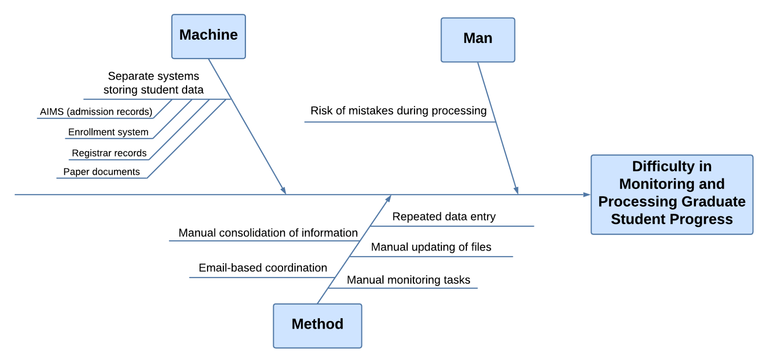

Figure 2. Ishikawa Diagram – Root Causes of Difficulty in Monitoring and Processing Graduate Student Progress
The difficulty in monitoring and processing graduate student progress is primarily caused by issues related to the systems used, the monitoring process, and the risk of errors during handling. Under the Machine category, student information is stored in separate systems such as AIMS for admission records, the enrollment system, registrar records, and paper documents. Because each system contains only a portion of the student lifecycle, staff are unable to view a complete and consolidated status in one place. This fragmentation requires them to access multiple sources when verifying student progress, which slows down monitoring and contributes to inefficiency.
Under the Method category, the monitoring process relies heavily on manual handling of information. Staff must manually consolidate information by gathering data from different records and combining them to confirm student status. Updates are also handled through manual file updates and repeated data entry, as the same information needs to be encoded across multiple records. In addition, coordination is done through email, which further delays communication and follow-ups. These practices make the monitoring process time-consuming and dependent on manual effort.
Under the Man category, the reliance on manual processes increases the risk of mistakes during processing. Because staff repeatedly encode and update information across multiple files, there is a higher chance of errors such as incorrect entries or missed updates. These errors can lead to inconsistencies in student records and affect the accuracy of monitoring. Altogether, the separation of systems, manual processes, and risk of human error contribute to inefficiencies and inconsistencies, which makes it difficult for the Graduate School to effectively monitor and process graduate student progress.
These root causes show why graduate student progress is difficult to monitor and process consistently, and why status confirmation and report generation often depend on delayed and manually combined information (Sorour & Atkins, 2024; CHED Region IV-B MIMAROPA, 2018).
These conditions make it difficult to maintain a consistent view of students standing across lifecycle stages and research milestones. Because process events, evidence requirements, ownership of next actions, and timestamps are kept across separate records and handled through manual coordination, Graduate School staff often need repeated checking, follow-up, and reconciliation just to confirm the current status of a case. This also makes pending items, delays, time in stage, scheduling status, and workload visibility harder to monitor reliably (Grooms et al., 2016; Sorour & Atkins, 2024; Datu, 2022; Tanate-Lazo, 2021).

1.5 Objectives of the Study
This study aims to analyze graduate school operations in order to identify operational inefficiencies that affect lifecycle monitoring and decision support. Specifically, it intends to:
- Understand and analyze graduate school operations to identify inefficiencies affecting lifecycle monitoring, follow-ups, and coordination of graduate student progress. (Grooms et al., 2016; CHED Region IV-B MIMAROPA, 2018)
- Identify the most appropriate solution to address the problem of divided monitoring signals and delayed status confirmation for Graduate School stakeholders. (Sorour & Atkins, 2024; Sancon, 2023)
- Design and implement modules that address the identified problems and sub-processes by enabling consistent capture of process events, evidence, next-action ownership, and timestamps. (Datu, 2022; Doce & Ching, 2018; Purcia & Velarde, 2022)
- Develop analytics outputs that match Graduate School monitoring needs such as dashboards, reports, queue aging, bottleneck indicators, process indicators, and rule-based next-action prompts. (Sorour & Atkins, 2024; Sancon, 2023)
- Conduct appropriate testing to verify the requirements of the Graduate School and confirm the platform supports its intended users. (Brooks, 2023; van Lill, 2024)

1.5.1 SDG Alignment (Sustainable Development Goals):
- SDG 4 – Quality Education: The study supports quality graduate education by making student progress easier to monitor, helping offices identify delayed cases earlier, and guiding timely follow-up so students can move through requirements and milestones more consistently.
- SDG 9 – Industry, Innovation and Infrastructure: The study supports digital improvement in graduate school operations by developing a centralized platform that brings together scattered records into a consistent monitoring and analytics system.
- SDG 16 – Peace, Justice and Strong Institutions: The study supports stronger institutional processes by clarifying responsibility for the next step, keeping key timestamps and status evidence consistent, and producing reports that are more traceable and less dependent on manual reconciliation.

1.6 Conceptual Framework/Design Architecture

1.6.1 Conceptual Framework

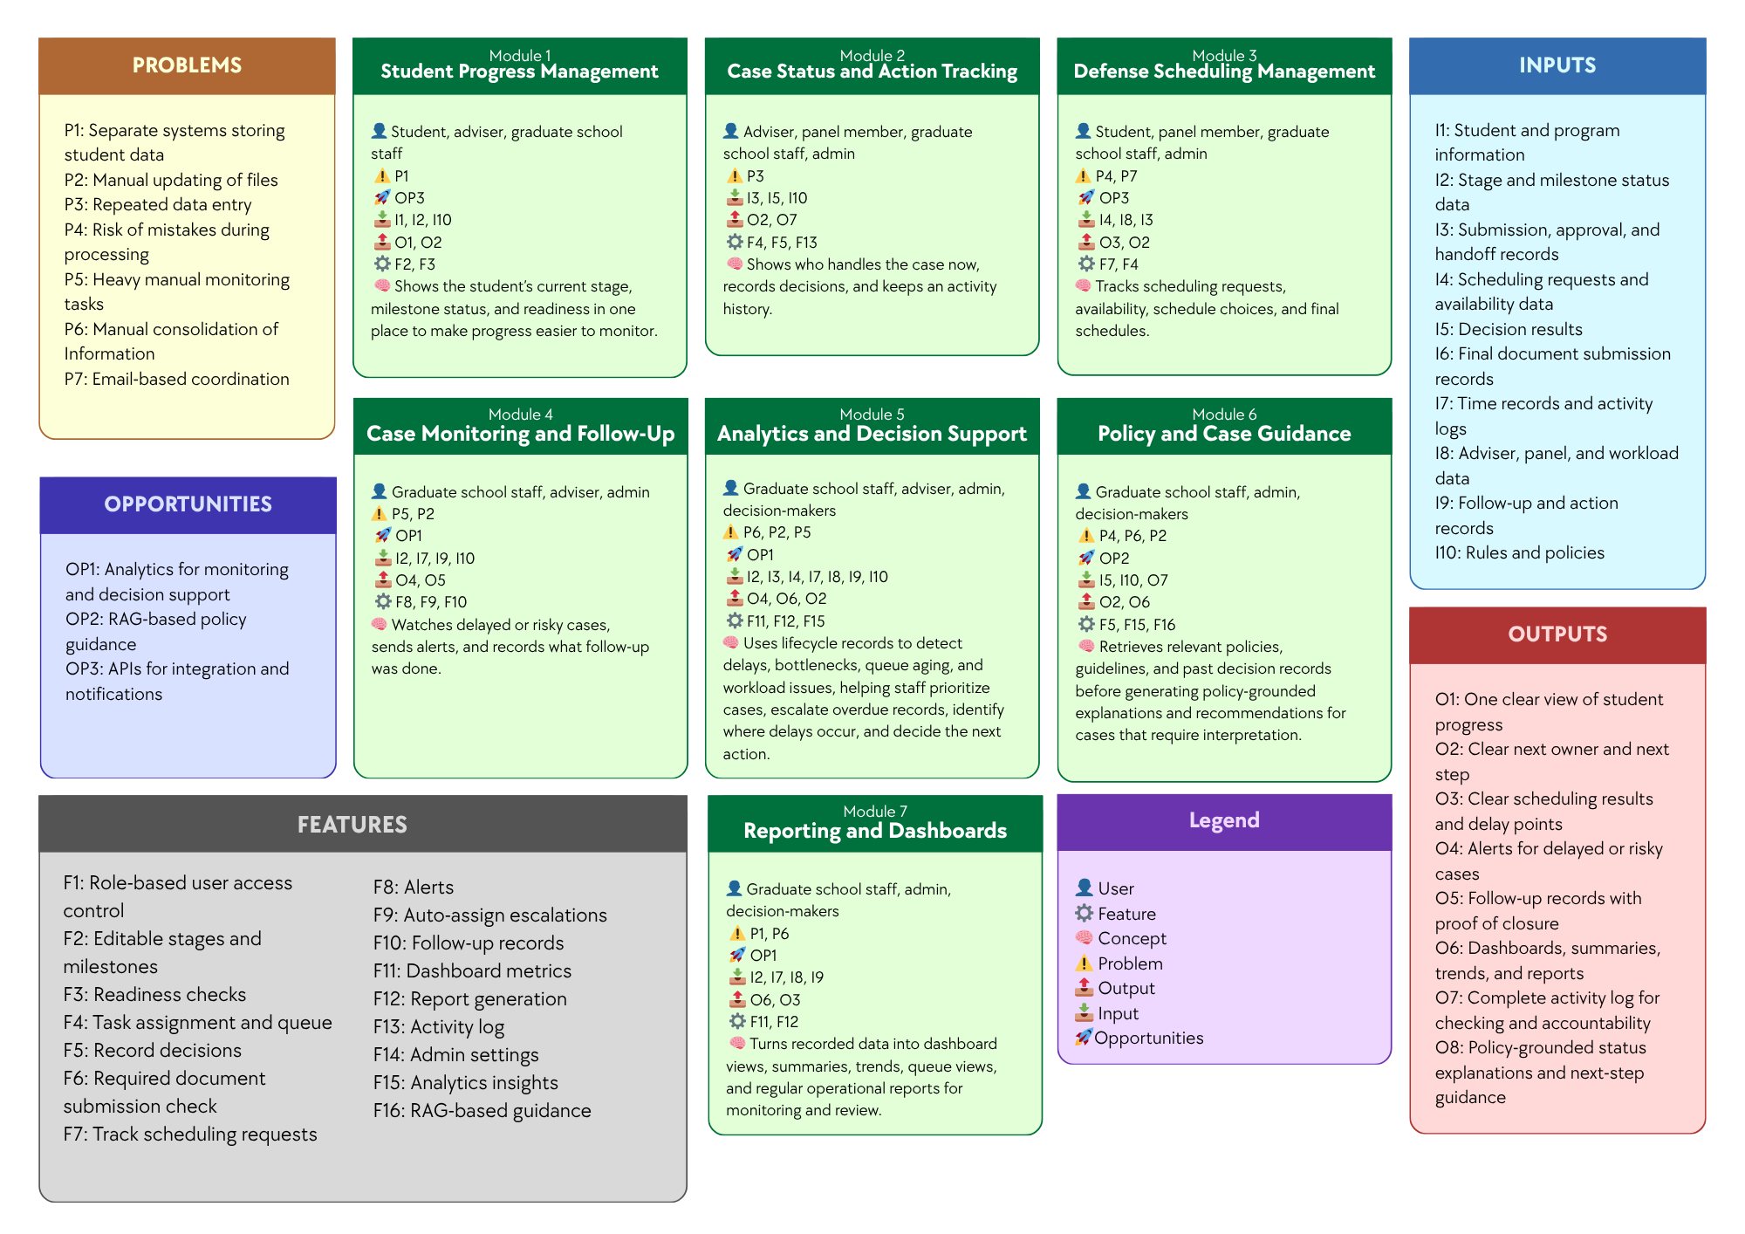

Figure 3. Conceptual Framework Diagram
The conceptual framework of the study presents the overall structure of the proposed Graduate Student Lifecycle Monitoring and Analytics Platform by linking the identified problems, opportunities, inputs, features, modules, and expected outputs. It serves as a high-level guide for understanding how the proposed system is intended to address the operational issues experienced by the Graduate School, such as Separate systems storing student data, Lack of integrated monitoring platform, Repeated data entry, Risk of mistakes during processing, Heavy manual monitoring tasks, Manual consolidation of Information, Email-based coordination, and Manual updating of files. At this stage, the framework is presented as an organizing model rather than a detailed technical design, showing the major parts of the proposed platform, how they are connected, and how they support graduate student lifecycle management. It also shows that the proposed modules and features are designed to respond directly to the identified problems while making use of the opportunities, namely Analytics for monitoring and decision support, RAG-based policy guidance, and APIs for integration and notifications. The discussion that follows explains how each module addresses specific problems, what technology can be used, and how such technology can help solve the problems and contribute to the expected outputs of the system.

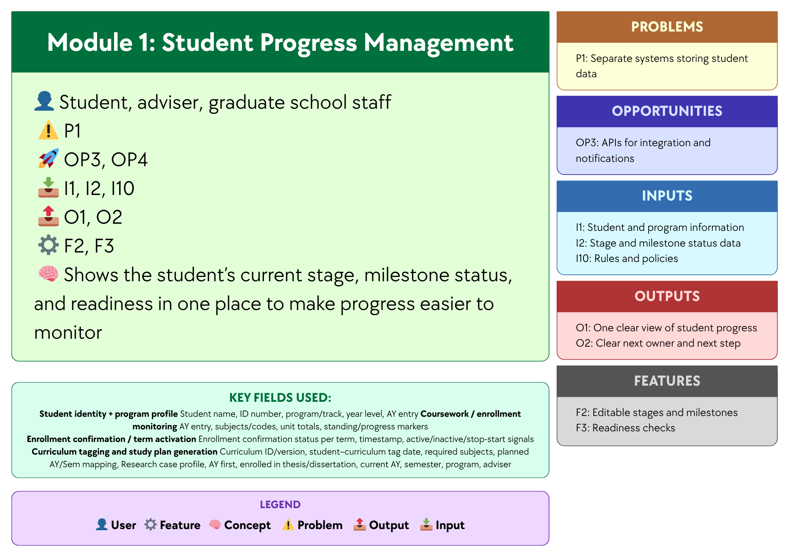

Figure 3.1 Module 1: Student Progress Management
This module focuses on providing a unified view of each student’s progress in the graduate student lifecycle by consolidating Student and program information, Stage and milestone status data, and Rules and policies. Through Editable stages and milestones and Readiness checks, the module helps address Separate systems storing student data and Lack of integrated monitoring platform by organizing progress-related records in one platform and showing the student’s current stage, milestone status, and readiness in a single view. A centralized database and a web-based monitoring interface may be used to support this module, since these technologies allow records to be stored, updated, and accessed in one place instead of across separate files or systems. In this way, the module produces One clear view of student progress and Clear next owner and next step, making progress monitoring more organized, consistent, and accessible for students, advisers, and Graduate School staff.

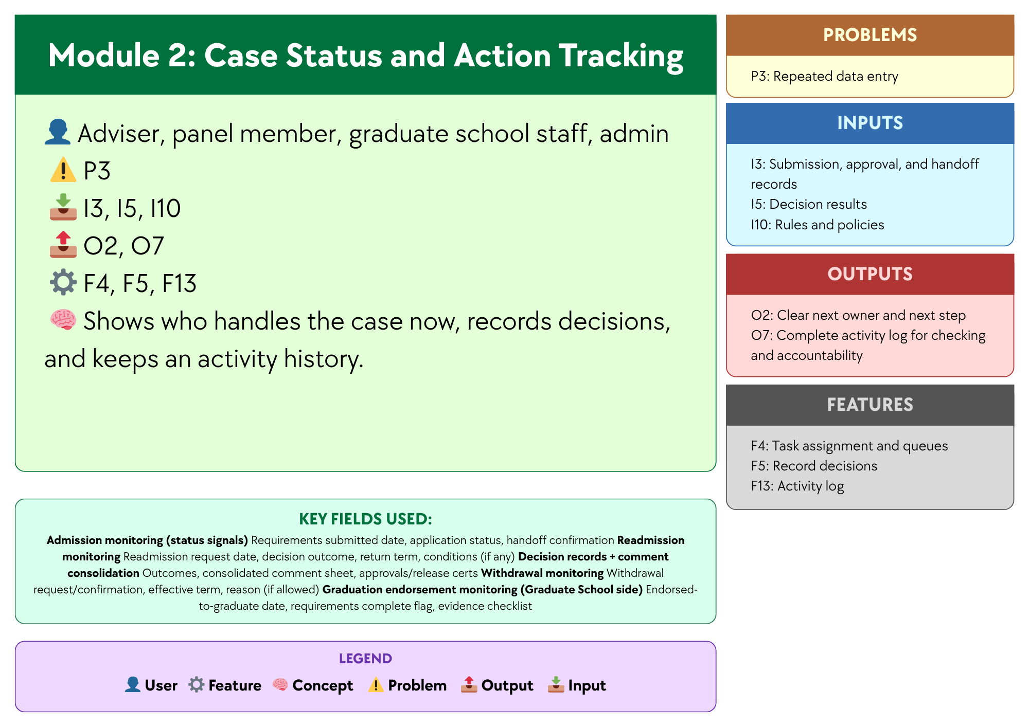

Figure 3.2 Module 2: Case Status and Action Tracking
This module focuses on recording case-related actions and status changes so users can see who currently handles the case, what action has been taken, and what should happen next. Using Submission, approval, and handoff records, Decision results, and Rules and policies, and supported by Task assignment and queue, Record decisions, and Activity log, the module helps address Lack of integrated monitoring platform and Repeated data entry by keeping case actions and records in one place instead of across separate files, emails, or manual logs. A centralized case record database and a status tracking interface may be used to support this module, since these technologies allow case updates, handoffs, and decision records to be stored and viewed in a structured and traceable way. In this way, the module produces Clear next owner and next step and Complete activity log for checking and accountability, helping improve visibility, coordination, and record consistency across the handling of graduate school cases.

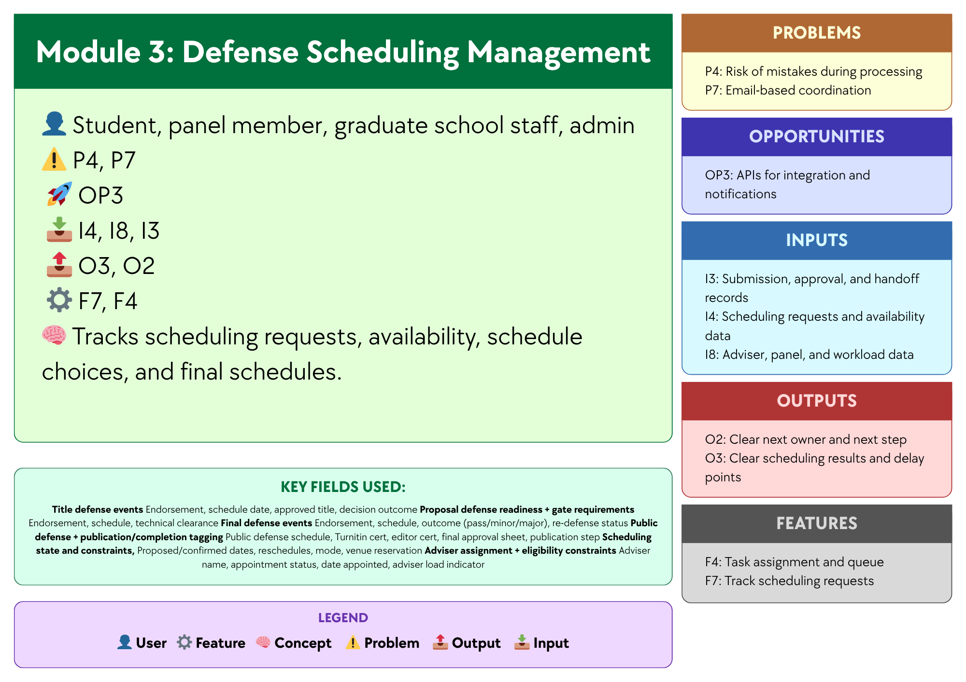

Figure 3.3 Module 3:Defense Scheduling Management
This module focuses on organizing and tracking the scheduling of defense-related activities by using Scheduling requests and availability data, Adviser, panel, and workload data, and Submission, approval, and handoff records. Supported by Track scheduling requests and Task assignment and queue, the module helps address Risk of mistakes during processing and Email-based coordination by recording schedule requests, availability, schedule choices, and final schedules in one place. A centralized scheduling database, a scheduling management interface, and APIs for integration and notifications may be used to support this module, since these technologies can help store scheduling records, match availability, and send updates or reminders to involved users. In this way, the module produces Clear scheduling results and delay points and Clear next owner and next step, making defense scheduling more organized, visible, and easier to coordinate among students, panel members, and Graduate School staff.

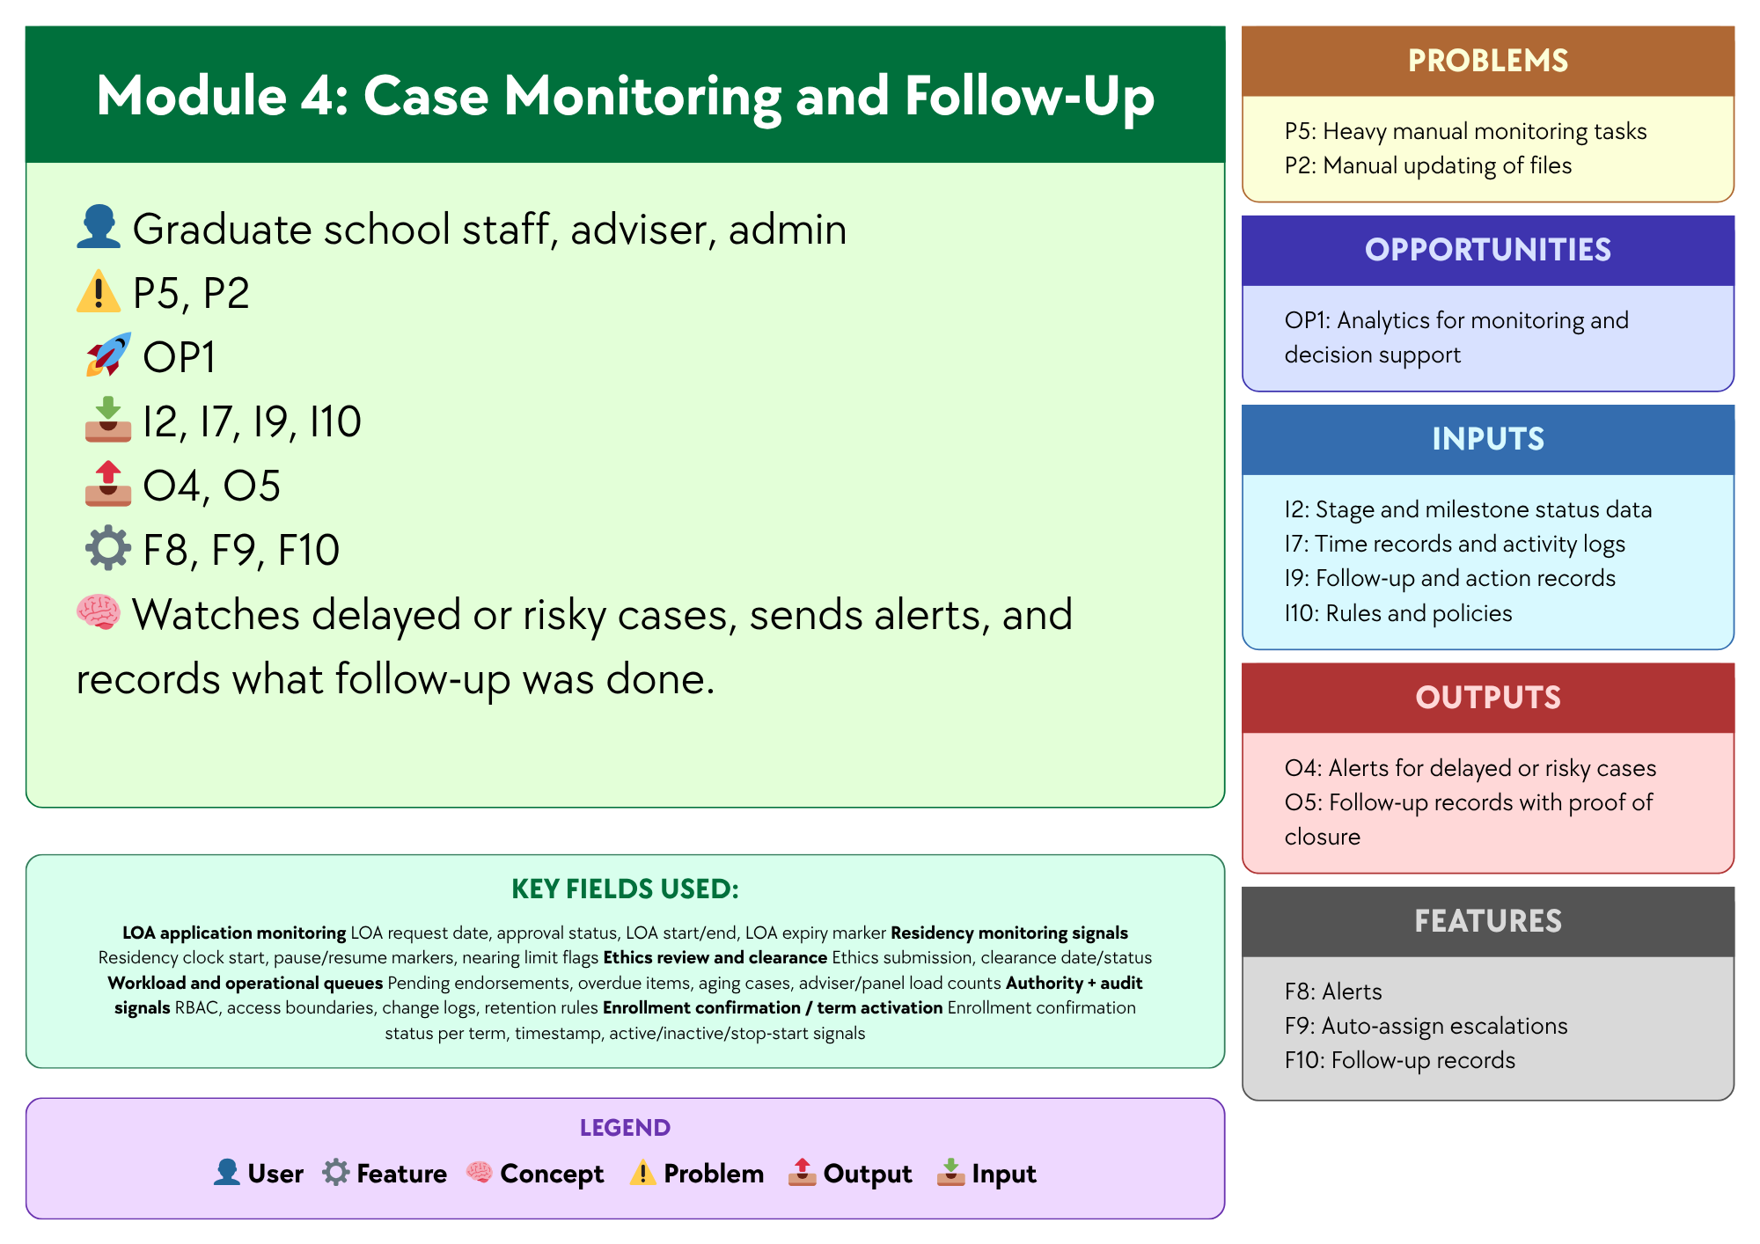

Figure 3.4 Module 4: Case Monitoring and Follow Up
This module focuses on monitoring ongoing cases and identifying those that need attention based on Stage and milestone status data, Time records and activity logs, Follow-up and action records, and Rules and policies. Supported by Alerts, Auto-assign escalations, and Follow-up records, the module helps address Heavy manual monitoring tasks and Manual updating of files by making delayed or risky cases easier to detect and by recording the follow-up actions taken. A monitoring dashboard, automated alert logic, and case tracking database may be used to support this module, since these technologies can help identify cases with delays or inactivity and keep follow-up records updated in a more consistent way. In this way, the module produces Alerts for delayed or risky cases and Follow-up records with proof of closure, helping Graduate School staff and advisers monitor cases more efficiently and respond to issues in a more timely manner.

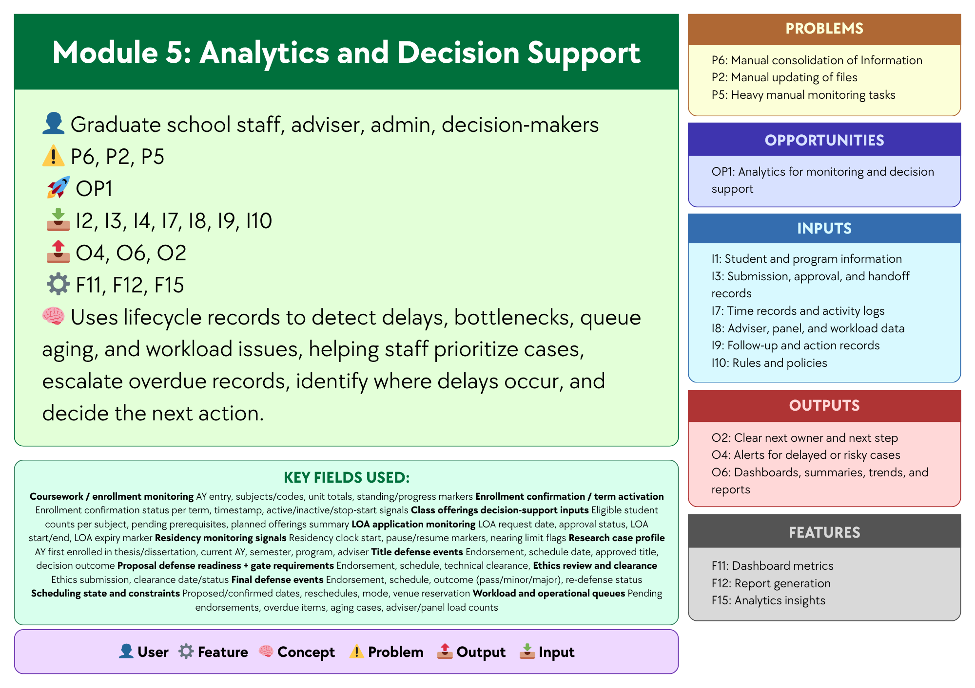

Figure 3.5 Module 5: Analytics and Decision Support
This module analyzes recorded lifecycle data to help the Graduate School better understand student progress and case movement. It uses data such as milestone status, approvals, scheduling records, activity logs, workload data, follow-up actions, and institutional rules and policies. By analyzing these data, the module helps identify patterns like delays, bottlenecks, queue aging, workload issues, and student risk trends. It also supports decisions such as identifying at-risk students, urgent cases, delayed stages, and groups with slower progress or higher attrition. These insights can help staff and decision-makers respond more quickly and appropriately.
The module is also designed to support key decision questions, including:
- Which students are at highest risk of delay, non-completion, or attrition?
- Which students require immediate intervention or priority follow-up?
- Which students are likely to exceed maximum residency based on current progress patterns?
- Which programs, cohorts, or student groups exhibit the slowest completion and highest attrition rates?
- Which lifecycle stages experience the longest delays and most significant bottlenecks?
- Which process areas show the greatest queue aging or case backlog?
- Which students are eligible or nearly ready for the next milestone, defense, or graduation endorsement?
- Which advisers, panels, or coordinators carry the heaviest workload or experience the slowest turnaround times?
- Which students show early signs of academic risk before entering the research stages?
- What completion, delay, and attrition trends should inform policy, resource allocation, and process improvement decisions?
Analytics is needed for these decision questions because reports only present raw or summarized information, while the answers to questions such as who is at risk, which cases need urgent action, where delays are happening, and which programs have slower completion require the system to combine and interpret multiple data points. The Associate Dean also emphasized the need for completion rates, attrition rates, average years to finish, residency tracking, and visibility into the student’s whole lifecycle, which may be presented in reports but require analytical interpretation to reveal patterns, identify risks, and support more informed decision-making.
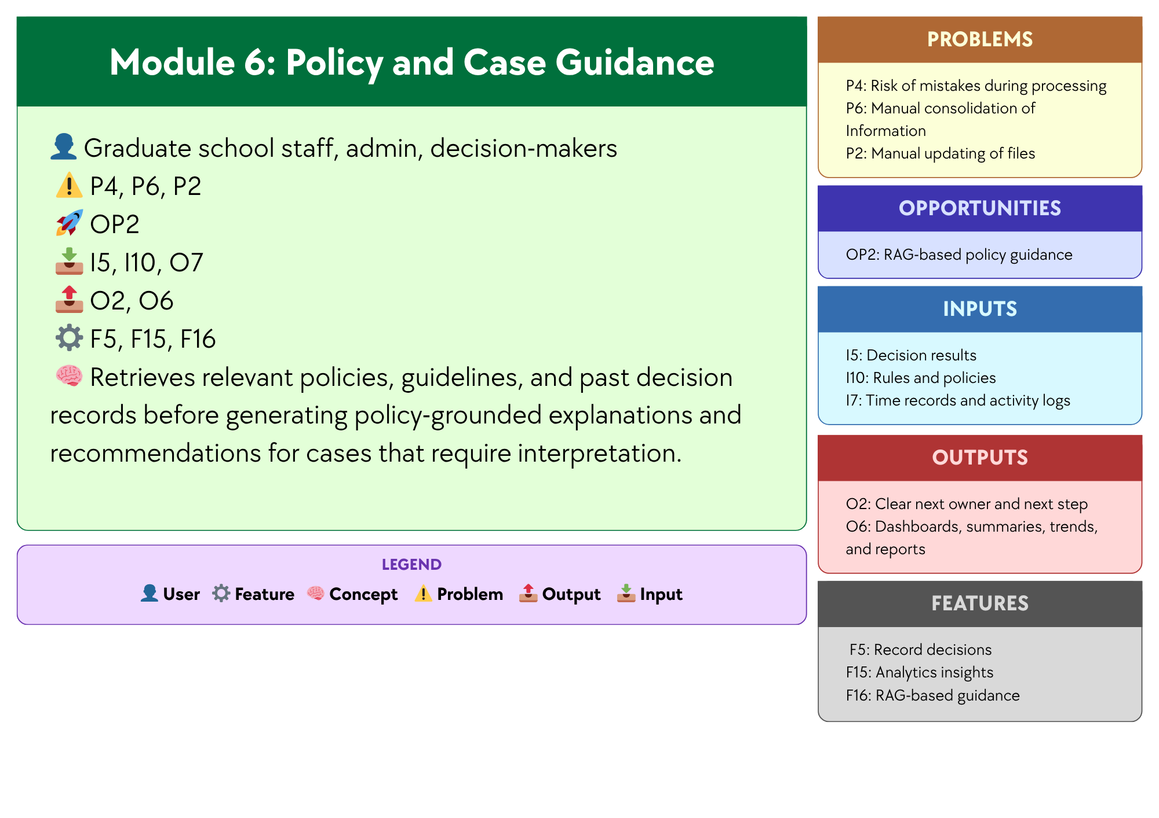

Figure 3.6 Module 6:Policy and Case Guidance
This module focuses on supporting policy and case review for situations that require interpretation in Graduate School operations. Using Graduate School policies, guidelines, forms, and past decision records, and supported by the opportunity to use AI through NotebookLM, the module helps address the time and effort needed to manually search for rules, check related documents, and review similar cases across different files and records. NotebookLM may be used to support this module, since it can work with uploaded reference materials and help users retrieve relevant information before giving explanations and recommendations. In this way, the module produces policy-grounded explanations and recommendations for cases that require interpretation, helping Graduate School staff, administrators, and decision-makers review cases more quickly and more consistently, while final decisions remain with the proper offices and authorized personnel.

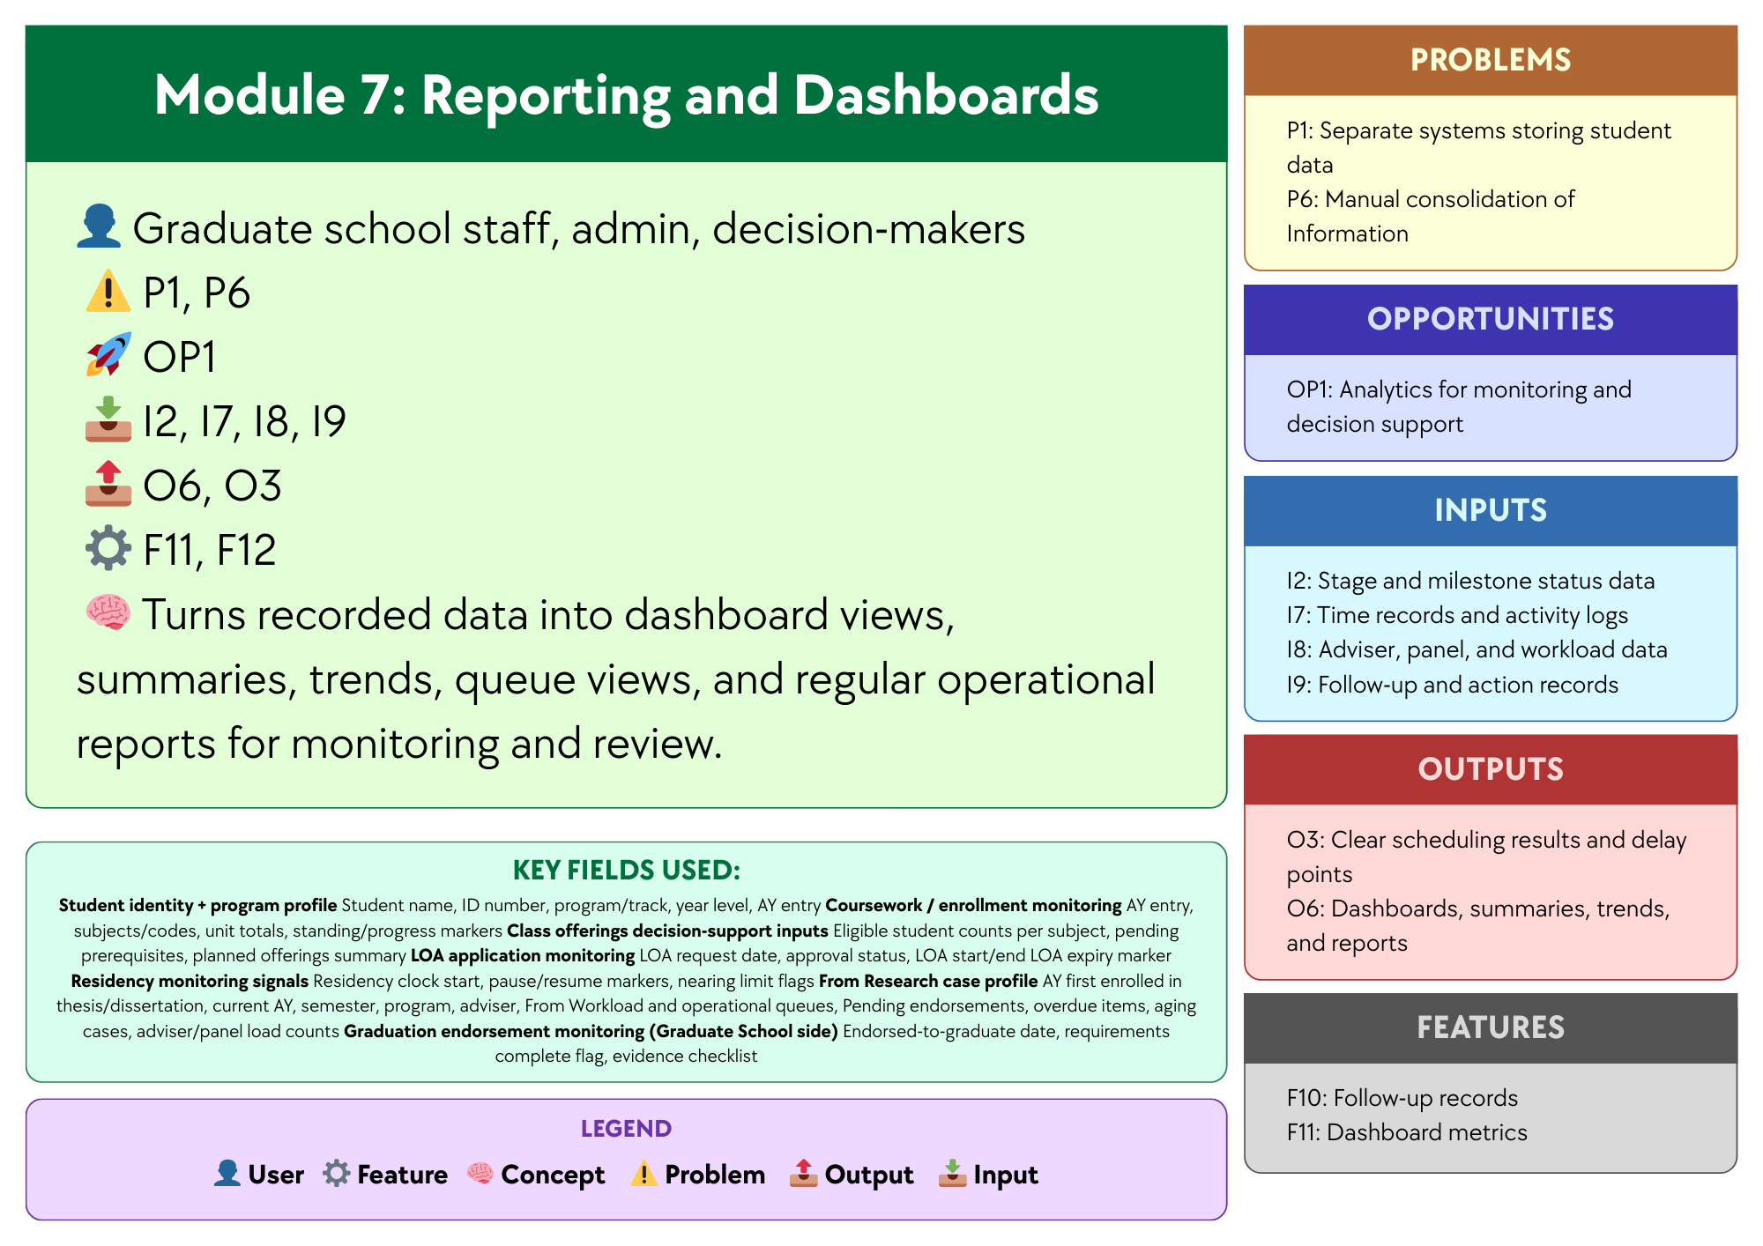

Figure 3.7 Module 7: Reporting and Dashboards
Module 7, Reporting and Dashboards, focuses on presenting recorded case and lifecycle data in a clear and organized form for monitoring, review, and communication. Using Stage and milestone status data, Time records and activity logs, Adviser, panel, and workload data, and Follow-up and action records, and supported by Dashboard metrics and Report generation, the module helps address Separate systems storing student data and Manual consolidation of Information by turning scattered records into summarized views that are easier to access and understand. Dashboard tools, reporting tools, and a centralized database may be used to support this module, since these technologies can gather data from different records and present them through dashboard views, summaries, trends, queue views, and regular operational reports. In this way, the module produces Dashboards, summaries, trends, and reports and Clear scheduling results and delay points, helping Graduate School staff, administrators, and decision-makers review operational conditions more efficiently.

1.6.2 Design Architecture

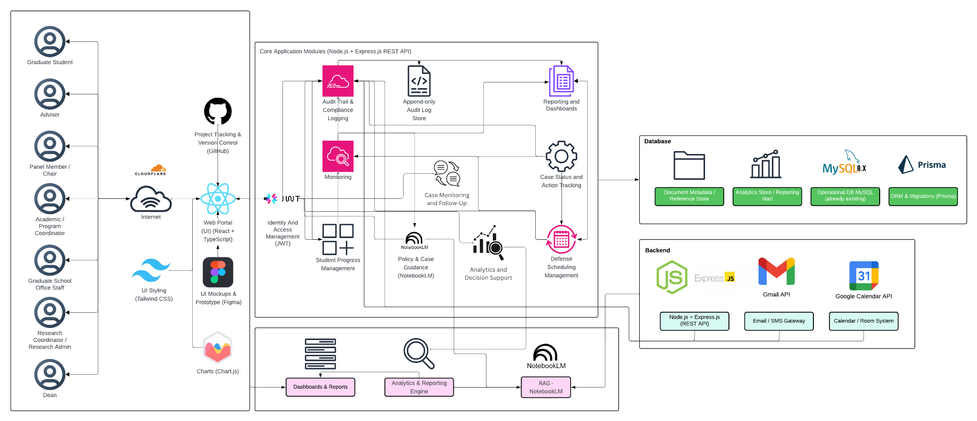

Figure 4. High-Level System Architecture Diagram
Figure 4 shows the high-level architecture of the proposed platform for graduate student lifecycle monitoring and decision support. The architecture begins with the main user groups, namely the graduate student, adviser, panel member or chair, Academic or Program Coordinator, Graduate School Office Staff, Research Coordinator or Research Admin, and the Dean. These users access the system through a web portal built with React and TypeScript, with Tailwind CSS for styling and Chart.js for data visualization. Figma is used for interface design and prototyping, while GitHub is used for project tracking and version control. Access to the platform is controlled through identity and access management using JWT.
At the center of the architecture are the Core Application Modules, built on Node.js and Express.js through a REST API. These modules handle the main functions of the system. The Student Progress Management module shows the student’s current stage, milestone status, and readiness in one place to make progress easier to monitor. The Case Status and Action Tracking module shows who handles the case now, records decisions, and keeps an activity history. The Defense Scheduling Management module tracks scheduling requests, availability, schedule choices, and final schedules. The Case Monitoring and Follow-Up module watches delayed or risky cases, sends alerts, and records what follow-up was done. The Analytics and Decision Support module uses lifecycle records to detect delays, bottlenecks, queue aging, and workload issues, helping staff prioritize cases, escalate overdue records, identify where delays occur, and decide the next action. The Policy and Case Guidance module retrieves relevant policies, guidelines, and past decision records before generating policy-grounded explanations and recommendations for cases that require interpretation. The Reporting and Dashboards module turns recorded data into dashboard views, summaries, trends, queue views, and regular operational reports for monitoring and review. The architecture also includes Audit Trail and Compliance Logging, supported by an append-only Audit Log Store, to keep a traceable record of actions and changes in the system.
The architecture connects these modules to the database layer. This layer includes the Operational Database in MySQL, the Analytics Store or Reporting Mart, and the Document Metadata or Reference Store, with Prisma used for ORM and migrations. This setup keeps daily operational records, reporting data, and document references connected but still organized according to their purpose. The architecture also shows the backend and integration components. The backend is built on Node.js and Express.js.
The use of APIs is also an important part of the architecture. APIs allow the platform to connect with other systems and services so that data does not need to be transferred manually. In the proposed system, APIs may be used to retrieve operational data from existing institutional systems and to support communication and scheduling functions. This helps reduce repeated encoding, lowers the risk of inconsistent records, and supports a more connected monitoring process across Graduate School activities.

Two API-based integrations are especially relevant in the design. The Google Calendar API may be used to support defense scheduling, meeting coordination, and possible room or calendar checks. This can help the system record and manage schedule requests in a more organized way. The Gmail API may be used to support email notifications, follow-up messages, and communication related to tasks, reminders, or case updates. These integrations make it easier for the platform to support actual Graduate School workflows, especially in areas where scheduling and communication are part of day-to-day monitoring.
For the proposed design, the study uses a RAG-based decision support approach for policy and case guidance. In this setup, the assistant retrieves relevant Graduate School policies, guidelines, forms, past case references, and other approved documents before generating any response. This means the assistant does not rely on free-form answers alone, but instead uses retrieved sources and system-generated indicators as the basis for its guidance. NotebookLM may be used as a practical prototyping environment for organizing and querying approved reference materials, but it is not treated as the core backend service or the source of truth of the platform. Official status signals, computed indicators, and rule-based recommendations remain generated by the system backend and database from validated records. In this way, the RAG layer serves as a retrieval and explanation tool for authorized users, while final decisions remain with the proper offices and authorized personnel.
Overall, Figure 4 shows that the proposed platform is designed as a web-based monitoring and decision-support system built around core modules, structured records, reporting tools, and controlled integrations. It supports multiple Graduate School roles while keeping lifecycle data, milestone tracking, case records, scheduling, alerts, and reporting within one connected system view. By combining a centralized platform, API-supported integration, and policy-grounded AI guidance through NotebookLM, the design supports faster monitoring, better record visibility, and more consistent administrative review.

1.7 Scope and Limitations
To avoid scope creep, this study uses a focused and depth-oriented scope. The prototype centers on a Graduate School monitoring and process coordination layer that supports milestone definitions, role-based task queues, dashboards and reports, event logging for analytics, and prescriptive decision support outputs. Its goal is to provide clear visibility and traceability of graduate student progress across lifecycle stages and research milestones, while also supporting day-to-day Graduate School follow-up through validated process signals and recorded timestamps.
This scope reflects the current AS-IS setup, where lifecycle signals and process steps already exist but are spread across spreadsheets, email coordination, and separate tools. The system will represent allowed progress indicators, such as completion markers, incomplete status flags, readiness checks, and document or evidence checkpoints. It will also formalize key process handoffs, such as next-step ownership and task routing. However, it will not replace institutional systems used for admissions processing, enrollment transactions, grading, learning management, registrar processing, or accounting and billing. Prescriptive analytics for decision support will be limited to rule-based recommendations based on allowed process events, timestamps, and encoded Graduate School policies. Final decisions and approvals will remain with authorized Graduate School stakeholders.

1.7.1 Scope

1.7.1.1 User Scope
The platform is intended for authorized Graduate School stakeholders responsible for monitoring, follow-up, and coordination of graduate student progress. These users include Graduate School administrative staff, coordinators, program-level coordinators, research advisers, panel members, research coordinators, designated reviewers or approvers, and the Graduate School dean. Each user accesses the platform through role-based dashboards that display lifecycle status, pending actions, submitted requirements, and scheduling information relevant to their responsibilities.
The platform supports graduate programs offered by the University of St. La Salle – Bacolod Graduate School, including programs under the following academic clusters:
- Arts and Sciences
- Business
- Education
- Engineering and Technology
- Nursing
Student coverage includes enrolled graduate students undergoing coursework, research milestones, or completion requirements within the Graduate School. The platform monitors lifecycle progression from admission onboarding to graduation endorsement within Graduate School processes.

1.7.1.2 Process Scope
The platform supports monitoring and coordination of the following Graduate School process areas:
- Admission Monitoring and Process Coordination – tracking requirements submission status signals, intake verification, enrollment confirmation handoff, and Graduate School onboarding.
- Enrollment Monitoring and Process Coordination – monitoring enrollment status, adding and dropping tracking, enrollment confirmation, offerings planning support, and course audit signals for program requirements.
- Coursework Monitoring and Process Coordination – monitoring student progress during coursework stages, including schedule visibility, module tracking, allowed monitoring signals for grade or standing, and readiness checks for transition to thesis or dissertation milestones.
- Leave of Absence and Readmission Monitoring – recording LOA applications, tracking pause in residency as a monitoring signal, and monitoring readmission processing for returning students.
- Thesis and Dissertation Monitoring and Defense Coordination – tracking research milestones such as adviser designation, title defense, proposal defense, revision cycles, manuscript finalization, defense scheduling, final defense completion, and evidence tracking.
- Practicum Monitoring (Program-Dependent) – tracking practicum hours, schedule monitoring, and related documentation for programs that require practicum completion.
- Withdrawal Monitoring – recording withdrawal requests, confirming withdrawal actions, and monitoring handoff closure steps.
- Graduation Endorsement Monitoring – verifying completion requirements, preparing endorsement lists on the Graduate School side, and handing off endorsed cases to the Registrar for final graduation processing.

1.7.1.3 Data Scope
The platform captures and uses only the operational data needed to support lifecycle monitoring and process coordination. These data elements include:
- Student lifecycle status signals and stage markers.
- Milestones, requirements, and evidence checklists linked to each stage.
- Process events such as submitted, received, verified, returned, approved, scheduled, and rescheduled.
- Ownership records and task assignments identifying the stakeholder responsible for the next action.
- Event timestamps and key dates used to support monitoring indicators such as time-in-stage and cycle-time tracking.
- Prescriptive analytics and decision-support signals derived from encoded policies and allowed process logs, such as next-step prompts, overdue flags, and escalation prompts.

1.7.1.4 Key Performance Indicators (KPIs) of the Conceptual Framework
To align the KPI section with the current conceptual framework and the Existing (AS-IS) vs Proposed (TO-BE) System section, the KPIs are grouped into two categories. The first category covers inherent system modules, which support access control, accountability, and secure use of the platform across all functions. The second category covers the new system modules (TO-BE), which directly address the Graduate School’s monitoring and processing needs. This grouping keeps the seven operational TO-BE modules unchanged while still allowing User and Access Management and Audit Trail and Accountability to be included in the KPI section.

A. Inherent System Modules
User and Access Management KPI
KPI | Target | Measurement Method | Reporting Frequency
Access control enforcement rate | 100% pass for all defined role-permission test cases | (Passed role-permission test cases ÷ Total defined role-permission test cases) × 100 | Every test cycle

Table 3.1 User and Access Management KPI
The User and Access Management KPI measures whether access to the platform is limited to the correct roles and permissions. Since the proposed system uses role-based access control, access restrictions must work consistently across modules and user types. This KPI is supported by ISO/IEC 25010 for system quality requirements and OWASP ASVS for access control testing.
Audit Trail and Accountability KPI
KPI | Target | Measurement Method | Reporting Frequency
Audit event coverage | 100% of defined auditable actions create timestamped log entries | (Auditable actions with valid timestamped logs ÷ Total defined auditable actions tested) × 100 | Every test cycle

Table 3.2 Audit Trail and Accountability KPI
The Audit Trail and Accountability KPI measures whether important actions in the system create timestamped logs that support accountability and traceability. These logs are needed to confirm who updated what, when the update happened, and what action was taken. This KPI is supported by ISO/IEC 25012 for data quality and NIST SP 800-53 for audit logging and accountability controls.
A. New System Modules (TO-BE)
Module 1: Student Progress Management KPI
KPI | Target | Measurement Method | Reporting Frequency
Required monitoring field completion rate | 100% of active prototype records have all required monitoring fields | (Active prototype records with all required monitoring fields ÷ Total active prototype records) × 100 | Every academic term

Table 3.3 Module 1: Student Progress Management KPI
This KPI checks whether the system records the required monitoring information needed to maintain a clear view of student progress. These records include lifecycle stage, completion status, curriculum tag, and AY/Sem taken markers. This KPI is based on the confirmed monitoring needs discussed in the 2nd Meeting Transcript Confirmation w/ Sir Eddie De Paula and is supported by ISO/IEC 25012 for completeness of records.
Module 2:Case Status and Action Tracking KPI
KPI | Target | Measurement Method | Reporting Frequency
Next-action ownership coverage | 100% of active in-scope cases have an assigned next-action owner | (Active in-scope cases with assigned next-action owner ÷ Total active in-scope cases) × 100 | Weekly

Table 3.4 Module 2: Case Status and Action Tracking KPI
This KPI checks whether active cases have a clearly assigned next-action owner. This helps confirm that handoffs, follow-ups, and decisions are visible and not left unclear across roles. This KPI is based on the confirmed role ownership and process needs documented in the 2nd Meeting Transcript Confirmation w/ Sir Eddie De Paula.
Module 3: Defense Scheduling Management KPI
KPI | Target | Measurement Method | Reporting Frequency
Scheduling record completeness | ≥ 90% of scheduling cases have both request and outcome timestamps | (Scheduling cases with complete request and outcome timestamps ÷ Total scheduling cases) × 100 | Per defense cycle

Table 3.5 Module 3: Defense Scheduling Management KPI
This KPI checks whether the required checklist items for a student’s current stage are recorded in the system. It supports monitoring of submissions, revisions, missing evidence, and linked document records. This KPI is supported by the Graduate School Research Protocol for required forms and stage rules, the 2nd Meeting Transcript Confirmation w/ Sir Eddie De Paula for confirmed process needs, and ISO/IEC 25012 for completeness of records.
Module 4: Case Monitoring and Follow-Up KPI
KPI | Target | Measurement Method | Reporting Frequency
Follow-up closure logging rate | ≥ 90% of flagged cases have a recorded follow-up action and closure status | (Flagged cases with recorded follow-up and closure status ÷ Total flagged cases) × 100 | Monthly

Table 3.6 Module 4: Case Monitoring and Follow-Up KPI
This KPI checks whether scheduling cases contain the records needed to monitor requests, outcomes, and delays. These records must be complete enough to measure scheduling cycle time. This KPI is supported by the Graduate School Research Protocol for scheduling rules and ISO/IEC 25012 for completeness and timeliness of scheduling records.
Module 5: Analytics and Decision Support
KPI | Target | Measurement Method | Reporting Frequency
Analytics report generation rate | ≥ 90% of required analytics outputs are successfully generated from recorded lifecycle data | (Number of required analytics outputs successfully generated ÷ Total required analytics outputs) × 100 | Monthly

Table 3.7 Module 5: Monitoring and Follow-ups KPI
This KPI checks whether flagged or delayed cases have recorded follow-up actions and closure status. It supports LOA monitoring, residency watchlists, alerts, and intervention tracking. This KPI is based on the confirmed monitoring needs in the 2nd Meeting Transcript Confirmation w/ Sir Eddie De Paula and on Google SRE guidance for tracking follow-up timing and operational response measures.
Module 6: Policy and Case Guidance KPI
KPI | Target | Measurement Method | Reporting Frequency
Policy-grounded response match rate for decision-support outputs | 100% match on the defined prototype rule and reference test set | (Decision-support outputs that correctly match the approved rule and retrieved reference test set ÷ Total rule-based test cases) × 100 | Every test cycle

Table 3.8 Module 6: Policy and Case Guidancet KPI
This KPI checks whether the decision-support assistant produces outputs that are consistent with the defined prototype rules and grounded on the retrieved approved reference documents. Since the assistant only supports monitoring and processing, its outputs must remain aligned with authorized rules, policies, and reference materials and must not replace authorized decisions. This KPI is based on the confirmed scope in the 2nd Meeting Transcript Confirmation w/ Sir Eddie De Paula and is supported by ISO/IEC 25010 for consistency and functional suitability.
Module 7: Reporting and Dashboardss KPI
KPI | Target | Measurement Method | Reporting Frequency
Required report availability | 100% of the agreed report set is available in the prototype | (Available agreed reports ÷ Total agreed report set) × 100 | Every academic term

Table 3.9 Module 6: Reporting and Dashboards KPI
This KPI checks whether the agreed report set is available in the prototype. These reports include subject needs, graduation candidate lists, LOA monitoring, residency tracking, and completion summaries. This KPI is based on the confirmed reporting needs in the 2nd Meeting Transcript Confirmation w/ Sir Eddie De Paula and is supported by ISO/IEC 25010 for consistent system outputs.
Reference labels used in the KPI table
Reference | Source | Brief explanation
SDP | 2nd Meeting Transcript Confirmation w/ Sir Eddie De Paula | Used for the confirmed AS-IS process, role ownership, monitoring needs, reporting needs, and scope boundaries.
GSRP | Graduate School Research Protocol | Used for required forms, stage rules, document checkpoints, and scheduling rules.
ISO 25012 | ISO/IEC 25012 Data Quality Model | Used for data quality measures such as completeness, consistency, and timeliness of records.
ISO 25010 | ISO/IEC 25010 System and Software Quality Model | Used for measurable system and software quality requirements.
Google SRE | Google Site Reliability Engineering guidance | Used for alert timing, follow-up timing, and target-setting ideas such as service level indicators and objectives.
OWASP ASVS | OWASP Application Security Verification Standard | Used to guide access control testing.
NIST SP 800-53 | NIST Security and Privacy Controls | Used to guide audit logging and accountability checks.

Table 4. Reference labels used in the KPI table
Table 4 explains the short reference labels used in the KPI table. These labels point to the main documents and standards used to support the expected outputs, KPI choices, and initial targets of the conceptual framework modules.
Note: The KPI types used in this study are aligned with recognized references. ISO/IEC 25012, which is an international standard for data quality in structured computer systems, supports measures related to completeness, consistency, and timeliness. ISO/IEC 25010, which is an international quality model for software and systems, supports defining measurable quality requirements. ISO 9241-11, which is a usability standard, explains usability in terms of effectiveness, efficiency, and satisfaction. For operational targets, Google SRE guidance, which is Google’s approach to service reliability, uses SLIs or service level indicators as measures and SLOs or service level objectives as target values. For security controls, OWASP ASVS, which is an open standard for testing web application security controls, can guide access control testing. For audit-related controls, NIST SP 800-53 and NIST SP 800-53A, which are NIST guidelines for security controls and their assessment, can guide what should be logged and how those controls can be checked.

1.7.1.2 Existing (AS-IS) vs Proposed (TO-BE) System
Module | AS-IS (Existing System) | TO-BE (Prototype)
Module 1: Student Progress Management | Student progress is tracked across spreadsheets, monitoring sheets, email updates, and separate records. There is no single view of where a student is in the graduate lifecycle or whether the student is ready for the next stage. | One monitoring view shows the student’s current lifecycle stage, milestone status, readiness checks, key status markers, required next steps, and recorded timestamps.
Module 2: Case Status and Action Tracking | Case actions, handoffs, and decisions are often handled through manual follow-up, email coordination, and person-to-person checking. It is not always clear who currently owns the case, what action was taken, or what should happen next. | Role-based task queues and case records show the current owner, recorded actions, decision results, handoff history, and the next required step for each case.
Module 3: Defense Scheduling Management | Defense scheduling is mainly coordinated through email and manual follow-up. Availability, schedule requests, delays, reschedules, and final outcomes are not consistently recorded in one place. | Scheduling requests, availability, assigned schedules, confirmations, reschedules, and outcomes are recorded as structured scheduling records with dates and status updates.
Module 4: Case Monitoring and Follow Up | Monitoring depends on manual checking, reminders, and role-maintained records. Delayed or risky cases may only be noticed after repeated follow-up, and proof of closure is not always easy to confirm. | Alerts, flagged cases, follow-up actions, escalation records, and proof of closure are tracked in one place to support faster monitoring and more consistent follow-through.
Module 5: Analytics and Decision Support | Staff often need to manually consolidate information from separate files, records, and updates before they can identify delays, bottlenecks, workload issues, or cases needing attention. | Dashboard metrics, summaries, trends, and analytics insights are generated from structured lifecycle data to help identify delays, workload concerns, bottlenecks, and priority cases.
Module 6: Policy and Case Guidance | Status questions, policy checking, and next-step guidance depend on manual review of forms, policy documents, previous records, spreadsheets, and emails. This takes time and may vary depending on who is doing the review. | A RAG-based assistant retrieves relevant policy documents, guidelines, and past case references, then produces grounded summaries, case guidance, and suggested next steps to support monitoring and processing. Final decisions still remain with authorized personnel.
Module 7: Reporting and Dashboards | Reports are prepared manually from separate files and records. Definitions may vary, and staff often need to consolidate data before reports can be used for monitoring and review. | Dashboards and reports are generated from the same structured data source, making operational views, summaries, trends, and monitoring reports more consistent and easier to prepare.

Table 5. Existing system (as-is) vs proposed system (to-be)
Table 5 compares the current setup and the proposed prototype based on the updated modules in the conceptual framework. The AS-IS side shows that monitoring, case handling, scheduling, follow-up, policy checking, and reporting are still spread across spreadsheets, forms, email coordination, policy documents, and manual checking. The TO-BE side shows how each module is intended to organize these activities into a more consistent monitoring and processing platform. Through structured records, analytics, dashboards, and RAG-based policy and case guidance, the proposed prototype is designed to improve visibility, consistency, and support for graduate student lifecycle management.

1.7.2 Limitations
The project is limited to Graduate School monitoring and decision support. It will not replace institutional systems or offices that handle official records, transactions, or financial processes. Specifically:
- The system will not replace AIMS admissions processing. It will only monitor status signals and handoffs where allowed.
- The system will not handle official enrollment transactions, grade encoding, or learning management functions. It will only represent allowed monitoring signals, such as completion markers, incomplete status flags, and readiness checks.
- The system will not replace Registrar functions, official academic records, transcript processing, or official graduation processing. Graduation status remains under Registrar ownership.
- The system will not implement accounting, billing, or payment processing, and it will not manage financial approvals.
- The system will not track private adviser-student communication, such as personal message threads. Monitoring will focus only on submissions, decisions, schedules, required evidence, and validated status signals.
- Predictive analytics that depend on unavailable or restricted data will not be implemented. Reporting will be limited to data that can be captured within the platform’s privacy and access limits.
- Program-dependent components, such as practicum, will only be included where the practicum are confirmed as part of the graduate program. In the validated notes, practicum was confirmed for Psychology and MSGC, and the current process is still paper-based with multiple certificates and MOAs where needed.

1.8 Significance of the Study
This study is significant because it helps improve how Graduate School monitoring and processing can be handled across the student lifecycle. The proposed platform makes student progress easier to see, supports coordination across roles, and improves reporting by capturing clear status signals, next-action ownership, and timestamps. It also keeps access to sensitive records controlled through role-based access and audit-ready logging (Datu, 2022; Doce & Ching, 2018; Tanate-Lazo, 2021).
For the University of St. La Salle – Bacolod Graduate School. The platform supports monitoring of student standing across lifecycle stages and research milestones. This can reduce the need to reconstruct status manually from spreadsheets, forms, and email coordination. It also supports queue-based visibility by showing what is pending, overdue, or waiting for action. This is important because the confirmed notes show that the Graduate School still needs reports such as subject needs, graduating student lists, LOA monitoring, and residency tracking, and that some reports still require manual checking and year counting from AIMS exports. The same notes also show that the current view is often per student in spreadsheets rather than a consolidated group view, which makes it harder to support class planning and status checking at the program level. In this sense, the study is significant to the Graduate School because it directly addresses the current difficulty of monitoring student progress, preparing reports, and following up cases using scattered records and manual processing.
For other educational institutions. The study provides a reference for how graduate lifecycle monitoring can be organized into one operational model, from admission up to graduation endorsement. It shows how status signals, exceptions, and role-based coordination can be structured in a way that supports term-level decisions and reporting needs. This is especially useful for institutions where monitoring is still spread across spreadsheets, forms, and email coordination (CHED Region IV-B MIMAROPA, 2018; Grooms et al., 2016). It is also useful for schools that want to improve visibility without replacing official admissions, Registrar, or accounting systems, since the confirmed scope in the Graduate School notes clearly keeps the platform as a monitoring and support layer only.
For academic purposes and other researchers. This study contributes an applied systems development perspective by translating graduate lifecycle operations into structured monitoring elements such as states, events, queues, and time-based indicators. It also shows how practical Graduate School records, such as monitoring templates, research protocol forms, and signed process validations, can be used as the basis for a monitoring and decision-support platform. In addition, it highlights the importance of privacy-aware design in educational monitoring platforms by showing how privacy and accountability can be supported through role-based access control and auditability mechanisms (Datu, 2022; Doce & Ching, 2018; Tanate-Lazo, 2021). The study may also support future research on how visibility, traceability, and milestone-based monitoring relate to student progress, delays, and completion in graduate education (van Lill, 2024; Willess, 2023; Young et al., 2024).

Chapter 2 – Review of Related Literature

2.1 Review of Related Concepts

2.1.1 Key Terms/Scope Labels
To keep the manuscript readable, this proposal uses five simple scope labels to organize the review of literature and the stakeholder-validated workflow analysis. These labels are not included to sound technical; they are used to group related operational issues and to clarify what the system is (and is not) intended to cover. Any technical term introduced later will be defined the first time it is used.
- Graduate Student Lifecycle & Progression Tracking refers to monitoring the student’s overall journey from entry/admission, through coursework progression, into research milestones, up to completion, so the institution can see where a student is “right now” without manual reconstruction across multiple tools.
- Thesis/Dissertation Pipeline Operations refers to the step-by-step research workflow (forms, endorsements, defenses, revisions, clearances, and completion tagging) that requires coordination among multiple roles and produces official decision artifacts.
- Time-to-Degree, Residency, Delay & Attrition refers to time-based indicators derived from lifecycle and milestone timestamps (e.g., time-in-program, time-in-stage, delayed/inactive status rules, completion vs non-completion patterns).
- Academic Operations (Decision Support) refers to operational reporting that helps offices make term-by-term decisions using counts and turnaround-time measures (e.g., pending queues, aging cases, adviser/panel load, bottlenecks).
- Data Privacy & Role-Based Access refers to limiting visibility and actions based on role (e.g., student vs adviser vs panel vs office) and ensuring that sensitive records and evaluation artifacts are handled with appropriate access boundaries, logging, and retention rules.
- Retrieval-Augmented Generation for Policy-Grounded AI Systems refers to an AI approach where a language model generates responses using information retrieved from trusted institutional documents such as policies, guidelines, and previous decisions. By grounding the AI’s responses in official records, RAG helps ensure that recommendations or summaries follow university rules and provide consistent decision support rather than relying solely on the model’s general knowledge.
- API-Based System Integration in Academic Information Systems refers to the use of Application Programming Interfaces (APIs) to allow different institutional systems to exchange data automatically. Through APIs, systems such as enrollment platforms, monitoring tools, and administrative databases can securely share information, reducing manual encoding, minimizing fragmented records, and improving the accuracy and timeliness of operational data used for monitoring and reporting.

2.1.2 Graduate Student Lifecycle Tracking and Milestone-Centric Progress
Graduate student progress monitoring differs from undergraduate contexts because graduate progression is often defined through milestones, decentralized rules, and non-linear pacing. Young et al. (2024) argue that graduate tracking should reflect milestone-based progression rather than simply repurposing undergraduate dashboards. This implies that lifecycle tracking systems must represent stage definitions, prerequisites, and milestone outcomes in a way that is interpretable to both students and administrators.
Doctoral monitoring work similarly emphasizes the importance of structured oversight mechanisms that allow institutions to observe progress patterns and intervene when progression stalls (Brooks, 2023). In practice, this requires operational representations of progress that can distinguish between genuine academic work-in-progress and administrative waiting points (e.g., pending approvals, scheduling unresolved, revisions not confirmed). Without such representations, “status” becomes an ambiguous concept that can vary depending on who is asked and what evidence they reference.

2.1.3 Thesis/Dissertation Pipeline as an Operational Workflow
Thesis and dissertation processes involve routable workflows that extend beyond writing and research design into operational coordination: adviser designation, endorsements, panel approvals, scheduling, decision capture, revision confirmation, and compliance documentation. Streamlining studies of graduate approval workflows demonstrate that administrative efficiency depends on clarity of routing, approvals, and status transitions (Grooms et al., 2016). System-oriented work that includes defense scheduling emphasizes that scheduling is not merely a calendar task but a pipeline step with constraints and outputs that must be tracked (Chio et al., 2022).
Feedback and revision loops are central to pipeline operations. Chugh et al. (2021) identify supervisory feedback as a complex process that requires clarity, consistency, and responsiveness, conditions that are difficult to maintain when feedback is dispersed across tools or when multiple reviewers provide uncoordinated inputs. This supports the need for comment consolidation mechanisms and traceable decision outcomes, which are monitoring-critical because they determine whether a student is “waiting for feedback,” “revising,” or “ready for the next gate.”

2.1.4 Time-to-Degree, Residency, Delay, and Attrition as Monitoring Measures
Time-to-degree and residency rules provide operational thresholds for defining whether progress is “on track” or “delayed,” but definitions and counting rules vary by policy and context. van Lill (2024) shows that time-to-degree differs across disciplines and contexts, implying that monitoring must be sensitive to program differences rather than assuming a uniform timeline. Willess (2023) further suggests that experiences and factors influencing time to degree are multifactorial, reinforcing the need for monitoring signals that capture prolonged time-in-stage and stalled milestones rather than relying on one indicator alone.

In Philippine contexts, studies and institutional handbooks illustrate the importance of locally defined policies and practice. For example, local work examining delays among master’s degree completers highlights contextual factors influencing delayed completion (Rapada Jr., n.d.). Institutional policy documents and handbooks (e.g., University of the Philippines Los Baños Graduate School, 2010; Philippine Normal University, 2024) also shape what “residency,” “good standing,” and “extensions” mean operationally. This supports the proposal’s emphasis that policy definitions must be validated with stakeholders and encoded into monitoring rules.

2.1.5 Academic Operations Analytics and Decision Support
Operational decision support in higher education frequently depends on dashboards and reporting that answer recurring questions: what is pending, what is overdue, where delays occur, and where capacity constraints exist. Sector reporting expectations, such as annual data collection and certification requirements, reflect that higher education decision-making relies on timely and accurate data (CHED Region IV-B MIMAROPA, 2018). However, analytics effectiveness depends on the underlying data capture: if workflow events do not generate timestamps and logs, reporting becomes unreliable or disputed (Sorour & Atkins, 2024).

Digital transformation discussions emphasize the role of data platforms and business intelligence as enabling infrastructure for reporting and performance monitoring in higher education (World Bank, 2023). This supports the proposal’s architectural decision to treat dashboards as downstream of structured lifecycle event capture, rather than as stand-alone reporting features.

2.1.6 Data Privacy, and Role-Based Access in Higher Education Systems
Graduate monitoring systems handle sensitive student information and evaluation artifacts, which raises authority and privacy concerns. Studies of Philippine higher education compliance with privacy boundaries highlight challenges in implementing privacy-aligned practices across institutions (Datu, 2022; Doce & Ching, 2018; Flores & Ching, 2018; Tanate-Lazo, 2021). Records management and digitization work suggests that institutional readiness and IAM practices influence the success of academic records systems (Purcia & Velarde, 2022). These sources support a design requirement that access boundaries (RBAC), audit trails, and controlled visibility are foundational, not optional, to lifecycle monitoring platforms.

2.1.7 Retrieval-Augmented Generation for Policy-Grounded AI Systems
Large language models (LLMs) have increasingly been explored for decision support and knowledge retrieval tasks in organizations, but their outputs can be unreliable when responses are generated without grounding in authoritative sources. Retrieval-Augmented Generation (RAG) addresses this limitation by combining document retrieval with generative language models so that responses are produced using relevant external knowledge sources rather than relying solely on the model’s internal training data (Lewis et al., 2020). In this approach, the system first retrieves documents or policy records relevant to a query and then uses those documents as contextual input for the language model’s response generation.
RAG is particularly suitable for environments where decisions must be aligned with formal policies, procedures, or precedent records. Gao et al. (2023) emphasize that retrieval-augmented approaches improve factual consistency and traceability because the generated responses can be linked back to the retrieved documents that informed them. In policy-bound environments such as higher education administration, this capability is critical because decisions related to student progression, approvals, and compliance must be justified using official guidelines.
In graduate school contexts, many administrative decisions depend on interpreting policy documents and previous decisions rather than applying purely numerical criteria. For example, determining whether a thesis title is acceptable, whether a leave of absence request should be approved, or whether a returning student requires penalty coursework often requires consultation of institutional policies and past cases. A RAG-based AI system can support such decision processes by retrieving relevant policy sections and prior decision artifacts before generating a recommendation summary for administrators.
This supports the proposal’s approach of implementing a policy-grounded decision support assistant where the AI component functions as a retrieval-supported reference tool rather than an autonomous decision maker. The system’s responses are therefore constrained by institutional documents such as graduate school handbooks, research protocol guidelines, and documented academic decisions, ensuring that AI outputs remain consistent with university policies.

2.1.8 API-Based System Integration in Academic Information Systems
Modern academic information systems often operate across multiple specialized platforms, including student information systems, learning management systems, research monitoring tools, and administrative databases. Application Programming Interfaces (APIs) are commonly used to enable communication and data exchange between these systems by defining standardized methods for requesting and transmitting data (Fielding, 2000). Through APIs, systems can share information automatically without requiring direct access to each other’s databases.
In higher education environments, API-based integration helps institutions address the problem of fragmented data sources. When operational data is distributed across multiple systems, manual extraction and re-encoding are often required to compile reports or track student progress. Studies of digital transformation in higher education emphasize that API integration allows institutions to synchronize operational data, reduce redundant data entry, and improve the reliability of institutional reporting (Al-Nuaimi et al., 2022). By enabling automated data exchange, APIs support more efficient administrative workflows and reduce the likelihood of inconsistent records.
For graduate school monitoring systems, API integration is particularly important because lifecycle information is typically stored across different platforms and artifacts. Enrollment records may exist in institutional student systems, research milestones may be recorded in monitoring spreadsheets or forms, and administrative decisions may be documented through separate office records. Without integration mechanisms, consolidating this information requires manual coordination across tools and personnel.
In the context of the proposed Graduate Student Lifecycle Monitoring and Analytics Platform, APIs provide a mechanism for connecting the monitoring system with existing institutional data sources. Through controlled API access, the system can retrieve relevant operational signals such as enrollment status, coursework completion indicators, or student identifiers while maintaining the authoritative role of existing institutional systems. This integration approach reduces manual encoding effort and supports more reliable lifecycle monitoring while preserving the integrity of official academic records.
Practical implementations of RAG are commonly supported through modern AI platforms and APIs that combine document retrieval with language model generation. Examples include frameworks and services such as Google Notebook LLM APIs, OpenAI retrieval-based APIs, and LangChain-based RAG pipelines, which allow systems to retrieve relevant institutional documents before generating responses. These platforms illustrate how RAG architectures can be implemented in policy-driven environments such as academic administration.

2.2 Review of Related Systems/Infrastructure

2.2.1 Thesis/Dissertation Management Portals and Scheduling Systems
THESISIT (Chio et al., 2022) provides an example of a web-based thesis management portal that includes a defense scheduling component. Such systems demonstrate the feasibility of integrating scheduling as part of thesis management rather than treating it as an external coordination task. In this proposal, scheduling is treated as both an operational bottleneck and an analytics-relevant pipeline step; therefore, scheduling outcomes must be captured as structured events that can feed capacity and backlog reporting.

2.2.2 Workflow-Based Approval Systems for Graduate Submissions
Grooms et al. (2016) demonstrate that streamlining approval workflows can reduce time and administrative burden by clarifying routing and approval steps. Although the proposed system is framed neutrally and avoids prescriptive claims as final answers, prior work supports the idea that when approvals are structured and visible, progress monitoring becomes easier because waiting points and ownership are more explicit.

2.2.3 Institutional Policies and Handbooks as Operational Infrastructure
Graduate school handbooks and policy documents function as infrastructure because they define stage rules, residency limits, and acceptable pathways (University of the Philippines Los Baños Graduate School, 2010; Philippine Normal University, 2024; The University of Adelaide, 2020; Monash University, 2024). For monitoring systems, these documents are not merely references; they are the basis for defining state transitions, required artifacts, and thresholds. The proposal therefore treats policy definition validation as a core requirements activity, since definition drift is a documented source of disagreement and monitoring distrust.

2.2.4 Sector Digital Transformation and Data Platform Context
World Bank (2023) highlights digital transformation needs in Philippine higher education, including data platforms and performance/reporting concepts. This is relevant because monitoring systems require integration thinking: lifecycle event capture must be designed so that reporting outputs are reliable and consistent with role requirements.
Recent developments in higher education digital systems also incorporate artificial intelligence and knowledge retrieval technologies to support administrative decision making. Retrieval-augmented approaches allow systems to generate responses grounded in institutional policy documents and previous administrative records, improving the reliability of AI-assisted decision support. At the same time, API-based architectures enable monitoring platforms to exchange data with existing institutional systems such as student information systems and academic databases. These technologies highlight the importance of integration-ready architectures that support both policy-grounded decision support and automated data exchange across institutional platforms.

2.3 Review of Related Methodologies

2.3.1 BPMN for Workflow Modeling and Analysis
BPMN-style process modeling is used in this proposal to represent workflows in a structured manner that is understandable to stakeholders and precise enough for technical translation. In graduate operations, BPMN is valuable because it makes handoffs, gateways, and responsibilities explicit, addressing the common problem where progress is stalled due to unclear ownership (Grooms et al., 2016). In this proposal, BPMN representations are required artifacts (Appendix A–G) to document workflows such as title defense, adviser designation, proposal defense, and final defense to publication.

2.3.2 Ishikawa (Fishbone) Analysis for Root Cause Identification
Ishikawa diagrams support structured categorization of root causes across People, Process, Technology, Policy, and Environment. Because monitoring failures are rarely attributable to a single cause, fishbone analysis helps separate symptoms (e.g., “no visibility”) from underlying causes (e.g., fragmented sources of truth, definition drift, absence of timestamps, privacy constraints). Importantly, graduate workflow outcomes can also be affected by human judgment and interpretation differences, for example, different reviewers may apply different expectations for what counts as “complete,” coordinators may prioritize cases differently based on urgency cues, and endorsement timing may vary depending on discretionary workload decisions. These subjective decision points do not imply improper behavior; rather, they are normal human factors that become operational risks when the process has weak standardization and limited traceability.
This proposal therefore treats subjectivity of decision-making as an explicit contributor to delays and visibility gaps, especially in endorsement, review, and approval gates where criteria may be applied inconsistently across roles or across programs. The proposal includes three required Ishikawa analyses aligned to core problem clusters (Appendix H–J), and the narrative interpretation of each fishbone highlights where interpretation differences and discretionary prioritization most commonly affect throughput.

2.3.3 Decision Support, Dashboards, and Process/Operations Analytics
Analytics methodology in this proposal emphasizes that dashboards are only as reliable as the events and definitions underlying them. Sector-level reporting mandates and BI dashboard discussions highlight that data collection and interpretability are essential for decision support (CHED Region IV-B MIMAROPA, 2018; Sorour & Atkins, 2024). The methodology therefore treats timestamp/event logging design as a first-class requirement, not an afterthought.
Recent decision support implementations also incorporate retrieval-based language model architectures to assist administrators in interpreting institutional policies and previous decisions. Retrieval-Augmented Generation (RAG) enables AI systems to retrieve relevant documents from a knowledge base before generating responses, improving the factual reliability and policy alignment of recommendations (Lewis et al., 2020). In operational environments such as graduate school administration, this approach allows AI systems to function as policy-grounded assistants that help summarize relevant guidelines and precedent cases while leaving final decision authority with institutional administrators.

2.4 Conflicting Arguments, Context Differences, and Monitoring Implications
A core finding from the synthesis guide is that contradictions across literature often arise not because one side is “wrong,” but because definitions and contexts differ. This proposal explicitly highlights three context-driven conflicts and their implications for monitoring.

2.4.1 Normative Timelines vs. Policy Ceilings
Some contexts treat “on-time” completion as an expected normative duration, while residency policies define maximum allowable time. These thresholds can produce different “delay” classifications even for the same student record. Time-to-degree variability across disciplines and contexts further complicates a single universal threshold (van Lill, 2024; Willess, 2023).
Implication: A monitoring system must distinguish between (a) normative pacing expectations (soft thresholds) and (b) formal residency ceilings (hard thresholds), and must allow program- or policy-specific configuration.

2.4.2 Milestone-Centric Progress vs. Enrollment-Centric Status
Milestone-based tracking emphasizes gate completion and operational readiness, while policy practice may treat enrollment breaks (leave of absence, readmission, non-enrollment terms) as the primary triggers for status changes. These can conflict: a student may be “enrolled” but operationally stalled, or “not enrolled” but still engaged in revision work.
Implication: The monitoring platform must represent both milestone states and enrollment-related states (where permitted), and the institution must validate which triggers are authoritative in practice.

2.4.3 Manual Operational Reality vs. Analytics Expectations
Analytics literature assumes structured event capture, yet pipeline operations may occur through paper/email processes that do not produce analyzable timestamps (Sorour & Atkins, 2024).
Implication: Requirements elicitation must identify which steps can realistically generate structured events without increasing workload unreasonably, and which metrics should be treated as “best-effort” rather than definitive until practices align.

Chapter 3 – Methodology
This capstone uses a development methodology based on the actual Graduate School setting. The current setup is still largely manual and spread across AIMS, spreadsheets, protocol forms, paper records, and email coordination. The confirmed notes with Sir Eddie De Paula show that admissions begin in AIMS, enrollment monitoring depends on files such as the AC-Student-Monitoring template, LOA and withdrawal are handled through email, and reports such as subject needs, graduating student lists, LOA monitoring, and residency tracking still require manual checking and consolidation. Because of this, the prototype must be built from validated Graduate School records and approved process details, not assumptions.
At this stage of the study, the problem statement, AS-IS analysis, and requirements have already been established in the earlier chapter. For this reason, Chapter 3 focuses on turning those validated findings into a workable prototype. The development flow used in this study has four parts: TO-BE BPMN refinement and process design (to be accomplished during the second phase of capstone, CAP-IT1), Sprint 0 for MVP and planning, sprint-based prototype development, and evaluation. This sequence keeps the work tied to the approved Graduate School scope and makes the prototype easier to review and improve.
For implementation, the project uses an Agile approach through Scrum. Scrum fits this project because the Graduate School processes are detailed and role-based, and several monitoring needs became clearer only after the BPMNs, forms, and signed notes were reviewed. The notes confirmed that the Academic Coordinator needs both per-student and consolidated subject views, that AY and semester taken are important fields, and that reports such as LOA monitoring and residency tracking are still difficult to prepare from separate records. A sprint-based approach allows the group to validate one part at a time, gather feedback, and revise the prototype before moving to the next set of functions.

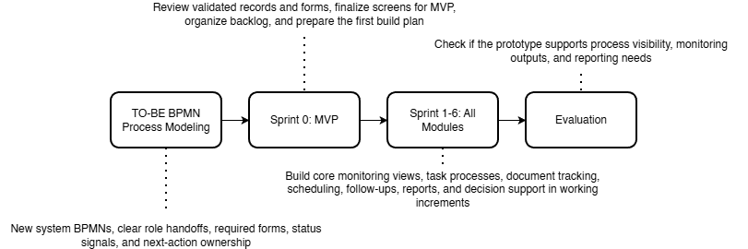

Figure 5.1 Methodology Flow of the Study with Scrum-Based Prototype Development
In this project, the capstone group will apply Scrum in a simple and practical way. One member will act as the Product Owner by organizing the backlog based on the validated Graduate School requirements. One member will act as the Scrum Master by keeping the sprint schedule, meetings, and follow-up actions on track. The remaining members will act as Developers by designing, building, and testing the prototype. Within Sprint 1 to n, the Scrum cycle is repeated through sprint planning, design, build, sprint review, and retrospective so that each increment can be improved before the next one begins.
The development process begins with TO-BE BPMN refinement and process design. In this stage, the group refines the Graduate School-only BPMNs so that the proposed flow matches the approved scope of the project. This includes clarifying who performs each step, what form or record is involved, what status signal is captured, and who owns the next action. This is important because the confirmed notes identify specific role ownership. Staff handle loading and support, the Academic Coordinator handles advising and most decisions, the Research Class Coordinator manages research-related monitoring, and the Dean approves LOA and withdrawal.
After that, the group moves to Sprint 0: MVP and Planning. During this stage, the team reviews the validated Graduate School records, including the AC-Student-Monitoring template, the Student-Research-Monitoring sheet, and the Graduate School Research Protocol. The group then prepares the first prototype screens, checks if the user flow matches the BPMNs, and organizes the backlog for the first coded sprint. This step is important because the prototype must match the actual Graduate School process, forms, and records before coding begins.
The next stage is Sprint 1 to 6: Incremental Prototype Development. In these sprints, the team builds the prototype in working increments. The early sprints focus on the most basic needs first, especially Student Progress Management and Case Status and Action Tracking because these are needed to make student status visible. Later sprints add scheduling, follow-up records, dashboards, reports, and the implementation of Retrieval-Augmented Generation (RAG) via NotebookLM. This order fits the confirmed Graduate School needs, which include one consolidated view of student status, clearer ownership of next actions, document evidence tracking, LOA monitoring, residency tracking, and reports for subject needs and graduating student lists. Each sprint goes through planning, design, build, review, and retrospective so the team can improve the next increment based on feedback.
The last stage is Evaluation. In this stage, the group checks whether the prototype supports the agreed monitoring outputs, process visibility, and reporting needs of the Graduate School. The evaluation focuses on whether the prototype helps users see where the student is now, what is pending, who owns the next action, and which reports can be generated from the structured records. This is directly tied to the confirmed Graduate School needs, especially subject needs, graduating student lists, LOA monitoring, and residency tracking.
This methodology also matches the scope of the project. The signed notes confirm that the platform should remain a monitoring and support layer only. It should not replace AIMS admissions, Registrar records, or Accounting processes. Instead, it should capture only the allowed status signals, evidence, handoffs, and timestamps needed by the Graduate School for monitoring, follow-up, and reporting. Because of this, the methodology focuses on refining the approved process flow, validating the interface through an MVP, and building only the functions that match the confirmed scope.

3.1 Proposed System Development
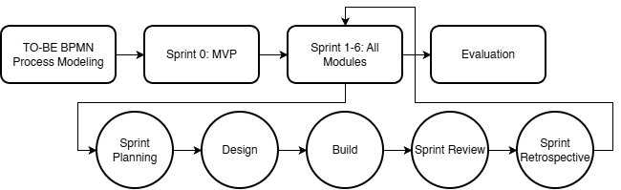

Figure 5.2 Proposed System Development Approach
The proposed platform is a Graduate School monitoring and processing platform designed to improve visibility of student progress and support Graduate School follow-up and reporting. It brings together allowed status signals, handoffs, required evidence, schedule events, and timestamps into one connected view so that Graduate School users can monitor cases without repeatedly checking separate spreadsheets, forms, and email threads.
The platform is intended for Graduate School use only and focuses on Graduate School-owned monitoring and processing. It covers admission handoff monitoring, enrollment monitoring, coursework and study plan tracking, LOA and readmission, thesis and dissertation milestones, practicum where confirmed, withdrawal, and graduation endorsement on the Graduate School side. These areas are directly supported by the confirmed notes, which identify subject needs, AY and semester taken, completion markers, LOA tracking, residency tracking, document evidence, and graduation candidate review as important monitoring needs.
The main users of the platform are Graduate School office staff, the Academic Coordinator, the Research Coordinator, the Dean, advisers and panel roles where applicable, and graduate students for limited progress viewing. The confirmed notes show that staff handle loading and support, the Academic Coordinator handles advising and most decisions, the Research Class Coordinator handles research-related monitoring, and the Dean approves LOA and withdrawal and receives reports. For this reason, the platform is designed around these Graduate School roles rather than around a general student information platform.
The prototype will first be developed as an MVP so the group can validate the screens, flow, and user actions before coding. After that, the coded prototype will be built in sprint-based increments. This allows the group to check that the screens match the BPMNs, the user roles, and the actual Graduate School records before more functions are added.
The platform organizes its main functions according to the conceptual framework modules. Student Progress Management keeps the student’s stage, status markers, curriculum tag, AY and semester taken, and completion indicators. Case Status and Action Tracking shows who owns the next action and what decision moved the case to its current state. Defense Scheduling Management records scheduling requests, availability, confirmations, and reschedules. Case Monitoring and Follow-Up supports alerts, watchlists, and follow-up records for delayed or incomplete cases. Policy and Case Guidance provides guided summaries, completion rate analysis, and next-step prompts by using Retrieval-Augmented Generation (RAG) via NotebookLM to access approved records, uploaded document repository contents, and system-computed indicators. Reports and Dashboards generate outputs such as subject needs lists, graduating student lists, LOA monitoring, residency tracking, and completion summaries.
The platform uses existing Graduate School records as its basis. For coursework and study plan monitoring, it uses fields grounded in the AC-Student-Monitoring template, especially curriculum alignment, taken or not taken status, and AY and semester taken. For research stages, it uses the Graduate School Research Protocol forms and rules, such as Form 4 for proposal or final defense endorsement, Form 5 and Form 5.1 for proposal comments and technical review, Form 5.2 for ethics review, and Forms 6, 7, 9, and 10 for final defense, manuscript finalization, and completion evidence. The protocol also provides timing rules, such as the two-week lead time, the 14-day rule, and the five-day public defense filing rule, which can be reflected in the prototype’s scheduling and follow-up logic.
The platform is not intended to replace official institutional systems. The confirmed notes state that admissions remain in AIMS, grades and official academic records remain on the Registrar side, and Accounting processes must not be replaced. The prototype therefore captures only the monitoring signals and process records that the Graduate School is allowed to use, such as status tags, handoffs, evidence checkpoints, and timestamps. This keeps the project within its approved scope and makes the proposed platform different from a full school information system.
Development under Scrum will move from the most basic monitoring needs to the more advanced outputs. The first coded sprints focus on Student Progress Management and Case Status and Action Tracking because two are the minimum functions needed to make status visible. Later sprints add scheduling, follow-up records, dashboards, reports, and the implementation of RAG via NotebookLM. This order fits the confirmed Graduate School need for a consolidated view first, followed by better reporting and guided next actions after the core records are in place.

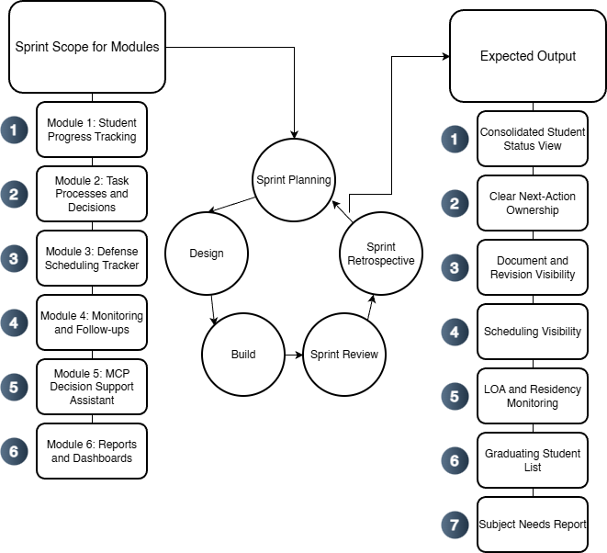

Figure 5.3. Proposed System Development Overview Using Agile Scrum
Figure 5.3 shows how the proposed platform is developed per module using a Scrum-based cycle. The validated Graduate School records serve as the basis of development. For each sprint, the team selects one module or a set of related functions, then goes through sprint planning, design, build, sprint review, and retrospective. Each sprint produces a working increment, and the cycle is then repeated for the next module. This keeps the development process aligned with the approved Graduate School scope while allowing the prototype to improve in small, reviewable increments.

3.2 Phases
Section 3.2 presents the project’s specification phases, which translate the Graduate School’s operational reality (task processing, protocol forms, records, and role handoffs) into implementable requirements. These phases are not the term-by-term schedule (which is presented later in the Workplan). Instead, the phases explain the sequence used to ensure that monitoring and decision support are built on clear definitions of completion, clear ownership of next actions, and feasible event capture, so dashboards, queues, and prescriptive recommendations do not rely on inconsistent or disputed status labels.
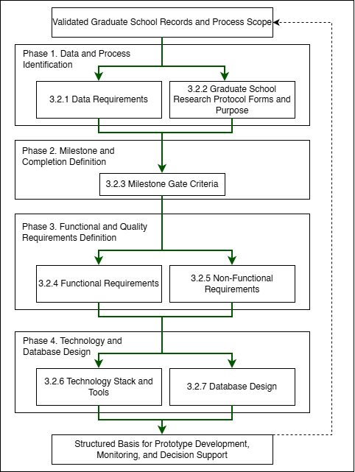

Figure 5.4. Specification Phases for the Proposed Graduate School Monitoring and Decision Support Platform
To keep the specification and requirements organized in an ordered flow:
- 3.2.1 Data Requirements identifies the minimum lifecycle and research data that must be captured, who provides it, where it currently resides (AS-IS), and why it is needed for monitoring and decision support.
- 3.2.2 Graduate School Research Protocol Forms and Purpose documents the official thesis/dissertation forms and clarifies what each form represents operationally, so form submissions and approvals can be captured as traceable process events.
- 3.2.3 Milestone Gate Criteria defines the definition of completion per gate (entry criteria, required evidence, decision outcomes, and exit criteria), and aligns these gates with the TO-BE process so completion and readiness checks become measurable and consistent.
- 3.2.4 to 3.2.5 Functional and Non-Functional Requirements convert validated processes and data needs into system capabilities and quality constraints (for example RBAC, auditability, usability, and reliability).
- 3.2.6 Technology Stack and Tools specifies the development tools and implementation approach aligned to the system scope and boundaries (monitoring and decision support layer, not an institutional record system replacement), including support for prescriptive decision support outputs and optional controlled LLM use.
- 3.2.7 Database Design defines how the platform stores lifecycle and milestone evidence as structured records, including core tables, key relationships, validation rules, the grouped ERD (A to G), and the derived indicators used for descriptive monitoring and prescriptive decision support recommendations.

3.2.1 Data Requirements
Data Category | Key Fields | Primary Source Role | Existing System (AS-IS) | Use for Monitoring and Analytics
Student identity + program profile | Student name; ID number; program/track; year level; AY entry | Staff/Admin; Student (for verification) | Student Monitoring Excel Sheet (AC-STUDENT-MONITORING-Template.xlsx) | Baseline linking key across coursework + research monitoring; supports cohort grouping and drill-down views.
Coursework / enrollment monitoring | AY entry; subjects/codes; unit totals; standing/progress markers | Staff/Admin; Coordinator | Student Monitoring Excel Sheet (AC-STUDENT-MONITORING-Template.xlsx) | Enables “coursework-to-research readiness” monitoring where applicable.
Admission monitoring (status signals) | Requirements submitted date; application status; handoff confirmation | Admission Office; Graduate School Staff | AIMS + email-based handoff | Completes lifecycle coverage from admission without replacing AIMS.
Enrollment confirmation / term activation | Enrollment confirmation status per term; timestamp; active/inactive/stop-start signals | Graduate School Staff; Academic Coordinator | Email-based triggers + enrollment platform status | Prevents “gap in enrollment” visibility; supports continuity monitoring.
Curriculum tagging and study plan generation | Curriculum ID/version; student–curriculum tag date; required subjects; planned AY/Sem mapping | Academic Coordinator; Staff | Curriculum records + Student Monitoring Excel Sheet (AC-STUDENT-MONITORING-Template.xlsx) / study plan form | Enables per-student course audit and cohort-based monitoring for offerings and readiness.
Class offerings decision-support inputs | Eligible student counts per subject; pending prerequisites; planned offerings summary | Academic Coordinator | Student Monitoring Excel Sheet (AC-STUDENT-MONITORING-Template.xlsx) + curriculum mapping outputs | Supports “subjects to offer next semester” decision support.
LOA application monitoring | LOA request date; approval status; LOA start/end; LOA expiry marker | Graduate School Staff; Dean | Email-based routing + LOA tracking record | Adds visibility and escalation signals for LOA.
Readmission monitoring | Readmission request date; decision outcome; return term; conditions (if any) | Graduate School Staff | Email/manual records | Tracks re-entry pathway after LOA; supports continuity/readiness checks.
Residency monitoring signals | Residency clock start; pause/resume markers; nearing limit flags | Graduate School Staff/Coordinator | Derived monitoring record (policy-confirmed parameters) | Supports residency monitoring without changing policy.
Research case profile | AY first enrolled in thesis/dissertation; current AY; semester; program; adviser | Staff/Admin; Coordinator | Thesis Student Research Monitoring Sheet (Student-Research-Monitoring.xlsx) | Timeline anchor for time-in-stage, residency indicators, and exception tracking.
Adviser assignment + eligibility constraints | Adviser name; appointment status; date appointed; adviser load indicator | Research leadership/Admin | Research Protocol (Form 3 / 3.1) + spreadsheet reflections | Supports routing/accountability and adviser load monitoring.
Title defense events | Endorsement; schedule date; approved title; decision outcome | Student; Coordinator; Panel Chair; Admin | Thesis Student Research Monitoring Sheet (Student-Research-Monitoring.xlsx) (Forms 1–2) | Captures early bottlenecks (endorsement + scheduling).
Proposal defense readiness + gate requirements | Endorsement; schedule; technical clearance; statistician consult (conditional) | Student; Adviser; Statistician; Admin | Thesis Student Research Monitoring Sheet (Student-Research-Monitoring.xlsx) (Forms 4, 4.1, 5) | Detects readiness blocks and scheduling bottlenecks.
Ethics review and clearance | Ethics submission; clearance date/status | Student; Ethics Office/Admin | Thesis Student Research Monitoring Sheet (Student-Research-Monitoring.xlsx) (Form 5.2) | Enables stop-the-clock/restart tracking around ethics review.
Final defense events | Endorsement; schedule; outcome (pass/minor/major); re-defense status | Student; Adviser; Panel; Admin | Thesis Student Research Monitoring Sheet (Student-Research-Monitoring.xlsx) (Forms 6–8) | Captures revision cycles/decision states for bottleneck identification.
Public defense + publication/completion tagging | Public defense schedule; Turnitin cert; editor cert; final approval sheet; publication step | Student; Adviser; Admin | Thesis Student Research Monitoring Sheet (Student-Research-Monitoring.xlsx) (Forms 9–10) + Turnitin step | Converts endgame requirements into a traceable checklist; supports stuck-case detection.
Scheduling state and constraints | Proposed/confirmed dates; reschedules; mode; venue reservation | Admin/Staff; Panel Chair; Student | Email-based coordination + protocol steps | Measures scheduling cycle time and repeated back-and-forth.
Decision records + comment consolidation | Outcomes; consolidated comment sheet; approvals/release certs | Panel Chair; Panel Members; Adviser | Research Protocol (Form 5 consolidation; Form 5.1; Form 6/7) | Reduces version confusion; strengthens traceability/accountability.
Workload and operational queues | Pending endorsements; overdue items; aging cases; adviser/panel load counts | Admin; Coordinator; Leadership | Derived from milestone events + role assignments | Core decision-support layer for escalation and workload balancing.
Authority + audit signals | RBAC; access boundaries; change logs; retention rules | Admin | Thesis Student Research Monitoring Sheet (Student-Research-Monitoring.xlsx) (Forms 1–2) | Supports privacy-aligned handling and auditability for sensitive documents.
Practicum/OJT monitoring (if applicable) | Required hours; schedule; completion status; evidence checklist | Program Coordinator | Manual logs / certificates (MOA/certifications) | Included only when the program requires it; treated as completion signals.
Withdrawal monitoring | Withdrawal request/confirmation; effective term; reason (if allowed) | Graduate School Staff; Dean | Email/manual records | Tracks stop pathway formally for attrition reporting where allowed.
Graduation endorsement monitoring (Graduate School side) | Endorsed-to-graduate date; requirements complete flag; evidence checklist | Graduate School Staff; Academic Coordinator | Endorsed list + manual checklist | Supports graduating list preparation without replacing registrar processing.

Table 5. Data to be collected and sources
Table 5 summarizes the operational data that must be captured to support lifecycle monitoring and decision support, including who provides each data element, where it currently resides (e.g., spreadsheets, email routing, and protocol forms), and what monitoring purpose it serves. In current practice, evidence of progress is distributed across spreadsheets and email-based coordination, while the Graduate School Research Protocol defines the official events, forms, decision gates, and role handoffs that must be tracked. Accordingly, the data scope emphasizes lifecycle status signals, milestone events, decision records, scheduling states, document/version evidence, and workload indicators needed to answer monitoring questions such as: where the student is now, what is pending, who owns the next action, and where delays occur.

3.2.2 Milestone Gate Criteria
Milestone | Entry Criteria | Required Evidence | Decision outcomes | Exit Criteria | Role
Admission Handoff Confirmed | Student has submitted requirements and admission status signal is available for handoff | AIMS status + handoff confirmation (email/record) | Accepted for onboarding / For completion / Not accepted | Handoff recorded; student is visible to Graduate School for onboarding and monitoring | Admission Office (status) + Graduate School Staff (handoff receipt)
Student Account + Program Onboarding Completed | Admission handoff confirmed | Enrollment platform account created; onboarding checklist (if used) | Activated / Returned for correction | Student account activated; student is tagged to program context for monitoring | Graduate School Staff / Academic Coordinator
Curriculum Tagged + Study Plan Generated | Student account exists; curriculum list/version exists | Curriculum ID/version record; student–curriculum tag record; generated study plan | Tagged / Corrected / Deferred | Student is linked to a curriculum; study plan (required subjects) is generated and viewable | Academic Coordinator
Term Enrollment Confirmed | Student is eligible to enroll for the term (per Graduate School) | Enrollment confirmation record (email trigger / enrollment platform status) | Confirmed / On hold / Not confirmed | Term status is recorded as active/inactive; monitoring continuity is visible (no “gap”) | Graduate School Staff / Academic Coordinator
Course Audit Updated | Term results/standing signals are available to be mirrored as monitoring indicators (without replacing grade encoding) | Monitoring sheet update (course completion/INC marker); supporting reference to official record where permitted | Updated / Pending update / Exception flagged | Course audit reflects latest completion/INC markers and remaining requirements for readiness checks | Academic Coordinator
Class Offerings Planning Completed | Curriculum + course audit data are available to compute eligible counts | Aggregated eligibility counts per subject; planned offerings summary | Approved offerings plan / Revised / Deferred | “Subjects to offer next semester” output is generated and recorded for term planning | Academic Coordinator
LOA Approved and Recorded | Student submits LOA request; case is active | LOA request record + approval decision + effective LOA start/end dates | Approved / Denied / Returned for completion | LOA status is recorded with effective period and expiry marker; student marked stop-start for monitoring | Dean (approval) + Graduate School Staff (recording)
Readmission Approved and Recorded | LOA period ended or readmission requested | Readmission request record + decision outcome + effective return term | Approved / Denied / Returned for completion | Readmission status recorded; student marked active for the return term | Graduate School Staff / Dean (as applicable)
Research Case Created | Readiness to start thesis/dissertation is confirmed (program-dependent) | Research case profile created (type, first enrolled AY, adviser pending/assigned) | Created / Deferred | Research case exists and becomes the basis for milestone event tracking | Research Coordinator / Staff
Adviser Designation Completed | Research case exists; adviser nomination is initiated | Research Protocol Forms 3 / 3.1 (adviser designation and appointment) and recorded adviser assignment | Appointed / Returned / Not appointed | Adviser assignment is recorded with date and ownership routing can begin | Research Leadership / Research Coordinator
Title Defense Completed | Adviser designation completed; title defense request endorsed | Research Protocol Forms 1–2 (title defense application + outcome); schedule record (if used) | Approved title / Returned for revision / Not approved | Approved title is recorded; status advances to proposal preparation stage | Panel Chair (decision) + Research Coordinator (recording)
Proposal Defense Completed | Title approved; proposal defense endorsed and scheduled | Research Protocol Forms 4, 4.1 (if applicable), 5 + schedule record + outcome/comments record | Passed / Revisions required / Re-defense required | Proposal defense outcome recorded; required changes captured as the authoritative revision basis | Panel Chair + Research Coordinator
Ethics Clearance Recorded | Proposal stage requires ethics review/clearance | Research Protocol Form 5.2 (ethics submission/clearance) | Cleared / Returned / Not cleared | Ethics clearance status and date are recorded; case may proceed to data collection/writing milestones | Ethics Office (clearance) + Research Coordinator (recording)
Final Defense Completed | Final defense endorsed and scheduled | Research Protocol Forms 6–8 (final defense comments/evaluation/settlement where applicable) + schedule/outcome record | Passed / Minor revisions / Major revisions / Re-defense | Final defense outcome recorded; revision pathway is explicit (minor/major/re-defense) | Panel Chair + Research Coordinator
Completion Evidence Verified | Final defense outcome permits completion processing | Research Protocol Forms 9–10 + Turnitin certificate + editor certification + approval sheet (as applicable) | Verified complete / Missing requirements / Returned | All required completion evidence is recorded as complete; case is eligible for GS endorsement | Graduate School Staff / Research Coordinator
Withdrawal Confirmed and Recorded | Student requests withdrawal; case is active | Withdrawal request/confirmation record (email/manual) | Approved / Denied / Returned | Withdrawal status recorded; monitoring stops with an auditable exit reason category (if allowed) | Dean + Graduate School Staff
Graduation Endorsement Completed | Completion evidence verified; no active stop-start/withdrawal | Endorsed-to-graduate list + requirements checklist (GS-side) | Endorsed / On hold / Returned for completion | Graduate School endorsement status recorded; endorsement list is prepared and handed off (registrar remains out-of-scope) | Graduate School Staff + Academic Coordinator / Dean

Table 6. Milestone Gate Criteria explaining definition of completion
Table 6 represents the “definition of completion” for lifecycle and research progress monitoring. It specifies the minimum entry criteria, required evidence, decision outcomes, and exit criteria for each gate so that process states are interpretable across roles and suitable for consistent monitoring (e.g., pending queues, aging/time-in-stage, and readiness checks). This reduces ambiguity in status labeling and supports decision support by clarifying what must be true before a case can advance and what evidence confirms completion.

3.2.3 Functional Requirements
Category | Description
Curriculum and Study Plan Management | Load and maintain program curricula, tag a student to the correct curriculum, generate a per-student study plan, and show required subjects with AY and semester taken. Record subject completion date and status for course audit.
Enrollment and Coursework Monitoring | Track enrollment confirmation and course audit status. Provide a student view of the next semester schedule where allowed, and a coordinator view of student eligibility and remaining requirements without replacing official grade encoding.
Class Offerings Decision Support | Generate outputs that help the Academic Coordinator decide what subjects to offer next semester, such as counts of eligible students per subject, pending requirements, and a planned offerings summary.
LOA and Readmission Monitoring | Track LOA request status, approval, and effective LOA period. Track residency pause and readmission status, and generate LOA monitoring views for staff and coordinators.
Thesis and Dissertation Monitoring | Track adviser designation, title defense, proposal defense, final defense, revision cycles, manuscript finalization, and required certifications or documents. Record status, assigned role, and time on stage.
Practicum or OJT Tracking (Program-dependent) | Where required by the program, track required hours, schedule, and uploaded evidence such as MOA or certifications as completion signals. Exclude this if the program does not require it.
Withdrawal and Graduation Monitoring | Track withdrawal confirmation status and Graduate School graduation endorsement status. Generate graduating list outputs based on completion evidence without replacing Registrar processing.
Task Processing and Task Queues | Provide role-based task queues for submissions, endorsements, approvals, and decisions. Show who owns the next action across lifecycle stages.
Decision Recording | Record decision outcomes such as approve, revise, or return, together with the next required action and closure evidence for each milestone step.
Document Tracking | Maintain a required document checklist for each stage, track document versions, and record consolidated comments or decision records.
Scheduling Tracking | Record defense request, availability, and schedule outcome. Log reschedules and cancellations as monitoring signals.
Dashboards and Reports | Generate counts per stage, pending queues, aging or time in stage, LOA counts, course audit readiness, adviser or panel counts where applicable, and residency, completion, or attrition outputs based on validated definitions.
Alerts and Intervention Tracking | Detect threshold breaches such as long time in stage, LOA nearing expiry, or residency nearing limits. Notify the correct roles and log intervention actions with closure evidence.
Audit Trail | Log actions, decisions, and changes in definitions or process settings to support accountability.

Table 7. Functional Requirements of the modules
Table 7 summarizes the functional requirements of the proposed platform. These requirements come from the main Graduate School monitoring and processing needs, including scattered records, unclear next-action ownership, scheduling delays, revision tracking problems, and missing or inconsistent timestamps.

3.2.4 Non-Functional Requirements
Category | Description
Security | Enforce role-based access control, strong authentication, secure session handling, and controlled privileges for higher-level users.
Privacy | Limit access to sensitive evaluation records, log access where needed, and handle data according to approved privacy boundaries (Datu, 2022).
Auditability | Keep append-only logs for key actions such as submissions, decisions, approvals, routing, and definition changes. Each log entry must show the actor, timestamp, and outcome.
Usability | Provide role-based dashboards and task queues, clear status labels, low encoding effort for staff, and consistent terms across modules.
Reliability | Apply data checks, validate required fields, support backup and recovery, and generate consistent timestamps for monitoring and reporting.
Maintainability | Allow milestone definitions, checklists, and process rules to be updated where possible without changing code, while keeping a controlled change process with logs.
Performance | Keep dashboard queries responsive, support efficient search and filtering, and handle document and log storage in a manageable way.
Interoperability | Allow export of reports and structured datasets. Allow integration or data exchange with institutional systems only where permitted by ownership and privacy rules.

Table 8. Non-Functional Requirements of the modules
Table 8 summarizes the non-functional requirements of the proposed platform. These requirements help make the system usable, dependable, and appropriate for Graduate School use. The platform also supports privacy, accountability, and adoption in an educational setting (Tanate-Lazo, 2021; Sancon, 2023).

3.2.5 Technology Stack and Tools
The proposed platform is a web-based graduate student lifecycle monitoring and decision-support system for Graduate School operations. The technology stack is selected to support the platform’s current core application modules: (1) Student Progress Management, (2) Case Status and Action Tracking, (3) Defense Scheduling Management, (4) Case Monitoring and Follow Up, (5) Analytics and Decision Support, (6) Policy and Case Guidance, and (7) Reporting and Dashboards. These modules are supported by cross-cutting platform capabilities for User and Access Management and Audit Trail and Compliance Logging to maintain secure access, traceability, and accountability across the system. The platform follows a web architecture that uses React and TypeScript for the frontend, Tailwind CSS for interface styling, Node.js and Express.js for backend services, MySQL and Prisma for data management, and JWT for authentication. This stack supports structured monitoring views, role-based task queues, scheduling records, dashboards, analytics outputs, and traceable activity logs within one system.
For analytics and reporting, the platform uses Chart.js to present counts, trends, queue conditions, and time-based monitoring indicators through dashboard views. GitHub is used for source control, issue tracking, and sprint management. Figma is used for interface mockups and clickable prototypes, while draw.io and dbdiagram.io are used for process diagrams, architecture diagrams, and database design.
For deployment and secure web access, Cloudflare is used for DNS management, HTTPS, SSL/TLS encryption, edge security, and content delivery. This supports secure access to the deployed system and helps protect the application during testing and demonstration.
For policy and case guidance, the proposed system implements Retrieval-Augmented Generation (RAG). The RAG pipeline uses LangChain.js for document retrieval orchestration, OpenAI API for embeddings and response generation, and ChromaDB as the vector database for storing and retrieving indexed policy documents, forms, guidelines, and case references. This setup allows the assistant to retrieve relevant institutional documents first and then generate grounded summaries, policy-based guidance, and suggested next steps. The assistant supports monitoring and administrative review only. Final decisions remain with authorized personnel.
The selected tools are feasible within a capstone timeline while keeping the architecture scalable, maintainable, and aligned with the project’s approved scope as a monitoring and decision-support platform rather than a replacement for official institutional systems.

3.2.5.1 Summary of IT Tools
Need | Specific Tools | Why this tool
UI mockups and clickable prototype |   Figma | Fast wireframing and interactive prototypes for stakeholder review and UI validation.
Frontend (web UI) |   React + TypeScript | Component-based UI for dashboards and queues, with TypeScript for safer handling of complex process states.
UI styling |   Tailwind CSS | Utility-first styling for consistent layouts with minimal custom CSS.
Charts for dashboards |   Chart.js | Lightweight charting for operational dashboards (counts, queues, aging/time-in-stage).
Backend (API + business rules) |   Node.js + Express.js (REST API) | Minimal backend framework for building API endpoints and implementing routing and process rules.
Authentication |   JWT (RFC 7519; internet standard) | Standard token format for stateless authentication between frontend and API.
Database |   MySQL 8 (InnoDB) | Relational data model with foreign keys for lifecycle, milestones, tasks, and audit logs, enabling consistent reporting queries.
Schema migration and DB access |   Prisma ORM (migrations + type-safe DB client) | One tool for repeatable schema migrations and type-safe database access, reducing manual SQL drift across sprints.
Project tracking and version control |   GitHub (Repo + Issues/Projects) | Source control and sprint tracking (issues, boards, basic backlog).
Diagrams |   draw.io    dbdiagram.io | Process and architecture diagrams (BPMN, ERD, system diagrams) with a lightweight tool.
Domain and DNS |   Cloudflare DNS  Cloudflare SSL/TLS  Cloudflare WAF and Firewall Tools  Cloudflare CDN | Manages the system domain/subdomain and DNS records (A/CNAME/TXT) for deployment and verification, with fast updates and centralized control
HTTPS and secure access |  | Provides HTTPS for users and encrypts traffic to the server (Full/Strict), reducing risks from misconfigured SSL on the origin.
Edge security |  | Adds a security layer in front of the server (e.g., basic filtering, rate limiting, DDoS protection) to reduce direct exposure of the origin.
Performance |  | Caches static assets to improve load time and reduce load on the origin server during peak access or demos.
RAG orchestration |   LangChain.js | Handles document chunking, retrieval flow, and prompt grounding for the assistant.
Embeddings and language model |   GPT-4.1 LLM | Generates embeddings for retrieval and grounded responses for policy and case guidance.
Vector database |   ChromaDB | Stores indexed document embeddings and supports similarity-based retrieval of policy and case references.
Policy and case guidance | RAG Pipeline | Retrieves approved documents first, then generates grounded summaries, guidance, and suggested next steps for administrative support.

Table 9. IT tools to be used

3.2.5.2 Platform Approach
The platform will be implemented as a web application with a simple three-layer structure:
- Presentation layer: React + TypeScript UI (dashboards, queues, forms)
- Service layer: Node.js + Express REST API for process rules, routing, and audit events
- Data layer: MySQL 8 relational database using InnoDB foreign keys for integrity; Prisma for schema migrations
This supports incremental delivery while ensuring monitoring outputs are derived from event history and timestamps, not only from manually maintained “current status” fields.

3.2.5.3 Database and Reporting
- MySQL 8 (InnoDB) stores structured entities such as Student, MilestoneEvent, TaskQueue, SchedulingEvent, DocumentArtifact metadata, Alert, and AuditLog. Foreign keys are used to keep linked records consistent.
- Dashboards and reports are computed using SQL queries and views (counts per stage, pending queues, aging/time-in-stage, LOA visibility, scheduling cycle time). Chart.js renders the results on the UI.
This approach remains scalable because reporting is based on indexed, timestamped events and relational joins, which are stable patterns for operational monitoring.

3.2.5.4 Prescriptive Analysis for Decision Support
Prescriptive decision support will be implemented as rule-based recommendations computed in the backend from confirmed events, timestamps, ownership assignments, evidence checklist status, and policy-confirmed parameters. These recommendations are not based on free-form interpretation alone. Instead, recommendations are produced from structured monitoring records and defined process logic. Examples include prompts such as “case exceeded allowed time-in-stage, escalate to coordinator,” “required evidence is incomplete, return to the student queue,” or “schedule request has no confirmed outcome, follow up with the assigned role.” The platform does not create, replace, or modify Graduate School policies. It only encodes policy-confirmed rules as decision-support logic.
These rule-based outputs are then made available to the through NotebookLM via Retrieval-Augmented Generation (RAG), which retrieves the computed indicators and related supporting records through approved tools and resources. This allows authorized stakeholders to ask natural-language questions and receive guided summaries, completion rate analysis, next-step prompts, queue prioritization prompts, and escalation prompts based on validated records. Final approvals and official decisions remain with authorized Graduate School personnel.
In this study, the purpose of prescriptive analytics is to reduce repeated manual checking across spreadsheets, protocol forms, and email-based coordination by turning recorded process data into actionable prompts. This directly supports the problem statement of the study, where graduate student status is spread across multiple sources and status confirmation is slow and prone to human error. By computing recommendations from structured records first, and then exposing them through the assistant, the platform improves visibility and follow-through without automating official authority.

3.2.5.5 RAG-Based Decision Support Assistant
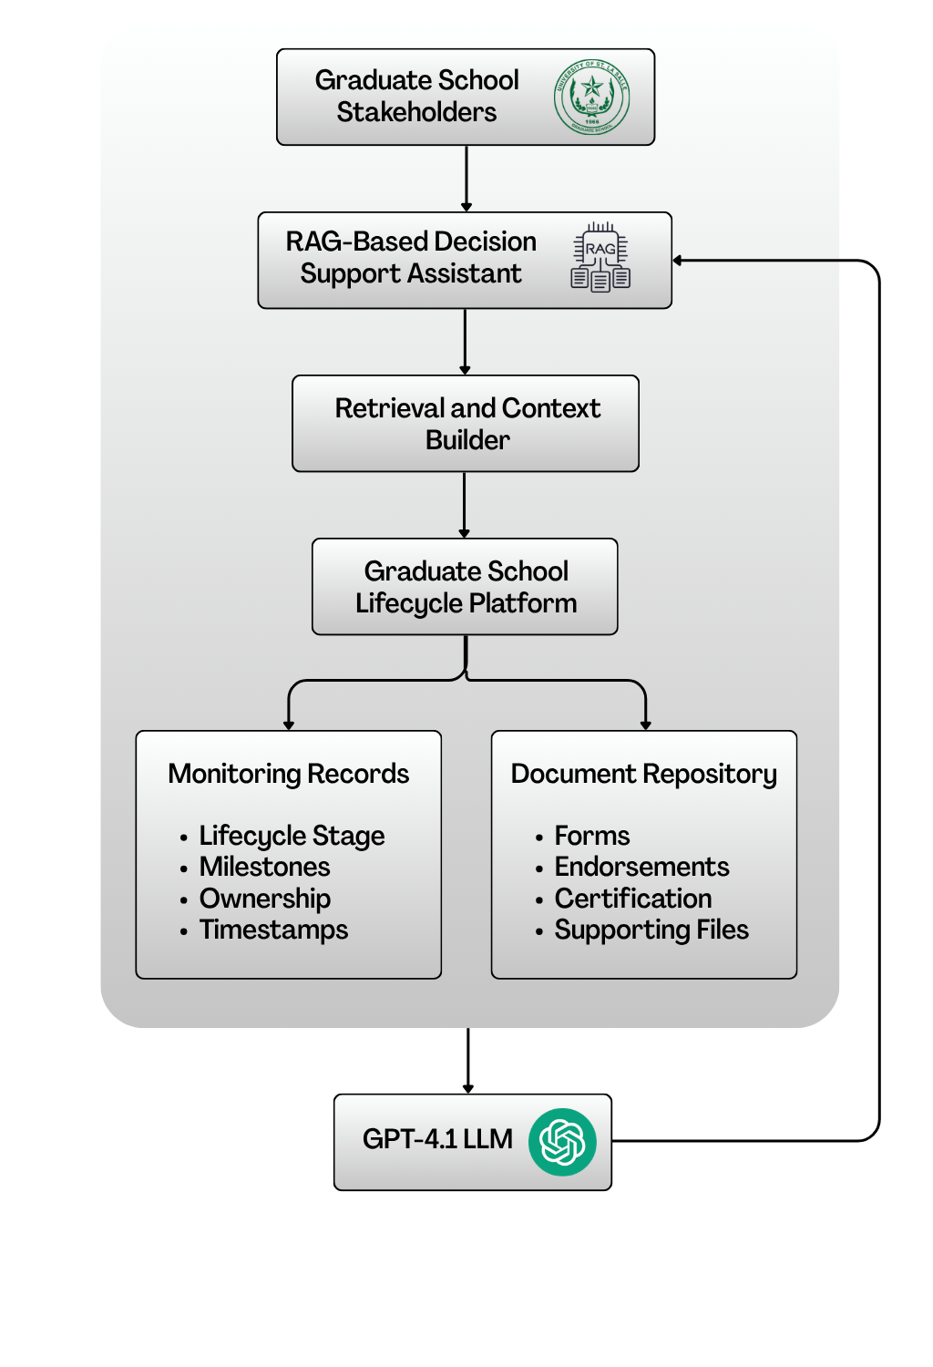

Figure 6. RAG-Based Decision Support Assistant Architecture
This study will use Retrieval-Augmented Generation (RAG) as the grounding approach for the decision support assistant. In this setup, the assistant retrieves relevant Graduate School records and approved reference documents before generating any response. This means the assistant does not rely on free-form guessing or manually maintained status text alone. Instead, it uses retrieved monitoring records, approved document contents, and system-generated indicators as the basis for its answers. This is consistent with the study’s use of RAG through NotebookLM and with the policy-grounded role of the assistant in the proposed platform.
In the proposed platform, the assistant draws from two main input groups. The first is structured operational and monitoring data, such as lifecycle stage, milestone events, ownership assignments, scheduling records, timestamps, checklist completion, and decision outcomes. The second is the approved repository of uploaded forms and documents collected throughout the Graduate School process, such as protocol forms, endorsements, comments, certifications, supporting files, and policy references. The retrieved materials are then used as context for the assistant’s response.
The assistant does not compute official status by itself. Official monitoring signals and prescriptive indicators are still computed first by the system backend and database using validated event history, timestamps, checklist rules, and policy-confirmed process logic. These computed results may include the current lifecycle stage, pending requirements, latest decision outcome, assigned next-action owner, aging or time-in-stage, overdue tasks, scheduling cycle time, evidence completeness, and completion rates. In this design, the backend remains the source of truth, while RAG serves as the retrieval and explanation layer that helps users access and understand those approved results more easily.
For example, when a stakeholder asks questions such as “What is the status of this student?”, “What is still pending?”, “Who owns the next action?”, or “Which students are delayed?”, the assistant retrieves the relevant monitoring records, computed indicators, and supporting documents before returning a guided summary. For completion rate analysis, the computation is still performed by the backend and database, not by the LLM alone. The completion rate is computed as:
Completion Rate = (Number of completed in-scope cases ÷ Total number of in-scope cases) × 100
A case is treated as completed only when the required exit criteria for the relevant lifecycle stage or milestone have been met based on the milestone gate definitions of the study. Through RAG, the assistant can retrieve these computed rates, grouped counts, and related filters such as program, term, milestone, or cohort, then explain the results in a readable form for stakeholders.
For decision support, the assistant may return guided student status summaries, completion rate summaries, pending requirement lists, next-step prompts, queue prioritization prompts, follow-up reminders, and escalation prompts for delayed cases. These outputs are for decision support only. The assistant does not automate approvals, override Graduate School authority, or change official policies. Final decisions remain with authorized personnel such as Graduate School staff, coordinators, advisers, panel members, and the Dean. This is aligned with the study’s positioning of the AI feature as a policy-grounded support tool rather than an autonomous decision maker.
This design directly supports the main problem statement of the study. Since graduate student status is currently spread across multiple sources and status confirmation depends on manual checking and encoding, the RAG-based assistant helps reduce repeated searching across spreadsheets, emails, forms, and separate records. It does this by allowing stakeholders to ask monitoring questions in natural language while still grounding the responses on validated system records, computed indicators, and approved reference documents.

3.2.5.6 Authentication, RBAC, and Audit Logging Tools
Access to information requires strict access control and traceability of actions. The system will implement:
- JWT authentication for UserAccount identities, based on the JWT standard (RFC 7519).
- RBAC authorization is mapped to system roles (staff, coordinator, research coordinator, adviser/panel, student) and scoped by ownership rules where applicable. RBAC enforcement will be validated using security control verification practices aligned with OWASP ASVS.
- Append-only audit logging (AuditLog table) capturing key events, including decisions, submissions, status transitions, evidence uploads, access attempts, and configuration changes (timestamp, actor, action type, affected record). This supports audit event logging expectations described in NIST SP 800-53.
These controls align with privacy requirements when handling sensitive student records and evaluation artifacts (Datu, 2022; Doce & Ching, 2018; Tanate-Lazo, 2021).

3.2.5.7 Reporting, Dashboards, and Analytics Tools
Dashboards and decision-support outputs will be generated through:
- Application dashboards using SQL aggregation (counts per stage, pending queues, aging/time-in-stage, scheduling cycle time, LOA visibility, workload indicators)
- Exportable reports in CSV and PDF for term-level summaries and endorsement preparation (PDF via printable report views for the prototype)
- A reporting schema or SQL views inside MySQL to standardize definitions and separate operational tables from reporting queries
This aligns with the principle that dashboards are only meaningful when events and timestamps are captured consistently and definitions are aligned (CHED Region IV-B MIMAROPA, 2018; Sorour & Atkins, 2024).

3.2.5.8 Notifications and Alerts Tools
The platform will support basic notification mechanisms for operational follow-through, such as:
- Email notifications using SMTP (for overdue items, LOA expiry reminders, missing evidence, and pending approvals).
- Notification events stored in the database (NotificationAlert records) to preserve traceability (who was notified, when, and why)
- Messages that avoid embedding sensitive content and direct users to log in to the portal for details
Messages will avoid embedding sensitive content and will direct users to log in to the portal for details.

3.2.5.9 Development, Collaboration, and Documentation Tools
To support Agile Scrum delivery and documentation needs, the project will use:
- GitHub for version control (source code, documentation, release tagging) and sprint tracking using Issues and Projects
- Figma for UI wireframes and prototype screens
- diagrams.net (draw.io) for BPMN, ERD, and architecture diagrams
These tools ensure traceability of changes, repeatable testing, and consistent deliverables per sprint.

3.2.6 Database Design
Because the project’s central contribution is monitoring and decision support, the database design prioritizes capturing lifecycle and milestone activity as structured, timestamped events. This avoids relying only on static “current status” fields and reduces inconsistencies from ad hoc spreadsheet updates. The model formalizes existing monitoring signals into related entities that support: (1) traceability (what happened, by whom, and when), (2) accountability routing (who owns the next action), and (3) reporting and prescriptive decision support (counts per stage, pending queues, aging or time-in-stage, scheduling cycle time, and workload visibility).
The model adopts a case-and-event approach. Each student has a profile and program context. Each research engagement is represented as a ResearchCase. Each progression step is recorded as a MilestoneEvent linked to a MilestoneType, including timestamps, decision outcomes, owner roles, and evidence links. Monitoring focuses on submissions, decisions, schedules, and permitted standing or readiness signals, not private adviser–student communication.

3.2.6.1 Core Entities/Tables
Area | Table | Purpose in the system
Identity and Access Management (IAM) | Student | Stores the primary student monitoring identity and program entry context (e.g., cohort/AY entry, program/track).
 | UserAccount | Stores login identities for staff, coordinators, adviser/panel roles, and students (permitted views).
 | Role | Defines system roles used for RBAC.
 | UserRole | Assigns system roles to users (supports RBAC enforcement).
 | AdviserAssignment / PanelAssignment | Links advisers and panel members to students for scoped access and review responsibilities.
Core lifecycle & milestone tracking (monitoring layer) | StudentLifecycle | Stores program/track fields and references to program-dependent settings notes.
 | MilestoneDefinition | Defines milestone requirements by lifecycle stage, expected durations, and criticality.
 | StudentMilestoneStatus | Tracks milestone progress status and due/completion timestamps at the student level.
Process routing & decisions | Task | Represents actionable process items (pending/overdue), ownership, due dates, and recommended next action fields.
 | DecisionLog | Captures decisions made on tasks (approve/revise/return) with decision actor and timestamp.
 | RoutingRule | Defines rule-based routing for next owner roles and follow-up task generation.
Academic lifecycle tracking (monitoring signals) | Program | Stores program/track information and references for program-dependent settings.
 | AcademicTerm | Stores academic year/term identifiers (start/end dates where needed).
 | TermEnrollment | Stores per-term enrollment monitoring signals (confirmation timestamps, allowed status signals).
 | Course | Master list of course code/title/units.
 | CourseEnrollment | Links term enrollment to courses and stores monitoring signals (e.g., in-progress/completed/incomplete markers).
 | Curriculum | Curriculum identifier/version information per program.
 | StudyPlanItem | Stores planned/required subjects per curriculum (and recommended term where applicable).
 | StudentCurriculumTag | Maps a student to a curriculum version/tag (e.g., revised plan/bridging).
Research pipeline tracking (case-and-event) | ResearchCase | Monitoring container for thesis/capstone engagements linked to a student.
 | MilestoneEvent | Records milestone execution as timestamped events (occurredAt, outcome, ownerRole, decision actor, notes) and may reference related process tasks.
Evidence, scheduling, and traceability | DocumentRecord | Stores required-document checklist items per student/milestone, including review status and outstanding revisions count.
 | DocumentVersion | Stores uploaded file versions (file reference, uploadedBy, timestamps) linked to DocumentRecord.
 | RevisionNote | Tracks revision comments/required changes and resolution status linked to DocumentRecord and/or DocumentVersion.
 | ScheduleRequest | Stores scheduling requests tied to a student (requestedBy, preferred dates, status).
 | Availability | Collects availability windows from users for a ScheduleRequest.
 | ScheduleEvent | Stores schedule outcomes (confirmed/rescheduled/cancelled) with timestamps and decision actor.
 | FormSubmission | Tracks protocol-driven forms with submitted/endorsed/approved timestamps and routing state.
 | ClearanceRecord | Tracks clearance submission/outcome dates where applicable.
 | TimelineEvent | Provides a consolidated “what happened” feed by recording key events and linking to related entities.
Monitoring actions and alerts | AlertThreshold | Stores configured monitoring thresholds (e.g., prolonged stage, delayed scheduling) used by the monitoring engine.
 | NotificationAlert | Logs notifications sent (recipient, reason, timestamp, success metadata).
 | Intervention | Stores follow-up actions with owner, timestamps, and closure evidence.
Auditability | AuditLog | Append-only log of key events (access attempts, decisions, transitions, uploads, configuration changes).

Table 10. Core tables and their purpose

3.2.6.2 Key Relationships and Integrity Rules
Relationship | Meaning | Integrity rule (what must be true)
Student (1) → (many) StudentLifecycle | A student has a stage history (entered/exited timestamps) | StudentLifecycle.StudentID must exist in Student
Student (1) → (many) StudentMilestoneStatus | A student has milestone progress records | StudentMilestoneStatus.StudentID must exist; MilestoneDefinitionID must exist
MilestoneDefinition (1) → (many) StudentMilestoneStatus | Milestone status references a valid milestone | StudentMilestoneStatus.MilestoneDefinitionID must exist
Student (1) → (many) TermEnrollment | A student has per-term monitoring records | TermEnrollment.StudentID must exist; TermEnrollment.TermID must exist
AcademicTerm (1) → (many) TermEnrollment | Enrollment records belong to a term | TermEnrollment.TermID must exist in AcademicTerm
TermEnrollment (1) → (many) CourseEnrollment | Term enrollment can include multiple courses | CourseEnrollment.TermEnrollmentID must exist; CourseEnrollment.CourseID must exist
Course (1) → (many) CourseEnrollment | Course enrollment references valid courses | CourseEnrollment.CourseID must exist in Course
Curriculum (1) → (many) StudyPlanItem | A curriculum defines planned subjects | StudyPlanItem.CurriculumID must exist; StudyPlanItem.CourseID must exist
Student (1) → (many) StudentCurriculumTag | A student can be tagged to a curriculum/version | StudentCurriculumTag.StudentID must exist; CurriculumID must exist
Student (1) → (many) ResearchCase | A student may have a research engagement container | ResearchCase.StudentID must exist
ResearchCase (1) → (many) MilestoneEvent | A case has milestone events over time | If used, MilestoneEvent.ResearchCaseID must exist in ResearchCase
MilestoneDefinition (1) → (many) MilestoneEvent | Events reference valid milestone definitions | MilestoneEvent.MilestoneDefinitionID must exist
Student (1) → (many) DocumentRecord | Document checklist items attach to a student | DocumentRecord.StudentID must exist
DocumentRecord (1) → (many) DocumentVersion | A checklist item can have multiple uploads/versions | DocumentVersion.DocumentRecordID must exist
DocumentRecord (1) → (many) RevisionNote | Revision notes attach to document checklist/version | RevisionNote.DocumentRecordID must exist
Student (1) → (many) ScheduleRequest | Scheduling requests attach to a student | ScheduleRequest.StudentID must exist; Requester must exist
ScheduleRequest (1) → (many) Availability | Availability windows belong to a scheduling request | Availability.ScheduleRequestID must exist; UserID must exist
ScheduleRequest (1) → (many) ScheduleEvent | Schedule outcomes/events belong to a request | ScheduleEvent.ScheduleRequestID must exist
UserAccount/Assignments → Student scope | People are linked to students for scoped access | AdviserAssignment/PanelAssignment.UserID must exist; StudentID must exist

Table 11. Key relationships (high-level PK/FK design)
Validation Rules:
- A MilestoneEvent should not be recorded as “completed/approved” unless required fields are present (timestamp, outcome, confirming role/actor) and required evidence checklist items (DocumentRecord status) are satisfied where applicable.
- A Task should not be closed without a corresponding DecisionLog entry that records decision outcome and decision actor.
- DocumentVersion should enforce version consistency (e.g., only one “current” version per DocumentRecord, if implemented), and revision notes should be traceable to a document record/version.
- A ScheduleEvent should not be marked “confirmed” unless the scheduled date/time (scheduledAt) and decision actor (decidedById) are captured.
- AuditLog entries are created for every decision, lifecycle stage transition, evidence upload, access attempt (success/denied), and configuration change.

3.2.6.3 Entity-Relationship Diagram (ERD) and Table Group Overview

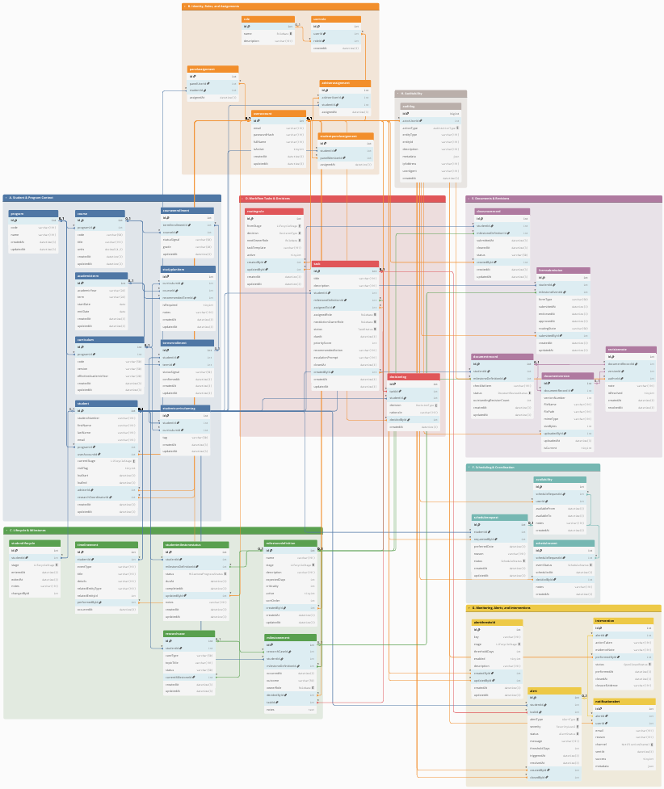

Figure 7. Full ERD of the proposed platform database (grouped)
Figure 7 presents the full ERD of the proposed database. For readability, the ERD is organized into functional groups (A to H). Figures X.1 to X.8 show cropped views of each group. Each caption highlights only the key tables and connections needed for monitoring and decision support.
A. Student and Program Context
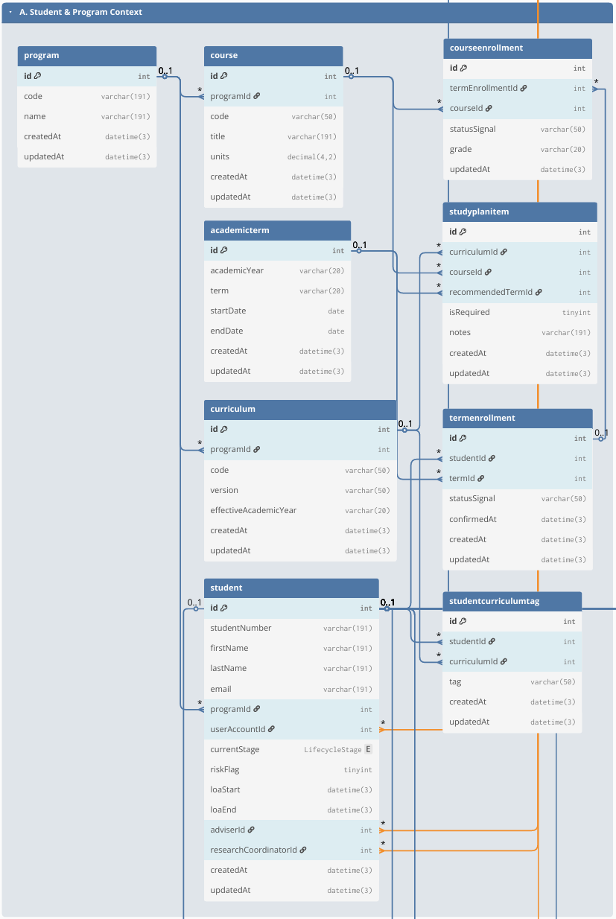

Figure 7.1 Group A. Student and Program Context
This group stores the core student monitoring identity and the student’s program context (Student, Program). Student serves as the primary reference across the database and links to academic monitoring (term/course records), lifecycle/milestone tracking, process tasks, documents, scheduling, alerts, and audit logs. Program provides the program/track context used for filtering, reporting, and program-dependent settings.
B. Identity, Roles, and Assignments

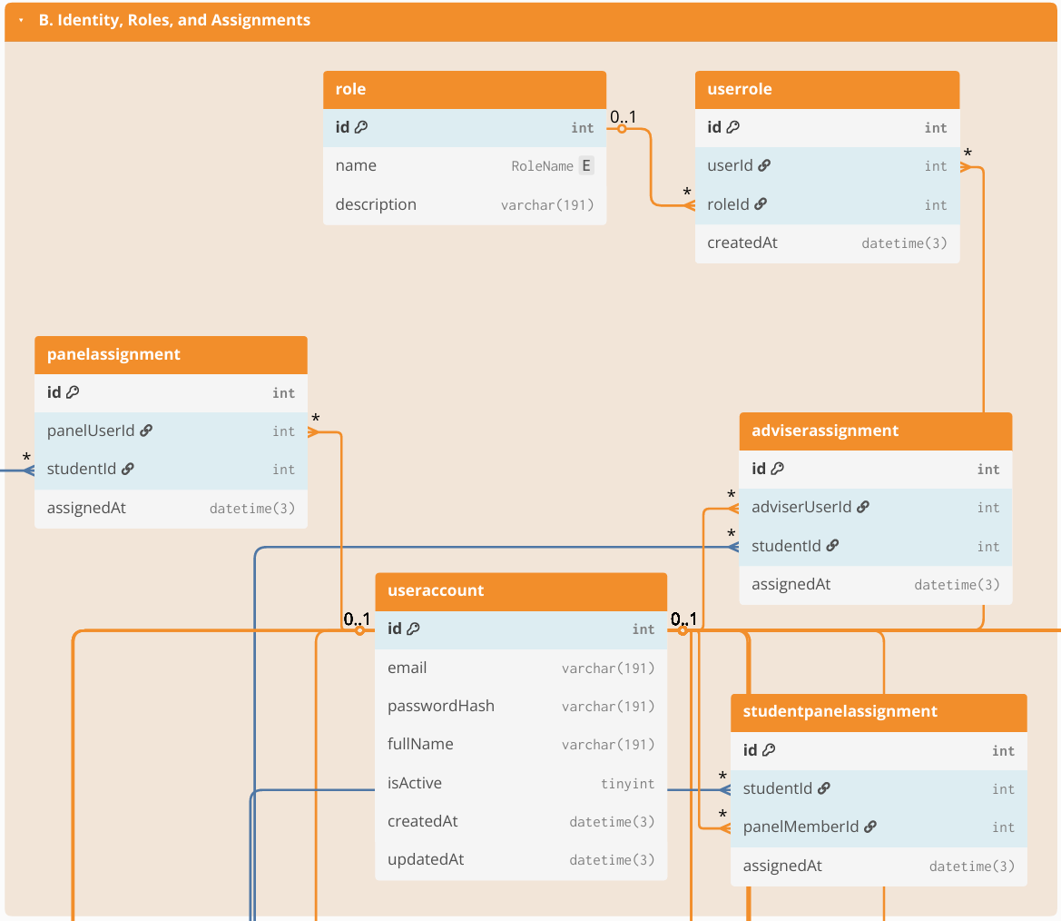

Figure 7.2 Group B. Identity, Roles, and Assignments
This group defines system accounts and role-based access control structures (UserAccount, Role, UserRole), and the scoped assignments that determine which students a user may access (e.g., AdviserAssignment, PanelAssignment, or equivalent assignment tables used by the system). These links enforce privacy boundaries (who can see which student/case) and support operational routing by clarifying who participates in review handoffs (coordinator/adviser/panel) without relying on informal messaging.
C. Lifecycle & Milestones

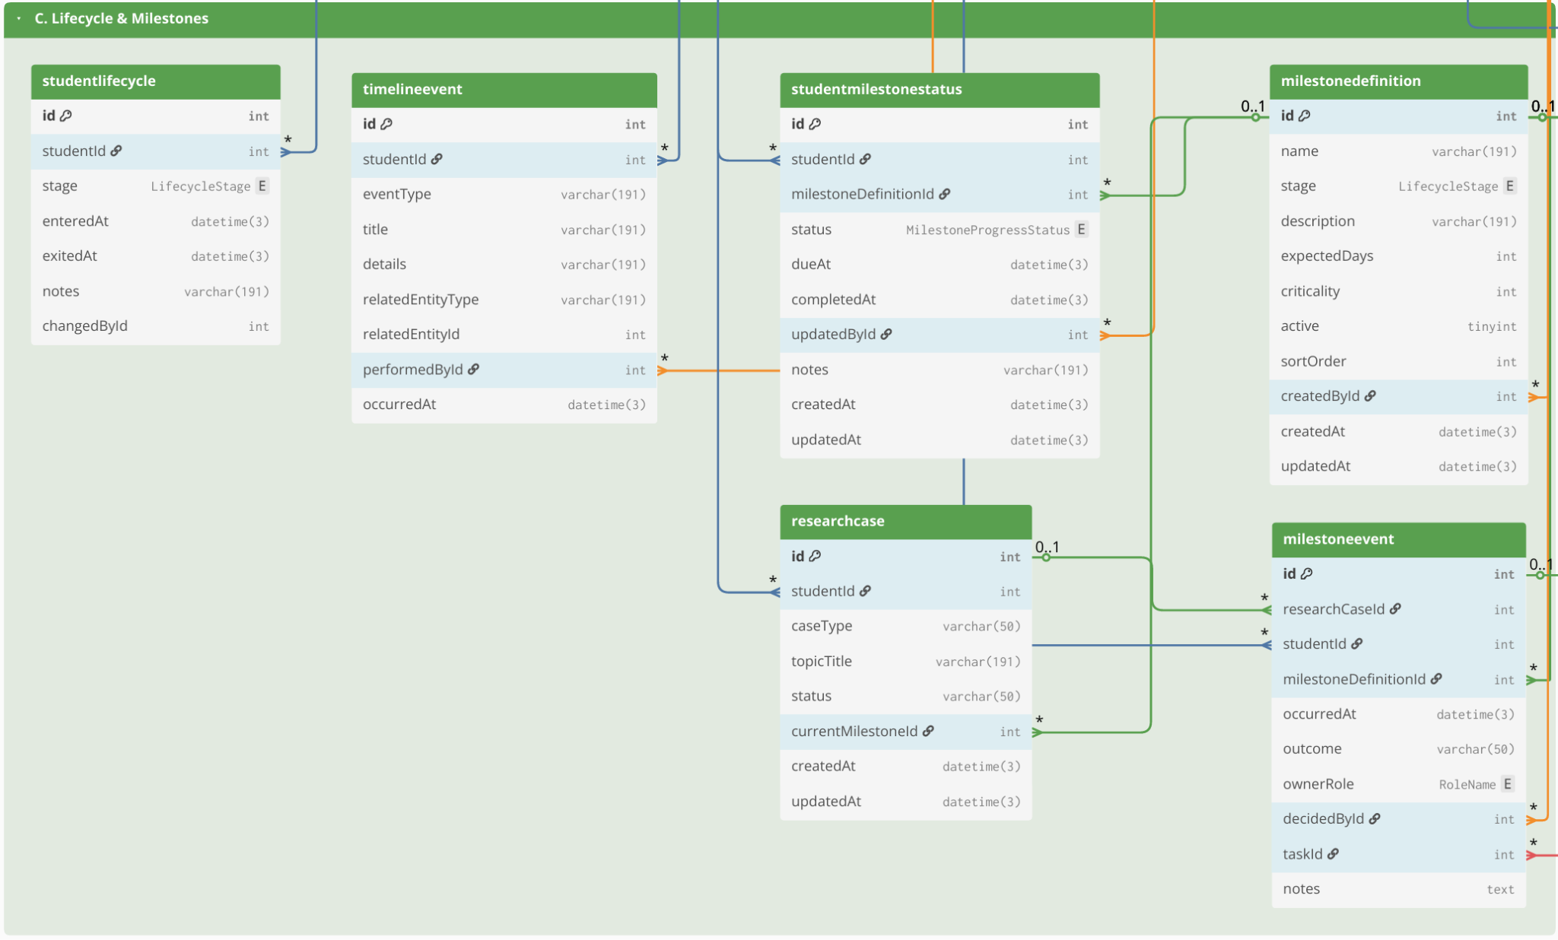Figure 7.3 Group C. Lifecycle & Milestones
This group provides the monitoring backbone for student standing and progress through lifecycle stages and requirements. It includes lifecycle stage history and milestone definitions (StudentLifecycle, MilestoneDefinition, StudentMilestoneStatus) and may also include the academic monitoring layer (AcademicTerm, TermEnrollment, CourseEnrollment, Course, Curriculum, StudyPlanItem, StudentCurriculumTag) when those signals are needed to support readiness views. The emphasis is on timestamped progress indicators (entered/exited stage, due/completion markers) that enable time-in-stage and overdue tracking.

D. Workflow Tasks & Decisions

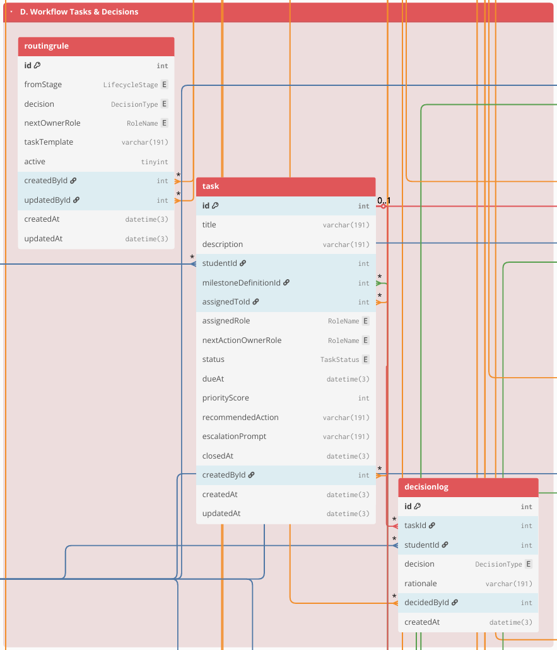

Figure 7.4 Group D. Workflow Tasks & Decisions
This group represents the operational “work queue” of the Graduate School. Workflow items are stored as Task records (owner, due date, priority/recommendations), and decisions are recorded as structured outcomes in DecisionLog (approve/revise/return), with routing rules handled through RoutingRule (or equivalent). Where the case-and-event approach is implemented, a student’s research engagement can be represented as ResearchCase, and milestone completion can be recorded as MilestoneEvent entries linked to tasks/decisions. This structure supports accountability (“who owns the next action”) and consistent decision traceability.
E. Documents & Revisions

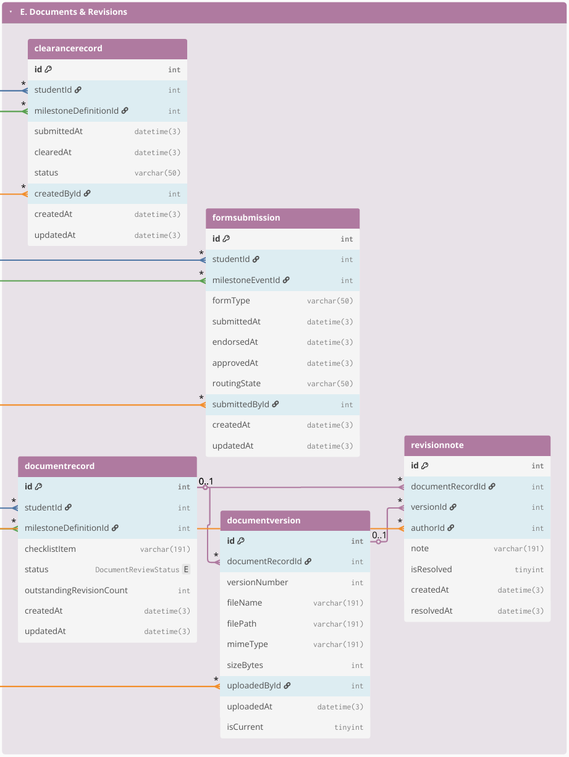

Figure 7.5 Group E. Documents & Revisions
This group stores evidence and version traceability for required submissions. Document requirements are represented through checklist-style records (DocumentRecord) and their uploaded versions (DocumentVersion), with revision and compliance tracking handled through RevisionNote (and status fields such as resolved/reopened). Where applicable, protocol-driven requirements and clearances are captured through FormSubmission and ClearanceRecord. The purpose is to keep a single, auditable reference for “what version was submitted,” “what revisions were required,” and “what is still pending.”
F. Scheduling & Coordination
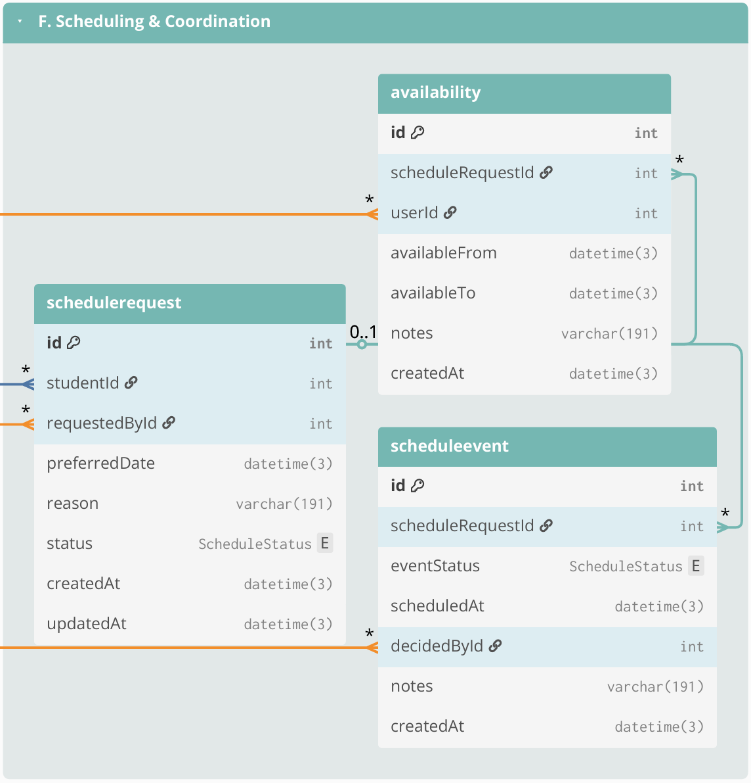

Figure 7.6 Group F. Scheduling & Coordination
This group manages scheduling process related to milestone activities (e.g., defenses and evaluations). Scheduling is stored using ScheduleRequest (request context and status), Availability (submitted availability windows), and ScheduleEvent (confirmed/rescheduled/cancelled outcomes with timestamps and decision actors). These records support scheduling cycle-time reporting and reduce back-and-forth coordination through email/chat by consolidating scheduling history in one place.
G. Monitoring, Alerts, and Interventions

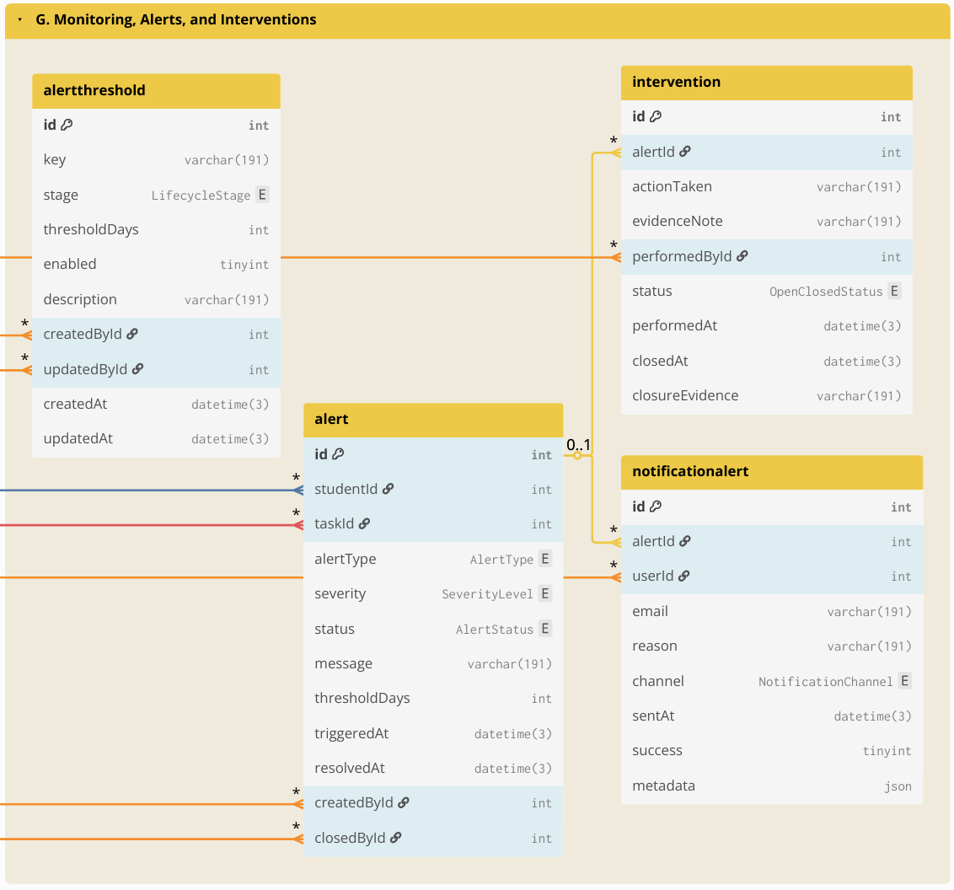

Figure 7.7 Group G. Monitoring, Alerts, and Interventions
This group supports proactive operational monitoring by turning derived indicators into actionable flags and follow-ups. Thresholds and rules may be stored in AlertThreshold (or equivalent), which are evaluated against timestamped monitoring signals (time-in-stage, overdue tasks, inactivity, delayed scheduling). Results are stored as Alert (or alert records) and notifications as NotificationAlert (who was notified, when, and why), while follow-up actions are tracked through Intervention (owner, due date, closure evidence/date). This enables early identification of delayed cases and operational follow-through.
H. Auditability
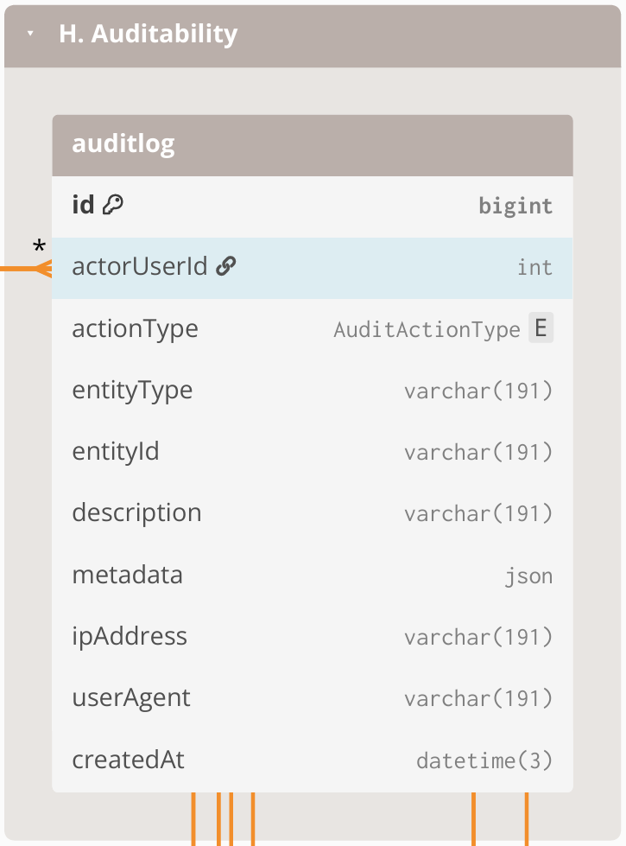

Figure 7.8 Group H. Auditability
This group provides accountability and traceability across the entire system. AuditLog is maintained as an append-only record of key events such as login/access attempts (including denied access), lifecycle transitions, task decisions, evidence uploads, scheduling outcomes, configuration changes, and notifications. Audit entries link to the acting user and store the affected record reference (entity type + entity ID), enabling traceability without requiring foreign keys from AuditLog to every table.

3.2.6.4 Computed Indicators for Prescriptive Analytics and Decision Support
To support descriptive monitoring and prescriptive decision support, operational data is transformed into computed indicators based on event history, timestamps, ownership assignments, decision outcomes, and evidence checklist status. These indicators serve as the system-generated inputs for prescriptive analytics and decision support. The computed indicators support (1) dashboards and monitoring views, such as counts per stage, pending queues, and aging or time-in-stage, and (2) rule-based recommendations such as queue prioritization, follow-up prompts, and escalation triggers. These indicators are computed from recorded events and completeness checks rather than from manually edited “current status” fields.
Computed indicator | Computed from | Decision-support use (how it drives prescriptive actions)
Current stage or milestone position | Latest MilestoneEvent per ResearchCase + MilestoneType ordering/definitions | Identifies where the case is now and which next action is relevant
Pending queue membership | MilestoneEvent with incomplete outcome + RoleAssignment owner + due date rules (if applicable) | Places cases into the correct role-based queue and enables prioritization
Aging or time-in-stage | Date difference between “now” and last MilestoneEvent timestamp, or between milestone timestamps | Flags stalled cases; triggers follow-up prompts and escalation when thresholds are reached
Overdue tasks and SLA breaches | Task due date (from process rules) vs current date + completion state | Generates “overdue” labels; recommends urgent follow-up or escalation
Scheduling cycle time | DefenseEvent request date to confirmed schedule date; reschedule count | Detects scheduling delays; recommends next coordination step and highlights repeated reschedules
Evidence completeness score | Required evidence checklist vs DocumentArtifact links for the milestone | Blocks completion when required evidence is missing; recommends what document to request
Decision outcome state | Latest decision outcome in MilestoneEvent (approve, revise, return) | Determines the next routing step; recommends who should act next
Prescriptive recommendation output | Rule-based checks applied to indicators above using policy-confirmed parameters | Produces recommended next actions, queue prioritization, and escalation prompts without automating final approvals

Table 13. Computed indicators from event history used for prescriptive analytics and decision support
This table shows that prescriptive analytics and decision support are based on system-generated indicators computed from timestamped events, ownership records, decision outcomes, and evidence completeness, rather than on manually maintained status fields. These computed indicators also serve as the structured inputs exposed for the Retrieval-Augmented Generation (RAG) through NotebookLM, so stakeholder-facing status explanations, completion rate analysis, and next-step prompts remain grounded on validated records and policy-confirmed logic.

3.2.6.5 Resource Planning
This subsection presents the resource requirements for implementing the proposed Graduate Student Lifecycle Monitoring and Analytics Platform. Since the Graduate School has a relatively small user population (approximately 400-500 students + staff) and the software stack is primarily open-source, the minimum cost of implementation can be kept low by leveraging existing school infrastructure. The major cost drivers are infrastructure availability (server and storage), routine system maintenance, and backup procedures. The following table summarizes the minimum resource requirements assuming existing campus resources, as well as the potential costs if additional resources are needed.
ON-SITE (On-Premises using existing infrastructure)
Item | Type | Cost | Potential Costs (if not existing) | Notes
Server hardware | One-time | ₱0 | ₱7,000–₱50,000 | Use an existing campus machine. Modest specs can support an MVP for a small graduate school with low concurrent usage.
OS + software stack | One-time | ₱0 | ₱0 | Open-source tools; no licensing fees.
HTTPS / SSL certificate | Annual | ₱0 | ₱0–₱5,000 | Free SSL via Let’s Encrypt; paid certificate optional depending on institutional policy.
Domain / subdomain | Annual | ₱0 | ₱800–₱1,500 | If USLS provides a subdomain under an existing domain, no additional cost.
Backups (storage + retention) | Monthly | ₱0 | ₱500–₱2,000 | Applies only if additional backup media/storage allocation or offsite copying is required.
IT operations (maintenance and support) | Monthly | ₱0 | Variable if there is an IT staff. | Patching, monitoring, user support, access management; typically absorbed by existing IT workload.
Email notification service (SMTP) | Monthly | ₱0 | ₱0–₱500 | Can use existing school email relay; external relay is optional for MVP use.
LLM API | Monthly/usage-based | ₱0 | ₱100–₱500 | Estimated for light MVP use only. If enabled, the LLM is used only for advisory outputs such as policy-grounded summaries, completion rate analysis, and next-step prompts. Official OpenAI pricing for GPT-4.1 is $2.00 per 1M input tokens, $0.50 per 1M cached input tokens, and $8.00 per 1M output tokens. Using a BSP reference rate of about ₱60.30 per US$1, this is roughly ₱120.60 per 1M input tokens, ₱30.15 per 1M cached input tokens, and ₱482.40 per 1M output tokens. A light MVP workload can reasonably stay around ₱100–₱400 per month, depending on prompt volume, retrieved context size, and output length.

Table 14. Cost table for on-site premises
This table summarizes the minimum (low-cost) resources required to deploy the platform either on-site (on-premises using existing campus infrastructure) and lists potential costs only when additional services are needed.
To minimize cost, the school may deploy the platform within the campus network using existing infrastructure. The minimum operational requirements are: (1) a stable host machine for the web application and database, (2) secured access controls (role-based access control and audit trail), and (3) backup and recovery procedures.
AI-assisted prescriptive recommendations, the system can operate fully without AI by keeping the feature flag disabled. If enabled, AI remains advisory only (no automatic decisions) and should only process aggregated, de-identified indicators. If the school wants zero additional cost and zero external processing, the AI feature remains OFF.

3.3 Workplan
This section presents the work timeline and sprint plan for the development of the Graduate Student Lifecycle Monitoring and Analytics Platform for the University of St. La Salle Graduate School. The workplan is divided into CAP-IT1 (primary build and internal validation) and CAP-IT2 (remaining refinements, stakeholder evaluation, and final packaging). CAP-IT1 carries the majority of implementation work, while CAP-IT2 focuses on evaluation-driven refinements and completion activities.

3.3.1 Target Accomplishment for CAP-IT1 (80% of IT development)
During CAP-IT1, the proponents aim to complete the main build of the proposed Graduate Student Lifecycle Monitoring and Analytics Platform. This phase will cover the primary implementation of the core platform, including user and access management, lifecycle and milestone management, workflow routing and decision tracking, document and revision management, scheduling and coordination, monitoring and alerts, analytics and reporting, and audit logging. By the end of CAP-IT1, the goal is to deliver an end-to-end working MVP with the main user interface, database, backend logic, and core module integrations already functioning. Initial testing and internal validation will also be conducted to confirm that the major monitoring, processing, and reporting features are already usable. This matches the workplan where CAP-IT1 is treated as the primary implementation phase for the system MVP.

3.3.2 Target Accomplishment for CAP-IT2 (20% of IT development)
During CAP-IT2, the proponents aim to complete the remaining 20% of the project through stakeholder evaluation, refinement, and final system improvement. This phase will focus on usability testing, user acceptance testing, workflow and dashboard refinements, access control and audit hardening, reporting polish, and final documentation and deployment preparation. In this phase, the proponents may also complete the limited prototype-level integration of the RAG-based policy and case guidance feature to support grounded policy and case interpretation, without making it the main implementation focus of the system. By the end of CAP-IT2, the goal is to deliver a more polished, validated, and defense-ready version of the platform. This follows the revised workplan, where CAP-IT2 is focused more on completion, refinement, and packaging rather than introducing new major modules.

3.3.3 CAP-IT1 Work Timeline
Development |  |  | May |  |  |  | Jun |  |  |  |  | Jul |  |  |  | Aug
# | Module | Activities | 4 | 11 | 18 | 25 | 1 | 8 | 15 | 22 | 29 | 6 | 13 | 20 | 27 | 3
1 | User & Access Management | Design role-based access interface (login, role dashboards)
 |  | Design RBAC database schema (users, roles, permissions)
 |  | Develop authentication and authorization prototype
 |  | Implement authentication logic, role-permission enforcement, and access validation rules
 |  | Conduct access testing
 |  | Sprint review and RBAC validation with stakeholders
2 | Lifecycle & Milestone Management | Design lifecycle stage interface
 |  | Design lifecycle database structure (stages, milestones, timestamps)
 |  | Prototype stage transition logic and milestone prerequisite checks
 |  | Implement lifecycle progression engine
 |  | Test stage gating and timestamp logging accuracy
 |  | Sprint review of lifecycle logic and milestone flow
3 | Workflow Routing & Decision Management | Design structured workflow queue interface
 |  | Design decision log and routing database schema
 |  | Prototype approve/revise/return decision pathways
 |  | Implement workflow routing engine and ownership reassignment
 |  | Conduct traceability and decision integrity testing
 |  | Sprint review on workflow clarity and ownership visibility
4 | Document & Revision Management | Design checklist and document submission interface
 |  | Design document metadata schema
 |  | Prototype document submission and revision tracking flow
 |  | Implement revision logging and checklist validation engine
 |  | Conduct version traceability testing
 |  | Sprint review of document tracking accuracy
5 | Scheduling & Coordination Management | Design scheduling request and availability interface
 |  | Design scheduling database
 |  | Prototype defense scheduling logic
 |  | Implement scheduling coordination engine
 |  | Conduct scheduling validation & sprint review
6 | Monitoring, Alerts & Intervention Engine | Design monitoring dashboard interface (risk indicators & alert views)
 |  | Design monitoring database logic (threshold rules, time-in-stage computation, escalation mapping)
 |  | Prototype automated alert detection logic
 |  | Implement monitoring and escalation engine (threshold evaluation + intervention logging)
 |  | Conduct alert accuracy testing (threshold validation & false-positive checks)
 |  | Sprint review of intervention logging and escalation clarity
7 | Analytics & Reporting | Design analytics dashboard layout (queue aging, bottleneck views, load metrics)
 |  | Design analytics aggregation schema reporting mart tables & computed metrics)
 |  | Implement reporting queries and dashboard visualizations
 |  | Conduct analytics validation testing (metric accuracy, aggregation consistency, cross-module data integrity)
 |  | Sprint review on reporting accuracy
8 | Database Audit | Design audit trail interface (activity log viewer & filtering tools)
 |  | Design append-only audit log schema (action logs, timestamp mapping, user-action trace)
 |  | Implement cross-module activity logging integration
 |  | Conduct audit integrity testing (log completeness, tamper resistance validation)
 |  | Sprint review on traceability coverage

Table 15.1. CAP-IT1 Work Timeline (80% target)
Table 15.1 outlines CAP-IT1 as the primary implementation phase where the system’s core modules are developed into an MVP. Modules correspond to the major components of the proposed lifecycle monitoring platform (e.g., core platform/RBAC, curriculum & study plan, enrollment/course audit, thesis/dissertation pipeline tracking, workflow routing and queues, evidence/document management, scheduling/LOA tracking, dashboards and audit logs), and analytics/reporting. Each sprint follows a consistent activity sequence (design → coding → testing → stakeholder feedback) to support iterative delivery.

3.3.4 CAP-IT2 Work Timeline
Development |  |  | Aug |  | Sep |  |  |  | Oct |  |  |  | Nov
# | Module | Activities | 24 | 31 | 7 | 14 | 21 | 28 | 5 | 12 | 19 | 26 | 2 | 9 | 16 | 23
9 | Evaluation Setup | Design structured usability and monitoring-interpretation evaluation instruments
 |  | Conduct pilot evaluation session
 |  | Finalize evaluation protocol for stakeholder sessions
10 | Stakeholder Usability / UAT | Conduct structured UAT Session 1 (Lifecycle tracking, Workflow routing validation)
Conduct structured UAT Session 2
(Monitoring alerts, Analytics dashboards, Access Control or Audit validation)
Consolidate findings
Document usability gaps and interpretation inconsistencies
11 | Refinements (Iteration 1) | Implement UI clarity improvements (dashboard readability, queue labeling, milestone visualization)
 |  | Refine workflow routing flows and decision-state clarity
Conduct full regression testing across Modules 1–8
(ensure refinements did not break monitoring, analytics, or access control logic)
12 | Access Control or Audit Hardening | RBAC scoping improvements
 |  | Audit log coverage + integrity checks
 |  | Regression testing
13 | Reporting & Export Polish | Access Control or Audit Hardening
Finalize export formats and endorsement-ready reporting outputs
(PDF/CSV exports, summary report structure validation)
14 | Documentation Finalization | Integrate final implementation updates into Chapter 3 & Chapter 4
 |  | Finalize User Guide and Admin Guide documentation
 |  | Clean appendix materials (BPMN, ERD, tables, architecture diagrams)
15 | Final Demo + Defense Prep | Package final build for deployment demonstration
 |  | Conduct final defense rehearsal and structured system walkthrough

Table 15.2. CAP-IT2 Work Timeline (20% target)
Table 15.2 outlines CAP-IT2 as the completion phase focused on stakeholder evaluation, refinement, and final packaging. Activities prioritize usability testing, validation of gate criteria and monitoring interpretations, RBAC/audit hardening, reporting polish, documentation finalization, and final defense readiness. CAP-IT2 intentionally concentrates on improving accuracy, interpretability, and stakeholder acceptability rather than introducing new major modules.

CHAPTER 4 – The Existing System
This chapter describes the existing setup of the University of St. La Salle (USLS) Graduate School as it operates today, before the deployment of the proposed platform. It presents the organizational context, the systems and records currently in use, the way each lifecycle process is actually carried out, the problem areas that follow from that arrangement, and the opportunities the Graduate School identified. The description is drawn from two confirmed consultations, the monitoring workbooks supplied by the Graduate School, and the correction checklists arising from those consultations.
Where this chapter restates a process already summarized in Section 1.3, it does so at the operational level of detail required to justify the design decisions in Chapter 5. Where the operational detail confirmed by the client differs from the earlier summary description, the account given in this chapter is the one carried forward into the implemented system, and the divergence is stated explicitly so that it can be reconciled with the adviser before the final defense.

4.1 Organization Profile
The University of St. La Salle is a private Catholic university in Bacolod City, Negros Occidental, Philippines. Its Graduate School administers the master's and doctoral programs of the university and is the organizational unit for which this study is conducted. The Graduate School is deliberately the unit of analysis: the system is designed for the specific working relationship between the USLS Graduate School and the USLS Registrar, and is not proposed as a generic product for other institutions.
The Graduate School currently administers twelve degree programs distributed across five academic clusters. Three of these programs carry a practicum requirement, which is why practicum handling in the proposed system is program-dependent rather than universal.

Table 16. Graduate School programs by cluster and practicum requirement
Cluster / College | Code | Program | Practicum
Arts and Sciences | MAPSY | Master of Arts in Psychology | Yes
Arts and Sciences | DPSY | Doctor of Philosophy in Psychology | Yes
Arts and Sciences | MASS | Master of Arts in Social Sciences | No
Business | MBA | Master of Business Administration | No
Business | DBA | Doctor of Business Administration | No
Education | MAED | Master of Arts in Education | No
Education | EDD | Doctor of Education | No
Education | MSGC | Master of Science in Guidance and Counseling | Yes
Engineering and Technology | MSCS | Master of Science in Computer Science | No
Engineering and Technology | MIT | Master in Information Technology | No
Nursing | MSN | Master of Science in Nursing | No
Nursing | MAN | Master of Arts in Nursing | No

4.1.1 Stakeholders and Their Present Responsibilities
The following actors participate in graduate student lifecycle monitoring. Their responsibilities as described below reflect present practice, not the proposed design.

Table 17. Existing stakeholders and present responsibilities
Stakeholder | Present responsibility in the existing setup
Graduate School Dean | Approves standing changes (leave of absence, readmission, return from AWOL, subject withdrawal), approves graduation endorsement, and decides escalated cases.
Graduate School Staff | Receives admission and enrollment information, maintains the monitoring workbook, prepares reports, files documents, and coordinates by email with students, faculty, and the Registrar.
Academic Coordinator | Determines which subjects are offered for the coming term, assigns the schedule and the handling faculty, tags students to subjects, and updates subject status as faculty report outcomes. Does not encode grades.
Research Coordinator | Reviews research submissions and research completion evidence, and participates in the graduation review of research requirements.
Faculty, Advisers, and Panel Members | Handle subjects, act as advisers, sit on title/proposal/final defense panels, and report subject outcomes and defense verdicts.
Graduate Students | Submit requirements, forms, and applications, and follow up on the status of their own records, largely through email and in-person visits.
Registrar (external office) | Holds the official student record. Executes the standing changes the Graduate School approves, and is the office to which endorsement and standing-change documents are sent.
Information Technology Services | Administers AIMS, the university academic information system, and can produce authorized data exports on request.

4.2 Description of the Existing System
The Graduate School does not operate a dedicated lifecycle monitoring system. What exists is a combination of one institutional system that the Graduate School does not control, a set of spreadsheets that the Graduate School maintains by hand, a set of printed or emailed forms, and email correspondence. The subsections below describe each of these components and then the processes they support.

4.2.1 AIMS as the Official Academic Information System
AIMS is the university's academic information system and the official record for student identity, enrollment, enrolled subjects, grades, and course completion. Two properties of AIMS, both confirmed during consultation, shape the entire design problem.
First, AIMS presents one student profile at a time. It is built to answer questions about an individual student and cannot produce the consolidated, cohort-level view of an entire program that the Graduate School needs in order to plan a term or to see who is delayed. The consolidated view has to be assembled outside AIMS.
Second, there is no live programmatic interface available to the Graduate School. Data exchange with AIMS is file-based and periodic: an authorized person requests or exports a workbook, and that workbook is then used elsewhere. Consequently the existing setup contains no automated synchronization, and any figure held outside AIMS is only as current as the last export.
The adviser consultation established the governing principle for this arrangement: where a locally held record disagrees with the institutional record, the institutional record is the one to be followed, and any change applied to reconcile the two must be visible to the user rather than applied silently.

4.2.2 The Manual Monitoring Workbook
The central artifact of the existing setup is a spreadsheet monitoring workbook maintained by the Graduate School. One worksheet is kept per program. Each row is a student and each column is either an identifying attribute or a curriculum subject.

Table 18. Structure of the existing monitoring workbook
Column group | Contents | What it records
Identity | IDNO, SN, FN | Student number, surname, first name.
Cohort | AY ENTRY, YR | Academic year of entry and current year level.
Curriculum subjects | One column per subject, grouped Basic / Major / Cognate | A unit value, typically 3, entered when the subject is completed. A blank cell means the subject has not been completed.
Comprehensive examination | COMPRE | Whether the comprehensive examination is passed.
Research milestones | TITLE, PROPOSAL, ETHICS, FINAL | Whether each research milestone has been reached.

The limitation of this structure is decisive and was raised directly by the client. The workbook records only completion. A blank subject cell is ambiguous: it may mean the student has never taken the subject, is enrolled in it right now, failed it, received an incomplete or deferred grade, dropped it mid-semester, or officially withdrew from it. The workbook cannot distinguish these states, yet nearly every operational question the Graduate School needs to answer depends on the distinction. The client specified the vocabulary the Graduate School actually uses—not taken, enrolled, taken, dropped, and withdrawn, with incomplete and failed reported by faculty—and confirmed that no existing export supplies it.
A second limitation is that the workbook is a snapshot with no history. When a value is changed, the previous value, the person who changed it, and the date of the change are not retained. There is therefore no basis for auditing a correction or for measuring how long a case has been waiting.

4.2.3 Forms, Documents, and Email Coordination
Alongside the workbook, the Graduate School relies on a set of research protocol forms and on document files. Form 1 is used for title defense endorsement and Form 4 is the Research Protocol Submission Form reviewed by the academic coordinator and faculty advisers. Practicum evidence arrives as memoranda of agreement and as certificates of completed hours, sometimes several certificates for one student when hours were accumulated at different establishments.
Coordination itself is conducted by email and conversation. Requests to drop a subject, queries about standing, notifications of defense schedules, and follow-ups on pending requirements all travel this way. Because the request and its resolution live in a mailbox rather than in a record, the fact that a request was made is not visible to anyone who was not on the message, and the elapsed time since it was made is not measurable.

4.2.4 Classification of the Existing Processes
The adviser consultation produced a classification that is important for understanding why the existing setup fails in different ways for different processes. Graduate School processes fall into three groups according to where authority sits.

Table 19. Classification of existing processes by locus of authority
Group | Processes | Existing behaviour and its weakness
Originating outside the Graduate School | Admission intake, enrollment, subject completion | Data originates with the Registrar or Admissions and reaches the Graduate School as a workbook. The Graduate School consumes it and cannot correct it at source, so local corrections risk diverging from the official record.
Internal to the Graduate School | Research gate, adviser designation, panel matching, defense scheduling, defense verdicts and revisions, practicum | Fully owned by the Graduate School. The weakness here is not authority but record-keeping: these are tracked in files, forms, and email, so status and ownership of the next action are not visible in one place.
Requiring a two-way exchange with the Registrar | Leave of absence, readmission, AWOL, residency, subject withdrawal, graduation endorsement | The Graduate School decides, then must produce a document for the Registrar, and the Registrar must later confirm that the change has been implemented. In the existing setup neither the outgoing document nor the returning confirmation is tracked, so record consistency between the two offices cannot be demonstrated.

The third group is the most consequential. As the adviser put it, the exchange with the Registrar is a two-way street: the Graduate School informs the Registrar of an approved change, and the Registrar must return an indication that the change has been carried out. Without that return signal, the two offices cannot establish that their records agree. The existing setup has no mechanism for either direction.

4.2.5 The Existing Lifecycle Processes in Detail
The following subsections describe how each process is presently carried out.

4.2.5.1 Admission Handoff
Admission decisions are made and recorded outside the Graduate School. During the term break the Graduate School receives a workbook containing the incoming students together with the continuing students. Because new and continuing students arrive in the same file, the Graduate School has no reliable marker distinguishing a newly admitted student from a continuing one, and identifying newcomers depends on inspecting the file. Late admissions and late enrollments that occur after the file is issued are not reflected until a subsequent file is produced.

4.2.5.2 Course Offering and Enrollment
Before a term begins the Academic Coordinator decides which subjects will be offered, together with the schedule and the handling faculty member. In the existing setup this decision is made from experience and from manual inspection of the monitoring workbook; there is no report that counts how many students still require each unoffered subject. The client described precisely the report that is missing: a list of subject codes, each with the number of students who have not yet taken it, used as the basis for deciding what to open.
Enrollment itself is executed in the institutional system. What the Graduate School needs, and does not have, is a record of which students are attached to which offered subject for the current term, maintained in the same place as the monitoring view. The client confirmed the two working methods the Graduate School would use for this: uploading a class list, and searching for an individual student and tagging that student to a subject.

4.2.5.3 Coursework and Subject Status
During the term, faculty report subject outcomes. The Academic Coordinator records these outcomes, but the workbook can express only completion, so incomplete, failed, dropped, and withdrawn outcomes have no representation. The client was explicit that the Academic Coordinator tags status only and does not encode grades; grade encoding is performed elsewhere in the university and is not a Graduate School responsibility.
Dropping a subject illustrates the gap. A student's request to drop is made by email or in conversation, is decided outside any system, and results at most in a note. There is no dated record of the drop and no place to attach the reason.

4.2.5.4 Leave of Absence, Readmission, AWOL, and Residency
A student who intends to stop attending for a period files a leave of absence with the Graduate School. The Dean decides. When a student stops attending without filing, the condition is treated as absence without leave, which carries the same practical effect on the student's standing as a leave. Residency is monitored by counting the years between a student's entry and the present, a calculation the Graduate School performs by hand from the entry year.
All four of these are two-way processes. The Graduate School's approval is not the official act; the Registrar implements the change. In the existing setup the document conveying the decision is prepared ad hoc, and the Registrar's confirmation that the change has been implemented is not recorded anywhere, so the Graduate School cannot demonstrate that its own record matches the official one.

4.2.5.5 Research Milestones and Defense Coordination
The research pipeline runs from adviser designation through title defense, proposal defense, ethics review, revisions, and final defense. This process is internal to the Graduate School. Scheduling a defense requires finding a date on which the student and every panel member are simultaneously available, which is presently done by circulating proposed dates by email and waiting for replies. Panel composition is decided from the coordinator's knowledge of faculty specialization; the client noted that the most reliable basis for judging specialization would be the faculty member's own curriculum vitae, which the Graduate School does not presently hold in any structured form.

4.2.5.6 Practicum
Practicum applies only to the programs that require it. The student submits a memorandum of agreement, completes the required hours, and submits certificates as evidence. Where hours were completed at more than one establishment, more than one certificate is submitted and the hours must be totalled across them. Graduate School staff forward the submission, the Academic Coordinator reviews it, and a status report reaches the Dean. The unusual case that the existing setup handles poorly is the student whose certificates do not add up to the required number of hours, which is discovered only on manual inspection.

4.2.5.7 Subject Withdrawal
Withdrawal in present Graduate School practice is the withdrawal of a student from one particular enrolled subject. It is available before classes begin or during the first seven calendar days of classes. A withdrawal granted in this window is penalty-free: the subject carries no grade and no adverse mark, the student's other subjects are unaffected, and the student remains active in the graduate program. It is distinct from a mid-semester drop. The record the client asked to keep is modest: the date the student applied, the date the withdrawal was granted, and a free-text area for the result.
This description must be read against Section 1.3.11. The earlier summary characterized withdrawal as an exit from the graduate program, following the adviser's framing during the July 20 consultation. The client subsequently specified subject-level withdrawal as the process the Graduate School actually operates, and the implemented system follows the client's specification. The as-built behaviour described in this section therefore supersedes the summary description given in Section 1.3.11 and in the glossary. This divergence between adviser framing and client specification remains open and is to be reconciled before the final defense.
As with the other standing changes, the Graduate School's approval is not the official act. An approved withdrawal must be conveyed to the Registrar, and the Registrar implements it.

4.2.5.8 Graduation Endorsement
Toward the end of a term the Graduate School determines which students have satisfied all requirements, assembles the list, and the Dean endorses it. The endorsed list is then conveyed to the Registrar, which performs the official graduation processing. Determining eligibility in the existing setup requires checking coursework completion, comprehensive examination status, and research completion across separate records for each candidate.
Section 1.3.12 describes the endorsed list as being sent to the Registrar with receipt acknowledged. In present practice, and in the implemented system, the conveyance is a file that a person sends through the official external channel; no automated transmission occurs and no acknowledgement is captured. The account in this section is the one carried forward.

4.2.6 Current State of Technology

4.2.6.1 Traditional Methods
The methods presently in use are spreadsheets, printed and emailed forms, filed documents, and email correspondence. Spreadsheets are flexible and require no procurement or training, which is why they persist. Their weaknesses in this application are that they hold no history, enforce no validation, admit no controlled vocabulary, provide no access control at the level of a single field, and offer no way to attach an action or an owner to a row. Email is an effective medium for conversation but a poor medium of record, because a message cannot be queried, aggregated, or aged.

4.2.6.2 Modern Methods
Institutions addressing comparable problems use student information systems for the official record, workflow and business process management platforms to route approvals and record ownership of the next action, and reporting or dashboard layers to aggregate operational status. More recently, retrieval-augmented generation has been applied to make institutional policy documents searchable in natural language while keeping answers grounded in the source text. The existing Graduate School setup uses the first of these categories, through AIMS, and none of the others.

4.3 Problem Areas
The root causes of difficulty in monitoring and processing graduate student progress were analysed using an Ishikawa diagram, presented as Figure 2 in Section 1.4 and reproduced in Appendix B. The three categories identified there are elaborated below against the operational detail established in this chapter.

4.3.1 Machine
Student information is divided among systems that do not communicate. AIMS holds the official record but cannot produce a cohort view. The monitoring workbook produces a cohort view but holds only completion and no history. Documents and forms hold evidence but are not indexed against the student record. Email holds the decisions but cannot be queried. No single component can answer the question of where a given student stands, so answering it requires consulting several of them and reconciling what they say.
The absence of any interface between the Graduate School's working records and the official record compounds this. Because reconciliation is manual and periodic, the two records drift between exports, and there is no mechanism that makes the drift visible.

4.3.2 Method
The monitoring method is manual consolidation. The same information is entered more than once, in more than one place, because no record is derived from another. Confirming a student's standing requires gathering information from several sources and combining it by hand. Reports that the Graduate School needs regularly—subject needs for class planning, graduating candidates, leave of absence monitoring, residency tracking—are assembled from scratch on each occasion rather than generated.
Residency is a clear instance. The Graduate School computes it by counting from the student's entry year to the present, for each student, by hand, even though every input to that calculation is already recorded. The calculation is deterministic and could be derived, but under the existing method it is repeated manually.
The method also lacks any notion of ownership or elapsed time. Nothing in the existing records states who must act next on a case or how long the case has been waiting, so delayed cases surface only when somebody notices or when the student follows up.

4.3.3 Man
Because the method depends on repeated manual encoding across several records, it is exposed to ordinary human error: transcription mistakes, updates applied to one record and not another, and updates missed entirely. These errors produce inconsistencies between records that are difficult to detect precisely because there is no cross-check between them.
The Graduate School also noted that this is not a staffing problem. Assigning additional people to the existing method would multiply the manual effort rather than remove it, and would leave the underlying exposure to encoding error unchanged.

4.3.4 Summary of Problem Areas

Table 20. Problem areas mapped to their operational consequence
Problem area | Operational consequence
Records divided across systems that do not communicate | No single consolidated view of a student's standing; confirmation requires manual reconciliation across sources.
Monitoring workbook records completion only | Enrolled, incomplete, failed, dropped, and withdrawn outcomes cannot be represented, so term-level operational questions cannot be answered from it.
No history retained on change | A correction cannot be audited; time-in-stage and cycle time cannot be measured.
No record of ownership of the next action | Cases stall without anyone being accountable, and delay is discovered late.
Coordination conducted in email | Requests and decisions are not queryable, aggregable, or ageable.
No tracked exchange with the Registrar | Neither the outgoing decision document nor the returning implementation confirmation is recorded, so record consistency between offices cannot be demonstrated.
Reports assembled manually each time | Class planning, graduation, leave, and residency reporting is slow and repeats the same consolidation effort.
Repeated manual encoding | Elevated exposure to transcription error, missed updates, and inconsistency between records.

4.4 Opportunities

4.4.1 Opportunities for the Graduate School
The problem areas above point to a coordination and monitoring layer rather than a replacement for the institutional system. The clearest opportunity is a consolidated cohort view assembled from the workbook the Graduate School already receives, presented so that the standing of every student in a program is visible at once. This addresses the limitation the client identified as the reason the Graduate School keeps its spreadsheet in the first place.
A second opportunity is a controlled vocabulary for subject status, maintained through audited actions rather than free cell editing. Recording that a subject is enrolled, incomplete, failed, dropped, or withdrawn—each change carrying the person, the time, and the previous value—supplies the distinction the workbook cannot express while preserving the authority of imported official values.
A third is derived reporting. Every report the Graduate School presently assembles by hand is a function of data that would already be held: subject needs from completion and offering data, graduating candidates from completion and research status, residency from entry year, leave monitoring from standing records. Deriving them removes both the effort and the transcription exposure.
A fourth is explicit ownership and ageing. Attaching to each open case the person responsible for the next action and the time since the case entered its present state makes delay visible before the student reports it, and makes workload measurable.
A fifth is a recorded exchange with the Registrar. Generating the document that conveys an approved standing change, and holding the case in a state that shows the confirmation has not yet been returned, gives both offices a basis for establishing record consistency.

4.4.2 Opportunities for Graduate Students
Students presently learn the status of their own requests by asking. A student-facing view of lifecycle status, pending requirements, and submitted requests would reduce follow-up traffic and shorten the interval between a requirement being missing and the student acting on it. Allowing structured submission of applications, with the rules checked at the point of submission, would also prevent applications that cannot succeed from entering the queue at all.

4.4.3 Opportunities for Faculty and Other Offices
Faculty participate in the lifecycle as subject handlers, advisers, and panel members, but hold no view of what is assigned to them. Availability collection for defense scheduling, panel invitations with an accept or decline response, and adviser designation responses are all presently conducted by email and could be recorded directly. For the Registrar, a predictable document accompanying each approved standing change, in a consistent format, reduces the interpretation currently required of ad-hoc correspondence.

4.4.4 Constraints on Any Proposed Solution
The consultations also fixed the boundaries within which any solution must operate. These constraints are carried directly into the design in Chapter 5.
1.The proposed system must not replace AIMS, and must not present a locally maintained value as though it were an official AIMS value.
2.No live integration with AIMS may be assumed. Exchange is file-based and periodic.
3.Imported official values are read-only. Corrections are raised as reported discrepancies and resolved at source, not overwritten locally.
4.Grade encoding is outside the Graduate School's responsibility and must not be required of the Academic Coordinator or of faculty.
5.Standing changes are not executed by the Graduate School. The system may record the decision and produce the document, but the official act belongs to the Registrar.
6.The system is built for the USLS Graduate School and its working relationship with the USLS Registrar, and is not generalized beyond it.
7.Policy values that have not been confirmed by the institution must be configurable and displayed as unconfirmed rather than assigned an invented default.

CHAPTER 5 – The Proposed System
This chapter describes the proposed Graduate School Lifecycle Portal as it has been built for the CAP-IT1 milestone. It presents the system description, objectives, modules, scope, assumptions, feasibility, technical and non-technical requirements, data specifications, screen specifications, report specifications, architecture, and infrastructure. The screens shown in Section 5.10 are captures of the running prototype operating on the seeded demonstration dataset.

5.1 System Description
The Graduate School Lifecycle Portal is a role-based web application that gives the USLS Graduate School a single consolidated workspace for monitoring and coordinating the graduate student lifecycle. It covers admission handoff, course offering and adjustment, enrollment, coursework status, the research pipeline from adviser designation to final defense, practicum, graduation endorsement, and the standing changes of leave of absence, readmission, AWOL, residency, and subject withdrawal.
The portal is deliberately a coordination and decision-support layer, not a replacement for the institutional academic information system. AIMS remains the official record for student identity, enrollment, enrolled subjects, grades, and course completion. Authorized staff import an approved monitoring workbook; the values that arrive by that route are presented as read-only and labelled with their source, and a discrepancy is raised as a reported exception rather than corrected in place. On top of that official data the portal adds what the existing setup lacks: a controlled status vocabulary maintained through audited actions, explicit ownership of the next action, elapsed-time measurement, derived reporting, generated documents for the Registrar, and a policy-grounded assistant.
The implemented system is a Python 3 and Flask JSON application server exposing 119 routes, backed by a relational database of 35 tables through SQLAlchemy, with a React single-page front end built with Vite and styled with Tailwind CSS. It runs against MySQL in the demonstration deployment and against SQLite for isolated automated testing. Access is session-based and role-gated, with seven distinct account types.

5.2 System Objectives

5.2.1 General Objective
The general objective of the Graduate School Lifecycle Portal is to give the USLS Graduate School one consolidated, auditable view of graduate student progress across the full lifecycle, so that the standing of any student can be confirmed without manual reconciliation across separate records, and so that delayed cases and pending actions become visible before they are reported.

5.2.2 Specific Objectives
The system aims to:
1.Consolidate the monitoring workbook the Graduate School already receives into a single cohort-level view, presented per program and per term, with the source of the official values labelled and those values held read-only.
2.Provide a controlled subject-status vocabulary covering not taken, enrolled, taken, incomplete, failed, dropped, and withdrawn, changed only through audited actions that record the actor, the time, and the previous value.
3.Support course offering setup, so the Academic Coordinator can declare the subjects offered for a given academic year and semester together with the schedule and the assigned faculty member.
4.Support enrollment by tagging students to officially offered subjects, both by uploading a class list and by searching for an individual student, with tagging restricted to subjects that are actually offered.
5.Generate the subject-needs report that identifies, for each subject, the number of students who still require it, as the demand basis for deciding what to offer.
6.Route the research pipeline, including research gate checks, panel matching against faculty specialization, and defense scheduling against faculty availability.
7.Track practicum for the programs that require it, including memorandum of agreement submission, accumulation of hours across multiple certificates, and the review sequence to the Dean.
8.Process standing changes through structured applications validated by explicit rules, routed for Dean decision, and concluded by generating the document that conveys the approved change to the Registrar.
9.Determine graduation eligibility from coursework, comprehensive examination, research, and practicum status, and prepare the Dean-approved endorsement list for export.
10.Record every consequential action in a transaction log, and derive from that log the dashboards, reports, ownership assignments, and ageing indicators that the Graduate School presently assembles by hand.
11.Provide a policy assistant that answers questions from Graduate School policy documents and verified system reports, grounded in retrievable sources rather than in unsupported generation.

5.3 System Modules
The implemented modules are described below. Each is presented in terms of what it does, who uses it, and which existing problem area it addresses.

5.3.1 Student Handoff and Monitoring Import
Imports the Academic Coordinator monitoring workbook and reconciles it against the existing student list. Students are created only from the imported workbook; the system provides no manual student creation and generates no student numbers, because student identity originates outside the Graduate School. The import records an upload history, detects validation issues and duplicate records, and marks newly appearing students. Newly admitted students carry a risk state of Not Yet Assessed rather than a default risk level, since no monitoring signal yet exists for them.

5.3.2 Course Adjustments and Course Offering Setup
Lets the Academic Coordinator declare which subjects are offered for a given academic year and semester, capturing the schedule, the section, and the assigned faculty member. The module also produces the subject-needs report, which counts for each subject the students who still require it. Subject need, proposed offering, approved offering, and scheduled class are kept as distinct states so that demand is not confused with a decision to open a class.

5.3.3 Enrollment
Tags students to offered subjects for the active term, either by uploading a class list in CSV or Excel format or by searching for a single student and selecting from that student's offered subjects. Tagging is validated on the server against the published offering list, so a student cannot be enrolled in a subject that is not offered. Every tagging action is logged, and the resulting enrollment is synchronized to the durable enrollment ledger and to the monitoring view.

5.3.4 Monitoring Sheet
Presents the consolidated cohort view: one row per student, one column per curriculum subject, grouped by Basic, Major, and Cognate, filtered by program, academic year, semester, progress, risk, and enrollment state. Officially imported values are read-only and the screen states so. A per-row Flag issue action records a discrepancy against the official value without altering it, and a subsequent corrected import can resolve the flag. Subject status changes are made through the audited status action rather than by editing cells.

5.3.5 Research Gate
Checks each student's required research submissions for the gate the student is currently at, covering title defense, proposal defense readiness, ethics, final defense, and completion evidence. Required documents are defined per gate, and the module records adviser approvals of submitted documents.

5.3.6 Panel Matching
Recommends a defense panel by matching the student's research title against faculty specialization, grounded in the faculty member's uploaded curriculum vitae rather than in external sources. The recommendation is advisory: it produces a ranked shortlist with the reason for each suggestion, and the coordinator makes the selection.

5.3.7 Defense Scheduling
Finds a defense slot at which the student and the panel are simultaneously available. Availability is taken from recurring faculty working hours and, where a faculty member has connected it, from that faculty member's own Google Calendar free/busy information. Where availability cannot be established the module fails closed rather than proposing a slot it cannot support, and proposed dates observe a required lead time.

5.3.8 Practicum
Applies only to the programs that require practicum. Tracks memorandum of agreement submission, the practicum site and supervisor, required and completed hours, and the certificates submitted as evidence. Multiple certificates are accumulated rather than replaced, so hours completed at different establishments total correctly, and a shortfall against the required hours is surfaced as an unusual case for staff attention. Student submission is locked until the eligibility conditions are met.

5.3.9 Graduation
Determines eligibility from coursework completion, comprehensive examination status, research completion, and practicum where applicable, and lists the candidates for a review window. Applications are gated on eligibility, candidates are processed in batches, each reviewing role acts in sequence, incomplete cases are returned for resubmission, and the Dean approves the endorsement. On approval the system prepares the endorsed list for export.

5.3.10 Leave of Absence and Readmission
Structured applications validated by explicit rules rather than by interpretation of an uploaded letter: the allowed reasons, the number of prior leaves, the permitted duration, and the requirement that the effective period be a term that has not already begun. The application is reviewed by Graduate School staff and decided by the Dean, who may approve or return it for revision. A student may withdraw a pending application. On approval the system generates the document conveying the decision to the Registrar.

5.3.11 AWOL and Residency
Monitors students who have stopped attending without filing a leave, applies the policy review for a return from AWOL, and records residency enrollment. Residency is derived from the recorded entry year rather than computed by hand. Both processes produce a Registrar document on decision, and an absolute limit on absence requires re-enrollment rather than a simple return.

5.3.12 Subject Withdrawal
Handles the penalty-free withdrawal of a student from one particular enrolled subject, filed before classes begin or during the first seven calendar days. The student submits the request against a specific enrolled subject; a request filed outside the window is blocked. Graduate School staff forward the request and the Dean decides. On approval staff explicitly tag only the selected subject as withdrawn; the student remains active in the program, other subjects are untouched, and the withdrawn subject carries no grade and no adverse mark. The approved withdrawals are exported for conveyance to the Registrar.

5.3.13 Work Queue, Activity Log, and Recommendations
The work queue lists open tasks with the owning role and the time outstanding, so ownership of the next action is explicit and delay is visible. The activity log presents the transaction record. The recommendations module derives rule-based prompts from recorded events and timestamps, each presented with the data used and the reasoning, and each leaving the decision with the responsible human.

5.3.14 Policy Assistant
Answers natural-language questions about Graduate School policy from indexed policy documents using retrieval-augmented generation, and routes questions that are really requests for operational figures to the verified system reports instead of generating an answer. Access is scoped by role, so a student cannot obtain staff-only information through it. The assistant is distinct from the Red-Amber-Green risk indicator, which is a separate concept.

5.3.15 Student, Faculty, and Dean Portals
The student portal shows the student's own lifecycle status, pending requirements, messages, and submitted requests, and is the point at which structured applications are filed. The faculty portal shows assigned advisees, adviser document approvals, defense verdicts, and the optional Google Calendar connection. The Dean portal presents the approvals awaiting decision. Files and messages are scoped so that a user sees only what belongs to that user's role and student.

5.3.16 Mapping to the Conceptual Framework
The seven modules of the conceptual framework in Section 1.6.1 map onto the implemented modules as follows.

Table 21. Conceptual framework modules mapped to implemented modules
Conceptual module | Implemented as | Status
Module 1 — Student Progress Management | Monitoring Sheet, Student Handoff, Students, Student Detail | Implemented
Module 2 — Case Status and Action Tracking | Workflow pages for every process, Work Queue, Activity Log | Implemented
Module 3 — Defense Scheduling Management | Panel Matching, Defense Scheduling, faculty availability | Implemented
Module 4 — Case Monitoring and Follow-Up | Work Queue ageing, overdue task counts, automatic policy alerts | Partially implemented
Module 5 — Analytics and Decision Support | Dashboard, Recommendations, derived indicators | Partially implemented
Module 6 — Policy and Case Guidance | Policy Assistant with document retrieval and report routing | Partially implemented
Module 7 — Reporting and Dashboards | Reports module with ten report views and four export documents | Implemented

The modules marked partially implemented are functional but do not yet compute the KPI formulas defined in Section 1.7.1.4. Implementing those measurements is scheduled for CAP-IT2 and is reflected in the remaining-work assessment.

5.4 System Scope

5.4.1 User Scope
The system serves seven account types. Six of them can sign in; the Registrar is represented in the data model as the external counterparty but has no interactive account, which reflects the deliberate decision that the Registrar's work happens outside this system.

Table 22. Account types and access
Account type | Signs in | Principal screens
Graduate School Staff | Yes | All lifecycle workflows, records, reports, work queue
Academic Coordinator | Yes | Monitoring sheet, enrollment, course adjustments, students, faculty, research gate, panel matching, practicum, graduation, AWOL, reports, work queue
Research Coordinator | Yes | Research gate, graduation, work queue
Dean | Yes | Approvals queue and decision screens
Faculty | Yes | Faculty portal: advisees, document approvals, defense verdicts, calendar
Student | Yes | Student portal: own status, requirements, requests, messages
Administrator | Yes | All staff screens, for review and administration
Registrar | No (external) | Receives generated documents through the official external channel

Role gating is enforced on the server, not only by hiding navigation items. A request for a resource outside a role's scope is refused by the API regardless of what the browser displays.

5.4.2 Process Scope
The system covers admission handoff, course offering setup and adjustment, enrollment, coursework status monitoring, the research pipeline, practicum for the programs that require it, graduation endorsement preparation, and the standing changes of leave of absence, readmission, AWOL, residency, and subject withdrawal.

5.4.3 Data Scope
The system holds student identity and program context imported from the monitoring workbook; curriculum, course, and offering definitions; enrollment and subject status records; research cases, milestones, and evidence; practicum records and documents; standing-change applications and decisions; faculty profiles, specialization, and availability; tasks with owners and due dates; messages; uploaded attachments; and a transaction log of consequential actions.

5.4.4 Exclusions
The following are outside the system by decision, not by omission. The system does not replace AIMS and does not clone it. It provides no live AIMS integration, no screen scraping, and no AIMS login. It does not encode grades and provides no path for the Academic Coordinator or faculty to do so. It does not execute standing changes, which remain the Registrar's official act. It does not perform admissions processing, enrollment transactions, learning management, or accounting and billing. It does not transmit documents to the Registrar automatically, and does not claim that a document has been received or acknowledged.

5.5 System Assumptions
1.An authorized person can obtain the monitoring workbook in the documented format and import it periodically. No live interface is assumed.
2.Values arriving by import are authoritative and are not edited locally; discrepancies are reported and corrected at source.
3.The Academic Coordinator maintains subject status in the system, because no institutional export supplies the status vocabulary the Graduate School uses.
4.Grades are encoded elsewhere in the university and are not entered here.
5.Approved standing changes are conveyed to the Registrar through the official external channel by a person, and the Registrar's implementation is confirmed outside the system until such time as a confirmation mechanism is agreed.
6.Faculty availability is either declared as recurring working hours or supplied by the faculty member's own connected calendar, with that connection made by the faculty member for the faculty member's own account only.
7.Users access the system through a modern browser on the university network or on the presenting machine for demonstration purposes.
8.Policy values that the institution has not confirmed are configurable and are displayed as unconfirmed rather than defaulted to an invented value.

5.6 System Feasibility

5.6.1 Developmental Feasibility
The system is built on a widely used and well-documented stack: Python with Flask for the application server, SQLAlchemy for data access, and React with Vite and Tailwind CSS for the interface. All are open-source and require no licensing. The team has demonstrated developmental feasibility by delivering the working prototype described in this chapter, comprising 119 API routes and 35 database tables, together with an automated regression suite of 61 workflow tests that exercises the implemented processes end to end.

5.6.2 Economic Feasibility
The software components carry no licence cost. The system is designed to run on existing university infrastructure, and the resource planning for on-premises operation is given in Table 14 of Section 3.2.6.5. The economic case rests on removing repeated manual consolidation: reports that are presently assembled by hand on each occasion are derived, and residency, subject demand, and graduation eligibility are computed from data already held rather than recalculated by staff.

5.6.3 Operational Feasibility
Operationally the system is designed to fit the Graduate School's existing division of responsibility rather than to change it. The Academic Coordinator continues to decide offerings and to tag status; the Dean continues to approve standing changes; the Registrar continues to execute them. The import-based data boundary means the Graduate School does not require new access to institutional systems in order to adopt the portal. The principal operational dependency is the periodic availability of the monitoring workbook.

5.7 Technical Requirements

5.7.1 For the Developers

Table 23. Development environment requirements
Component | Requirement | Purpose
Python | 3.10 or higher (3.12 used in the verified environment) | Application server runtime
Flask | 3.0.3 | HTTP routing and JSON API
Flask-SQLAlchemy | 3.1.1 | Object-relational mapping and schema management
PyMySQL | 1.1.1 | MySQL database driver
Node.js | 18 or higher (22.16 used in the verified environment) | Front-end build toolchain
Vite | 5.4 | Front-end bundler and development server
React | 18 | User interface framework
Tailwind CSS | 3 | Interface styling
openpyxl | 3.1.5 | Reading and writing Excel workbooks
pypdf / PyMuPDF | 5.6.0 / 1.24 or higher | PDF parsing for submitted documents
Pillow, pytesseract | 10.4 or higher / 0.3.13 or higher | Image handling and optical character recognition for scanned evidence
python-dotenv | 1.0.1 | Environment configuration
cryptography | 42.0.8 | Credential and token protection
MySQL | 8.0 | Relational database for the deployed instance
Git | Any current version | Source control

5.7.2 For the Users
Users require a current desktop or laptop browser, specifically a recent version of Google Chrome or Microsoft Edge, and network access to the server on which the portal is deployed. The interface is designed for a desktop working width; the monitoring sheet in particular presents a wide table and is intended for a full-size display. No client software is installed. An internet connection beyond the university network is required only for the optional Policy Assistant and for the optional faculty calendar connection.

5.7.3 For the Server
The application server requires a host capable of running Python 3 and serving the built front-end assets, with a MySQL 8.0 database available to it, and file storage for uploaded attachments and imported workbooks. In the demonstration deployment the application listens on port 5050 and the database runs on the same host.

5.8 Non-Technical Requirements

5.8.1 Data Security and Integrity
Authentication is session-based, and passwords are stored only as salted hashes; no password is held in recoverable form. Every request is authorized on the server against the signed-in role, so hiding a control in the interface is never the only protection. Files uploaded against a request are scoped to the owning student and to the roles entitled to see them, and a request for a file outside that scope is refused.
Integrity rests on three rules. Imported official values are read-only. Status changes are made only through the dedicated audited actions, each of which records the actor, the timestamp, and the previous value. Every consequential action is written to the transaction log, which is the basis both for the activity view and for the derived indicators. Where a faculty member connects an external calendar, the credentials are held against that faculty member's own record and the authorization flow refuses to operate on another account.

5.8.2 System Performance
The consolidated monitoring view is the performance-critical screen, since it renders every student in a program against every curriculum subject. In the verified environment the seeded dataset of 371 students renders within a normal page load and the dashboard aggregates are computed on request from recorded transactions. Reports are filtered on the server so that the browser receives only the rows it will display.

5.8.3 User Interface
The interface presents the graduate lifecycle as an explicitly numbered sequence in the left navigation, so that the order of the process is legible from the screen itself. Navigation is grouped into Overview, Records, Lifecycle Workflows, Standalone Processes, and Monitoring and support. Each workflow screen opens with a statement of what the process does, who uses it, and what data it captures, so that a user arriving at an unfamiliar screen is oriented without documentation. Status is communicated by consistently coloured labels, and the Red-Amber-Green risk indicator is used only for risk. Screens that display official values carry an explicit read-only notice naming the source.

5.9 Data Specifications

5.9.1 Entity Relationship Diagram
The full entity-relationship diagram of the platform database is presented as Figure 7 in Section 3.2.6.3, with the grouped views as Figures 7.1 to 7.8 and in Appendix Q. The implemented database comprises 35 tables organized into the same groups: student and program context; identity, roles, and assignments; lifecycle and milestones; workflow tasks and decisions; documents and revisions; scheduling and coordination; monitoring, alerts, and interventions; and auditability.

5.9.2 Tables and File Layouts
The principal tables are specified below. Field names are those of the implemented schema. The complete list of all 35 implemented tables is given in Appendix Z.

5.9.2.1 program
Field name | Description | Data type
id | Unique identifier for the program | Integer, primary key
code | Program code, for example MAED | Varchar(30), indexed
name | Full program name | Varchar(160)
college | Academic cluster the program belongs to | Varchar(120)
has_practicum | Whether the program requires a practicum | Boolean

5.9.2.2 student
Field name | Description | Data type
id | Unique identifier for the student | Integer, primary key
student_number | Institutional student number from the import | Varchar(40), indexed
first_name, last_name | Student name as imported | Varchar(80)
email | Student electronic mail address | Varchar(160)
program_id | Reference to the program | Integer, foreign key
entry_year | Year the student entered the program | Integer
academic_year_entry | Academic year of entry as recorded in the workbook | Varchar(20)
year_level | Current year level | Varchar(20)
current_stage | Current lifecycle stage | Varchar(60)
standing | Standing, such as Active, On Leave, AWOL | Varchar(60)
enrollment_tag | Enrollment state for the active term | Varchar(20)
comprehensive_exam_status | Comprehensive examination status | Varchar(30)
risk_level | Red-Amber-Green risk state, or Not Yet Assessed | Varchar(20)
adviser_name | Designated research adviser | Varchar(120)
monitoring_new_student | Whether the student first appeared in the latest import | Boolean
monitoring_upload_id | Reference to the import that produced this record | Integer, foreign key
monitoring_imported_at | Timestamp of that import | Datetime
created_at, updated_at | Record creation and last modification timestamps | Datetime

5.9.2.3 user_account
Field name | Description | Data type
id | Unique identifier for the account | Integer, primary key
email | Sign-in identifier | Varchar(160), indexed
full_name | Display name | Varchar(160)
password_hash | Salted hash of the password; never the password itself | Varchar(255)
role | Account role governing authorization | Varchar(40)
student_id | Reference to the student, for student accounts | Integer, foreign key
faculty_id | Reference to the faculty member, for faculty accounts | Integer, foreign key
active | Whether the account may sign in | Boolean
created_at | Account creation timestamp | Datetime

5.9.2.4 course
Field name | Description | Data type
id | Unique identifier for the subject | Integer, primary key
program_id | Program the subject belongs to | Integer, foreign key
code | Subject code | Varchar(40), indexed
title | Subject title | Varchar(160)
units | Credit units | Integer
category | Basic, Major, or Cognate | Varchar(40)
recommended_term | Term in which the subject is normally taken | Varchar(40)

5.9.2.5 curriculum_offering
Field name | Description | Data type
id | Unique identifier for the offering | Integer, primary key
program_id | Program for which the subject is offered | Integer, foreign key
course_id | Subject being offered | Integer, foreign key
academic_year | Academic year of the offering | Varchar(20)
semester | Semester of the offering | Varchar(20)
assigned_faculty_id | Faculty member assigned to handle the subject | Integer, foreign key
schedule | Declared schedule for the offering | Varchar(160)
section | Section identifier | Varchar(40)
added_by | Account that published the offering | Varchar(160)
created_at, updated_at | Creation and modification timestamps | Datetime

5.9.2.6 course_record
Field name | Description | Data type
id | Unique identifier for the record | Integer, primary key
student_id | Student the record belongs to | Integer, foreign key
course_id | Subject the record concerns | Integer, foreign key
status | Subject status: Not Taken, Current, Completed, Dropped, Withdrawn | Varchar(40)
term_label | Term in which the subject was taken | Varchar(40)
grade_status | Outcome as reported, such as Passed, Failed, Incomplete | Varchar(40)
grade_value | Reported grade value where supplied by import | Varchar(40)
incomplete_deadline | Deadline for resolving an incomplete | Date
resolved_at | When an incomplete was resolved | Datetime
evidence_reference | Reference to the source of the value | Varchar(160)
remarks | Free-text remarks recorded with a status change | Text
updated_at | Last modification timestamp | Datetime

5.9.2.7 withdrawal_application
Field name | Description | Data type
id | Unique identifier for the application | Integer, primary key
student_id | Student applying | Integer, foreign key
subject_enrollment_id | The specific enrolled subject being withdrawn from | Integer, foreign key
withdrawal_scope | Scope of the withdrawal; subject-level in this implementation | Varchar(30)
reason | Reason given by the student | Text
effective_term | Term in which the withdrawal takes effect | Varchar(80)
effective_date | Effective date of the withdrawal | Date
status | Workflow state of the application | Varchar(80)
dean_decision | Dean's decision on the application | Varchar(40)
staff_remarks | Remarks recorded by Graduate School staff | Text
academic_coordinator_remarks | Remarks recorded by the Academic Coordinator | Text
registrar_status | State of the handoff to the Registrar | Varchar(80)
registrar_reference | Reference recorded for the Registrar handoff | Varchar(160)
registrar_report_generated_at | When the Registrar document was generated | Datetime
registrar_sent_at | When the document was recorded as sent | Datetime
registrar_confirmed_at | When the Registrar confirmed implementation | Datetime
decided_at, completed_at | Decision and completion timestamps | Datetime
created_at, updated_at | Creation and modification timestamps | Datetime

5.9.2.8 practicum_record
Field name | Description | Data type
id | Unique identifier for the record | Integer, primary key
student_id | Student undertaking the practicum | Integer, foreign key
moa_status | State of the memorandum of agreement | Varchar(60)
moa_attachment_id | Reference to the uploaded memorandum | Integer, foreign key
practicum_site | Establishment at which hours are served | Varchar(180)
supervisor_name | Supervising officer at the site | Varchar(160)
required_hours | Hours required by the program | Integer
completed_hours | Hours evidenced, totalled across certificates | Integer
certificate_count | Number of certificates submitted | Integer
certificate_attachment_id | Reference to a submitted certificate | Integer, foreign key
document_status | State of the documentary evidence | Varchar(60)
completion_status | Whether the practicum is complete | Varchar(80)
status | Workflow state of the record | Varchar(80)
report_sent_at, dean_reviewed_at | Reporting and review timestamps | Datetime
remarks | Free-text remarks | Text

5.9.2.9 graduation_endorsement
Field name | Description | Data type
id | Unique identifier for the endorsement | Integer, primary key
student_id | Candidate | Integer, foreign key
review_window | Review window the candidate belongs to | Varchar(80)
batch_name | Endorsement batch the candidate is processed in | Varchar(120)
coursework_status | Coursework completion state | Varchar(60)
research_status | Research completion state | Varchar(60)
practicum_status | Practicum state where applicable | Varchar(60)
missing_coursework | Coursework requirements outstanding | Text
missing_research_requirements | Research requirements outstanding | Text
missing_practicum_requirement | Practicum requirement outstanding | Text
endorsement_status | Workflow state of the endorsement | Varchar(80)
dean_remarks | Remarks recorded by the Dean | Text
registrar_status | State of the handoff to the Registrar | Varchar(80)
submitted_at, dean_decision_at, registrar_received_at | Process timestamps | Datetime

5.9.2.10 research_case
Field name | Description | Data type
id | Unique identifier for the case | Integer, primary key
student_id | Student the case belongs to | Integer, foreign key
case_type | Thesis or dissertation | Varchar(40)
title | Research title | Varchar(220)
current_gate | Milestone gate currently in progress | Varchar(80)
status | State of the case at that gate | Varchar(60)
adviser_name | Designated adviser | Varchar(120)
opened_at | When the case was opened | Datetime

5.9.2.11 faculty
Field name | Description | Data type
id | Unique identifier for the faculty member | Integer, primary key
name | Faculty name | Varchar(120)
email | Faculty electronic mail address | Varchar(160)
college | Academic cluster | Varchar(120)
role | Institutional role | Varchar(80)
specialization | Declared area of specialization | Varchar(160)
eligible_roles | Panel roles the faculty member may take | Text
active | Whether the record is in use | Boolean
google_calendar_id, google_calendar_email | Connected calendar identifiers | Varchar
google_calendar_access_token, google_calendar_refresh_token | Calendar credentials held against this faculty record only | Text
google_calendar_token_expires_at, google_calendar_connected_at | Credential lifetime and connection timestamps | Datetime

5.9.2.12 schedule_request
Field name | Description | Data type
id | Unique identifier for the request | Integer, primary key
student_id | Student whose defense is being scheduled | Integer, foreign key
defense_type | Title, proposal, or final defense | Varchar(60)
preferred_date, preferred_end_date | Requested date range | Date
start_time, end_time | Requested time window | Time
mode | Mode of the defense | Varchar(40)
venue | Venue where applicable | Varchar(160)
status | State of the scheduling request | Varchar(40)
matched_count | Number of panel members matched to the slot | Integer
panel_snapshot | Panel composition recorded at scheduling time | Text
required_forms_status | Whether the required forms are complete | Varchar(40)
conflict_reason | Why a slot could not be confirmed | Text
created_at, confirmed_at | Creation and confirmation timestamps | Datetime

5.9.2.13 task
Field name | Description | Data type
id | Unique identifier for the task | Integer, primary key
student_id | Student the task concerns | Integer, foreign key
title | What must be done next | Varchar(180)
owner_role | Role responsible for the next action | Varchar(80)
due_at | Date by which the action is due | Date
status | Open, completed, or cancelled | Varchar(40)
priority | Relative priority | Integer

5.9.2.14 transaction_log
Field name | Description | Data type
id | Unique identifier for the log entry | Integer, primary key
transaction_slug | Process to which the action belongs | Varchar(80)
student_id | Student the action concerns | Integer, foreign key
workflow_request_id | Related workflow request where applicable | Integer
actor_user_id | Account that performed the action | Integer, foreign key
actor_role | Role under which the action was performed | Varchar(80)
action_type | Nature of the action recorded | Varchar(40)
visibility | Whether the entry is internal or visible to the student | Varchar(30)

5.10 Screen Specifications
The screens below are captures of the running prototype. Unless stated otherwise each screen is shown as seen by an administrator account, which has visibility of all staff screens. Full-page captures of the same screens are collected in Appendix U.

5.10.1 Login Screen
The login screen presents four account types—Staff, Faculty, Dean, and Student—and, when Staff is selected, a further choice of staff responsibility between Graduate School Staff, Academic Coordinator, Research Coordinator, and Administrator. Selecting a responsibility fills the corresponding account so that a demonstration can move between roles quickly. Authentication is performed on the server, which verifies that the chosen account type matches the role recorded against the account; a mismatch is refused even if the password is correct.
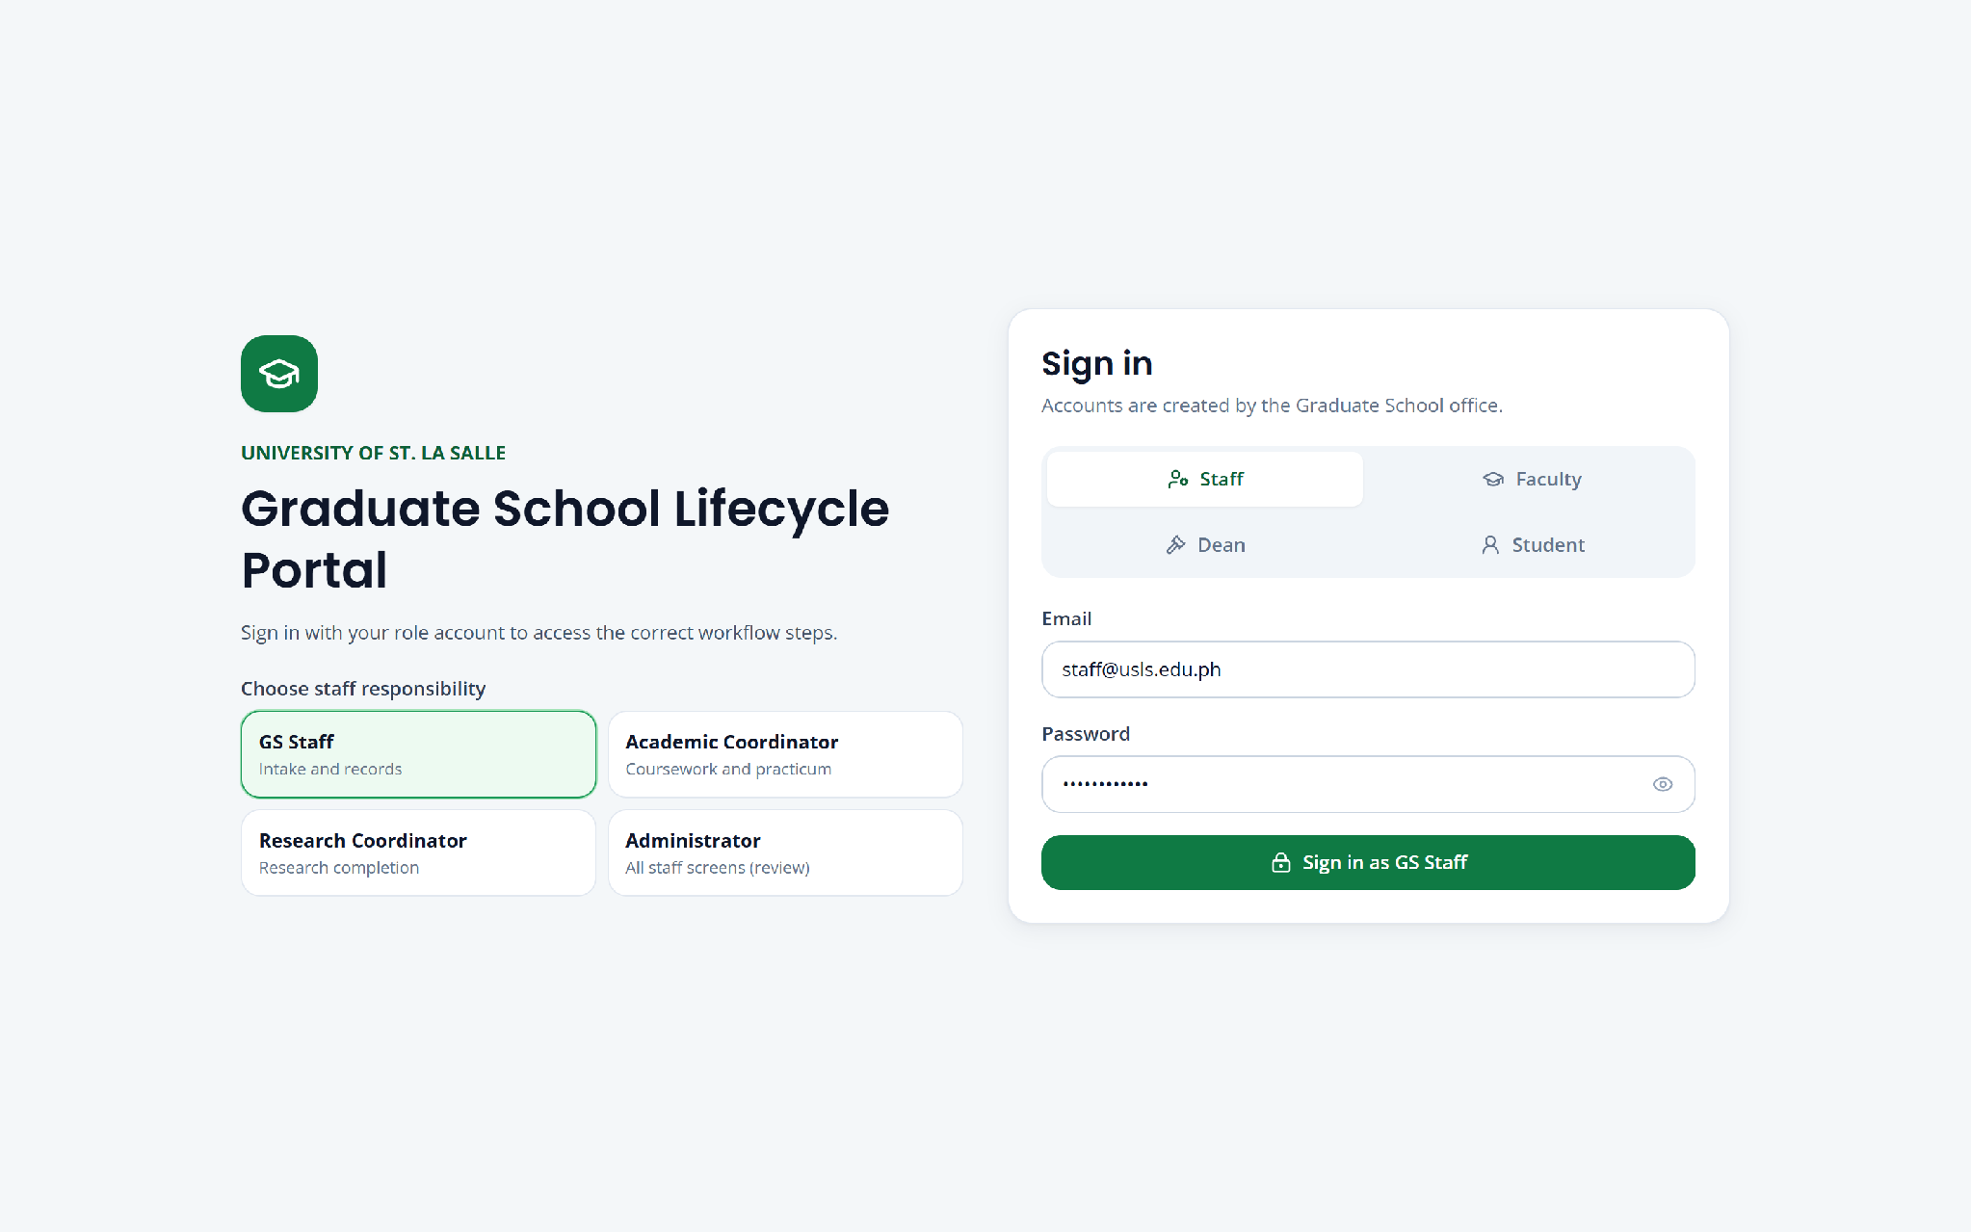

Figure 8. Login screen

5.10.2 Dashboard
The dashboard is the landing screen for staff roles. It states explicitly that every figure is computed from recorded transactions rather than entered. The headline counters give students monitored, students at risk or delayed, open tasks, and confirmed defenses, with secondary counters for active, on-leave, completed, and overdue. Below these, the lifecycle stage distribution shows where students currently sit, the risk panel breaks the cohort into On Track, At Risk of Delay, Delayed, and Not Yet Assessed, and further panels present students by college, research gate position, and defense scheduling outcomes. The open work queue by owner answers the question of who currently holds the next action. All panels respond to the program, progress, risk, standing, and owner filters at the top of the screen.
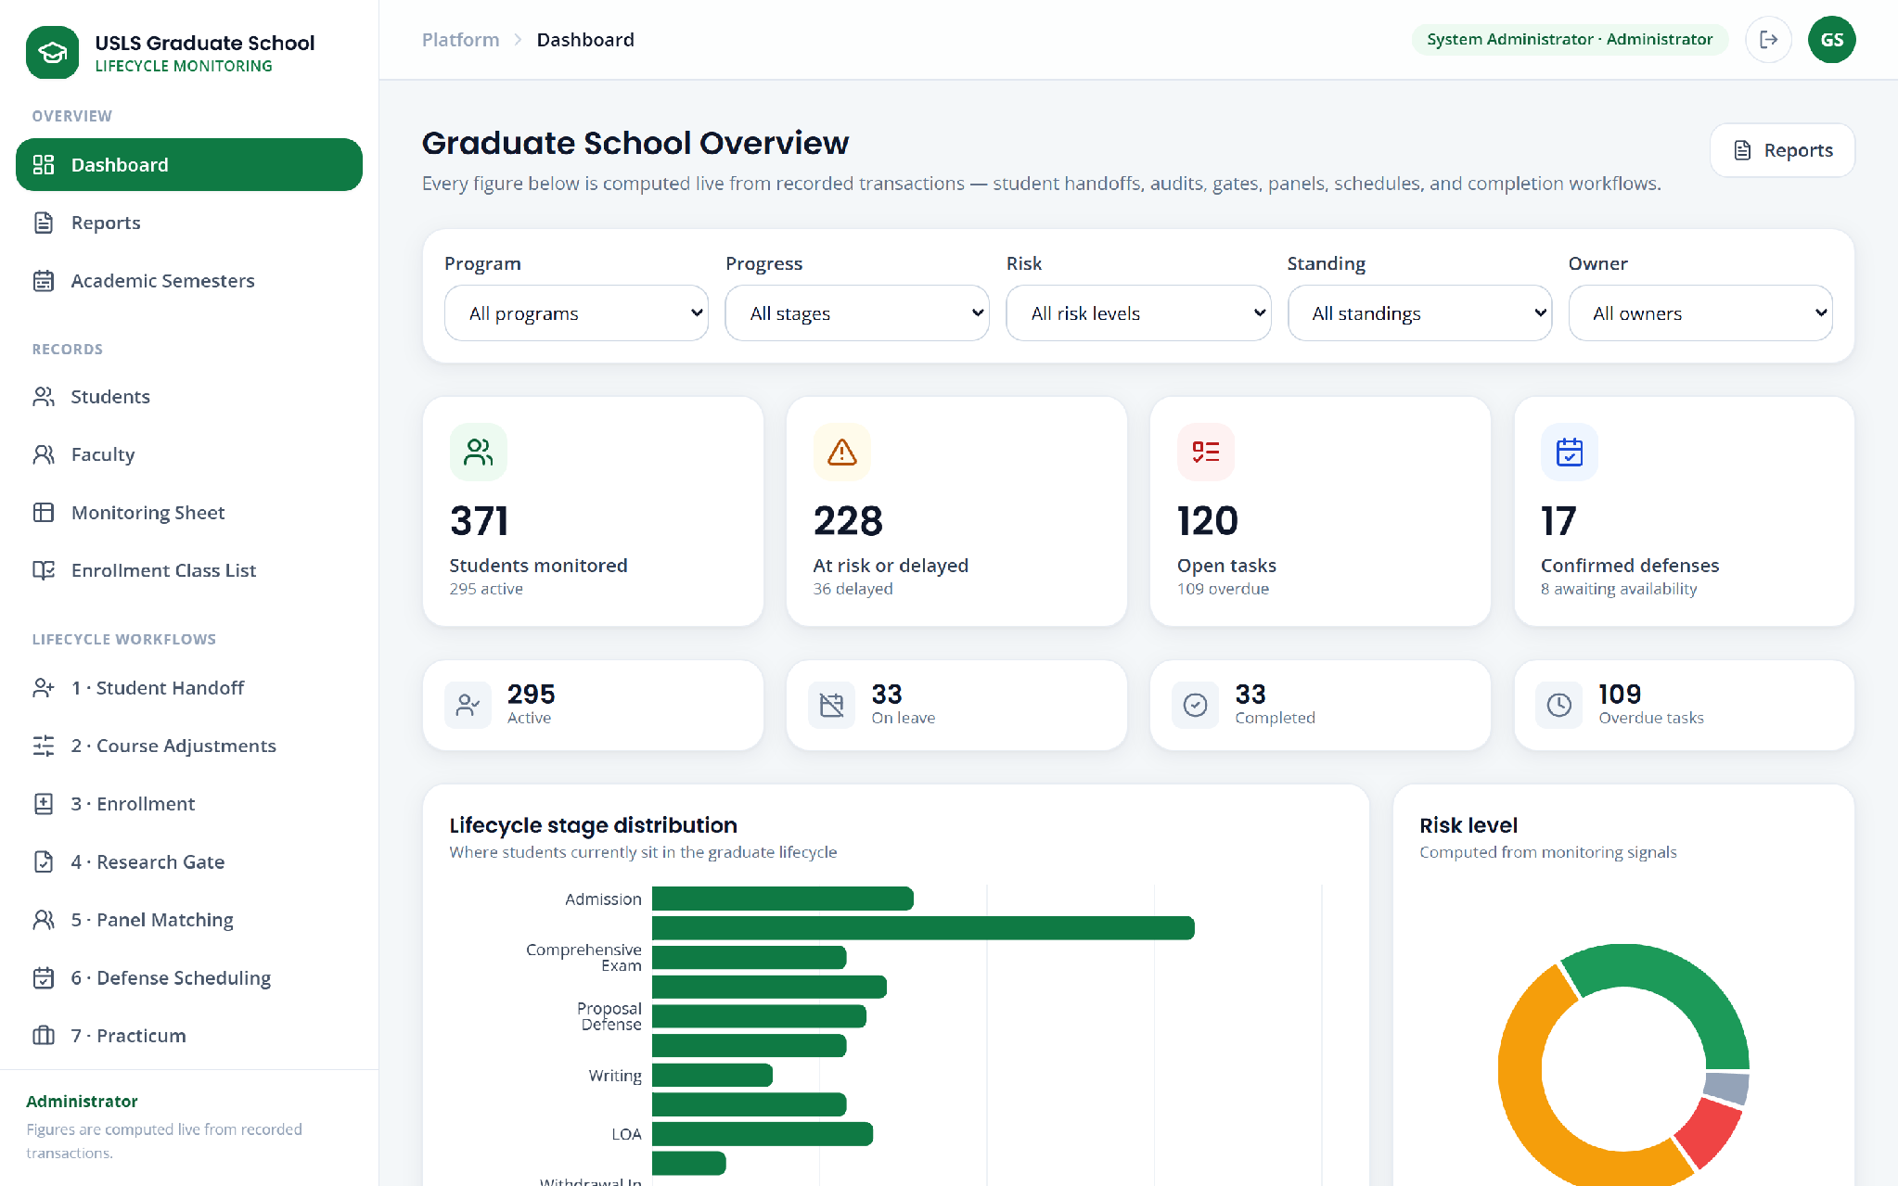

Figure 9. Graduate School overview dashboard

5.10.3 Monitoring Sheet
The monitoring sheet is the consolidated cohort view that the existing spreadsheet cannot provide. Each row is a student and each column group is a curriculum category—Basic, Major, and Cognate—with one column per subject. Cell shading encodes the controlled status vocabulary: officially completed, taken, enrolled, failed, dropped, and not taken. The screen carries an explicit read-only notice stating that enrollment, approved withdrawal, and verified source imports update the page automatically and that the Flag issue action records a discrepancy without changing the source value. Students carrying a standing condition are labelled inline, and an integrity banner reports enrollment and profile inconsistencies detected against the import. The view is filtered by program, academic year and semester, progress, risk, and enrollment state, and exports to CSV.
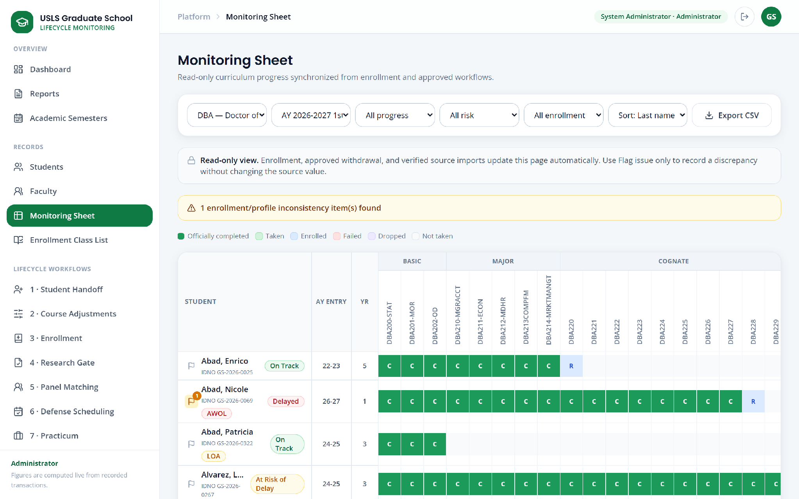

Figure 10. Monitoring sheet

5.10.4 Student Handoff
Student handoff is the point at which the monitoring workbook enters the system. It presents the import action, the history of previous uploads, and the validation issues detected in the imported file. There is no manual student creation on this screen: students exist only because they appeared in an import, which preserves the rule that student identity originates outside the Graduate School.
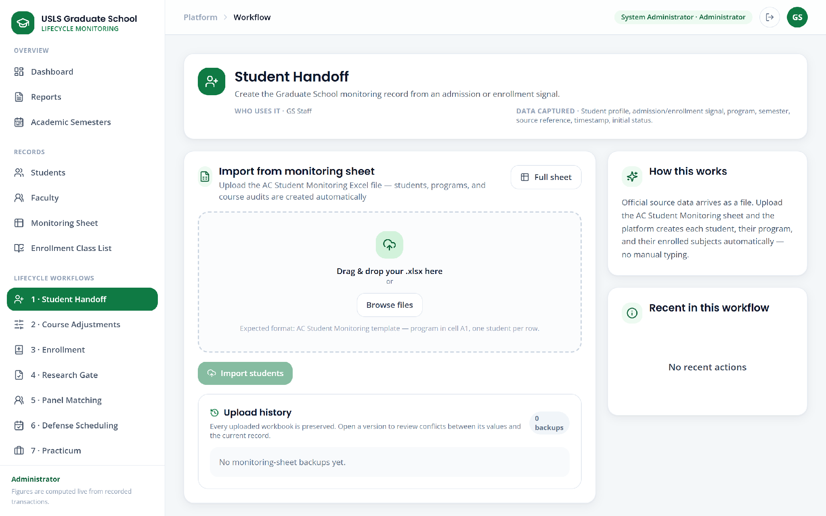

Figure 11. Student handoff

5.10.5 Course Adjustments
Course adjustments is where the demand basis for the coming term is established. The subject-needs report lists each subject with the number of students who still require it, and expands to show which students are affected and what delay results if the subject is not opened. Subject need is kept distinct from a proposed offering, an approved offering, and a scheduled class, so that evidence of demand is not mistaken for a decision to open a class.
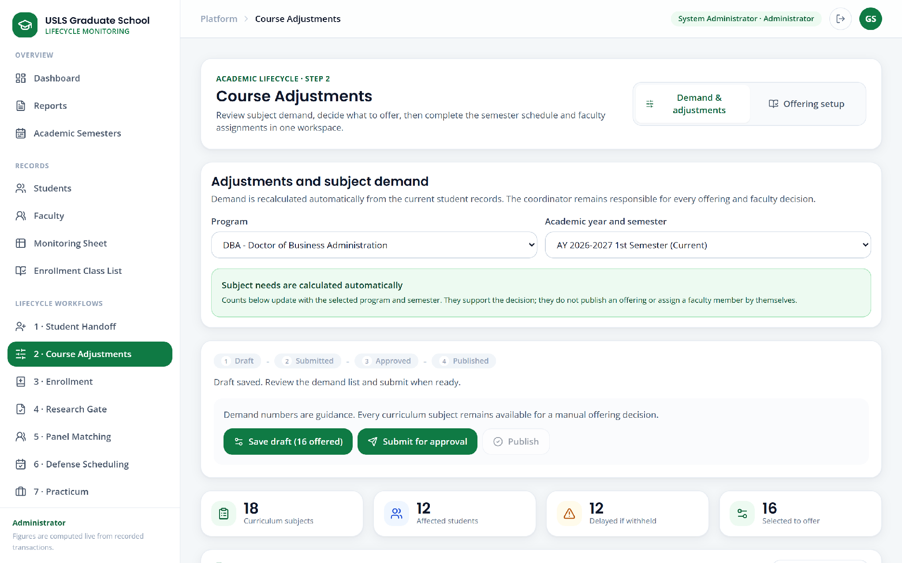

Figure 12. Course adjustments and subject needs

5.10.6 Course Offering Setup
Course offering setup is the declaration of what will actually be offered for a given academic year and semester. Each offering records the subject, the schedule, the section, and the faculty member assigned to handle it. The Academic Coordinator and the administrator may manage offerings; other staff roles see the list read-only. The published offering list is the authority against which enrollment tagging is validated.
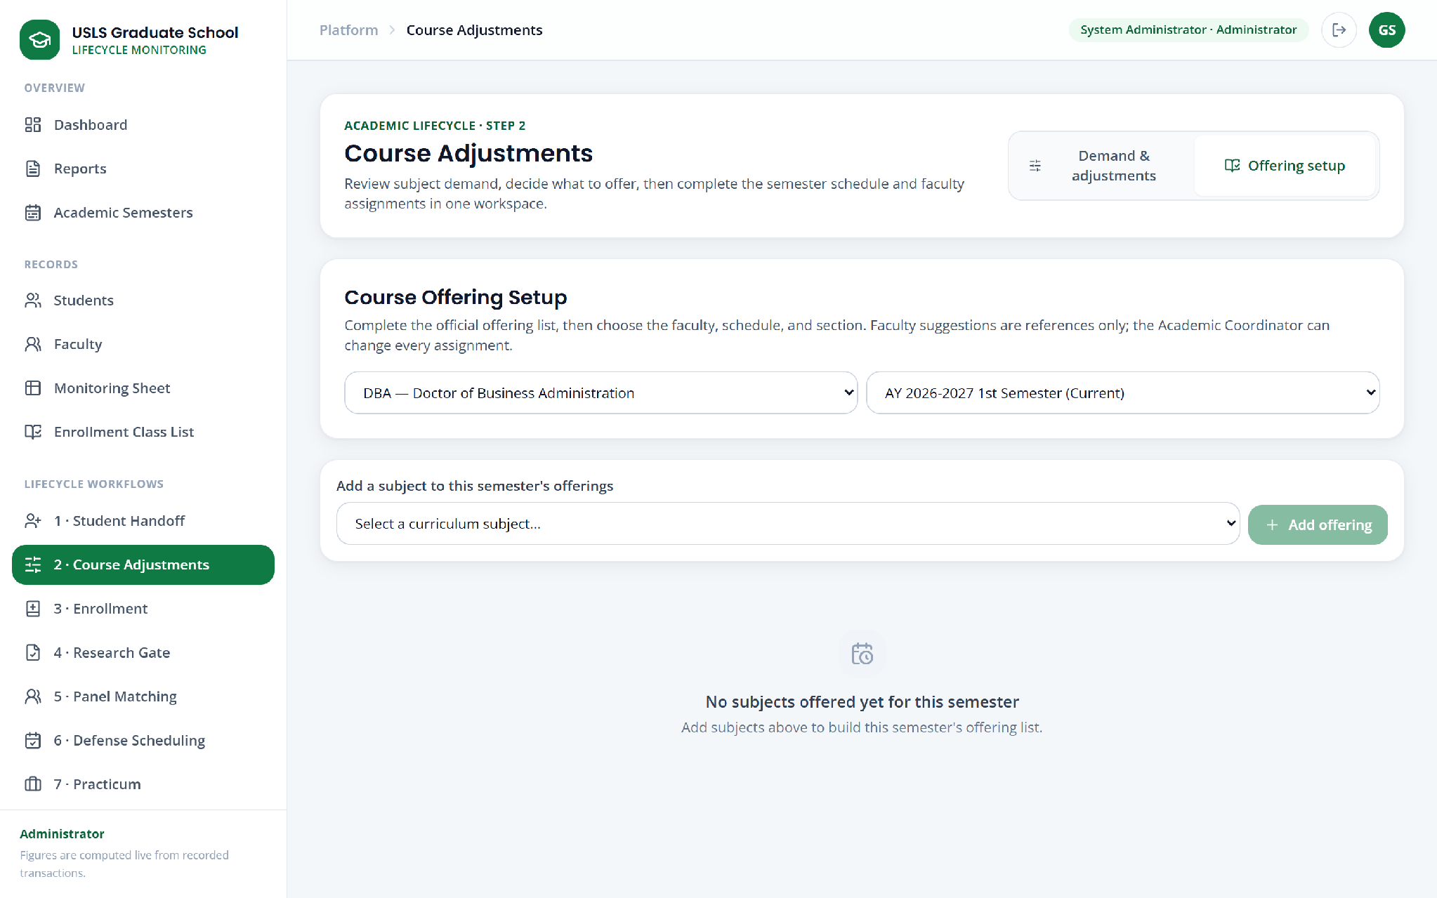

Figure 13. Course offering setup

5.10.7 Enrollment
Enrollment provides the two methods the client specified. A class list in CSV or Excel format may be uploaded, in which case the system previews the parsed rows, reports which students were matched and which rows could not be matched, and tags only the matched students. Alternatively a single student is searched for and tagged to a selected offered subject. In both cases the server validates that the subject is officially offered for the term before accepting the tag, and a subject that is not offered requires explicit resolution rather than being silently accepted.
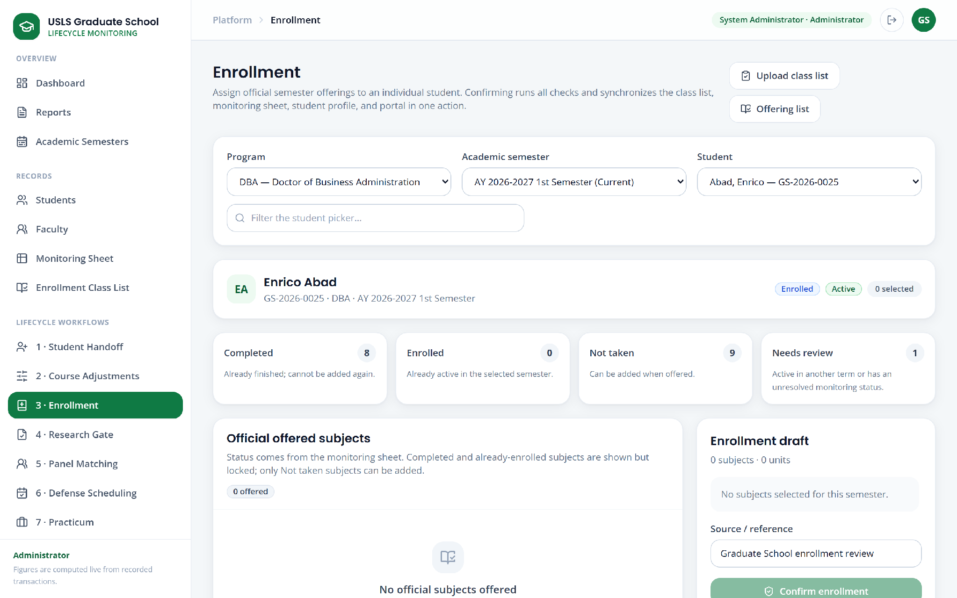

Figure 14. Enrollment

5.10.8 Enrollment Class List
The enrollment class list presents the consolidated list of students against subjects with the taken or not-taken state, in the same shape as the workbook the Graduate School already uses. The list is synchronized from enrollment and is read-only, so it reflects the enrollment ledger rather than being separately maintained.
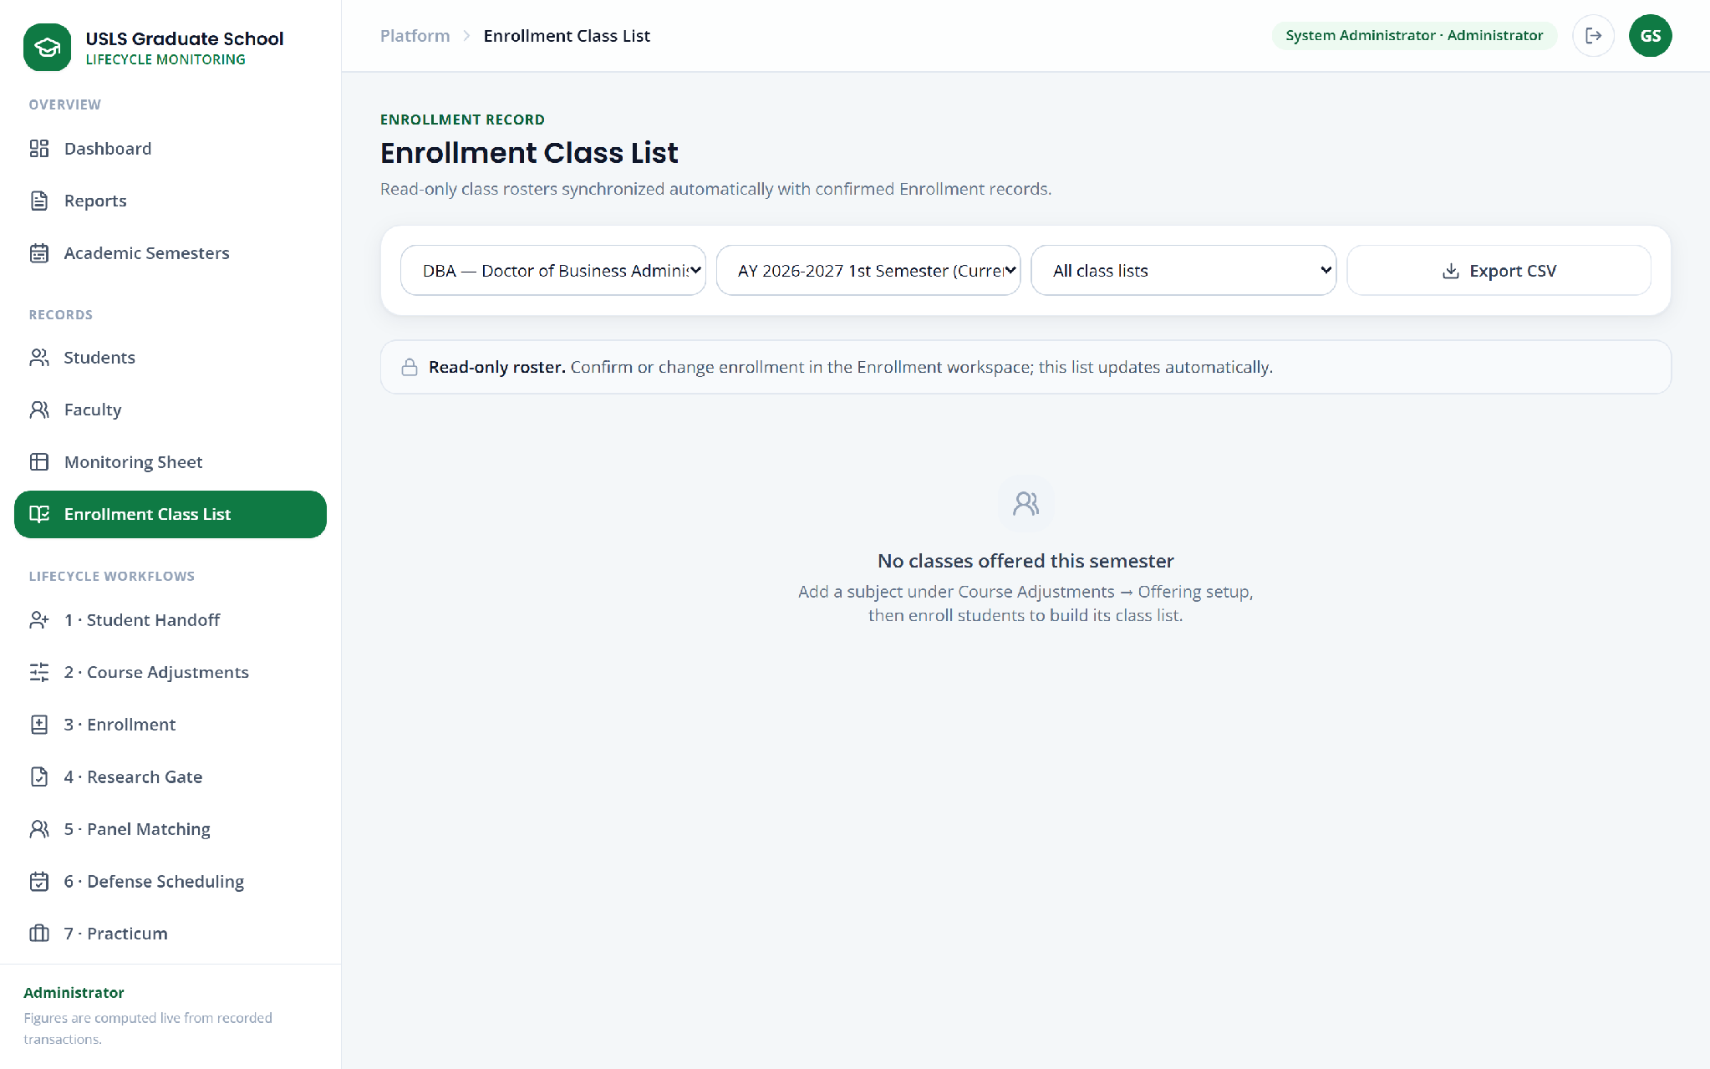

Figure 15. Enrollment class list

5.10.9 Research Gate
The research gate screen shows, for each student, the gate currently in progress and the documents that gate requires, together with which have been submitted and which are outstanding. Required documents are defined per gate across title defense, proposal defense readiness, ethics, final defense, and completion evidence.
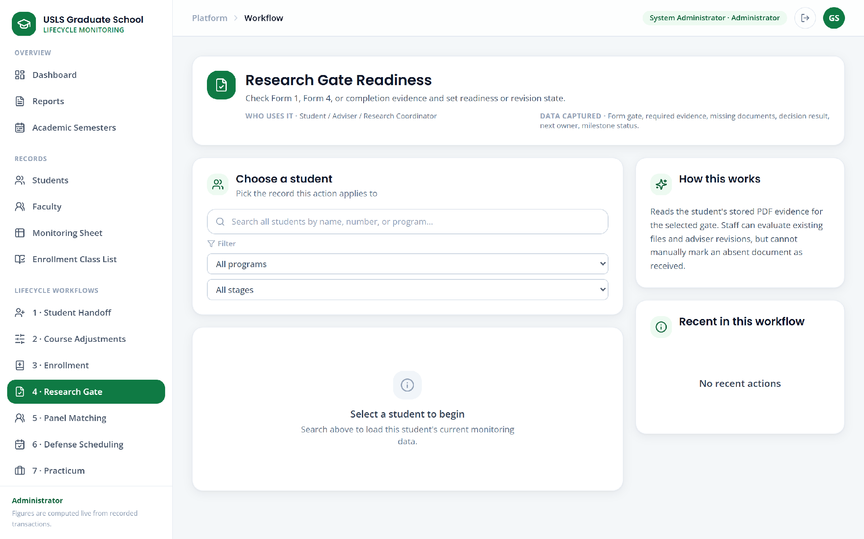

Figure 16. Research gate

5.10.10 Panel Matching
Panel matching produces a ranked shortlist of faculty for a student's defense panel, matching the research title against faculty specialization grounded in the faculty member's uploaded curriculum vitae. Each suggestion is accompanied by the reason for it and by the eligibility note for the panel role. The recommendation is advisory until the coordinator makes the selection.
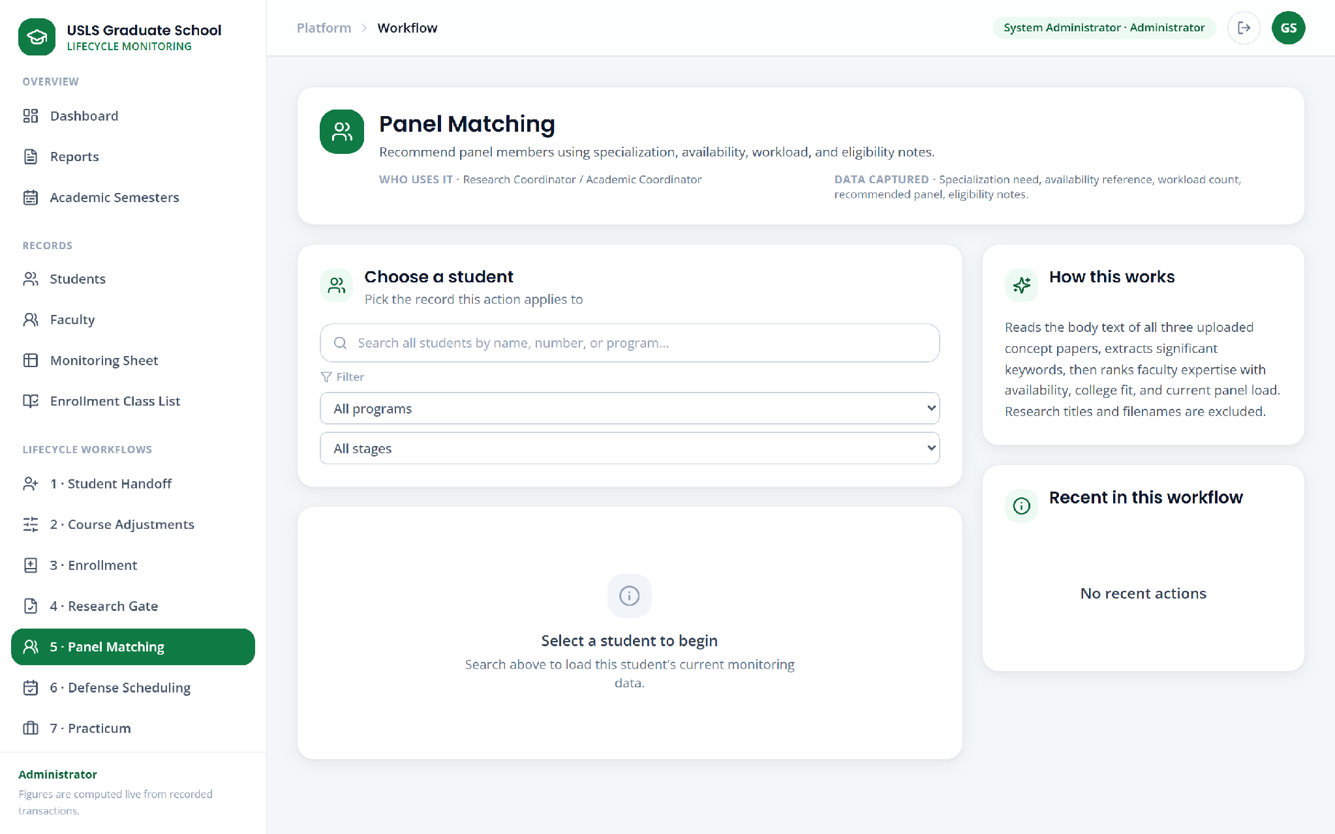

Figure 17. Panel matching

5.10.11 Defense Scheduling
Defense scheduling proposes slots at which the student and every panel member are simultaneously available, drawing availability from recurring faculty working hours and from connected faculty calendars where those exist. Proposals begin only after the required lead time. Where availability cannot be established the screen reports that it cannot confirm a slot rather than proposing one, and the reason for the conflict is recorded against the request.
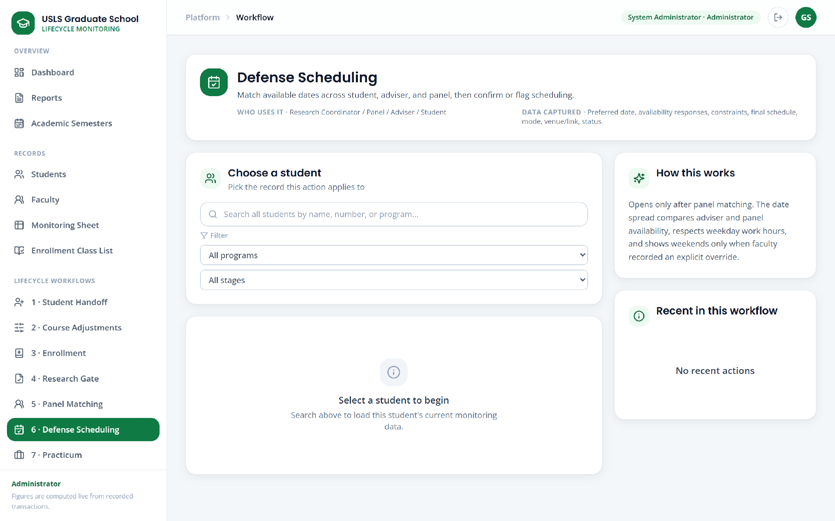

Figure 18. Defense scheduling

5.10.12 Practicum
The practicum screen is restricted to the programs that require a practicum. It shows the memorandum of agreement status, the practicum site and supervisor, the required hours against the hours evidenced, and the certificates submitted. Where hours were completed at more than one establishment the certificates accumulate and the hours total across them; a shortfall against the requirement is surfaced for staff attention rather than left to manual inspection.
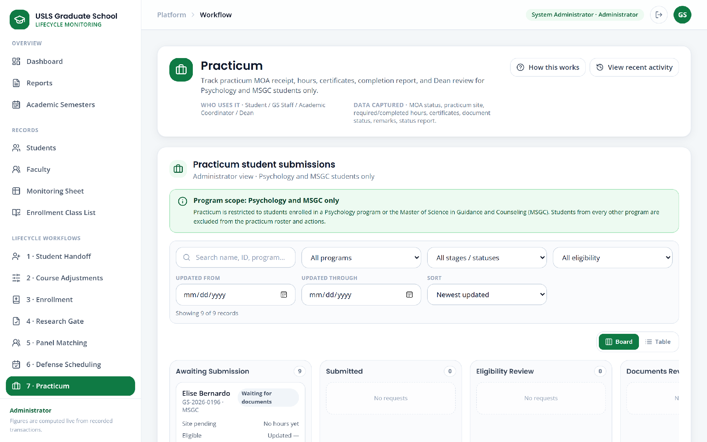

Figure 19. Practicum monitoring

5.10.13 Graduation
The graduation screen lists candidates for a review window with the eligibility check resolved into coursework, research, and practicum components, naming precisely what is outstanding where a candidate is not yet eligible. Candidates are processed in batches, each reviewing role acts in sequence, incomplete cases are returned for resubmission, and the Dean approves the endorsement. On approval the endorsed list is prepared for export.
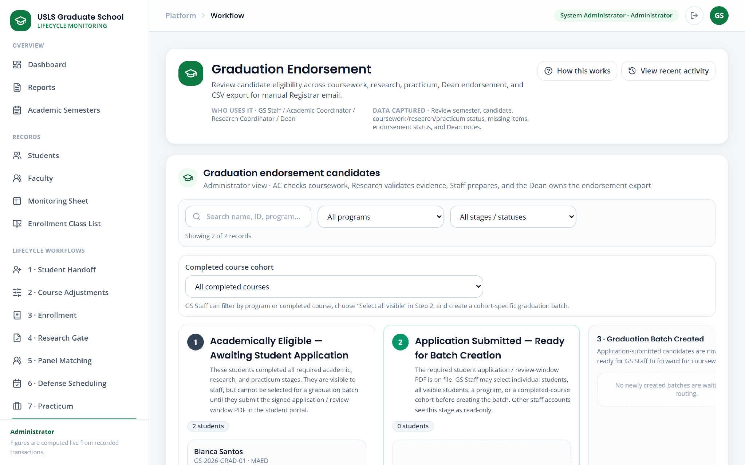

Figure 20. Graduation endorsement

5.10.14 Leave of Absence
The leave of absence screen presents structured applications and the rule checks applied to them: the permitted reasons, the number of prior leaves, the allowed duration, and the requirement that the effective period be a term that has not already begun. Staff review precedes the Dean's decision, which may be an approval or a return for revision, and a pending application may be withdrawn by the student. On approval the screen offers the generated document conveying the decision to the Registrar.
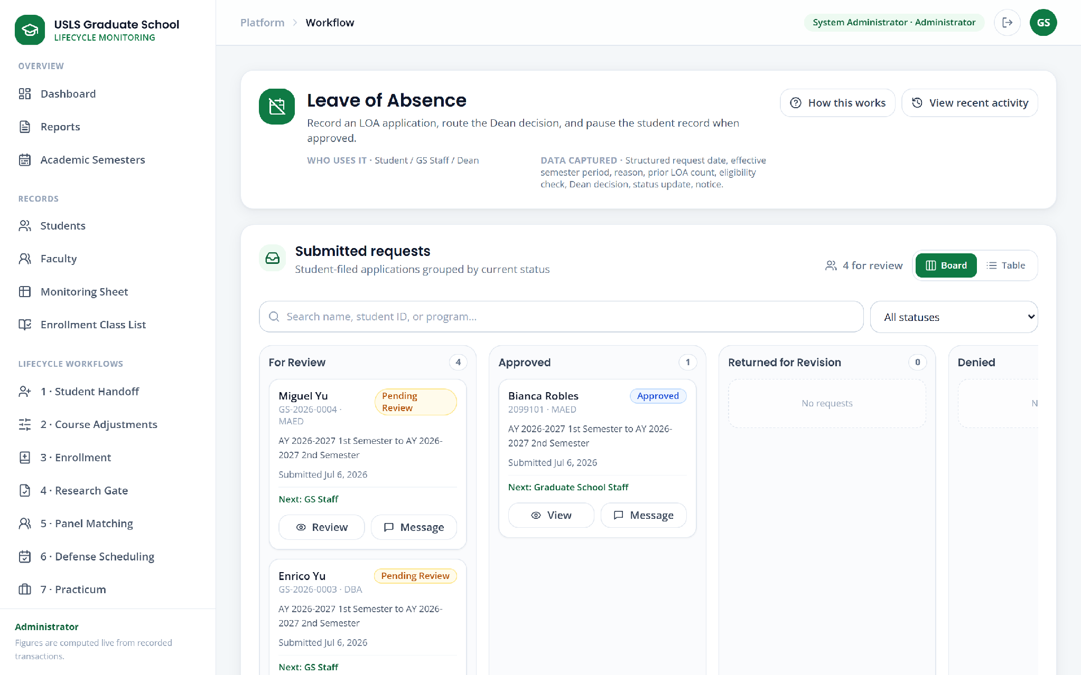

Figure 21. Leave of absence

5.10.15 Readmission
Readmission follows the same structured pattern as leave of absence. Applications that require review are routed to the Dean rather than resolved automatically, and the approved decision produces the corresponding Registrar document.
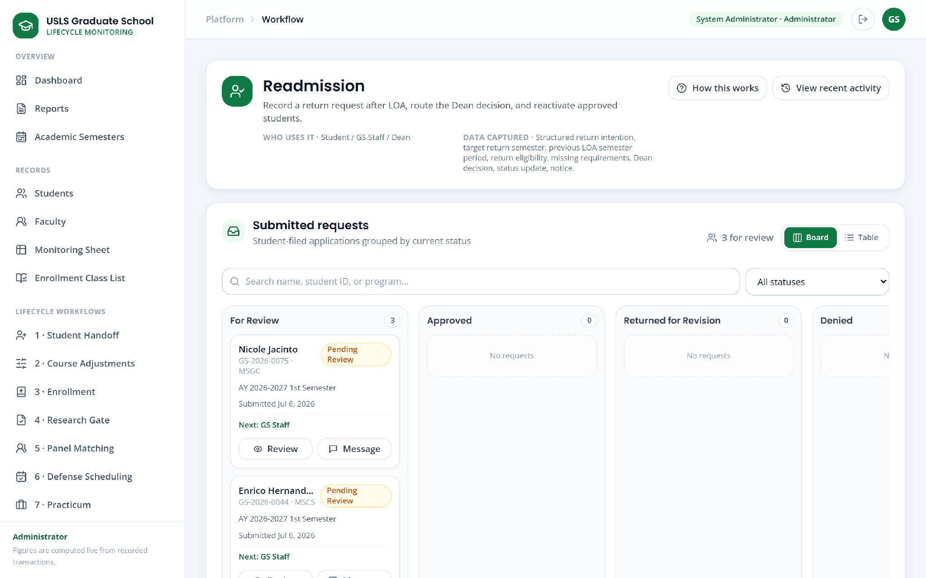

Figure 22. Readmission

5.10.16 AWOL and Residency
This screen combines the monitoring of students absent without leave with residency tracking. Automatic policy alerts are raised for review rather than acted on automatically. A return from AWOL is policy-reviewed and decided by the Dean, and an absolute limit on absence requires re-enrollment rather than a simple return. Residency is derived from the recorded entry year rather than counted by hand.
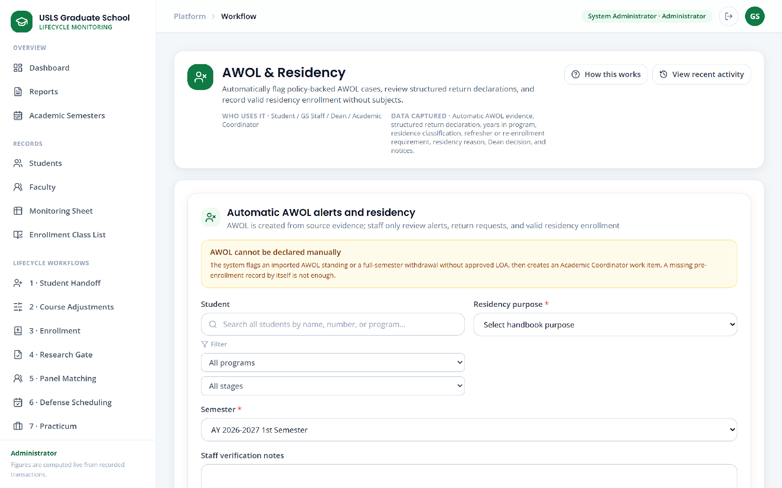

Figure 23. AWOL and residency

5.10.17 Withdrawal Requests
The withdrawal screen states the process on its face: penalty-free subject withdrawals filed before classes or during the first week, handed to the Registrar as an approved list. The stated sequence is student request, Graduate School staff, Dean, staff tagging of the subject, Excel export, and manual Registrar email, with approved withdrawals carrying no academic grade or penalty. Requests are presented on a board by stage—Submitted, Dean Review, Returned for Clarification, and Subject Tagging—and each card names the specific subject pending withdrawal. This screen is the operative statement of the subject-level definition discussed in Section 4.2.5.7.
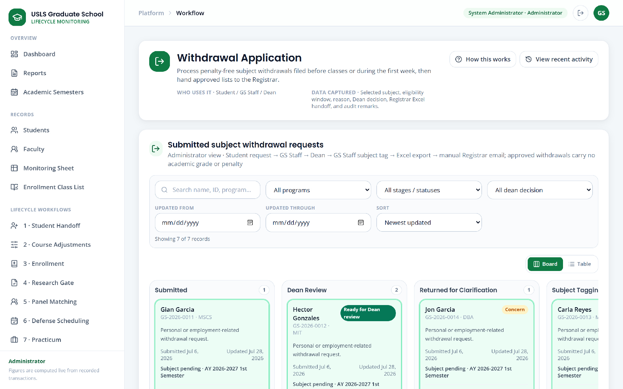

Figure 24. Subject withdrawal

5.10.18 Work Queue
The work queue lists open tasks with the role that owns the next action and the time the task has been outstanding, which is the mechanism by which delay becomes visible before it is reported.
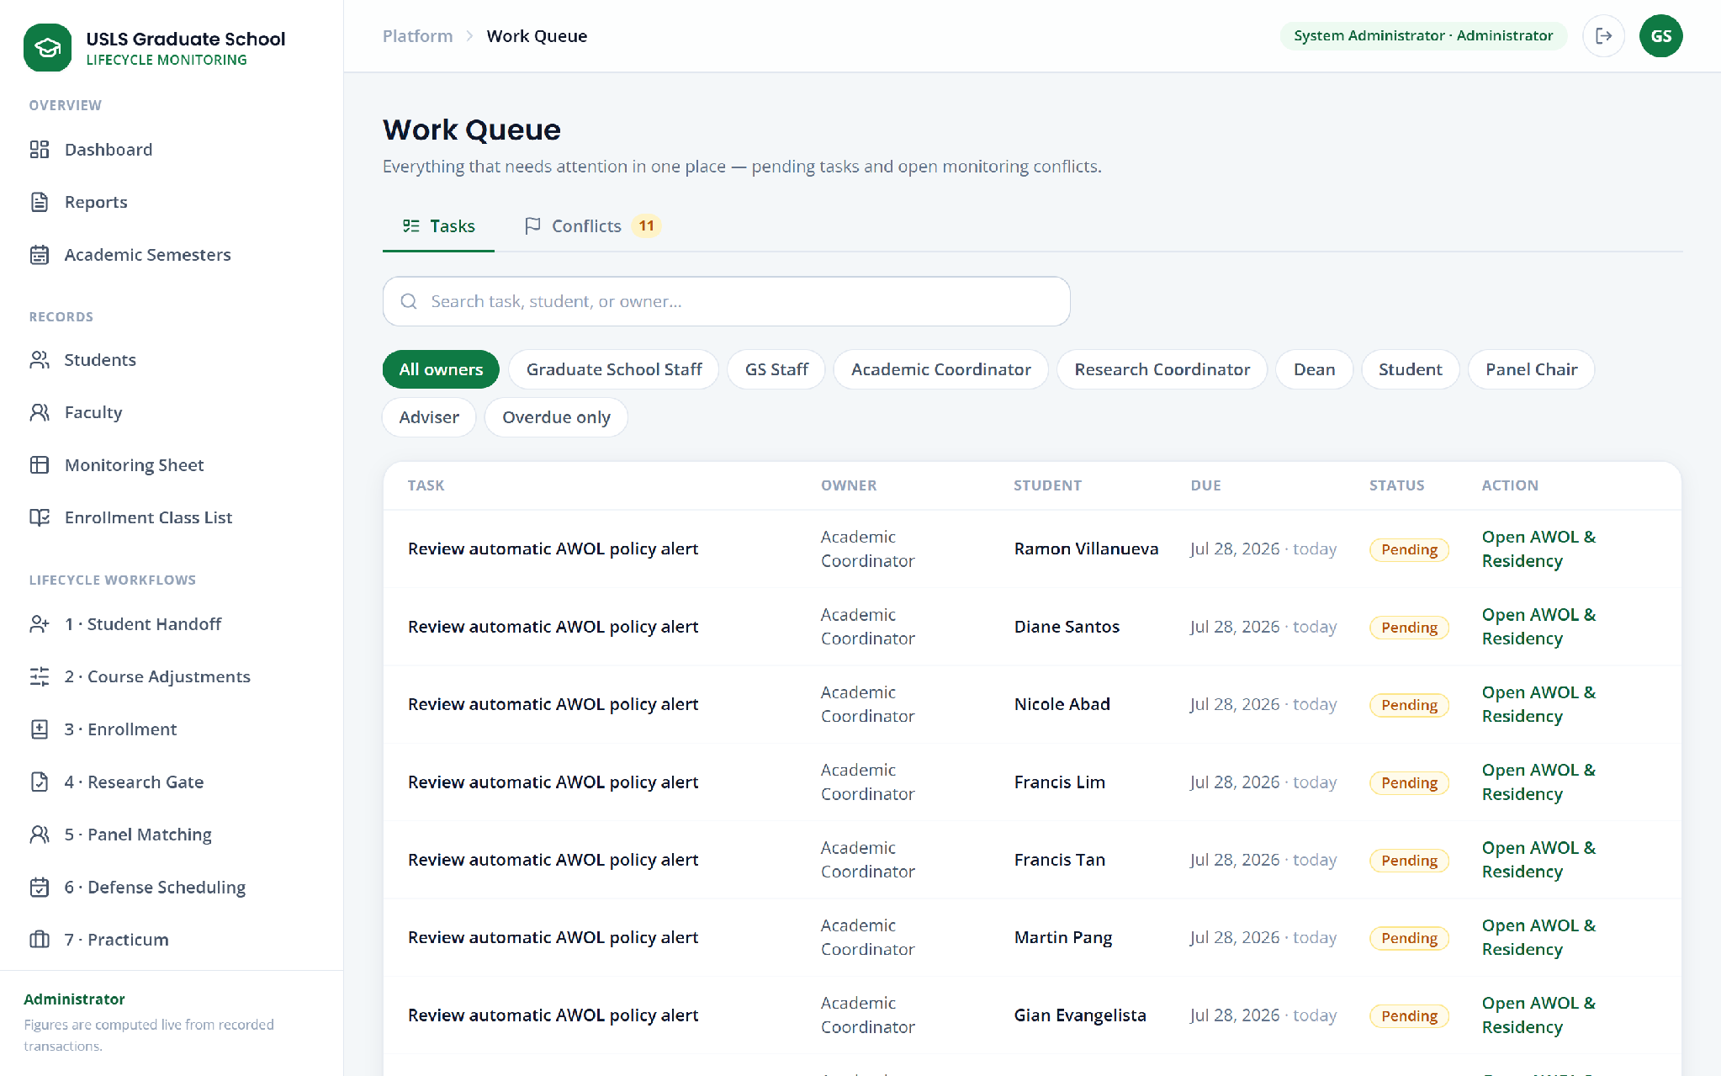

Figure 25. Work queue

5.10.19 Activity Log
The activity log presents the transaction record of consequential actions, showing the actor, the role under which the action was taken, the process concerned, and the nature of the action. It is the audit surface for the status changes and decisions recorded elsewhere in the system.
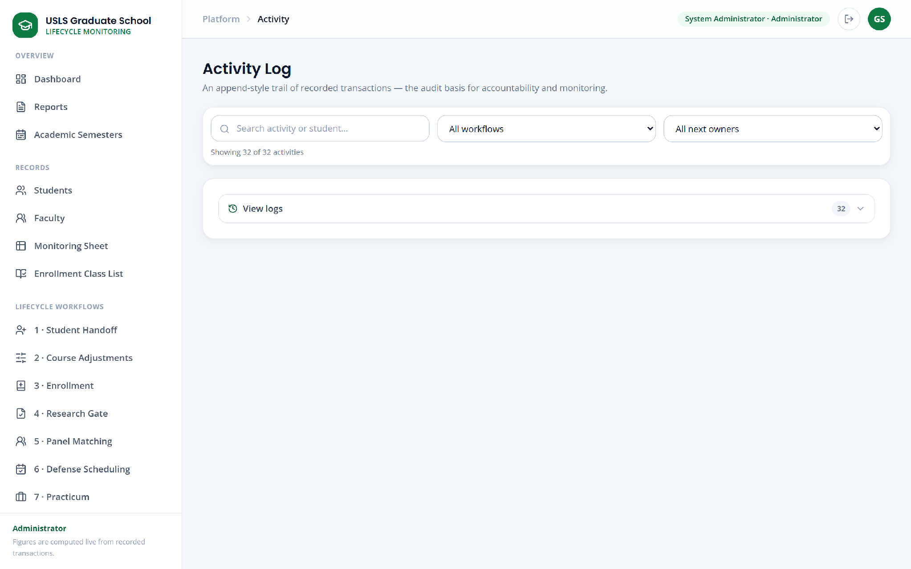

Figure 26. Activity log

5.10.20 Recommendations
The recommendations screen presents rule-based prompts derived from recorded events and timestamps. Each recommendation is explainable: it states the data used and the reasoning applied, and identifies the human decision-maker, since the system prompts but does not decide.
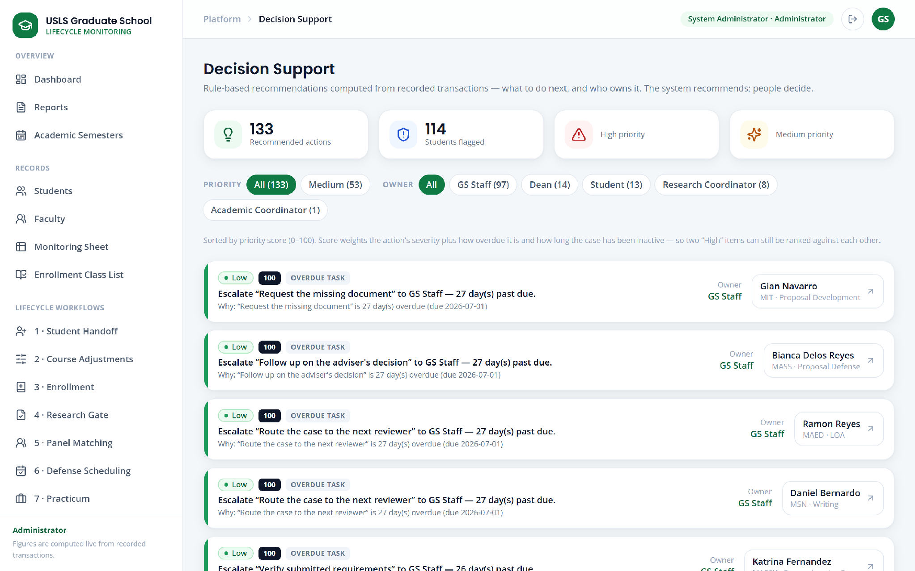

Figure 27. Recommendations

5.10.21 Policy Assistant
The policy assistant answers policy questions from indexed Graduate School documents using retrieval-augmented generation. Questions that are in substance requests for operational figures are routed to the verified reports rather than answered by generation, and access is scoped by role so that a student cannot obtain staff-only information through it.
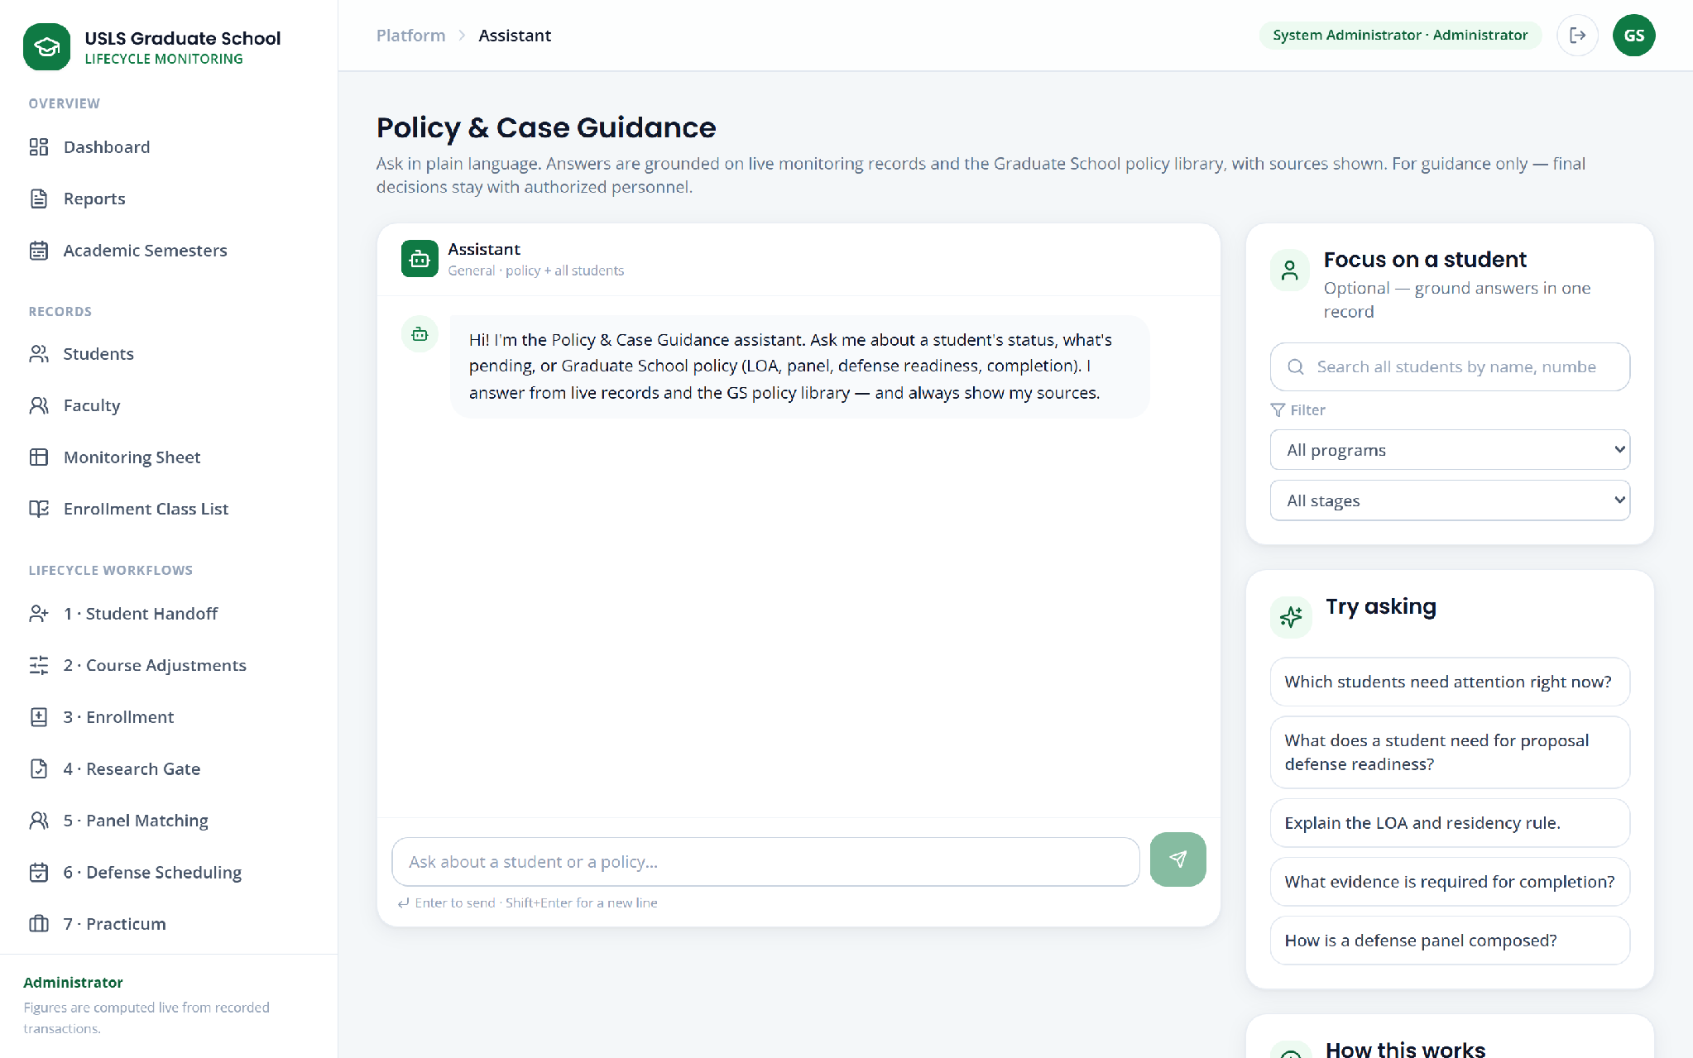

Figure 28. Policy assistant

5.10.22 Reports
The reports screen presents the ten report views described in Section 5.11, each filtered by program, progress, risk, standing, and workflow, with the record count shown against each report so the size of the result is visible before it is opened.
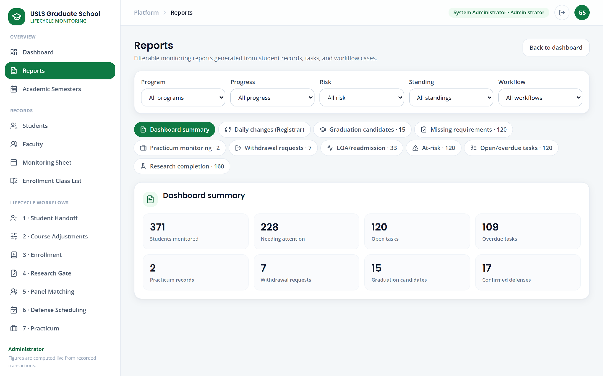

Figure 29. Reports

5.10.23 Students and Student Detail
The students list presents every monitored student with program, stage, standing, and risk. The student detail screen consolidates one student's record: profile, curriculum progress, enrollment, research case and milestones, practicum where applicable, standing history, tasks, and the transaction history for that student. It is the screen that answers, in one place, the question that the existing setup requires several sources to answer.
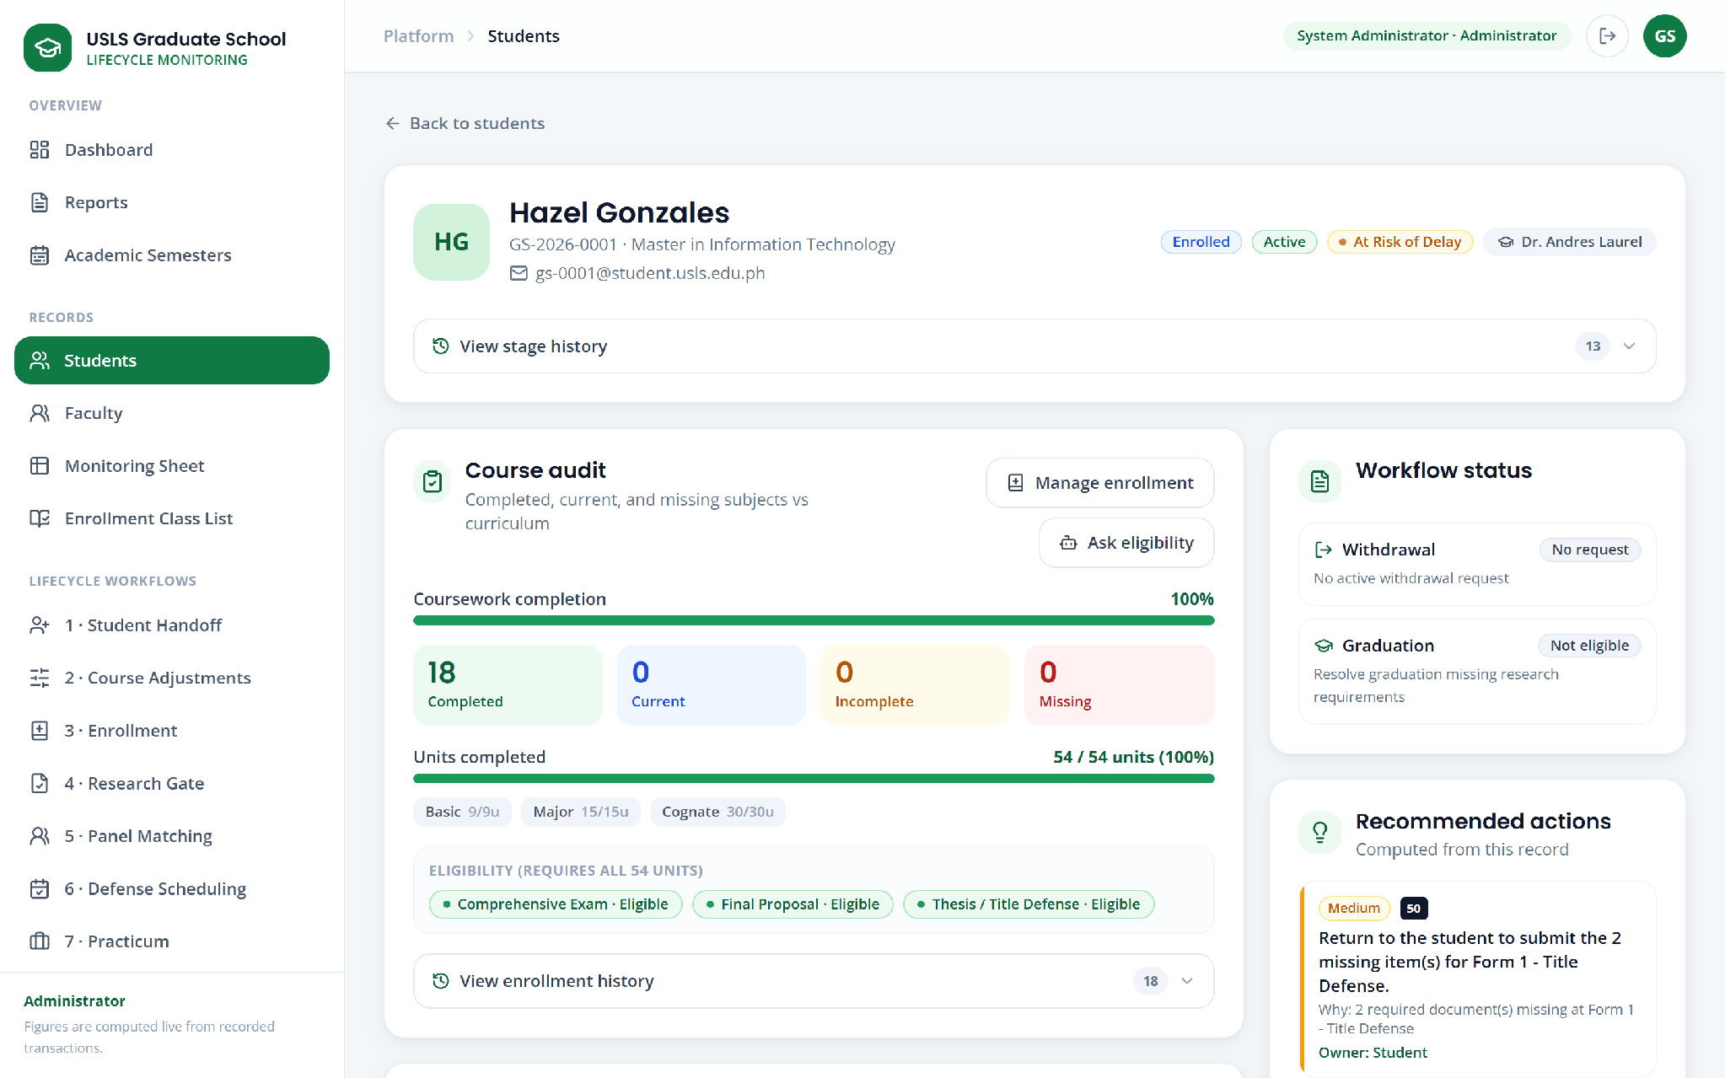

Figure 30. Student detail

5.10.24 Faculty
The faculty screen holds the faculty roster with college, institutional role, declared specialization, and the panel roles for which each member is eligible. It is the source against which panel matching and offering assignment operate.
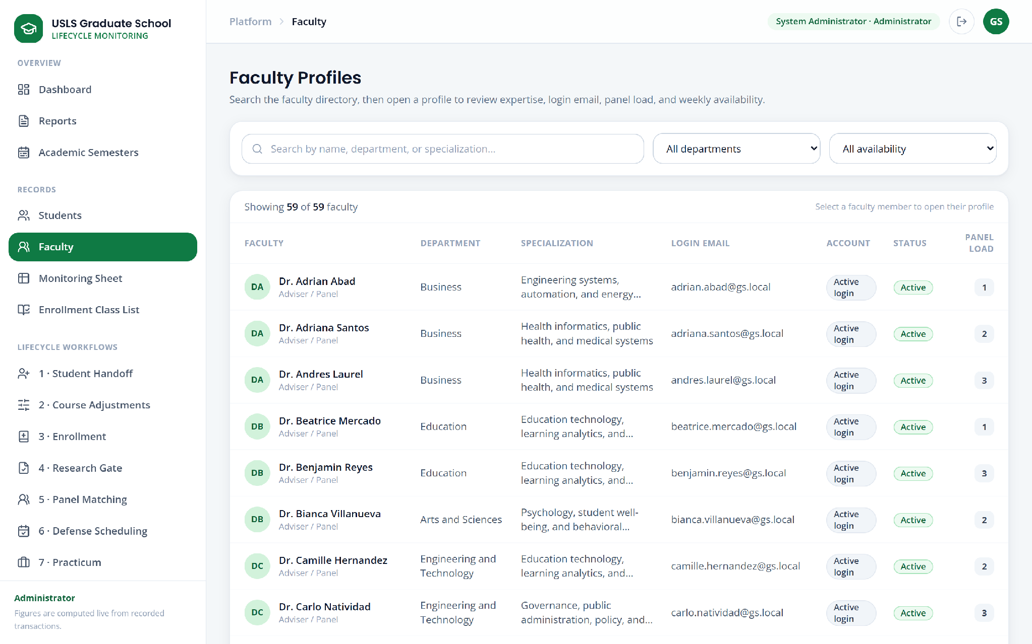

Figure 31. Faculty records

5.10.25 Academic Semesters
Academic semester settings define the terms the system operates against, including the active planning term and the planning window. Removing a semester preserves the history that references it rather than deleting dependent records.
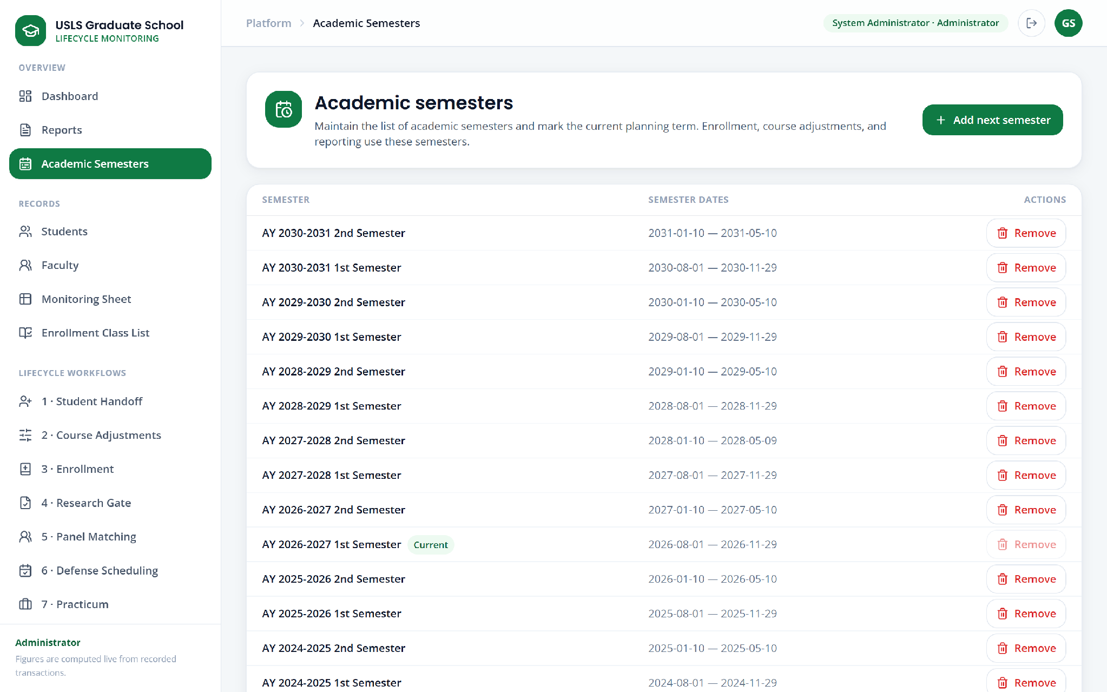

Figure 32. Academic semester settings

5.10.26 Dean Approvals
The Dean signs in to a dedicated portal presenting the decisions awaiting action across every process—leave of absence, readmission, return from AWOL, subject withdrawal, and graduation endorsement—rather than requiring the Dean to visit each workflow screen separately.
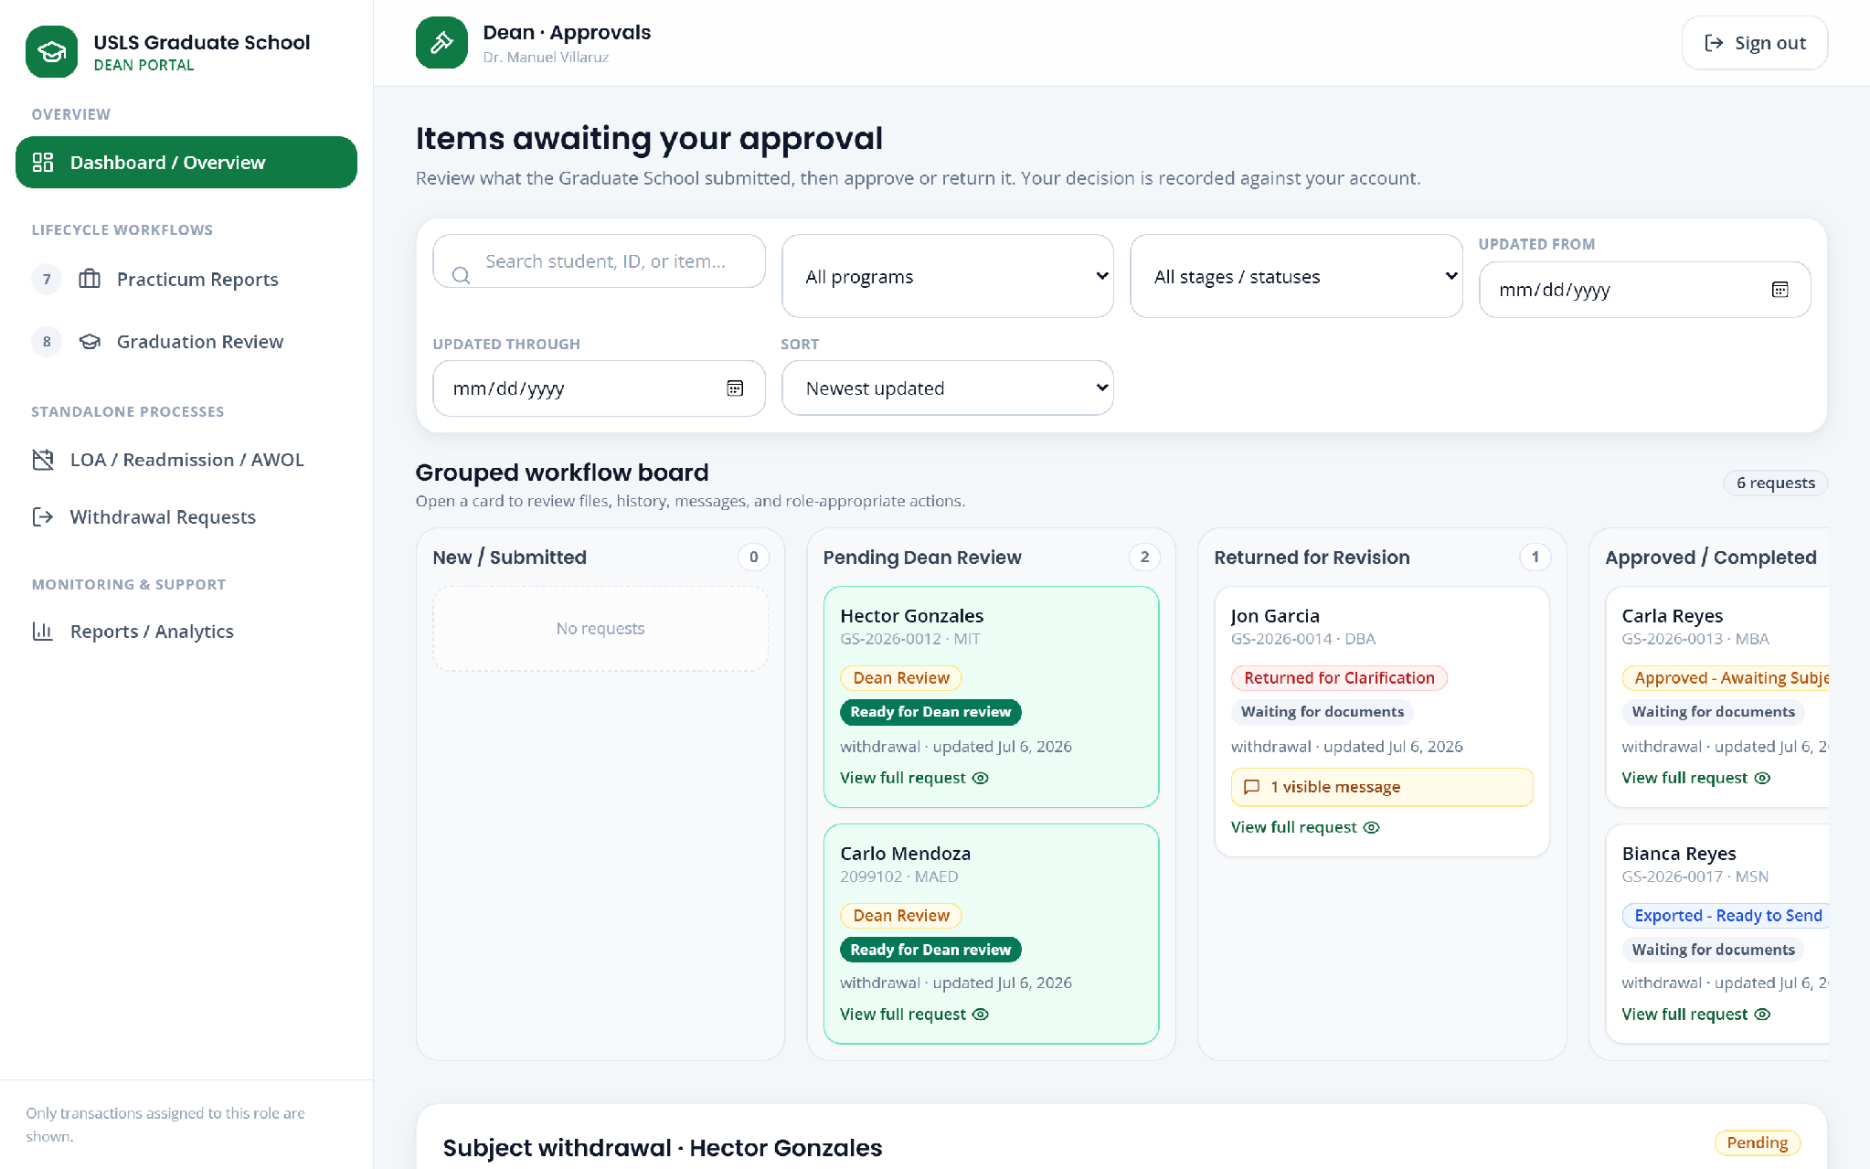

Figure 33. Dean approvals queue

5.10.27 Student Portal
The student portal presents the student's own lifecycle status, outstanding requirements, submitted requests and their state, and messages. Structured applications for leave of absence, readmission, return from AWOL, subject withdrawal, practicum, graduation, research gate submissions, and defense scheduling are filed here, with the eligibility rules checked at the point of submission so that an application that cannot succeed does not enter the queue. Internal staff messages are not exposed to the student.
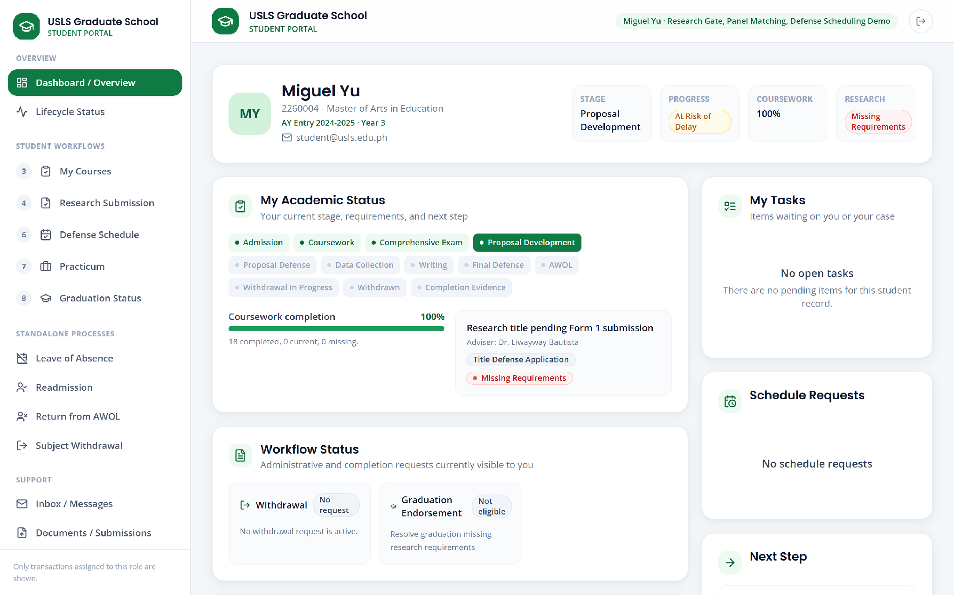

Figure 34. Student portal

5.10.28 Faculty Portal
The faculty portal presents the assignments belonging to the signed-in faculty member: advisees, research documents awaiting adviser approval, defense panels and verdicts, and the optional connection of that faculty member's own calendar for availability. The authorization flow permits a faculty member to connect only that faculty member's own account.
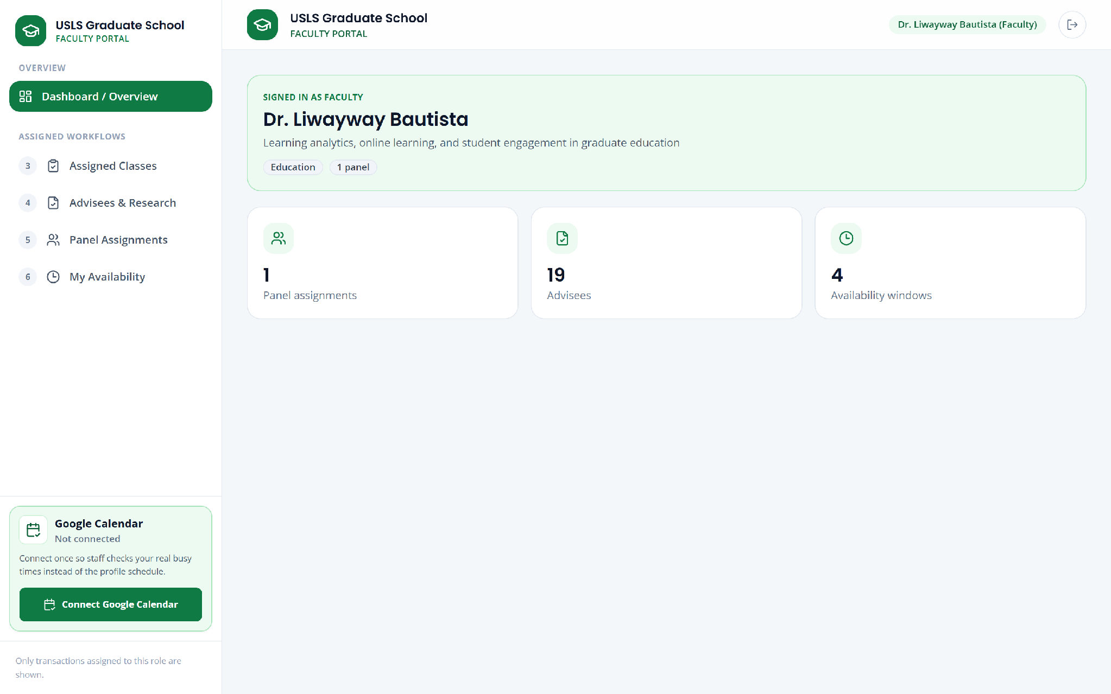

Figure 35. Faculty portal

5.10.29 Role-Scoped Views
The same screens present different navigation depending on the signed-in role. The Academic Coordinator sees records, enrollment, course adjustments, research gate, panel matching, practicum, graduation, AWOL, reports, and the work queue, but not the administrative screens. The Research Coordinator sees only the research gate, graduation, and the work queue. This restriction is applied by the server, not only by the navigation.
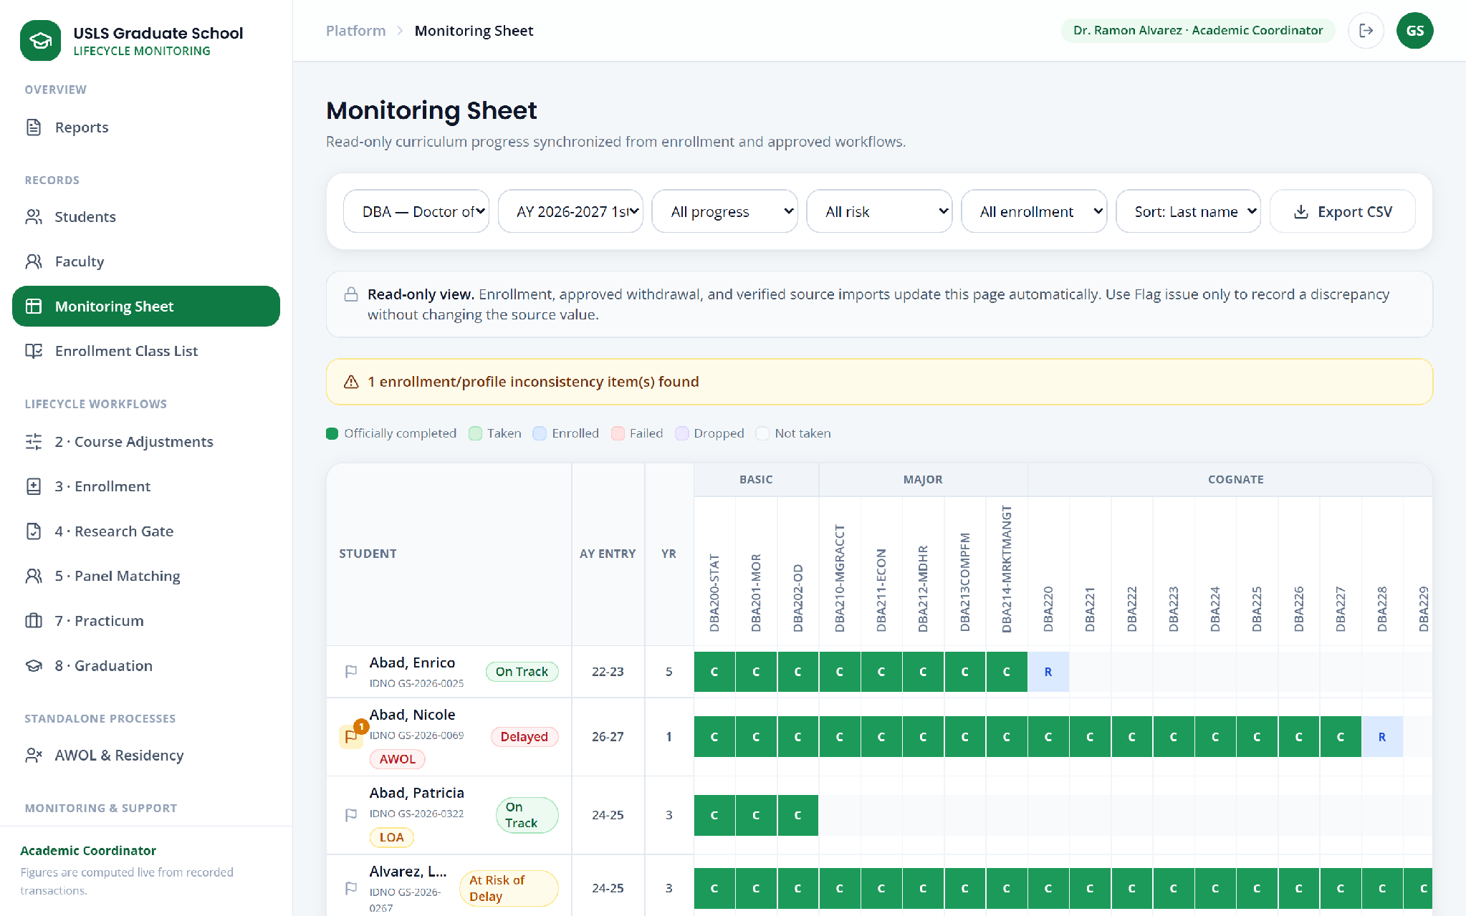

Figure 36. Academic Coordinator view of the monitoring sheet

5.11 Report Specifications
The system generates ten report views and four export documents. The counts shown against each report in the following table are those observed in the seeded demonstration dataset of 371 students and are given to indicate the shape of the output, not as institutional figures.

Table 24. Report specifications
Report | Purpose | Observed count
Dashboard summary | Headline monitoring figures: students monitored, needing attention, open and overdue tasks, practicum records, withdrawal requests, graduation candidates, confirmed defenses. | 371 students
Daily changes (Registrar) | Changes recorded on a given date that are relevant to the Registrar, with a mark-reflected action to record that a change has been carried across. | By date
Graduation candidates | Students eligible or under review for graduation in the review window, with the outstanding requirement named where a candidate is not yet eligible. | 15
Missing requirements | Students with outstanding coursework, research, or practicum requirements. | 120
Practicum monitoring | Practicum records with hours evidenced against hours required and the document state. | 2
Withdrawal requests | Subject withdrawal applications by stage and Dean decision. | 7
LOA / readmission | Leave of absence and readmission cases with standing and decision state. | 33
At-risk | Students flagged At Risk of Delay or Delayed by the risk indicator. | 120
Open / overdue tasks | Open work items with the owning role and time outstanding. | 120 open, 109 overdue
Research completion | Research cases by gate and completion state. | 160

5.11.1 Generated Documents and Exports
Four documents are generated for conveyance outside the system. In every case the system prepares the file and records that it has done so; it does not transmit the file and does not represent it as received.

Table 25. Generated documents and exports
Document | Produced by | Content and boundary
Approved withdrawal list (Excel) | Withdrawal module on Dean approval | The approved subject withdrawals for conveyance to the Registrar. The state remains pending confirmation until the Registrar's implementation is recorded.
Graduation endorsement list (CSV) | Graduation module on Dean approval | The Dean-approved endorsed candidates. The system states explicitly that no message has been sent and that the file must be sent through the official external channel.
Standing-change Registrar report | Leave of absence, readmission, AWOL, and residency modules on decision | The document conveying the approved standing change, with the generation, sending, and confirmation timestamps held against the case.
Monitoring sheet export (CSV) | Monitoring sheet, on demand | The filtered consolidated cohort view, for use in reporting and planning.

This boundary is deliberate and is the corrected position discussed in Section 4.2.5.8. The system does not claim that a document has been transmitted to or acknowledged by the Registrar, because no mechanism for either exists. Recording the Registrar's confirmation is carried as remaining work; the data model already provides the fields to hold it.

5.12 System Architecture
The system follows a three-tier architecture. The presentation tier is a React single-page application built by Vite and served as static assets. It holds no business rules; every decision it displays has been made on the server. The application tier is a Flask server exposing a JSON API over 119 routes, which performs authentication, authorization, rule validation, workflow transitions, import parsing, document generation, and transaction logging. The data tier is a relational database of 35 tables accessed through SQLAlchemy, together with a file store for uploaded attachments and imported workbooks.
Two architectural rules follow from the requirements in Chapter 4. First, authorization is enforced in the application tier: the presentation tier hides controls a role may not use, but the server independently refuses the corresponding request, so a disabled button is never the only protection. Second, the boundary with AIMS is a file boundary. The application tier parses an imported workbook into read-only official values and records the import; there is no live connection, and no path exists by which a locally maintained value can be presented as an official one.
The retrieval-augmented policy assistant sits alongside the application tier. Policy documents are indexed, a question retrieves the relevant passages, and the answer is generated against those passages. Where retrieval fails the assistant falls back rather than generating unsupported text, and where a question is really a request for an operational figure it is routed to the verified reports. The architecture of the assistant is presented as Figure 6 in Section 3.2.5.5 and in Appendix P.

5.13 Infrastructure

5.13.1 Front End
The front end is React 18 built with Vite 5 and styled with Tailwind CSS 3. It is compiled to static assets and served by the application server, so the deployment is a single process rather than two. Routing is client-side, with role-gated routes that redirect an unauthorized user rather than rendering a screen that the server would refuse to populate.

5.13.2 Back End
The back end is Python 3 with Flask 3.0.3 and Flask-SQLAlchemy 3.1.1. Schema migrations are applied at application startup, before the rest of the startup sequence runs, so that a schema change is present before any code depends on it. Workbook parsing uses openpyxl, document parsing uses pypdf and PyMuPDF, and scanned evidence is handled with Pillow and pytesseract.

5.13.3 Database
The deployed instance runs MySQL 8.0 through PyMySQL. The automated test suite runs against a temporary SQLite database created for the run, so tests neither depend on nor modify the deployed data. The database connection is supplied by environment configuration rather than embedded in the source.

5.13.4 Deployment
For demonstration the system runs locally on the presenting machine: the front end is built, the application server is started, and the database is prepared and seeded on first run. The application listens on port 5050. For institutional deployment the same components are intended to run on university infrastructure, with the resource planning for on-premises operation given in Table 14 of Section 3.2.6.5. An external network connection is required only for the optional policy assistant and the optional faculty calendar connection.

CHAPTER 6 – System Testing
This chapter reports the testing performed on the Graduate School Lifecycle Portal at the CAP-IT1 milestone. It describes the testing approach and environment, reports the results of the automated workflow test suite, records the defect the suite identified, reports the role-based access verification and the scenario walkthrough, states the limitations observed, and sets out the user acceptance testing that is prepared for CAP-IT2 but has not yet been administered.
The results in this chapter are those of an actual execution of the test suite against the implemented system. No result is projected or estimated. Where a test failed, the failure is reported and its cause is stated.

6.1 Testing Approach
Testing at this milestone is organized in four levels, of which the first three have been carried out and the fourth is prepared.

Table 26. Testing levels
Level | Method | Status at CAP-IT1
Unit and integration testing | Automated workflow test suite exercising the implemented processes end to end against an isolated database, asserting on both the resulting data state and the API responses. | Executed; results in Section 6.3
Functional and scenario testing | Manual execution of the demonstration scenarios covering the lifecycle from monitoring import through to graduation and standing changes. | Executed; results in Section 6.4
Role-based access verification | Signing in under each account type and confirming that the screens and navigation presented match the authorization the server enforces. | Executed; results in Section 6.5
User acceptance testing | Structured evaluation by Graduate School stakeholders against the prepared instrument. | Instrument prepared; not yet administered

The reason user acceptance testing has not been administered is that the CAP-IT1 milestone targets a functional prototype rather than a deployed system, and the stakeholder evaluation is scheduled against the CAP-IT2 completion phase in the work timeline of Section 3.3.4. The instrument that will be used is given in Appendix X so that it can be reviewed in advance.

6.2 Test Environment

Table 27. Test environment
Component | Specification
Operating system | Windows 10 Pro, version 10.0.19045
Application runtime | Python 3.12.0
Web framework | Flask 3.0.3 with Flask-SQLAlchemy 3.1.1
Front-end toolchain | Node.js 22.16.0, Vite 5.4.21, React 18
Deployed database | MySQL 8.0 accessed through PyMySQL 1.1.1
Test database | Temporary SQLite file created per run and discarded afterwards
Browser | Microsoft Edge, driven both interactively and under automation
Application endpoint | http://localhost:5050
Demonstration dataset | 371 students across 12 programs, 216 subjects, 59 faculty records, and 19 seeded demonstration student accounts covering every process
Test framework | Python unittest

The automated suite creates its own temporary SQLite database at the start of the run and directs the application at it. The suite therefore neither depends on nor modifies the deployed MySQL demonstration data, and repeated runs begin from an identical state.

6.3 Automated Workflow Test Suite

6.3.1 Coverage
The suite comprises 61 test cases exercising the implemented lifecycle processes. Each case drives a process through the application in the same sequence a user would, and asserts on the resulting database state, the API responses, the transaction log entries, and the authorization outcome. Coverage by module is as follows.

Table 28. Automated test coverage by module
Module | Test cases | Passed | Failed
Subject Withdrawal | 3 | 3 | 0
Practicum | 5 | 5 | 0
Graduation | 7 | 7 | 0
Leave of Absence, Readmission, AWOL and Residency | 7 | 7 | 0
Research, Panel Matching and Defense Scheduling | 9 | 9 | 0
Policy Assistant and Document Retrieval | 5 | 5 | 0
Monitoring and Data Integrity | 7 | 7 | 0
Enrollment and Course Offering | 11 | 11 | 0
Access Control, Messaging and Audit | 7 | 6 | 1
Total | 61 | 60 | 1

6.3.2 Execution Results
The suite was executed in full against the implemented system. Of 61 test cases, 60 passed and 1 failed, with no errors. The complete run took 323.166 seconds. The per-case results are given in Appendix V.

Table 29. Automated test execution summary
Measure | Result
Test cases executed | 61
Passed | 60 (98.4%)
Failed | 1
Errors | 0
Execution time | 323.166 seconds
Outcome | FAILED (failures=1)

The suite reports an overall failure status because one case did not pass. That case is described in the following section. The remaining 60 cases, covering enrollment and offering setup, monitoring integrity, subject withdrawal, practicum, graduation, the standing changes, the research and defense pipeline, the policy assistant, and access control, all passed.

6.3.3 Defect Identified
One defect was identified by the suite and is recorded here rather than deferred.

Table 30. Defect record DEF-001
Attribute | Detail
Identifier | DEF-001
Test case | test_workflow_demo_students_quick_login_and_central_reset
Module | Demonstration account seeding and reset
Expected | After a central reset, the subject withdrawal demonstration student holds exactly one subject in Current status: MAED-MAJ1.
Actual | The student holds three subjects in Current status: MAED-COG1, MAED-MAJ1, and MAED-MAJ3.
Severity | Low
Scope of impact | Affects the demonstration fixture only. The reset baseline leaves additional enrolled subjects beyond the single subject the withdrawal scenario is intended to target, so the demonstration account does not return to the precise intended starting state.
Not affected | The subject withdrawal logic itself. The withdrawal approval and denial sequence, and the enforcement of the submission window including the blocking of a late request, are covered by separate test cases which both passed.
Cause | The demonstration baseline routine enrolls the student in the subjects required to satisfy the scenario's prerequisites but does not restrict the Current status to the single subject the assertion expects.
Disposition | Logged for correction in CAP-IT2. The correction is to the seeding routine, not to the withdrawal workflow.

6.3.4 Results by Module

Subject Withdrawal
3 test cases, 3 passed, 0 failed. The approval sequence and the denial branch were both verified, as was the rule that a student may submit within the withdrawal window and that a late request is blocked. Marking a subject dropped was verified to be restricted to the Academic Coordinator and to route withdrawal through the workflow rather than through direct status editing.

Practicum
5 test cases, 5 passed, 0 failed. The completion path and the incomplete-certificate loop were both verified, including the accumulation of an additional certificate without replacing the submission history. Practicum was verified to be restricted to the programs that require it, and student submission was verified to be locked until the eligibility conditions are met.

Graduation
7 test cases, 7 passed, 0 failed. The return, resubmit, approve, and export sequence was verified end to end. Application was verified to require eligibility together with the signed document. Incomplete coursework and incomplete research were verified to route to staff rather than to fail silently, and batch processing was verified to skip unverified candidates while sending those that are eligible.

Leave of Absence, Readmission, AWOL and Residency
7 test cases, 7 passed, 0 failed. Eligible leave and readmission cases were verified to require a Dean decision, and a readmission needing review was verified still to reach the Dean rather than resolving automatically. The structured leave and readmission forms were verified to operate without the previous document-upload and extraction path. A return from AWOL was verified to be policy-reviewed and Dean-decided, and the absolute absence limit was verified to require re-enrollment with a valid residency record. An approved leave was verified not to generate a spurious delay risk.

Research, Panel Matching and Defense Scheduling
9 test cases, 9 passed, 0 failed. Defense availability was verified to work from recurring profile hours where no dated rows exist, and a connected calendar was verified to replace the profile schedule and to fail closed when free/busy information is unavailable. Panel matching was verified to count free days and likewise to fail closed. Faculty preference was verified to remain advisory until the coordinator selects, and the curriculum-vitae reference used for matching was verified to be grounded and to link to the source document. Calendar authorization was verified to be restricted to the faculty member's own account.

Policy Assistant and Document Retrieval
5 test cases, 5 passed, 0 failed. The assistant was verified to reject staff-only questions when asked by a student, to use the fast path and guard unsupported requests, to fall back when document retrieval fails rather than generating unsupported text, and to route paraphrased requests for operational figures to the verified reports. Document retrieval was verified to prefer semantic vectors while retaining the lexical fallback.

Monitoring and Data Integrity
7 test cases, 7 passed, 0 failed. The monitoring sheet was verified to reject manual status updates, confirming that official values cannot be edited in place. Flags were verified to be typed and audited, and a corrected source import was verified to resolve outstanding flags, including across multiple selected students. The class list was verified to be synchronized from enrollment and held read-only. Grade writes through the course audit path were verified to be disabled, confirming that the system provides no grade-encoding route.

Enrollment and Course Offering
11 test cases, 11 passed, 0 failed. Course offering setup and class-list import were verified end to end, including the rule that a student cannot be tagged to a subject that is not officially offered and that such a case requires explicit resolution. The subject-needs report was verified to draw on active students without a future enrollment, and to list the full delay impact even where only one student requires a subject, confirming the demand cutoff the client specified. Removing an academic semester was verified to preserve the history that references it.

Access Control, Messaging and Audit
7 test cases, 6 passed, 1 failed. Back-office accounts were verified to sign in as distinct roles. Request files were verified to be scoped to the owning student and to the entitled workflow role. The student inbox was verified to hide internal messages and to track read state. A reviewer transition was verified to create a linked student notice together with an audit entry. Staff were verified to be unable to reset a non-demonstration student through the demonstration controls.

6.4 Functional and Scenario Testing
In addition to the automated suite, the lifecycle was exercised manually through the demonstration scenarios, each carried out against the seeded dataset in the browser.

Table 31. Scenario test results
Scenario | Expected outcome | Result
Import and reconcile the monitoring workbook | Students imported, upload recorded, validation issues surfaced, no manual creation path. | Passed
Set up the subjects offered for a semester | Offering published with schedule and assigned faculty; visible read-only to other roles. | Passed
Tag students as enrolled in offered subjects | Class-list upload previews matches and non-matches; single-student search tags correctly; non-offered subject refused. | Passed
Review which subjects are needed and who is affected | Subject-needs report lists counts and expands to the affected students and delay impact. | Passed
Process a subject withdrawal from student to Dean | Request filed against a specific enrolled subject, forwarded, decided, and the selected subject alone tagged withdrawn. | Passed
Research gate, panel matching, and defense scheduling | Required documents checked per gate; shortlist produced with reasons; slot proposed only where availability supports it. | Passed
Graduation eligibility and endorsement | Eligibility resolved into components; batch processed; Dean approves; list exported with the no-message-sent notice. | Passed
Standing change: leave of absence | Structured form validated by rule, staff review, Dean decision, Registrar document generated. | Passed

6.5 Role-Based Access Verification
Each account type was signed in and the presented navigation compared against the authorization the server enforces. The observed differences confirm that access is scoped per role rather than uniform.

Table 32. Observed access by role
Role | Observed on sign-in | Result
Administrator | All staff screens across Overview, Records, Lifecycle Workflows, Standalone Processes, and Monitoring and support. | As specified
Graduate School Staff | Full staff workspace with the dashboard as the landing screen. | As specified
Academic Coordinator | Reports, records, monitoring sheet, enrollment class list, course adjustments, enrollment, research gate, panel matching, practicum, graduation, AWOL, and work queue. Administrative screens absent. | As specified
Research Coordinator | Research gate, graduation, and work queue only. | As specified
Dean | Dean portal presenting the approvals queue. | As specified
Faculty | Faculty portal presenting assigned workflows only. | As specified
Student | Student portal presenting the student's own lifecycle status only. | As specified
Registrar | No interactive account; sign-in refused by design. | As specified

6.6 Observations and Limitations
The following were observed during testing. They are recorded for completeness and are carried into the remaining work.
1.Defect DEF-001, described in Section 6.3.3, affects the demonstration account reset baseline. It does not affect the subject withdrawal workflow.
2.The login screen's prefilled faculty account does not match the seeded faculty accounts. The prefilled address uses the institutional domain while seeded faculty accounts use the internal demonstration domain, so the faculty quick-select requires the address to be corrected before it will authenticate. This is a demonstration convenience defect, not an authentication defect: faculty sign-in itself was verified to work with a valid seeded account.
3.The Registrar has no interactive account. This is by design and consistent with the external boundary established in Chapter 4, but it means the Registrar's confirmation of an implemented standing change cannot presently be recorded through the interface, even though the data model provides the fields for it.
4.The application emits deprecation warnings from the object-relational mapper for a legacy query construct. These do not affect behaviour and no test failed because of them, but they should be resolved before deployment.
5.The key performance indicator formulas defined in Section 1.7.1.4 are not yet computed by the system. The figures reported by the dashboard and reports are operational counts derived from recorded transactions, not the defined KPI measurements. Implementing those measurements is remaining work.
6.Several policy values, including the graduation review window dates and the official document checklist, remain to be confirmed with the Graduate School. These are held as configurable values displayed as unconfirmed rather than as invented defaults.

6.7 User Acceptance Testing Plan
User acceptance testing has been prepared but not administered. The instrument is reproduced in Appendix X. It is recorded here so that the evaluation design can be reviewed before it is carried out, and so that no claim of stakeholder validation is implied at this milestone.

6.7.1 Respondents
The intended respondents are the Graduate School stakeholders who perform the processes the system supports: the Dean, Graduate School administrative staff, the Academic Coordinator, the Research Coordinator, faculty who serve as advisers or panel members, and graduate students. Respondents are selected by role rather than sampled, because the population for each role is small and the evaluation concerns whether the system supports that role's actual work.

6.7.2 Evaluation Criteria

Table 33. User acceptance evaluation criteria
Criterion | What is evaluated
Functional correctness | Whether each module performs the process as the respondent actually performs it.
Completeness against present practice | Whether anything the respondent must do today is not supported.
Accuracy of derived output | Whether the reports, counts, and eligibility determinations agree with what the respondent would produce manually.
Usability | Whether the screens can be operated without reference to documentation.
Data boundary confidence | Whether the respondent is satisfied that official values are not misrepresented and that the Registrar boundary is correctly stated.
Perceived time saved | The respondent's estimate of effort relative to the present manual method.

6.7.3 Procedure
Each respondent will be given the demonstration environment and asked to carry out the tasks belonging to their own role, using the scenarios of Section 6.4 as the starting structure. Responses will be recorded against the instrument in Appendix X, which combines rated items with free-text observations. Results will be reported in CAP-IT2, together with the changes made in response to them.

6.8 Summary of Testing Results
The implemented system was exercised by 61 automated workflow test cases, of which 60 passed and one failed, together with eight manual lifecycle scenarios and a role-based access verification across all eight account types. The scenarios and the access verification passed in full. The single automated failure is a defect in the demonstration account reset baseline, recorded as DEF-001 and scoped to the demonstration fixture rather than to a lifecycle process.
On this evidence the implemented processes function as specified for the CAP-IT1 milestone. The system should be described as an approximately eighty to eighty-five per cent complete functional monitoring and workflow-coordination prototype. It should not be described as production-ready, as institutionally validated, or as integrated with official university systems, since user acceptance testing has not been administered, the defined KPI measurements are not yet computed, and the exchange with the Registrar remains a manual external step.

REFERENCES
Aiken, J. M., De Bin, R., Hjorth-Jensen, M., & Caballero, M. D. (2020). Predicting time to graduation at a large enrollment American university. PLOS ONE, 15(11), e0242334. https://doi.org/10.1371/journal.pone.0242334
Al-Nuaimi, H., et al. “Integration of Higher Education Systems Using APIs and Service-Oriented Architecture.” International Journal of Advanced Computer Science and Applications, 2022.
Althubiti, A., Alharthi, R., Alqarni, R., Alharthi, H., Alzahrani, F., Alotaibi, S., Al-Qahtaniy, M., & Alnfiai, M. (2024). Graduates’ progression tracking system. International Journal of Computer Science and Network Security, 24(6), 119–130. https://doi.org/10.22937/IJCSNS.2024.24.6.15
Aman, M. E. A., Delacruz, J. K. D., & (additional authors as listed in the paper). (2023). Career readiness of graduating BSA students of De La Salle University.
Arikpo, I., & Okokon, A. (2018). An automated scheduling system for university lectures and examinations. International Journal of Scientific and Engineering Research, 9, 809–813.
Arrieta, G. S., & Zulieta, N. B. (2024). Back to graduate school: Inputs for intervention program. Asia-Pacific Journal of Human Development and Family Studies (AHEAD), 3(1), 92–106.
Bernard, N. (2022). Graduate enrollment management: A case study on enrollment managers (Doctoral dissertation). ProQuest Dissertations & Theses Global.
Bíró, V., Hinnrichs, A., Krüger, I., Staack, V., Vössing, D., & Veit, V. (2012). Tracking learners’ and graduates’ progression paths: TRACKIT. European University Association.
Bizagi. (n.d.). Process modeling software: Bizagi Modeler. https://www.bizagi.com/en/platform/modeler
Brooke, J. (1996). SUS: A “quick and dirty” usability scale. In P. W. Jordan, B. Thomas, B. A. Weerdmeester, & I. L. McClelland (Eds.), Usability evaluation in industry (pp. 189–194). Taylor & Francis. https://www.taylorfrancis.com/chapters/edit/10.1201/9781498710411-35/sus-quick-dirty-usability-scale-john-brooke
Brooks, J. (2023). Monitoring the progress of doctoral students. Encyclopedia, 3, 1409–1418. https://doi.org/10.3390/encyclopedia3040101
Calora, P. O., Maranan, D. S., & Cerdeña, G. R. (2020). Exploring the potential of a ticketing-based student support system for open and distance e-learning institutions. International Journal on Open and Distance e-Learning (IJODeL), 6(2), 43–52.
Carcary, M. (2021). The research audit trail: Methodological guidance for application in practice. The Electronic Journal of Business Research Methods, 18(2). https://doi.org/10.34190/jbrm.18.2.008
Carmo, J. E. S., Lacerda, D. P., Klingenberg, C. O., & Piran, F. A. S. (2025). Digital transformation in the management of higher education institutions. Sustainable Futures, 9, 100692. https://doi.org/10.1016/j.sftr.2025.100692
Chart.js. (n.d.). Chart.js documentation. https://www.chartjs.org/docs/
Chio, M. E. B., Dal, P. M. M., Garrido, J. L., Baldelovar, A., & Saledaien, J. V. M. (2022). THESISIT: Web-based university thesis management portal with a defense scheduling system. Sci. Int. (Lahore), 34(6), 531–536.
Cieciora, M., Pietrzak, P., & Bołkunow, W. (2025). Graduate career tracking: A case study of a faculty of management in Poland. In Proceedings of the 11th International Conference on Higher Education Advances (HEAd’25) (pp. 331–338). Editorial Universitat Politècnica de València. https://doi.org/10.4995/HEAd25.2025.19973
Commission on Higher Education, Region IV-B MIMAROPA. (2018, August 6). Memorandum from the Regional Director: AY 2018–2019 annual higher education data collection (refers to CMO No. 45, Series of 2016). (Memorandum.)
Cruz, R. L., & DeLos Reyes, M. M. (2023). Using integer linear programming for university class scheduling in the College of Science in De La Salle University. (Thesis/Report). Animo Repository.
Datu, N. H. (2022). Compliance of higher education institutions (HEIs) with the Data Privacy Act of 2012: A case study approach (Dissertation). De La Salle University.
De Guzman, J. A. C. (2022). Using MS Power BI visualization and dashboard to improve financial reporting in a data analytics company. (Thesis).
Deleña, R. D., et al. (2025). Predicting student retention: A comparative study of machine learning approach utilizing sociodemographic and academic factors. Systems and Soft Computing, 7, 200352. https://doi.org/10.1016/j.sasc.2025.200352
Delos Santos, M. S. M. (2025). Thesis and dissertation advising preferences and best practices in the Philippines. Frontiers in Education, 10, 1541115. https://doi.org/10.3389/feduc.2025.1541115
Doce, L. J. P., & Ching, M. R. D. (2018). RA 10173 and its challenges to Philippine state universities and colleges’ compliance performance: The case of Mindanao State University – General Santos City. In Proceedings of the 2nd International Conference on E-commerce, E-Business and E-Government (ICEEG ’18). Association for Computing Machinery. https://doi.org/10.1145/3234781.3234789
Eclarin, B. A. (2020). Mariano Marcos State University IT-assets management system. (Thesis).
Essex, N. L. (2004). Confidentiality and student records: Ten ways to invite legal challenges. The Clearing House, 77(3), 111–113.
Express. (n.d.). Express: Node.js web application framework. https://expressjs.com/
Fielding, Roy. Architectural Styles and the Design of Network-Based Software Architectures. University of California, Irvine, 2000.
Figma. (n.d.). Guide to prototyping in Figma. https://help.figma.com/hc/en-us/articles/360040314193-Guide-to-prototyping-in-Figma
Flores, R. T. G., & Ching, M. R. D. (2018). Philippine SUCs compliance performance on RA 10173: A case study on Bukidnon State University. In Proceedings of the 2nd International Conference on E-commerce, E-Business and E-Government (ICEEG ’18). Association for Computing Machinery. https://doi.org/10.1145/3234781.3234790
Flores, R. T. G., & Ong, E. C. (2024). Exploring learning analytics: A case study of tertiary educators’ utilization and integration of AnimoSpace LMS in the online learning environment. In Proceedings of the 32nd International Conference on Computers in Education (ICCE 2024). Asia-Pacific Society for Computers in Education.
Gao, Yunfan, et al. “Retrieval-Augmented Generation for Large Language Models: A Survey.” arXiv, 2023.
GitHub. (n.d.). GitHub Issues documentation. https://docs.github.com/issues
Grooms, J., Kline, D., & Cummings, J. (2016). Streamlining the capstone process: A time-saving approval system for graduate theses/projects. Information Systems Education Journal, 14(4), 81–96.
Gutiérrez, F., Seipp, K., Ochoa, X., Chiluiza, K., De Laet, T., & Verbert, K. (2020). LADA: A learning analytics dashboard for academic advising. Computers in Human Behavior, 107, 105826. https://doi.org/10.1016/j.chb.2018.12.004
Hashim, H. B. (2025). Securing data transfer in MySQL cloud environments using role-based access control. International Journal of Computational and Applied Mathematics & Computer Science, 5, 66–72. https://doi.org/10.37394/232028.2025.5.8
Hillison, W., Pacini, C., & Williams, P. F. (2000). Confidentiality of student records in the electronic frontier: Professors’ and administrators’ obligations. Journal of Accounting Education, 18(4), 301–313. https://doi.org/10.1016/S0748-5751(01)00003-3
Huang, M., Wang, Y., Dai, X., & Chang, J. (2024). Online cloud management and quality monitoring of the whole process of undergraduate thesis. Applied Mathematics and Nonlinear Sciences, 9(1). https://doi.org/10.2478/amns.2023.2.00591
Hyzy, M., Bond, R., Mulvenna, M., Bai, L., Dix, A., Leigh, S., & Hunt, S. (2022). System Usability Scale benchmarking for digital health apps: Meta-analysis. JMIR mHealth and uHealth, 10(8), e37290. https://doi.org/10.2196/37290
International Organization for Standardization. (2018). ISO 9241-11:2018 Ergonomics of human-system interaction—Part 11: Usability: Definitions and concepts. https://www.iso.org/standard/63500.html
International Organization for Standardization. (2011). ISO/IEC 25010:2011 Systems and software engineering—Systems and software quality requirements and evaluation (SQuaRE)—System and software quality models. https://www.iso.org/standard/35733.html
International Organization for Standardization. (2008). ISO/IEC 25012:2008 Software engineering—Software product Quality Requirements and Evaluation (SQuaRE)—Data quality model. https://www.iso.org/standard/35736.html
Joint Task Force. (2020). Security and privacy controls for information systems and organizations (NIST Special Publication 800-53, Revision 5). National Institute of Standards and Technology. https://doi.org/10.6028/NIST.SP.800-53r5
Jones, C., Wilkes, J., Murphy, N., & Smith, C. (2016). Service level objectives. In B. Beyer, C. Jones, J. Petoff, & N. R. Murphy (Eds.), Site reliability engineering: How Google runs production systems. O’Reilly Media. https://sre.google/sre-book/service-level-objectives/
Jones, M., Bradley, J., & Sakimura, N. (2015). JSON Web Token (JWT) (RFC 7519). Internet Engineering Task Force. https://datatracker.ietf.org/doc/html/rfc7519
Kamala, K., & Kamalakar, G. (2023). Academic leadership and governance of higher education. Indian Journal of Social Research, 64, 159–172.
Khader, A. A. H., & Mahmoud, W. W. (2025). Graduate student management system: Enhancing organization in the academic department. International Research Journal of Innovations in Engineering and Technology (IRJIET), 9(3), 239–248. https://doi.org/10.47001/IRJIET/2025.903032
Khosravi, H., Shabaninejad, S., Bakharia, A., Sadiq, S., Indulska, M., & Gašević, D. (2021). Intelligent learning analytics dashboards: Automated drill-down recommendations to support teacher data exploration. Journal of Learning Analytics, 8(3), 133–154. https://doi.org/10.18608/jla.2021.7279
Klensin, J. (2008). Simple Mail Transfer Protocol (RFC 5321). Internet Engineering Task Force. https://datatracker.ietf.org/doc/html/rfc5321
Lee, W. C., Holloman, T. K., Knight, D. B., Huggins, N., Matusovich, H. M., & Brisbane, J. (2024). Catalyzing organizational change for equity in graduate education: A case study of adopting collective impact in a college of engineering. Education Sciences, 14(3), 292. https://doi.org/10.3390/educsci14030292
Lewis, Patrick, et al. “Retrieval-Augmented Generation for Knowledge-Intensive NLP Tasks.” Advances in Neural Information Processing Systems, 2020.
Masiello, I., Mohseni, Z., Palma, F., Nordmark, S., Augustsson, H., & Rundquist, R. (2024). A current overview of the use of learning analytics dashboards. Education Sciences, 14, 82. https://doi.org/10.3390/educsci14010082
Mendoza, A. D., & Mendoza, L. M. D. (2023). Students’ life concerns and graduate school journey. International Journal of Science and Management Studies, 6(6), 107–117. https://doi.org/10.51386/25815946/ijsms-v6i6p107
Mendoza, L., Lindblom-Ylänne, S., Lehtonen, T., & Hyytinen, H. (2022). Writing a master’s thesis: Associations between the grade, self-efficacy for thesis writing, approaches to writing, and experiences of the thesis as a teaching and learning environment. Journal of Writing Research, 14(2), 257–286. https://doi.org/10.17239/jowr-2022.14.02.04
Monash University. (2024, June 30). Graduate research progress management procedure (Version 1.0).
Montalban, L. J. T. (2023). Record management with a decision support system for faculty and employees association. Open Access Research Journal of Engineering and Technology, 4(2), 018–023. https://doi.org/10.53022/oarjet.2023.4.2.0059
MySQL (Oracle). (n.d.). CREATE VIEW statement. MySQL Reference Manual. https://dev.mysql.com/doc/refman/8.2/en/create-view.html
MySQL (Oracle). (n.d.). FOREIGN KEY constraints. MySQL documentation. https://dev.mysql.com/doc/en/create-table-foreign-keys.html
MySQL (Oracle). (n.d.). Introduction to InnoDB. MySQL 8.0 Reference Manual. https://docs.oracle.com/cd/E17952_01/mysql-8.0-en/innodb-introduction.html
Nurkamto, J., Djatmika, D., & Prihandoko, L. A. (2022). Students’ problems of academic writing competencies, challenges in online thesis supervision, and the solutions: Thesis supervisors’ perspectives. TEFLIN Journal, 33(1), 123–147. https://doi.org/10.15639/teflinjournal.v33i1/123-147
Onunga, J. O. (2020). Information systems audit framework to improve the quality of audit in higher education in East Africa. Open Journal for Information Technology, 3(2), 53–62. https://doi.org/10.32591/coas.ojit.0302.02053o
OpenAI. (n.d.). Data controls in the OpenAI platform. https://developers.openai.com/api/docs/guides/your-data/
OpenAI. (n.d.). Responses API reference. https://developers.openai.com/api/reference/resources/responses/
OWASP. (2021). OWASP Application Security Verification Standard (ASVS), Version 4.0.3 [PDF]. https://raw.githubusercontent.com/OWASP/ASVS/v4.0.3/4.0/OWASP%20Application%20Security%20Verification%20Standard%204.0.3-en.pdf
Pan, Z., Biegley, L., Taylor, A., & Zheng, H. (2024). A systematic review of learning analytics–incorporated instructional interventions on learning management systems. Journal of Learning Analytics, 11(2), 52–72. https://doi.org/10.18608/jla.2023.8093
Paulsen, L., & Lindsay, E. (2024). Learning analytics dashboards are increasingly becoming about learning and not just analytics: A systematic review. Education and Information Technologies, 29, 14279–14308. https://doi.org/10.1007/s10639-023-12401-4
Perera, M. P. L., & Vidanagama, D. U. (2020). A web-based paperless meeting management system. In Proceedings of the 11th International Research Conference, General Sir John Kotelawala Defence University.
Philippine Normal University, Student Affairs and Services Office. (2024). Graduate student handbook (2024 ed.). Philippine Normal University.
Pitogo, V. (2019). National government agency’s compliance on Data Privacy Act of 2012: A case study. Journal of Physics: Conference Series, 1201(1), 012021. https://doi.org/10.1088/1742-6596/1201/1/012021
Podobnikar, T. (2025). Bridging perceived and actual data quality: Automating the framework for governance reliability. Geosciences, 15(4), 117. https://doi.org/10.3390/geosciences15040117
Prisma. (n.d.). Prisma Migrate documentation. https://www.prisma.io/docs/orm/prisma-migrate
Prisma. (n.d.). Prisma ORM documentation. https://www.prisma.io/docs/orm
Purcia, E. L., & Velarde, A. (2022). Student registration and records management services of the three private universities in the Philippines: Basis for academic records digitization. American Journal of Multidisciplinary Research and Innovation, 1(4), 1–10. https://doi.org/10.54536/ajmri.v1i4.447
Rapada, V. P., Jr. (2023). Factors affecting the delay in the completion of the masters degree among CAR (complete academic requirement) holder teachers in Borongan City Division: Inputs for a proposed extension projects. AD ALTA: Journal of Interdisciplinary Research, 14(2).
React. (n.d.). Using TypeScript. React documentation. https://react.dev/learn/typescript
Republic Act No. 10173. (2012). Data Privacy Act of 2012 (Philippines).
Reyes, C. T. (2018). Developing a student support system through learning analytics for undergraduates at the University of the Philippines Open University. Foundation for Information Technology Education and Development, Inc. (FIT-ED).
Sancon, R. J. S. (2023). Data privacy best practices of a local higher educational institution: A model for governance. IOER International Multidisciplinary Research Journal. https://doi.org/10.54476/ioer-imrj/688585
Semler, R. F., Semler, J. R., Wehrmeister, M. A., Southier, L. F. P., Casanova, D., & Teixeira, M. (2025). Educational process mining: Literature classification, gaps, and emerging opportunities. Frontiers in Education, 10, 1543761. https://doi.org/10.3389/feduc.2025.1543761
Silva, C., Barraca, J. P., & Salvador, P. (2025). Proactive data categorization for privacy in DevPrivOps. Information, 16(3), 185. https://doi.org/10.3390/info16030185
Sorour, A., & Atkins, A. S. (2024). Big data challenge for monitoring quality in higher education institutions using business intelligence dashboards. Journal of Electronic Science and Technology, 22, 100233. https://doi.org/10.1016/j.jnlest.2024.100233
Susnjak, T., Ramaswami, G. S., & Mathrani, A. (2022). Learning analytics dashboard: A tool for providing actionable insights to learners. International Journal of Educational Technology in Higher Education, 19, 12. https://doi.org/10.1186/s41239-021-00313-7
Tailwind CSS. (n.d.). Styling with utility classes. https://tailwindcss.com/docs/styling-with-utility-classes
Tanate-Lazo, R. J. C., & Cabonero, D. A. (2021). Philippine Data Privacy Law: Is it implemented in a private university library, or not? Library Philosophy and Practice.
TechnoScience Academy. (2025). Decoding role-based access control (RBAC). International Journal of Scientific Research in Computer Science Engineering and Information Technology, 11(1), 2082–2090. https://doi.org/10.32628/cseit251112211
The University of Adelaide. (2020). Research student handbook 2020. The University of Adelaide.
Ulanday, M. L. P., Verdejo, M. N., Cayanan, E. N., Santos, J. A., & Obispo, R. D. (2024). Making decisions: An analysis of styles and time pressure among selected graduate students in the Philippines. Diversitas Journal, 9(Special Issue 1), 193–202. https://doi.org/10.48017/dj.v9iSpecial1.2832
University of the Free State, Centre for Graduate Support. (2023). Graduate research management (GRM): Manual for postgraduate students 2023. University of the Free State.
University of the Philippines Los Baños, Graduate School. (2010). Graduate school organization, policies, rules and regulations (Revised 2010). University of the Philippines Los Baños.
van Lill, M. H. (2024). A study of doctoral time-to-degree in selected disciplines at South African public universities. South African Journal of Higher Education, 38(1), 168–188. https://doi.org/10.20853/38-1-6268
Wambsganss, T., & Schmitt, A. (2024). Enhancing personalized learning through process mining: A taxonomy and design patterns approach. Business & Information Systems Engineering. Advance online publication. https://doi.org/10.1007/s12599-024-00901-7
Willess, B. J. (2023). A mixed methods design exploring factors and experiences of Ed.D. graduates and time to degree (Doctoral dissertation). California State University, San Bernardino.
World Bank. (2022). Digital transformation of Philippine higher education (Report No. AUS0002964). World Bank.
Young, M. E., Miller, M., Urban, C., & Petrescu, C. (2024). Tracking student progress through graduate programs. Discover Education, 3, 43. https://doi.org/10.1007/s44217-024-00129-3

GLOSSARY OF TERMS
Academic Coordinator (AC) – The Graduate School personnel responsible for many academic monitoring tasks such as checking student progress, reviewing requirements, and helping prepare reports.
Academic operations – The day-to-day work involved in managing Graduate School processes, such as monitoring student progress, checking requirements, preparing reports, and coordinating actions.
Access control – A system feature that limits what each user can view or do based on their assigned role.
Admissions handoff – The stage where admission-related results or records are passed to the Graduate School for monitoring and follow-through.
Adviser / Research Adviser – The faculty member assigned to guide a student in thesis, dissertation, or other research work.
Adviser designation – The process of officially assigning a research adviser to a student.
Aging / Queue aging – The amount of time a case or task has remained pending without being completed.
Agile – A development approach where a system is built and improved in small working parts through repeated feedback.
AIMS – The existing university system used for official academic and student records. In this study, it is treated as an existing institutional system and not something to be replaced.
Analytics – The use of data to produce summaries, trends, reports, and insights that help users understand what is happening.
Append-only audit log – A record of system actions where entries are only added and not deleted, so past actions remain traceable.
Approval sheet – A required document used to confirm that a student has completed a particular academic or research requirement.
Attrition – A situation where a student leaves the program without completing it.
Audit trail – A traceable record showing who performed an action, what was done, and when it happened.
Auditability – The ability of a system to provide records that can be checked later for review and accountability.
Backlog – The list of planned features, tasks, and requirements for the system.
Bottleneck – A point in the process where work slows down because of delays, missing requirements, or too much manual coordination.
BPMN (Business Process Model and Notation) – A standard way of drawing process flows to show tasks, decisions, handoffs, and the roles involved.
Case – A student record or process instance being monitored by the system, such as a leave request, defense schedule, or graduation endorsement.
Case monitoring – The process of tracking a case over time to see if it is moving properly, delayed, or missing requirements.
Checklist – A list of required documents, actions, or conditions that must be completed at a certain stage.
Clearance – Official confirmation that a requirement has been satisfied.
Closed-door final defense – A final defense stage that is conducted privately before the public final defense, depending on the research protocol.
Cohort – A group of students considered together, usually based on program, year level, or academic entry period.
Completion evidence – Documents, records, or status entries that prove a student has completed a requirement or milestone.
Completion marker – A status sign that shows a required stage or activity has been completed.
Completion rate – The percentage of students or cases that successfully completed a required step or process.
Compliance monitoring – The checking of whether students or cases are following required policies, rules, and academic procedures.
Conceptual framework – The part of the study that shows how the problem, inputs, processes, system features, and expected outputs are connected.
Consolidated group view – A combined view where many student records can be seen together in one place instead of checking them one by one in separate files.
Course audit – A review of completed and remaining subjects based on the student’s curriculum.
Course offerings – The subjects that the Graduate School plans to open in a given term.
Course offerings decision support – System-generated information that helps the Graduate School decide which subjects should be offered.
Curriculum alignment – Ensuring that a student is matched with the correct curriculum and subject requirements.
Curriculum version – A specific version of a program curriculum that applies to a particular batch or student group.
Cycle time – The total time it takes for a case or process step to move from start to completion.
Dashboard – A screen that shows summarized information such as status counts, pending items, delays, and alerts.
Data privacy – The protection of sensitive student information so that it is only accessible to authorized users.
Decision log – A record of decisions made in the system, including the action taken, the person responsible, and the date.
Decision outcome – The result of a review or action, such as approved, returned, revised, endorsed, or denied.
Decision support – System-generated help such as summaries, reports, alerts, or recommendations that assist users in making decisions.
Dean – The Graduate School authority who approves or confirms certain actions such as leave of absence, withdrawal, or endorsement-related matters.
Defense scheduling – The process of arranging the date, time, and participants for a title, proposal, or final defense.
Delayed case – A case that has stayed too long in one stage or has not progressed within the expected period.
Derived indicator / Computed indicator – A value that is calculated from existing records, timestamps, and status entries instead of being manually typed in.
Document checklist – A list of required documents for a certain stage or process.
Document version – A specific copy or revision of a file used to track changes over time.
Document tracking – Monitoring what has been submitted, what is missing, and what still needs revision.
Email-based coordination – A process where updates, approvals, and follow-ups are mainly done through email instead of through one centralized system.
Encoding – The act of manually entering or updating data into a file or system.
Enrollment confirmation – The recorded status that shows whether a student is officially enrolled or active for a term.
Endorsement – A formal approval or recommendation that allows a student to move to the next academic or administrative stage.
Endorsement list – A prepared list of students or cases that are ready to be forwarded for the next official step.
Entity-Relationship Diagram (ERD) – A diagram that shows the database tables and how they are connected.
Escalation – The act of forwarding a case to a higher authority or role when attention or action is urgently needed.
Ethics clearance / Ethics review – A formal research approval process required for studies involving ethical review.
Evidence – A document, status entry, or recorded action used to prove that something happened or was completed.
Final defense – The research stage where the student presents the completed study for formal evaluation.
Follow-up – A reminder or action made to move a pending, delayed, or incomplete case forward.
Form 1 to Form 10 – The Graduate School research protocol forms used to document major research stages such as title defense, adviser designation, proposal review, final defense, technical review, and approval.
Gate / Milestone gate – A required checkpoint that must be passed before a student can move to the next stage.
Gate criteria – The required conditions, evidence, and decisions needed for a case to pass a stage.
Graduate School monitoring layer – The role of the proposed system as a support and visibility platform for monitoring Graduate School processes without replacing official institutional systems.
Graduate student lifecycle – The full student journey from admission up to graduation endorsement, including enrollment, coursework, leave of absence, readmission, research milestones, practicum when applicable, withdrawal, and graduation processing.
Graduation candidate list – A report showing which students appear ready for graduation endorsement based on monitored requirements.
Graduation endorsement – The Graduate School’s confirmation that a student appears ready to proceed to the official graduation process.
Handoff – The transfer of responsibility, information, or status from one person, office, or stage to another.
Human error – Mistakes that happen during manual checking, counting, encoding, or report preparation.
IAM (Identity and Access Management) – The part of the system that handles user accounts, roles, permissions, and access levels.
INC – A subject status meaning incomplete.
In-scope – Included within the intended coverage of the study or system.
Interoperability – The ability of the system to exchange or work with data from other systems when allowed.
Intervention – An action taken to address a delayed, stalled, or problematic case.
Ishikawa diagram / Fishbone diagram – A tool used to identify and organize the possible causes of a problem.
JWT (JSON Web Token) – A standard token used in web systems for user authentication and secure access.
KPI (Key Performance Indicator) – A measurable value used to check whether a process, module, or system is performing as expected.
Leave of Absence (LOA) – An approved temporary break from studies.
Lifecycle stage – A major part of the student journey, such as admission, enrollment, research, leave, withdrawal, or graduation.
Lifecycle status – The student’s current recorded position in the graduate student lifecycle.
LLM (Large Language Model) – The AI model used in the proposed decision-support feature to generate summaries or responses based on approved data.
Loading – Entering or importing records into the system.
Manual consolidation – The process of combining information from different files or sources by hand.
Manual coordination – A process that depends on checking separate files, sending emails, and following up manually instead of using one shared system.
Manuscript – The student’s thesis, dissertation, or research paper being reviewed and revised.
Manuscript finalization – The last stage of preparing the research document before completion or endorsement.
Milestone – A key checkpoint in student progress, especially in research, such as title approval, proposal defense, or final defense.
Milestone-based tracking – Monitoring progress using major checkpoints and approvals instead of only general enrollment records.
Monitoring – The continuous checking of student status, pending requirements, delays, and next actions.
Monitoring artifact – Any file, form, spreadsheet, or record currently used to help monitor student progress.
Monitoring signal – A status, event, document, or date that helps show the current condition of a student or case.
MOA (Memorandum of Agreement) – A formal agreement document often used for practicum or external placement requirements.
MVP (Minimum Viable Product) – The earliest usable version of the system with only the core features needed for initial testing and validation.
Next action – The immediate step that needs to be completed so the case can move forward.
Next-action owner – The person or role currently responsible for doing the next required step.
Non-functional requirements – System requirements related to quality, such as security, usability, reliability, maintainability, and performance.
Official record – The formal record maintained by the proper office or institutional system.
Operational dashboard – A dashboard focused on day-to-day work such as pending items, delays, watchlists, and cases needing action.
Operational oversight – The ability to clearly see what is happening across many cases and process stages.
ORM (Object-Relational Mapping) – A development tool that makes it easier to work with database records through code.
Out-of-scope – Not included within the intended coverage of the study or system.
Ownership mapping – A clear identification of which office or role is responsible for each process or task.
Panel – The group of evaluators assigned to assess a student during a defense.
Panel chair – The lead member of the defense panel who helps organize the review and discussion.
Pending – Waiting for action, review, approval, or completion.
Pending queue – A list of cases or tasks waiting for action from a specific person or role.
Performance – How efficiently and responsively the system works.
Policy-confirmed parameter – A rule or system setting based on confirmed Graduate School policy.
Prescriptive analytics – Analytics that not only describe the current situation but also suggest what action should be taken next based on rules and recorded data.
Practicum – A program-related requirement involving supervised fieldwork, placement, or practice-based learning.
Privacy boundary – The limit that defines who can see particular information in the system.
Program-dependent – A requirement or process that applies only to certain programs and not to all students.
Project owner / Product Owner – The team role responsible for helping define priorities and organize development work.
Proposal defense – A research milestone where the student presents and defends the proposed study before proceeding further.
Prototype – An early working version of the system used for review, feedback, and testing.
Public defense / Public final defense – A defense stage that is publicly announced or opened according to the research protocol.
Queue – A list of tasks or cases waiting for action.
Queue prioritization – The process of deciding which tasks or cases should be acted on first.
RBAC (Role-Based Access Control) – A security method where user access depends on their role.
Readiness check – A check to confirm whether a student or case has met the requirements to move to the next stage.
Readmission – The process of returning to active student status after an approved leave of absence.
Record completeness – The condition in which all required fields, documents, or details are present.
Registrar-side system – The official academic records system maintained by the Registrar and not replaced by the proposed platform.
Reliability – The ability of the system to work consistently and keep dependable records.
Research case – A student’s tracked research progress, including research milestones and related requirements.
Research Coordinator / Research Class Coordinator – The Graduate School role responsible for helping monitor research-related requirements, scheduling, and progress.
Residency – The allowed or monitored period within which a graduate student is expected to complete the program.
REST API – A structured way for the frontend and backend of a system to exchange data.
Revision cycle – The repeated process of receiving comments, making revisions, resubmitting, and waiting for confirmation.
Role lane – In a BPMN diagram, the section showing which role is responsible for a particular task.
Root cause analysis – A method used to identify the deeper reasons behind a problem.
Routing – Sending a task, case, or request to the correct next step or responsible role.
Schedule request – A formal request to set a defense or milestone schedule.
Schedule outcome – The result of the scheduling process, such as confirmed, rescheduled, or cancelled.
Scheduling cycle time – The total time from the scheduling request to the final confirmed schedule.
Scheduling tracker – The part of the system that records scheduling requests, confirmations, and changes.
Scope creep – The gradual expansion of a project beyond its original purpose or limits.
Scrum – A practical Agile framework where work is done in short, focused development cycles called sprints.
Semester taken / Academic Year and Semester Taken – The academic year and semester when a student actually took a subject.
Sprint – A short work period in Agile development during which a set of planned tasks is completed.
Sprint review – A meeting where the team checks what was built and collects feedback.
Stakeholder – Any person or office involved in or affected by the process, such as students, staff, coordinators, advisers, panel members, and the Dean.
Stakeholder validation – The process of confirming with actual users or personnel that the study’s descriptions, assumptions, and requirements are correct.
Stage marker – A recorded sign showing where a student is currently positioned in the process.
Start-stop / Stop-start process – A process that can pause and later continue, such as leave of absence and readmission.
Status confirmation – The act of verifying a student’s actual standing using records and supporting evidence.
Status tagging – Assigning a clear label such as active, LOA, readmitted, withdrawn, or endorsed.
Structured event capture – Recording actions in a standard format that includes details such as date, actor, outcome, and related case.
Study plan – The list and sequence of subjects that a student is expected to complete under the correct curriculum.
Subject needs – The subjects that students still need to take, often used for planning course offerings.
Task – A recorded action item assigned to a person or role.
Task queue – A list of open tasks waiting for action by a user or role.
Technical review certificate – A document that confirms a required technical review has been completed.
Term activation – Marking a student as active for a particular academic term.
Thesis / Dissertation pipeline – The series of linked research stages from adviser designation up to final completion.
Time in stage / Time-to-stage – The amount of time a case has stayed in a particular process stage.
Time-to-degree – The total length of time it takes for a student to complete the degree.
Timestamp – The recorded date and time of an event, status update, or action.
Title defense – An early research milestone where the student presents the proposed research title for approval.
TO-BE system – The improved or proposed version of the process or platform.
Traceability – The ability to follow what happened, who did it, and when it happened across the process.
Turnaround time – The time needed to complete a process, action, or request after it has started.
UAT (User Acceptance Testing) – Testing performed by intended users to confirm that the system is understandable, useful, and aligned with real work processes.
Unified monitoring system / Unified view – A single place where users can see student status, progress, pending items, ownership, and next actions without checking many separate records.
Usability – How easy the system is to understand and use correctly.
Validation – The process of checking whether data, process details, or system rules are correct.
Version control – A method of tracking changes to files or source code over time.
Visibility – How easily users can see the true current status, pending items, delays, and next steps in the process.
Watchlist – A list of cases that need closer monitoring because they may be delayed or require attention.
Withdrawal – The formal process of leaving the graduate program.
Workflow – The sequence of tasks, approvals, handoffs, and decisions that move a case from one stage to another.
Workflow routing – The logic that determines where a task or case goes next after an action or decision.

LIST OF ACRONYMS
AC – Academic Coordinator
AIMS – Academic Information Management System
AY – Academic Year
BPMN – Business Process Model and Notation
ERD – Entity-Relationship Diagram
GS – Graduate School
IAM – Identity and Access Management
INC – Incomplete
JWT – JSON Web Token
KPI – Key Performance Indicator
LLM – Large Language Model
LOA – Leave of Absence
MOA – Memorandum of Agreement
MVP – Minimum Viable Product
ORM – Object-Relational Mapping
RBAC – Role-Based Access Control
REST API – Representational State Transfer Application Programming Interface
UAT – User Acceptance Testing

APPENDICES

Appendix A. BPMN Workflows

Appendix A.1. Admission

Appendix A.2. : Enrollment


Appendix A.3. Course Adjustments


Appendix A.4. Coursework


Appendix A.5. Leave of Absence and Readmission


Appendix A.6. Title Defense


Appendix A.7. Advisor Designation


Appendix A.8. Thesis/Dissertation Pipeline (Milestone Workflow)


Appendix A.9. Defense and Revisions
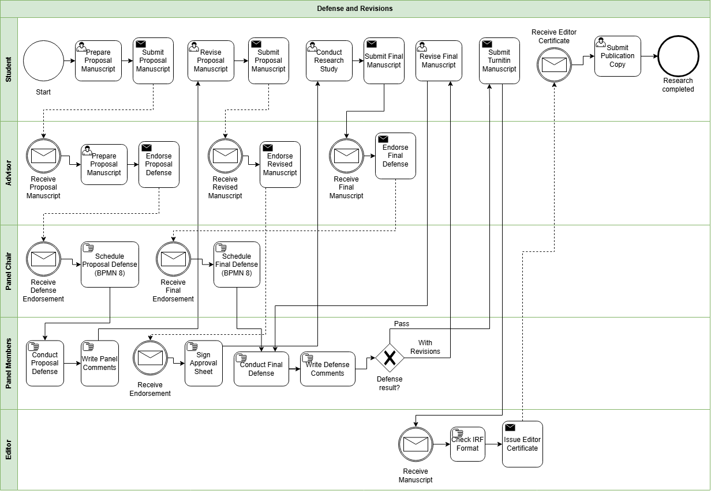
Appendix A.10. Practicum
Appendix A.11. Withdrawal

Appendix A.12. Graduation


Appendix B. Ishikawa Diagram – Root Causes of Difficulty in Monitoring and Processing Graduate Student Progress


Appendix C. Conceptual Framework Diagram

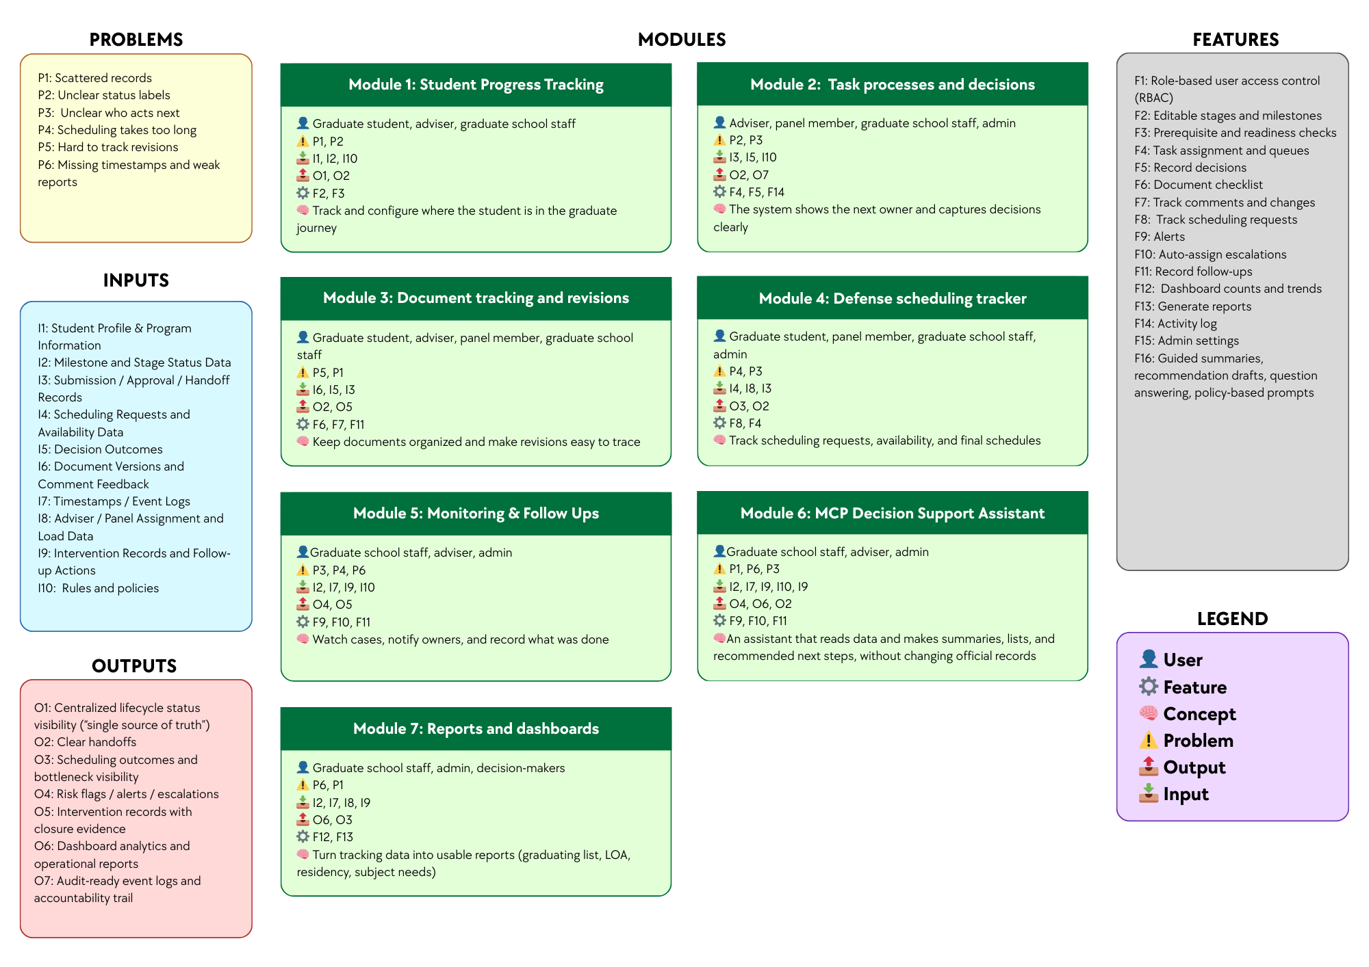

Appendix D. High-Level System Architecture Diagram
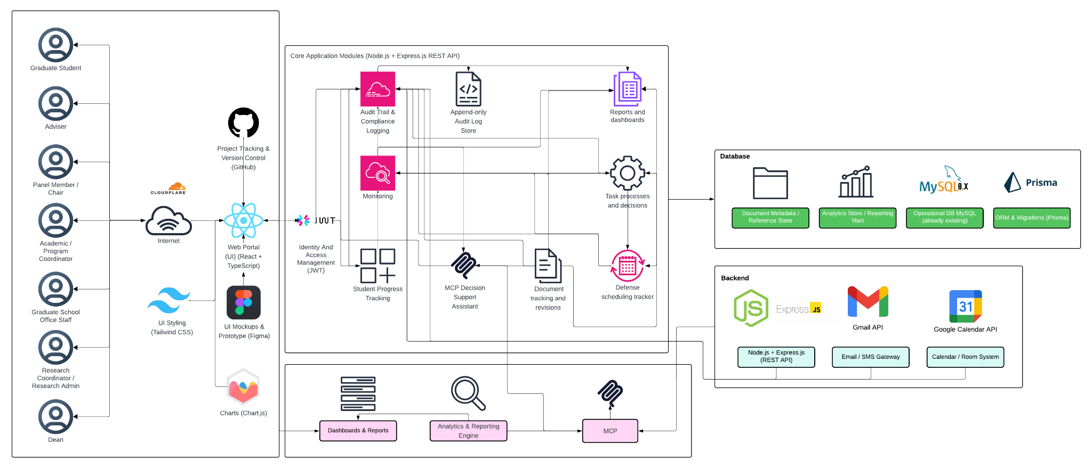

Appendix E. Key Performance Indicators (KPIs) of the Conceptual Framework

Appendix E.1. User and Access Management KPI
KPI | Target | Measurement Method | Reporting Frequency
Access control enforcement rate | 100% pass for all defined role-permission test cases | (Passed role-permission test cases ÷ Total defined role-permission test cases) × 100 | Every test cycle

Appendix E.2. Audit Trail and Accountability KPI
KPI | Target | Measurement Method | Reporting Frequency
Audit event coverage | 100% of defined auditable actions create timestamped log entries | (Auditable actions with valid timestamped logs ÷ Total defined auditable actions tested) × 100 | Every test cycle

Appendix E.3. Student Progress Management KPI
KPI | Target | Measurement Method | Reporting Frequency
Required monitoring field completion rate | 100% of active prototype records have all required monitoring fields | (Active prototype records with all required monitoring fields ÷ Total active prototype records) × 100 | Every academic term

Appendix E.4. Case Status and Action Tracking KPI

KPI | Target | Measurement Method | Reporting Frequency
Next-action ownership coverage | 100% of active in-scope cases have an assigned next-action owner | (Active in-scope cases with assigned next-action owner ÷ Total active in-scope cases) × 100 | Weekly

Appendix E.5. Defense Scheduling Management KPI
KPI | Target | Measurement Method | Reporting Frequency
Scheduling record completeness | ≥ 90% of scheduling cases have both request and outcome timestamps | (Scheduling cases with complete request and outcome timestamps ÷ Total scheduling cases) × 100 | Per defense cycle

Appendix E.6. Case Monitoring and Follow-Up KPI
KPI | Target | Measurement Method | Reporting Frequency
Follow-up closure logging rate | ≥ 90% of flagged cases have a recorded follow-up action and closure status | (Flagged cases with recorded follow-up and closure status ÷ Total flagged cases) × 100 | Monthly

Appendix E.7.Analytics and Decision Support KPI
KPI | Target | Measurement Method | Reporting Frequency
Follow-up closure logging rate | ≥ 90% of flagged cases have a recorded follow-up action and closure status | (Flagged cases with recorded follow-up and closure status ÷ Total flagged cases) × 100 | Monthly

Appendix E.8. RAG-Based Decision Support Assistant KPI
KPI | Target | Measurement Method | Reporting Frequency
Policy-grounded response match rate for decision-support outputs | 100% match on the defined prototype rule and reference test set | (Decision-support outputs that correctly match the approved rule and retrieved reference test set ÷ Total rule-based test cases) × 100 | Every test cycle

Appendix E.9. Reporting and Dashboards KPI
KPI | Target | Measurement Method | Reporting Frequency
Required report availability | 100% of the agreed report set is available in the prototype | (Available agreed reports ÷ Total agreed report set) × 100 | Every academic term

Appendix F. Reference labels used in the KPI table
Reference | Source | Brief explanation
SDP | 2nd Meeting Transcript Confirmation w/ Sir Eddie De Paula | Used for the confirmed AS-IS process, role ownership, monitoring needs, reporting needs, and scope boundaries.
GSRP | Graduate School Research Protocol | Used for required forms, stage rules, document checkpoints, and scheduling rules.
ISO 25012 | ISO/IEC 25012 Data Quality Model | Used for data quality measures such as completeness, consistency, and timeliness of records.
ISO 25010 | ISO/IEC 25010 System and Software Quality Model | Used for measurable system and software quality requirements.
Google SRE | Google Site Reliability Engineering guidance | Used for alert timing, follow-up timing, and target-setting ideas such as service level indicators and objectives.
OWASP ASVS | OWASP Application Security Verification Standard | Used to guide access control testing.
NIST SP 800-53 | NIST Security and Privacy Controls | Used to guide audit logging and accountability checks.

Appendix G. Existing (AS-IS) vs Proposed (TO-BE) System
Module | AS-IS (Existing System) | TO-BE (Prototype)
Module 1: Student Progress Management | Student progress is tracked across spreadsheets, monitoring sheets, email updates, and separate records. There is no single view of where a student is in the lifecycle. | One monitoring view shows the student’s current lifecycle stage, key status markers, required next steps, and recorded timestamps.
Module 2: Case Status and Action Tracking | Handoffs and decisions are often handled through manual follow-up, email coordination, and person-to-person checking. It is not always clear who owns the next action. | Role-based task queues show who owns the next action, what decision was recorded, and which cases need follow-up.
Module 3: Defense Scheduling Tracker | Scheduling is mainly coordinated through email and manual follow-up. Delays, reschedules, and final outcomes are not consistently recorded in one place. | Scheduling requests, availability, confirmations, and reschedules are recorded as structured events with dates and outcomes.
Module 4: Case Monitoring and Follow-Up | Monitoring depends on manual checking, reminders, and role-maintained records. Delayed cases may only be noticed after repeated follow-up. | Flagged cases, alerts, follow-up actions, and intervention records are tracked in one place to support case monitoring and follow-through.
Module 5: Analytics and Decision Support | There is no existing analytics and decision support function in the current process. Records may exist across different files and systems, but they are not consolidated in a way that produces timely insights for monitoring, planning, or intervention. | Structured lifecycle records are transformed into analytics outputs that show trends, delays, bottlenecks, and case patterns, helping Graduate School personnel monitor operations and support decisions using organized data.
Module 6: Policy and Case Guidance | Status questions, summaries, and next-step checking depend on manual review of forms, sheets, and emails. This takes time and depends on who is doing the checking. | The assistant reads allowed records and produces summaries, lists, and suggested next steps to support monitoring and processing. Final decisions still remain with authorized personnel.
Module 7: Reporting and Dashboards | Reports are prepared manually from separate files and records. Definitions may vary, and staff often need to consolidate data before reports can be used. | Dashboards and reports are generated from the same structured data, including subject needs, graduating student lists, LOA monitoring, residency tracking, and completion summaries.

Appendix H. Methodology

Appendix H.1. Methodology Flow of the Study with Scrum-Based Prototype Development
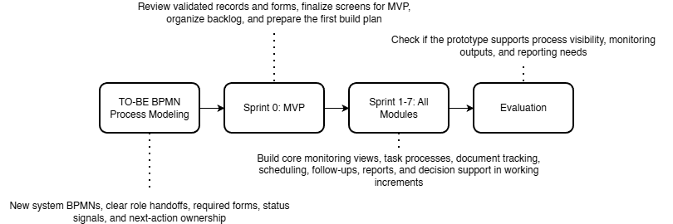

Appendix H.2. Proposed System Development Approach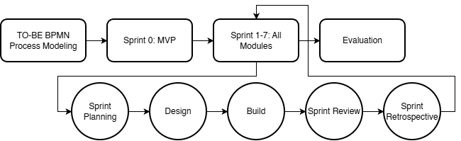

Appendix H.3. Proposed System Development Overview Using Agile Scrum

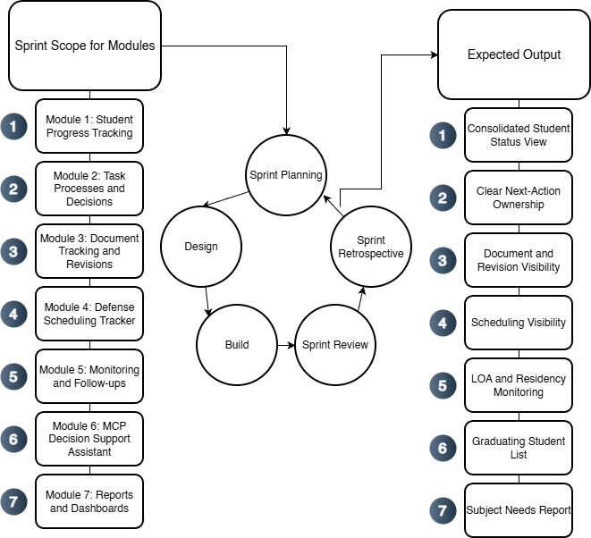

Appendix H.4. Specification Phases for the Proposed Graduate School Monitoring and Decision Support Platform


Appendix I. Data Requirements

Appendix I.1. Data to be collected and sources
Data Category | Key Fields | Primary Source Role | Existing System (AS-IS) | Use for Monitoring and Analytics
Student identity + program profile | Student name; ID number; program/track; year level; AY entry | Staff/Admin; Student (for verification) | Student Monitoring Excel Sheet (AC-STUDENT-MONITORING-Template.xlsx) | Baseline linking key across coursework + research monitoring; supports cohort grouping and drill-down views.
Coursework / enrollment monitoring | AY entry; subjects/codes; unit totals; standing/progress markers | Staff/Admin; Coordinator | Student Monitoring Excel Sheet (AC-STUDENT-MONITORING-Template.xlsx) | Enables “coursework-to-research readiness” monitoring where applicable.
Admission monitoring (status signals) | Requirements submitted date; application status; handoff confirmation | Admission Office; Graduate School Staff | AIMS + email-based handoff | Completes lifecycle coverage from admission without replacing AIMS.
Enrollment confirmation / term activation | Enrollment confirmation status per term; timestamp; active/inactive/stop-start signals | Graduate School Staff; Academic Coordinator | Email-based triggers + enrollment platform status | Prevents “gap in enrollment” visibility; supports continuity monitoring.
Curriculum tagging and study plan generation | Curriculum ID/version; student–curriculum tag date; required subjects; planned AY/Sem mapping | Academic Coordinator; Staff | Curriculum records + Student Monitoring Excel Sheet (AC-STUDENT-MONITORING-Template.xlsx) / study plan form | Enables per-student course audit and cohort-based monitoring for offerings and readiness.
Class offerings decision-support inputs | Eligible student counts per subject; pending prerequisites; planned offerings summary | Academic Coordinator | Student Monitoring Excel Sheet (AC-STUDENT-MONITORING-Template.xlsx) + curriculum mapping outputs | Supports “subjects to offer next semester” decision support.
LOA application monitoring | LOA request date; approval status; LOA start/end; LOA expiry marker | Graduate School Staff; Dean | Email-based routing + LOA tracking record | Adds visibility and escalation signals for LOA.
Readmission monitoring | Readmission request date; decision outcome; return term; conditions (if any) | Graduate School Staff | Email/manual records | Tracks re-entry pathway after LOA; supports continuity/readiness checks.
Residency monitoring signals | Residency clock start; pause/resume markers; nearing limit flags | Graduate School Staff/Coordinator | Derived monitoring record (policy-confirmed parameters) | Supports residency monitoring without changing policy.
Research case profile | AY first enrolled in thesis/dissertation; current AY; semester; program; adviser | Staff/Admin; Coordinator | Thesis Student Research Monitoring Sheet (Student-Research-Monitoring.xlsx) | Timeline anchor for time-in-stage, residency indicators, and exception tracking.
Adviser assignment + eligibility constraints | Adviser name; appointment status; date appointed; adviser load indicator | Research leadership/Admin | Research Protocol (Form 3 / 3.1) + spreadsheet reflections | Supports routing/accountability and adviser load monitoring.
Title defense workflow events | Endorsement; schedule date; approved title; decision outcome | Student; Coordinator; Panel Chair; Admin | Thesis Student Research Monitoring Sheet (Student-Research-Monitoring.xlsx) (Forms 1–2) | Captures early bottlenecks (endorsement + scheduling).
Proposal defense readiness + gate requirements | Endorsement; schedule; technical clearance; statistician consult (conditional) | Student; Adviser; Statistician; Admin | Thesis Student Research Monitoring Sheet (Student-Research-Monitoring.xlsx) (Forms 4, 4.1, 5) | Detects readiness blocks and scheduling bottlenecks.
Ethics review and clearance | Ethics submission; clearance date/status | Student; Ethics Office/Admin | Thesis Student Research Monitoring Sheet (Student-Research-Monitoring.xlsx) (Form 5.2) | Enables stop-the-clock/restart tracking around ethics review.
Final defense workflow events | Endorsement; schedule; outcome (pass/minor/major); re-defense status | Student; Adviser; Panel; Admin | Thesis Student Research Monitoring Sheet (Student-Research-Monitoring.xlsx) (Forms 6–8) | Captures revision cycles/decision states for bottleneck identification.
Public defense + publication/completion tagging | Public defense schedule; Turnitin cert; editor cert; final approval sheet; publication step | Student; Adviser; Admin | Thesis Student Research Monitoring Sheet (Student-Research-Monitoring.xlsx) (Forms 9–10) + Turnitin step | Converts endgame requirements into a traceable checklist; supports stuck-case detection.
Scheduling state and constraints | Proposed/confirmed dates; reschedules; mode; venue reservation | Admin/Staff; Panel Chair; Student | Email-based coordination + protocol steps | Measures scheduling cycle time and repeated back-and-forth.
Decision records + comment consolidation | Outcomes; consolidated comment sheet; approvals/release certs | Panel Chair; Panel Members; Adviser | Research Protocol (Form 5 consolidation; Form 5.1; Form 6/7) | Reduces version confusion; strengthens traceability/accountability.
Workload and operational queues | Pending endorsements; overdue items; aging cases; adviser/panel load counts | Admin; Coordinator; Leadership | Derived from milestone events + role assignments | Core decision-support layer for escalation and workload balancing.
Authority + audit signals | RBAC; access boundaries; change logs; retention rules | Admin | Thesis Student Research Monitoring Sheet (Student-Research-Monitoring.xlsx) (Forms 1–2) | Supports privacy-aligned handling and auditability for sensitive documents.
Practicum/OJT monitoring (if applicable) | Required hours; schedule; completion status; evidence checklist | Program Coordinator | Manual logs / certificates (MOA/certifications) | Included only when the program requires it; treated as completion signals.
Withdrawal monitoring | Withdrawal request/confirmation; effective term; reason (if allowed) | Graduate School Staff; Dean | Email/manual records | Tracks stop pathway formally for attrition reporting where allowed.
Graduation endorsement monitoring (Graduate School side) | Endorsed-to-graduate date; requirements complete flag; evidence checklist | Graduate School Staff; Academic Coordinator | Endorsed list + manual checklist | Supports graduating list preparation without replacing registrar processing.

Appendix J. Milestone Gate Criteria

Appendix J.1 Milestone Gate Criteria explaining definition of completion
Milestone | Entry Criteria | Required Evidence | Decision outcomes | Exit Criteria | Role
Admission Handoff Confirmed | Student has submitted requirements and admission status signal is available for handoff | AIMS status + handoff confirmation (email/record) | Accepted for onboarding / For completion / Not accepted | Handoff recorded; student is visible to Graduate School for onboarding and monitoring | Admission Office (status) + Graduate School Staff (handoff receipt)
Student Account + Program Onboarding Completed | Admission handoff confirmed | Enrollment platform account created; onboarding checklist (if used) | Activated / Returned for correction | Student account activated; student is tagged to program context for monitoring | Graduate School Staff / Academic Coordinator
Curriculum Tagged + Study Plan Generated | Student account exists; curriculum list/version exists | Curriculum ID/version record; student–curriculum tag record; generated study plan | Tagged / Corrected / Deferred | Student is linked to a curriculum; study plan (required subjects) is generated and viewable | Academic Coordinator
Term Enrollment Confirmed | Student is eligible to enroll for the term (per Graduate School) | Enrollment confirmation record (email trigger / enrollment platform status) | Confirmed / On hold / Not confirmed | Term status is recorded as active/inactive; monitoring continuity is visible (no “gap”) | Graduate School Staff / Academic Coordinator
Course Audit Updated | Term results/standing signals are available to be mirrored as monitoring indicators (without replacing grade encoding) | Monitoring sheet update (course completion/INC marker); supporting reference to official record where permitted | Updated / Pending update / Exception flagged | Course audit reflects latest completion/INC markers and remaining requirements for readiness checks | Academic Coordinator
Class Offerings Planning Completed | Curriculum + course audit data are available to compute eligible counts | Aggregated eligibility counts per subject; planned offerings summary | Approved offerings plan / Revised / Deferred | “Subjects to offer next semester” output is generated and recorded for term planning | Academic Coordinator
LOA Approved and Recorded | Student submits LOA request; case is active | LOA request record + approval decision + effective LOA start/end dates | Approved / Denied / Returned for completion | LOA status is recorded with effective period and expiry marker; student marked stop-start for monitoring | Dean (approval) + Graduate School Staff (recording)
Readmission Approved and Recorded | LOA period ended or readmission requested | Readmission request record + decision outcome + effective return term | Approved / Denied / Returned for completion | Readmission status recorded; student marked active for the return term | Graduate School Staff / Dean (as applicable)
Research Case Created | Readiness to start thesis/dissertation is confirmed (program-dependent) | Research case profile created (type, first enrolled AY, adviser pending/assigned) | Created / Deferred | Research case exists and becomes the basis for milestone event tracking | Research Coordinator / Staff
Adviser Designation Completed | Research case exists; adviser nomination is initiated | Research Protocol Forms 3 / 3.1 (adviser designation and appointment) and recorded adviser assignment | Appointed / Returned / Not appointed | Adviser assignment is recorded with date and ownership routing can begin | Research Leadership / Research Coordinator
Title Defense Completed | Adviser designation completed; title defense request endorsed | Research Protocol Forms 1–2 (title defense application + outcome); schedule record (if used) | Approved title / Returned for revision / Not approved | Approved title is recorded; status advances to proposal preparation stage | Panel Chair (decision) + Research Coordinator (recording)
Proposal Defense Completed | Title approved; proposal defense endorsed and scheduled | Research Protocol Forms 4, 4.1 (if applicable), 5 + schedule record + outcome/comments record | Passed / Revisions required / Re-defense required | Proposal defense outcome recorded; required changes captured as the authoritative revision basis | Panel Chair + Research Coordinator
Ethics Clearance Recorded | Proposal stage requires ethics review/clearance | Research Protocol Form 5.2 (ethics submission/clearance) | Cleared / Returned / Not cleared | Ethics clearance status and date are recorded; case may proceed to data collection/writing milestones | Ethics Office (clearance) + Research Coordinator (recording)
Final Defense Completed | Final defense endorsed and scheduled | Research Protocol Forms 6–8 (final defense comments/evaluation/settlement where applicable) + schedule/outcome record | Passed / Minor revisions / Major revisions / Re-defense | Final defense outcome recorded; revision pathway is explicit (minor/major/re-defense) | Panel Chair + Research Coordinator
Completion Evidence Verified | Final defense outcome permits completion processing | Research Protocol Forms 9–10 + Turnitin certificate + editor certification + approval sheet (as applicable) | Verified complete / Missing requirements / Returned | All required completion evidence is recorded as complete; case is eligible for GS endorsement | Graduate School Staff / Research Coordinator
Withdrawal Confirmed and Recorded | Student requests withdrawal; case is active | Withdrawal request/confirmation record (email/manual) | Approved / Denied / Returned | Withdrawal status recorded; monitoring stops with an auditable exit reason category (if allowed) | Dean + Graduate School Staff
Graduation Endorsement Completed | Completion evidence verified; no active stop-start/withdrawal | Endorsed-to-graduate list + requirements checklist (GS-side) | Endorsed / On hold / Returned for completion | Graduate School endorsement status recorded; endorsement list is prepared and handed off (registrar remains out-of-scope) | Graduate School Staff + Academic Coordinator / Dean

Appendix K. Functional Requirements
Category | Description
Curriculum and Study Plan Management | Load and maintain program curricula, tag a student to the correct curriculum, generate a per-student study plan, and show required subjects with AY and semester taken. Record subject completion date and status for course audit.
Enrollment and Coursework Monitoring | Track enrollment confirmation and course audit status. Provide a student view of the next semester schedule where allowed, and a coordinator view of student eligibility and remaining requirements without replacing official grade encoding.
Class Offerings Decision Support | Generate outputs that help the Academic Coordinator decide what subjects to offer next semester, such as counts of eligible students per subject, pending requirements, and a planned offerings summary.
LOA and Readmission Monitoring | Track LOA request status, approval, and effective LOA period. Track residency pause and readmission status, and generate LOA monitoring views for staff and coordinators.
Thesis and Dissertation Monitoring | Track adviser designation, title defense, proposal defense, final defense, revision cycles, manuscript finalization, and required certifications or documents. Record status, assigned role, and time on stage.
Practicum or OJT Tracking (Program-dependent) | Where required by the program, track required hours, schedule, and uploaded evidence such as MOA or certifications as completion signals. Exclude this if the program does not require it.
Withdrawal and Graduation Monitoring | Track withdrawal confirmation status and Graduate School graduation endorsement status. Generate graduating list outputs based on completion evidence without replacing Registrar processing.
Task Processing and Task Queues | Provide role-based task queues for submissions, endorsements, approvals, and decisions. Show who owns the next action across lifecycle stages.
Decision Recording | Record decision outcomes such as approve, revise, or return, together with the next required action and closure evidence for each milestone step.
Document Tracking | Maintain a required document checklist for each stage, track document versions, and record consolidated comments or decision records.
Scheduling Tracking | Record defense request, availability, and schedule outcome. Log reschedules and cancellations as monitoring signals.
Dashboards and Reports | Generate counts per stage, pending queues, aging or time in stage, LOA counts, course audit readiness, adviser or panel counts where applicable, and residency, completion, or attrition outputs based on validated definitions.
Alerts and Intervention Tracking | Detect threshold breaches such as long time in stage, LOA nearing expiry, or residency nearing limits. Notify the correct roles and log intervention actions with closure evidence.
Audit Trail | Log actions, decisions, and changes in definitions or process settings to support accountability.

Appendix L. Non-Functional Requirements
Category | Description
Security | Enforce role-based access control, strong authentication, secure session handling, and controlled privileges for higher-level users.
Privacy | Limit access to sensitive evaluation records, log access where needed, and handle data according to approved privacy boundaries (Datu, 2022).
Auditability | Keep append-only logs for key actions such as submissions, decisions, approvals, routing, and definition changes. Each log entry must show the actor, timestamp, and outcome.
Usability | Provide role-based dashboards and task queues, clear status labels, low encoding effort for staff, and consistent terms across modules.
Reliability | Apply data checks, validate required fields, support backup and recovery, and generate consistent timestamps for monitoring and reporting.
Maintainability | Allow milestone definitions, checklists, and workflow rules to be updated where possible without changing code, while keeping a controlled change process with logs.
Performance | Keep dashboard queries responsive, support efficient search and filtering, and handle document and log storage in a manageable way.
Interoperability | Allow export of reports and structured datasets. Allow integration or data exchange with institutional systems only where permitted by ownership and privacy rules.

Appendix M. IT tools to be used
Need | Specific Tools | Why this tool
UI mockups and clickable prototype |   Figma | Fast wireframing and interactive prototypes for stakeholder review and UI validation.
Frontend (web UI) |   React + TypeScript | Component-based UI for dashboards and queues, with TypeScript for safer handling of complex workflow states.
UI styling |   Tailwind CSS | Utility-first styling for consistent layouts with minimal custom CSS.
Charts for dashboards |   Chart.js | Lightweight charting for operational dashboards (counts, queues, aging/time-in-stage).
Backend (API + business rules) |   Node.js + Express.js (REST API) | Minimal backend framework for building API endpoints and implementing routing and workflow rules.
Authentication |   JWT (RFC 7519; internet standard) | Standard token format for stateless authentication between frontend and API.
Database |   MySQL 8 (InnoDB) | Relational data model with foreign keys for lifecycle, milestones, tasks, and audit logs, enabling consistent reporting queries.
Schema migration and DB access |   Prisma ORM (migrations + type-safe DB client) | One tool for repeatable schema migrations and type-safe database access, reducing manual SQL drift across sprints.
Project tracking and version control |   GitHub (Repo + Issues/Projects) | Source control and sprint tracking (issues, boards, basic backlog).
Diagrams |   draw.io    dbdiagram.io | Process and architecture diagrams (BPMN, ERD, system diagrams) with a lightweight tool.
Domain and DNS |   Cloudflare (DNS)  Cloudflare (SSL/TLS + Origin Certificate)  Cloudflare (Proxy + WAF/Firewall tools)  Cloudflare (CDN caching) | Manages the system domain/subdomain and DNS records (A/CNAME/TXT) for deployment and verification, with fast updates and centralized control
HTTPS and secure access |  | Provides HTTPS for users and encrypts traffic to the server (Full/Strict), reducing risks from misconfigured SSL on the origin.
Edge security |  | Adds a security layer in front of the server (e.g., basic filtering, rate limiting, DDoS protection) to reduce direct exposure of the origin.
Performance (optional) |  | Caches static assets to improve load time and reduce load on the origin server during peak access or demos.
RAG-enabled decision support | NotebookLM | Enables the system to retrieve relevant institutional records, policies, and supporting documents first, then generate responses based on those sources. This makes the assistant more appropriate for student status checking, guided summaries, completion rate analysis, and rule-guided next-step prompts. The tool is intended for retrieval-based decision support only and does not perform automated approvals or policy modifications.

Appendix N. Core tables and their purpose
Area | Table | Purpose in the system
Identity and Access Management (IAM) | Student | Stores the primary student monitoring identity and program entry context (e.g., cohort/AY entry, program/track).
 | UserAccount | Stores login identities for staff, coordinators, adviser/panel roles, and students (permitted views).
 | Role | Defines system roles used for RBAC.
 | UserRole | Assigns system roles to users (supports RBAC enforcement).
 | AdviserAssignment / PanelAssignment | Links advisers and panel members to students for scoped access and review responsibilities.
Core lifecycle & milestone tracking (monitoring layer) | StudentLifecycle | Stores program/track fields and references to program-dependent settings notes.
 | MilestoneDefinition | Defines milestone requirements by lifecycle stage, expected durations, and criticality.
 | StudentMilestoneStatus | Tracks milestone progress status and due/completion timestamps at the student level.
Workflow routing & decisions | Task | Represents actionable workflow items (pending/overdue), ownership, due dates, and recommended next action fields.
 | DecisionLog | Captures decisions made on tasks (approve/revise/return) with decision actor and timestamp.
 | RoutingRule | Defines rule-based routing for next owner roles and follow-up task generation.
Academic lifecycle tracking (monitoring signals) | Program | Stores program/track information and references for program-dependent settings.
 | AcademicTerm | Stores academic year/term identifiers (start/end dates where needed).
 | TermEnrollment | Stores per-term enrollment monitoring signals (confirmation timestamps, allowed status signals).
 | Course | Master list of course code/title/units.
 | CourseEnrollment | Links term enrollment to courses and stores monitoring signals (e.g., in-progress/completed/incomplete markers).
 | Curriculum | Curriculum identifier/version information per program.
 | StudyPlanItem | Stores planned/required subjects per curriculum (and recommended term where applicable).
 | StudentCurriculumTag | Maps a student to a curriculum version/tag (e.g., revised plan/bridging).
Research pipeline tracking (case-and-event) | ResearchCase | Monitoring container for thesis/capstone engagements linked to a student.
 | MilestoneEvent | Records milestone execution as timestamped events (occurredAt, outcome, ownerRole, decision actor, notes) and may reference related workflow tasks.
Evidence, scheduling, and traceability | DocumentRecord | Stores required-document checklist items per student/milestone, including review status and outstanding revisions count.
 | DocumentVersion | Stores uploaded file versions (file reference, uploadedBy, timestamps) linked to DocumentRecord.
 | RevisionNote | Tracks revision comments/required changes and resolution status linked to DocumentRecord and/or DocumentVersion.
 | ScheduleRequest | Stores scheduling requests tied to a student (requestedBy, preferred dates, status).
 | Availability | Collects availability windows from users for a ScheduleRequest.
 | ScheduleEvent | Stores schedule outcomes (confirmed/rescheduled/cancelled) with timestamps and decision actor.
 | FormSubmission | Tracks protocol-driven forms with submitted/endorsed/approved timestamps and routing state.
 | ClearanceRecord | Tracks clearance submission/outcome dates where applicable.
 | TimelineEvent | Provides a consolidated “what happened” feed by recording key events and linking to related entities.
Monitoring actions and alerts | AlertThreshold | Stores configured monitoring thresholds (e.g., prolonged stage, delayed scheduling) used by the monitoring engine.
 | NotificationAlert | Logs notifications sent (recipient, reason, timestamp, success metadata).
 | Intervention | Stores follow-up actions with owner, timestamps, and closure evidence.
Auditability | AuditLog | Append-only log of key events (access attempts, decisions, transitions, uploads, configuration changes).

Appendix O. Key relationships (high-level PK/FK design)
Relationship | Meaning | Integrity rule (what must be true)
Student (1) → (many) StudentLifecycle | A student has a stage history (entered/exited timestamps) | StudentLifecycle.StudentID must exist in Student
Student (1) → (many) StudentMilestoneStatus | A student has milestone progress records | StudentMilestoneStatus.StudentID must exist; MilestoneDefinitionID must exist
MilestoneDefinition (1) → (many) StudentMilestoneStatus | Milestone status references a valid milestone | StudentMilestoneStatus.MilestoneDefinitionID must exist
Student (1) → (many) TermEnrollment | A student has per-term monitoring records | TermEnrollment.StudentID must exist; TermEnrollment.TermID must exist
AcademicTerm (1) → (many) TermEnrollment | Enrollment records belong to a term | TermEnrollment.TermID must exist in AcademicTerm
TermEnrollment (1) → (many) CourseEnrollment | Term enrollment can include multiple courses | CourseEnrollment.TermEnrollmentID must exist; CourseEnrollment.CourseID must exist
Course (1) → (many) CourseEnrollment | Course enrollment references valid courses | CourseEnrollment.CourseID must exist in Course
Curriculum (1) → (many) StudyPlanItem | A curriculum defines planned subjects | StudyPlanItem.CurriculumID must exist; StudyPlanItem.CourseID must exist
Student (1) → (many) StudentCurriculumTag | A student can be tagged to a curriculum/version | StudentCurriculumTag.StudentID must exist; CurriculumID must exist
Student (1) → (many) ResearchCase | A student may have a research engagement container | ResearchCase.StudentID must exist
ResearchCase (1) → (many) MilestoneEvent | A case has milestone events over time | If used, MilestoneEvent.ResearchCaseID must exist in ResearchCase
MilestoneDefinition (1) → (many) MilestoneEvent | Events reference valid milestone definitions | MilestoneEvent.MilestoneDefinitionID must exist
Student (1) → (many) DocumentRecord | Document checklist items attach to a student | DocumentRecord.StudentID must exist
DocumentRecord (1) → (many) DocumentVersion | A checklist item can have multiple uploads/versions | DocumentVersion.DocumentRecordID must exist
DocumentRecord (1) → (many) RevisionNote | Revision notes attach to document checklist/version | RevisionNote.DocumentRecordID must exist
Student (1) → (many) ScheduleRequest | Scheduling requests attach to a student | ScheduleRequest.StudentID must exist; Requester must exist
ScheduleRequest (1) → (many) Availability | Availability windows belong to a scheduling request | Availability.ScheduleRequestID must exist; UserID must exist
ScheduleRequest (1) → (many) ScheduleEvent | Schedule outcomes/events belong to a request | ScheduleEvent.ScheduleRequestID must exist
UserAccount/Assignments → Student scope | People are linked to students for scoped access | AdviserAssignment/PanelAssignment.UserID must exist; StudentID must exist

Appendix P. RAG-Based Decision Support Assistant Architecture


Appendix Q. Entity-Relationship Diagram (ERD) and Table Group Overview



Appendix Q.1. Group A. Student and Program Context

Appendix Q.2. Group B. Identity, Roles, and Assignments



Appendix Q.3. Group C. Lifecycle & Milestones



Appendix Q.4. D. Workflow Tasks & Decisions

Appendix Q.5. Group E. Documents & Revisions

Appendix Q.6. Group F. Scheduling & Coordination



Appendix Q.7. Group G .Monitoring, Alerts, and Interventions

Appendix Q.8. Group H. Auditability

Appendix R. Computed indicators from event history used for prescriptive analytics and decision support
Computed indicator | Computed from | Decision-support use (how it drives prescriptive actions)
Current stage or milestone position | Latest MilestoneEvent per ResearchCase + MilestoneType ordering/definitions | Identifies where the case is now and which next action is relevant
Pending queue membership | MilestoneEvent with incomplete outcome + RoleAssignment owner + due date rules (if applicable) | Places cases into the correct role-based queue and enables prioritization
Aging or time-in-stage | Date difference between “now” and last MilestoneEvent timestamp, or between milestone timestamps | Flags stalled cases; triggers follow-up prompts and escalation when thresholds are reached
Overdue tasks and SLA breaches | Task due date (from workflow rules) vs current date + completion state | Generates “overdue” labels; recommends urgent follow-up or escalation
Scheduling cycle time | DefenseEvent request date to confirmed schedule date; reschedule count | Detects scheduling delays; recommends next coordination step and highlights repeated reschedules
Evidence completeness score | Required evidence checklist vs DocumentArtifact links for the milestone | Blocks completion when required evidence is missing; recommends what document to request
Decision outcome state | Latest decision outcome in MilestoneEvent (approve, revise, return) | Determines the next routing step; recommends who should act next
Prescriptive recommendation output | Rule-based checks applied to indicators above using policy-confirmed parameters | Produces recommended next actions, queue prioritization, and escalation prompts without automating final approvals

Appendix S. Cost table for on-site premises
ON-SITE (On-Premises using existing infrastructure)
Item | Type | Cost | Potential Costs (if not existing) | Notes
Server hardware | One-time | ₱0 | ₱7,000–₱50,000 | Use an existing campus machine. Modest specs can support an MVP for a small graduate school with low concurrent usage.
OS + software stack | One-time | ₱0 | ₱0 | Open-source tools; no licensing fees.
HTTPS / SSL certificate | Annual | ₱0 | ₱0–₱5,000 | Free SSL via Let’s Encrypt; paid certificate optional depending on institutional policy.
Domain / subdomain | Annual | ₱0 | ₱800–₱1,500 | If USLS provides a subdomain under an existing domain, no additional cost.
Backups (storage + retention) | Monthly | ₱0 | ₱500–₱2,000 | Applies only if additional backup media/storage allocation or offsite copying is required.
IT operations (maintenance and support) | Monthly | ₱0 | Variable if there is an IT staff. | Patching, monitoring, user support, access management; typically absorbed by existing IT workload.
Email notification service (SMTP) | Monthly | ₱0 | ₱0–₱500 | Can use existing school email relay; external relay is optional for MVP use.
LLM API | Monthly/usage-based | ₱0 | ₱100–₱500 | Estimated for light MVP use only. If enabled, the LLM is used only for advisory outputs such as summaries, completion rate analysis, and next-step prompts. Official OpenAI text pricing currently ranges from $0.25 / 1M input tokens and $2.00 / 1M output tokens for GPT-5 mini, up to $1.25 / 1M input and $10.00 / 1M output for GPT-5, and $2.50 / 1M input and $15.00 / 1M output for GPT-5.4.

Appendix T. Workplan

Appendix T.1. CAP-IT1 Work Timeline (80% target)
Development |  |  | May |  |  |  | Jun |  |  |  |  | Jul |  |  |  | Aug
# | Module | Activities | 4 | 11 | 18 | 25 | 1 | 8 | 15 | 22 | 29 | 6 | 13 | 20 | 27 | 3
1 | User & Access Management | Design role-based access interface (login, role dashboards)
 |  | Design RBAC database schema (users, roles, permissions)
 |  | Develop authentication and authorization prototype
 |  | Implement authentication logic, role-permission enforcement, and access validation rules
 |  | Conduct access testing
 |  | Sprint review and RBAC validation with stakeholders
2 | Lifecycle & Milestone Management | Design lifecycle stage interface
 |  | Design lifecycle database structure (stages, milestones, timestamps)
 |  | Prototype stage transition logic and milestone prerequisite checks
 |  | Implement lifecycle progression engine
 |  | Test stage gating and timestamp logging accuracy
 |  | Sprint review of lifecycle logic and milestone flow
3 | Workflow Routing & Decision Management | Design structured workflow queue interface
 |  | Design decision log and routing database schema
 |  | Prototype approve/revise/return decision pathways
 |  | Implement workflow routing engine and ownership reassignment
 |  | Conduct traceability and decision integrity testing
 |  | Sprint review on workflow clarity and ownership visibility
4 | Document & Revision Management | Design checklist and document submission interface
 |  | Design document metadata schema
 |  | Prototype document submission and revision tracking flow
 |  | Implement revision logging and checklist validation engine
 |  | Conduct version traceability testing
 |  | Sprint review of document tracking accuracy
5 | Scheduling & Coordination Management | Design scheduling request and availability interface
 |  | Design scheduling database
 |  | Prototype defense scheduling logic
 |  | Implement scheduling coordination engine
 |  | Conduct scheduling validation & sprint review
6 | Monitoring, Alerts & Intervention Engine | Design monitoring dashboard interface (risk indicators & alert views)
 |  | Design monitoring database logic (threshold rules, time-in-stage computation, escalation mapping)
 |  | Prototype automated alert detection logic
 |  | Implement monitoring and escalation engine (threshold evaluation + intervention logging)
 |  | Conduct alert accuracy testing (threshold validation & false-positive checks)
 |  | Sprint review of intervention logging and escalation clarity
7 | Analytics & Reporting | Design analytics dashboard layout (queue aging, bottleneck views, load metrics)
 |  | Design analytics aggregation schema reporting mart tables & computed metrics)
 |  | Implement reporting queries and dashboard visualizations
 |  | Conduct analytics validation testing (metric accuracy, aggregation consistency, cross-module data integrity)
 |  | Sprint review on reporting accuracy
8 | Database Audit | Design audit trail interface (activity log viewer & filtering tools)
 |  | Design append-only audit log schema (action logs, timestamp mapping, user-action trace)
 |  | Implement cross-module activity logging integration
 |  | Conduct audit integrity testing (log completeness, tamper resistance validation)
 |  | Sprint review on traceability coverage

Appendix T.2. CAP-IT2 Work Timeline (20% target)

Development |  |  | Aug |  | Sep |  |  |  | Oct |  |  |  | Nov
# | Module | Activities | 24 | 31 | 7 | 14 | 21 | 28 | 5 | 12 | 19 | 26 | 2 | 9 | 16 | 23
9 | Evaluation Setup | Design structured usability and monitoring-interpretation evaluation instruments
 |  | Conduct pilot evaluation session
 |  | Finalize evaluation protocol for stakeholder sessions
10 | Stakeholder Usability / UAT | Conduct structured UAT Session 1 (Lifecycle tracking, Workflow routing validation)
Conduct structured UAT Session 2
(Monitoring alerts, Analytics dashboards, Access Control or Audit validation)
Consolidate findings
Document usability gaps and interpretation inconsistencies
11 | Refinements (Iteration 1) | Implement UI clarity improvements (dashboard readability, queue labeling, milestone visualization)
 |  | Refine workflow routing flows and decision-state clarity
Conduct full regression testing across Modules 1–8
(ensure refinements did not break monitoring, analytics, or access control logic)
12 | Access Control or Audit Hardening | RBAC scoping improvements
 |  | Audit log coverage + integrity checks
 |  | Regression testing
13 | Reporting & Export Polish | Access Control or Audit Hardening
Finalize export formats and endorsement-ready reporting outputs
(PDF/CSV exports, summary report structure validation)
14 | Documentation Finalization | Integrate final implementation updates into Chapter 3 & Chapter 4
 |  | Finalize User Guide and Admin Guide documentation
 |  | Clean appendix materials (BPMN, ERD, tables, architecture diagrams)
15 | Final Demo + Defense Prep | Package final build for deployment demonstration
 |  | Conduct final defense rehearsal and structured system walkthrough

Appendix U. System Screenshots
The screens below are captures of the running prototype operating on the seeded demonstration dataset. Where a screen fits on a page it is reproduced in full, including the portion that requires scrolling in the browser. Where a screen is too long to reproduce at a legible size — the recommendations and work queue screens in particular run to several screen heights — the visible window is shown instead and the caption says so. Screens are captured under an administrator account unless the caption names another role.

Appendix U.1. Login screen


Figure U.1. Login screen (full screen)

Appendix U.2. Dashboard — Graduate School overview


Figure U.2. Dashboard — Graduate School overview (visible window; the screen continues below)

Appendix U.3. Reports


Figure U.3. Reports (full screen)

Appendix U.4. Academic semesters


Figure U.4. Academic semesters (full screen)

Appendix U.5. Students
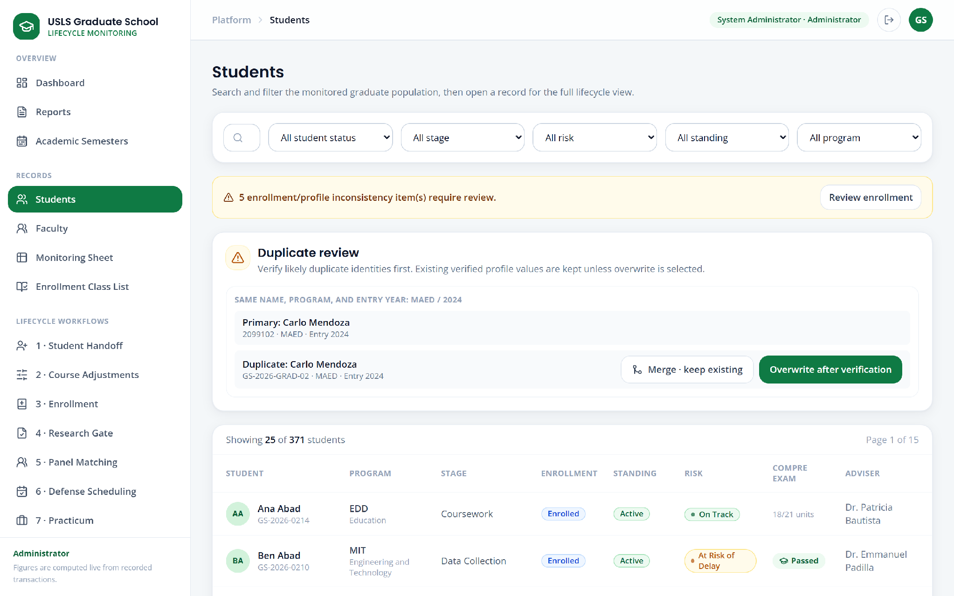

Figure U.5. Students (visible window; the screen continues below)

Appendix U.6. Faculty records


Figure U.6. Faculty records (visible window; the screen continues below)

Appendix U.7. Monitoring sheet


Figure U.7. Monitoring sheet (full screen)

Appendix U.8. Enrollment class list


Figure U.8. Enrollment class list (full screen)

Appendix U.9. Student handoff


Figure U.9. Student handoff (full screen)

Appendix U.10. Course adjustments and subject needs


Figure U.10. Course adjustments and subject needs (visible window; the screen continues below)

Appendix U.11. Course offering setup


Figure U.11. Course offering setup (full screen)

Appendix U.12. Enrollment


Figure U.12. Enrollment (full screen)

Appendix U.13. Research gate


Figure U.13. Research gate (full screen)

Appendix U.14. Panel matching


Figure U.14. Panel matching (full screen)

Appendix U.15. Defense scheduling


Figure U.15. Defense scheduling (full screen)

Appendix U.16. Practicum monitoring


Figure U.16. Practicum monitoring (visible window; the screen continues below)

Appendix U.17. Graduation endorsement


Figure U.17. Graduation endorsement (full screen)

Appendix U.18. Leave of absence


Figure U.18. Leave of absence (full screen)

Appendix U.19. Readmission


Figure U.19. Readmission (full screen)

Appendix U.20. AWOL and residency


Figure U.20. AWOL and residency (visible window; the screen continues below)

Appendix U.21. Subject withdrawal requests


Figure U.21. Subject withdrawal requests (full screen)

Appendix U.22. Work queue


Figure U.22. Work queue (visible window; the screen continues below)

Appendix U.23. Activity log


Figure U.23. Activity log (full screen)

Appendix U.24. Recommendations


Figure U.24. Recommendations (visible window; the screen continues below)

Appendix U.25. Policy assistant


Figure U.25. Policy assistant (full screen)

Appendix U.26. Form 1 endorsements


Figure U.26. Form 1 endorsements (visible window; the screen continues below)

Appendix U.27. Student detail


Figure U.27. Student detail (full screen)

Appendix U.28. Dean approvals queue


Figure U.28. Dean approvals queue (visible window; the screen continues below)

Appendix U.29. Student portal


Figure U.29. Student portal (full screen)

Appendix U.30. Faculty portal


Figure U.30. Faculty portal (full screen)

Appendix U.31. Academic Coordinator view of the monitoring sheet


Figure U.31. Academic Coordinator view of the monitoring sheet (full screen)

Appendix U.32. Research Coordinator view of graduation
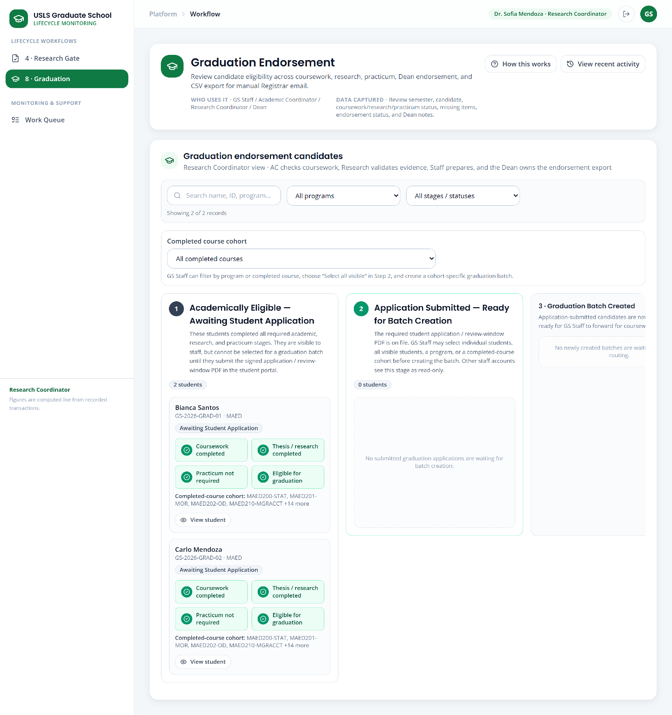

Figure U.32. Research Coordinator view of graduation (full screen)

Appendix U.33. Graduate School Staff dashboard
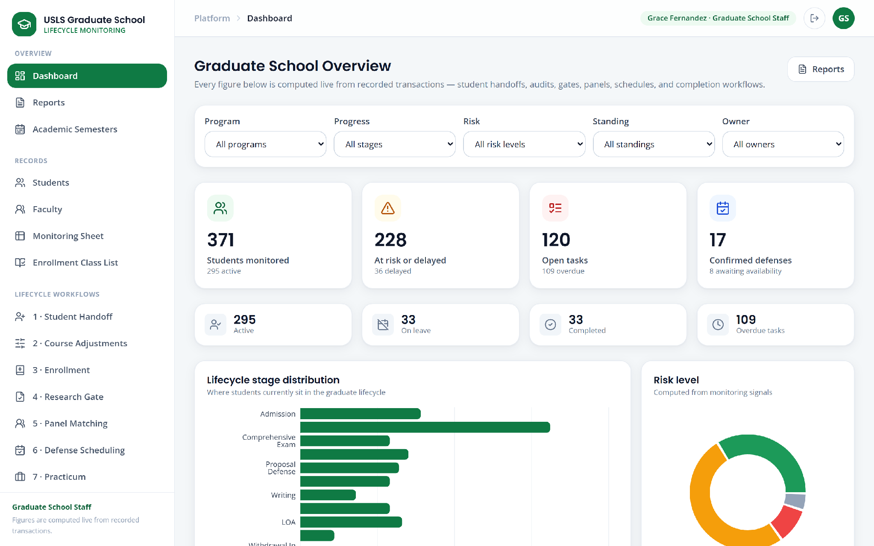

Figure U.33. Graduate School Staff dashboard (visible window; the screen continues below)

Appendix V. Automated Test Case Matrix
The complete list of automated test cases executed against the implemented system, with the result recorded for each. The execution summary is given in Section 6.3.2.
ID | Module | Test case — what is verified | Result
TC-01 | Subject Withdrawal | Only academic coordinator can mark subject dropped and withdrawal uses workflow | Pass
TC-02 | Subject Withdrawal | Student can submit within withdrawal window and late request is blocked | Pass
TC-03 | Subject Withdrawal | Withdrawal approval sequence and denial branch | Pass
TC-04 | Practicum | Existing practicum demo students migrate to configured programs | Pass
TC-05 | Practicum | Practicum complete and incomplete certificate loop | Pass
TC-06 | Practicum | Practicum is restricted to psychology and msgc programs | Pass
TC-07 | Practicum | Student can upload additional practicum pdf without replacing history | Pass
TC-08 | Practicum | Student practicum submission is locked until eligible | Pass
TC-09 | Graduation | Graduation batch skips unverified and sends eligible candidates | Pass
TC-10 | Graduation | Graduation incomplete coursework and research are routed to staff | Pass
TC-11 | Graduation | Graduation projects research workflow progress and uses it for roster discovery | Pass
TC-12 | Graduation | Graduation return resubmit approve and export | Pass
TC-13 | Graduation | Policy assistant forecasts next semester graduation readiness | Pass
TC-14 | Graduation | Student completion evidence uploads feed graduation checklist | Pass
TC-15 | Graduation | Student graduation application requires eligibility and signed pdf | Pass
TC-16 | Leave of Absence, Readmission, AWOL and Residency | Approved loa does not create delay risk | Pass
TC-17 | Leave of Absence, Readmission, AWOL and Residency | Awol absolute limit requires reenrollment and valid residency is recorded | Pass
TC-18 | Leave of Absence, Readmission, AWOL and Residency | Awol return is policy reviewed and decided by dean | Pass
TC-19 | Leave of Absence, Readmission, AWOL and Residency | Eligible loa and readmission require dean decisions | Pass
TC-20 | Leave of Absence, Readmission, AWOL and Residency | Monitoring flags are typed audited and source uploads can resolve them | Pass
TC-21 | Leave of Absence, Readmission, AWOL and Residency | Readmission needs review still goes to dean | Pass
TC-22 | Leave of Absence, Readmission, AWOL and Residency | Structured loa and readmission need no rag or pdf | Pass
TC-23 | Research, Panel Matching and Defense Scheduling | Connected google calendar fails closed when freebusy is unavailable | Pass
TC-24 | Research, Panel Matching and Defense Scheduling | Connected google calendar replaces dummy profile schedule | Pass
TC-25 | Research, Panel Matching and Defense Scheduling | Defense availability uses recurring profile hours without dated rows | Pass
TC-26 | Research, Panel Matching and Defense Scheduling | Defense suggestions start after required lead time | Pass
TC-27 | Research, Panel Matching and Defense Scheduling | Faculty can start google calendar oauth for only their account | Pass
TC-28 | Research, Panel Matching and Defense Scheduling | Faculty cv reference is grounded and links to full demo document | Pass
TC-29 | Research, Panel Matching and Defense Scheduling | Faculty preference is advisory until coordinator selects | Pass
TC-30 | Research, Panel Matching and Defense Scheduling | Google calendar oauth callback saves faculty owned credentials | Pass
TC-31 | Research, Panel Matching and Defense Scheduling | Panel matching google availability counts free days and fails closed | Pass
TC-32 | Policy Assistant and Document Retrieval | Document rag prefers semantic vectors and keeps lexical fallback | Pass
TC-33 | Policy Assistant and Document Retrieval | Policy assistant falls back when document rag fails | Pass
TC-34 | Policy Assistant and Document Retrieval | Policy assistant routes database paraphrases to verified reports | Pass
TC-35 | Policy Assistant and Document Retrieval | Policy assistant uses fast path and guards unsupported requests | Pass
TC-36 | Policy Assistant and Document Retrieval | Student assistant rejects staff only questions | Pass
TC-37 | Monitoring and Data Integrity | Corrected monitoring workbook resolves multiple selected students | Pass
TC-38 | Monitoring and Data Integrity | Cumulative monitoring validation resolution and new student badge | Pass
TC-39 | Monitoring and Data Integrity | Failed course record does not create delay risk | Pass
TC-40 | Monitoring and Data Integrity | Maed monitoring sheet seeds all policy valid demo personas | Pass
TC-41 | Monitoring and Data Integrity | Monitoring class list is synced from enrollment and read only | Pass
TC-42 | Monitoring and Data Integrity | Monitoring sheet rejects manual status updates | Pass
TC-43 | Monitoring and Data Integrity | Usls course audit grade writes are disabled | Pass
TC-44 | Enrollment and Course Offering | Academic semester removal keeps referenced history | Pass
TC-45 | Enrollment and Course Offering | Authoritative curricula and derived course year | Pass
TC-46 | Enrollment and Course Offering | Course adjustments manual selection publishes to curriculum planning | Pass
TC-47 | Enrollment and Course Offering | Course offering setup and class list import work end to end | Pass
TC-48 | Enrollment and Course Offering | Enrollment requires resolution for non offered subject | Pass
TC-49 | Enrollment and Course Offering | Enrollment syncs ledger profile and operational monitoring | Pass
TC-50 | Enrollment and Course Offering | Enrollment workspace uses monitoring status for subject eligibility | Pass
TC-51 | Enrollment and Course Offering | One student demand lists full delay impact | Pass
TC-52 | Enrollment and Course Offering | Recommended year delay only uses authoritative curricula | Pass
TC-53 | Enrollment and Course Offering | Student curriculum checklist adds without removing existing enrollment | Pass
TC-54 | Enrollment and Course Offering | Subject needs report uses active students without future enrollment | Pass
TC-55 | Access Control, Messaging and Audit | Demo backoffice accounts sign in as distinct roles | Pass
TC-56 | Access Control, Messaging and Audit | Request files are scoped to student and workflow role | Pass
TC-57 | Access Control, Messaging and Audit | Reviewer transition creates linked student notice and audit | Pass
TC-58 | Access Control, Messaging and Audit | Staff cannot reset a non demo student through demo controls | Pass
TC-59 | Access Control, Messaging and Audit | Student inbox hides internal messages and tracks read state | Pass
TC-60 | Access Control, Messaging and Audit | Workflow clarification can be returned and answered | Pass
TC-61 | Access Control, Messaging and Audit | Workflow demo students quick login and central reset | Fail

Total: 61 test cases, 60 passed, 1 failed.

Appendix W. Automated Test Execution Record
The summary output of the test execution reported in Section 6.3.2, reproduced as recorded.
Field | Recorded value
Command | python -m unittest tests.test_bpm_workflows -v
Test module | tests/test_bpm_workflows.py
Test class | BpmWorkflowSimulationTests
Database | Temporary SQLite file created for the run
Tests run | 61
Execution time | 323.166 s
Result line | FAILED (failures=1)
Failing case | test_workflow_demo_students_quick_login_and_central_reset
Assertion | self.assertEqual(current_withdrawal_courses, ['MAED-MAJ1'])
Reported difference | ['MAED-COG1', 'MAED-MAJ1', 'MAED-MAJ3'] != ['MAED-MAJ1']
Errors | 0

The failure is analysed as defect DEF-001 in Section 6.3.3.

Appendix X. User Acceptance Testing Instrument
The instrument below has been prepared for the user acceptance testing described in Section 6.7. It has not been administered, and no responses to it exist at the time of this report. It is included so that the evaluation design may be reviewed in advance.

Appendix X.1. Respondent Profile
Item | Response
Role in the Graduate School | Dean / GS Staff / Academic Coordinator / Research Coordinator / Faculty / Student
Length of service or enrollment in the Graduate School
Processes personally performed today
Tools currently used for those processes
Comfort with using web applications | Very low / Low / Moderate / High / Very high

Appendix X.2. Rated Items
Each item is rated on a five-point scale: 1 Strongly disagree, 2 Disagree, 3 Neutral, 4 Agree, 5 Strongly agree. Items are presented only for the modules the respondent uses in their own role.
No. | Statement | Rating
1 | The module performs the process the way I actually perform it today. | 1 2 3 4 5
2 | Everything I need to do in this process is supported. | 1 2 3 4 5
3 | The information shown is accurate against what I would produce manually. | 1 2 3 4 5
4 | I can find what I need without being told where it is. | 1 2 3 4 5
5 | The screen makes clear which values come from official records. | 1 2 3 4 5
6 | The screen makes clear who must act next. | 1 2 3 4 5
7 | The reports give me what I currently assemble by hand. | 1 2 3 4 5
8 | Using this would take less time than my present method. | 1 2 3 4 5
9 | I would be confident using the output of this module in a decision. | 1 2 3 4 5
10 | The boundary with the Registrar is stated correctly. | 1 2 3 4 5

Appendix X.3. Per-Module Items
Administered only to respondents whose role uses the module.
Module | Item
Monitoring sheet | The consolidated view shows the standing of the whole cohort in a way the present spreadsheet cannot.
Student handoff | Importing the workbook produced the student list I expected, and reported the problems in the file.
Course offering setup | I can declare the subjects, schedule, and assigned faculty for a term as I decide them.
Subject needs | The subject-needs counts match my own judgement of what should be offered.
Enrollment | Tagging students to offered subjects, by upload and by search, matches how I would do it.
Research gate | The required documents shown for each gate are the correct requirements.
Panel matching | The suggested panel members are plausible, and the reason given for each is sound.
Defense scheduling | The proposed slots are ones I could actually use.
Practicum | Hours and certificates are handled correctly, including hours from more than one site.
Graduation | The eligibility determination agrees with my own assessment of each candidate.
Leave, readmission, AWOL, residency | The rules applied to each application match Graduate School policy.
Subject withdrawal | The process, the window, and the penalty-free treatment are correctly represented.
Reports | The reports are the ones I need, and the figures are ones I would rely on.
Policy assistant | The answers are grounded in actual policy and do not state things that are not in it.
Student portal | I can see my own status and submit what I need to submit.
Faculty portal | I can see what is assigned to me and respond to it.

Appendix X.4. Free-Response Items
1.What, in the process you perform, is not supported by the system?
2.Where did the system show something you believe to be incorrect? Please identify the screen and the value.
3.Which screen was hardest to understand, and what was unclear about it?
4.What would you need to be true before you would use this instead of your present method?
5.Is there any point at which you think the system misrepresents official data or the role of the Registrar?
6.Any other observation.

Appendix Y. As-Built API Endpoint Inventory
The application server exposes the routes below. They are listed as implemented, grouped by area. Where a path appears more than once in the source it serves more than one HTTP method.
Area | Route
Authentication and session | /api/auth/demo-students
Authentication and session | /api/auth/demo-students/<demo_key>/reset
Authentication and session | /api/auth/login
Authentication and session | /api/auth/logout
Authentication and session | /api/auth/me
Students and records | /api/faculty
Students and records | /api/faculty/<int:faculty_id>
Students and records | /api/faculty/<int:faculty_id>/calendar.ics
Students and records | /api/faculty/<int:faculty_id>/cv-rag
Students and records | /api/faculty/<int:faculty_id>/preferences
Students and records | /api/faculty-portal/adviser-approvals/<int:evidence_id>
Students and records | /api/faculty-portal/context
Students and records | /api/faculty-portal/defense-verdicts/<int:schedule_id>
Students and records | /api/faculty-portal/google-calendar/authorization
Students and records | /api/faculty-portal/google-calendar/callback
Students and records | /api/health
Students and records | /api/meta
Students and records | /api/students
Students and records | /api/students/<int:student_id>
Students and records | /api/students/<int:student_id>/flag-issue
Students and records | /api/students/<int:student_id>/flags
Students and records | /api/students/<int:student_id>/flags/<int:flag_id>/resolve
Students and records | /api/students/<int:student_id>/remove
Students and records | /api/students/duplicates
Students and records | /api/students/merge
Monitoring and imports | /api/course-audit/roster
Monitoring and imports | /api/course-audit/subjects
Monitoring and imports | /api/monitoring/class-list
Monitoring and imports | /api/monitoring/compre-exam
Monitoring and imports | /api/monitoring/conflicts
Monitoring and imports | /api/monitoring/grid
Monitoring and imports | /api/monitoring/issues/<int:issue_id>/resolve
Monitoring and imports | /api/monitoring/issues/resolve-upload
Monitoring and imports | /api/monitoring/subject-status
Monitoring and imports | /api/monitoring/uploads
Monitoring and imports | /api/monitoring/uploads/<int:upload_id>/download
Offerings, adjustments and enrollment | /api/course-adjustments
Offerings, adjustments and enrollment | /api/course-adjustments/plan
Offerings, adjustments and enrollment | /api/course-adjustments/subject-needs-report
Offerings, adjustments and enrollment | /api/course-offerings
Offerings, adjustments and enrollment | /api/course-offerings/<int:offering_id>
Offerings, adjustments and enrollment | /api/curriculum-planning
Offerings, adjustments and enrollment | /api/curriculum-planning/generate
Offerings, adjustments and enrollment | /api/curriculum-planning/offerings
Offerings, adjustments and enrollment | /api/curriculum-planning/offerings/<int:offering_id>
Offerings, adjustments and enrollment | /api/curriculum-planning/subjects
Offerings, adjustments and enrollment | /api/enrollment
Offerings, adjustments and enrollment | /api/enrollment/class-list-import
Offerings, adjustments and enrollment | /api/enrollment/class-list-preview
Offerings, adjustments and enrollment | /api/enrollment/preview
Offerings, adjustments and enrollment | /api/enrollment/subject-status
Research, panel and scheduling | /api/research-evidence/<int:evidence_id>/concept-paper-compliance
Research, panel and scheduling | /api/research-evidence/<int:evidence_id>/file
Research, panel and scheduling | /api/research-gate/form1-endorsements
Research, panel and scheduling | /api/research-gate/form1-endorsements/<int:student_id>
Research, panel and scheduling | /api/research-gate/template
Standing changes and graduation | /api/awol/<int:case_id>/registrar-report
Standing changes and graduation | /api/awol/policy-review
Standing changes and graduation | /api/graduation/batch-actions
Standing changes and graduation | /api/graduation/endorsed.csv
Standing changes and graduation | /api/leave-of-absence/policy-review
Standing changes and graduation | /api/readmission/policy-review
Standing changes and graduation | /api/residency/<int:residency_id>/registrar-report
Standing changes and graduation | /api/standing-changes/<slug>/<int:student_id>/registrar-report
Standing changes and graduation | /api/withdrawal/<int:application_id>/registrar-report
Standing changes and graduation | /api/withdrawal/approved.xlsx
Workflows, tasks and approvals | /api/activity
Workflows, tasks and approvals | /api/admin/terms
Workflows, tasks and approvals | /api/admin/terms/<int:term_id>
Workflows, tasks and approvals | /api/admin/terms/<int:term_id>/set-active
Workflows, tasks and approvals | /api/admin/terms/add-next
Workflows, tasks and approvals | /api/approvals
Workflows, tasks and approvals | /api/approvals/<int:plan_id>/decide
Workflows, tasks and approvals | /api/approvals/workflow/<case_type>/<int:item_id>/decide
Workflows, tasks and approvals | /api/tasks
Workflows, tasks and approvals | /api/terms/active
Workflows, tasks and approvals | /api/transactions/<slug>
Workflows, tasks and approvals | /api/transactions/<slug>/context
Workflows, tasks and approvals | /api/transactions/<slug>/demo-reset
Workflows, tasks and approvals | /api/transactions/<slug>/messages
Workflows, tasks and approvals | /api/transactions/student-handoff/import
Student portal | /api/student-portal/assistant
Student portal | /api/student-portal/assistant/suggestions
Student portal | /api/student-portal/context
Student portal | /api/student-portal/documents/<int:document_id>/upload
Student portal | /api/student-portal/enrollment
Student portal | /api/student-portal/messages/read
Student portal | /api/student-portal/request-attachments/upload
Student portal | /api/student-portal/requests/awol-return
Student portal | /api/student-portal/requests/defense-scheduling
Student portal | /api/student-portal/requests/graduation
Student portal | /api/student-portal/requests/leave-of-absence
Student portal | /api/student-portal/requests/leave-of-absence/withdraw
Student portal | /api/student-portal/requests/practicum
Student portal | /api/student-portal/requests/readmission
Student portal | /api/student-portal/requests/research-gate
Student portal | /api/student-portal/requests/withdrawal
Student portal | /api/student-portal/research-evidence/<int:evidence_id>
Student portal | /api/student-portal/research-evidence/upload
Student portal | /api/student-portal/title-defense/parse
Student portal | /api/student-request-attachments/<int:attachment_id>/file
Dashboard, reports and decision support | /api/assistant
Dashboard, reports and decision support | /api/assistant/suggestions
Dashboard, reports and decision support | /api/dashboard
Dashboard, reports and decision support | /api/dashboard/drilldown
Dashboard, reports and decision support | /api/decision-support
Dashboard, reports and decision support | /api/reports
Dashboard, reports and decision support | /api/reports/daily-changes
Dashboard, reports and decision support | /api/reports/daily-changes/<int:log_id>/reflected
Application shell | /
Application shell | /<path:path>

Total routes implemented: 119.

Appendix Z. As-Built Database Table Inventory
The implemented database comprises the 35 tables below, presented with the purpose of each. Field-level specifications for the principal tables are given in Section 5.9.2.
Table | Purpose
program | Graduate programs, their cluster, and whether they require a practicum.
student | Monitored students, their program, cohort, stage, standing, and risk state.
user_account | Sign-in accounts and the role that governs authorization.
academic_term | Academic terms, the active planning term, and the planning window.
course | Curriculum subjects with units and category.
curriculum_offering | Subjects published as offered for a term, with schedule and faculty.
course_offering_plan | Planned offerings under course adjustment.
course_offering | Offering demand and planning records.
course_record | Per-student subject status, outcome, and remarks.
course_drop_request | Requests to drop a subject, with date and notes.
term_enrollment | Enrollment confirmation per student per term.
subject_enrollment | Durable ledger of students tagged to offered subjects.
monitoring_sheet_upload | History of monitoring workbook imports.
monitoring_validation_issue | Validation problems detected in an import.
student_monitoring_flag | Discrepancies reported against official values.
research_case | Thesis and dissertation cases with title, gate, and status.
document_check | Required-document checks per research gate.
research_evidence_file | Files submitted as research evidence.
adviser_document_approval | Adviser approvals of submitted research documents.
adviser_assignment | Designation of advisers to students.
panel_assignment | Faculty assigned to a defense panel with role and eligibility note.
schedule_request | Defense scheduling requests, proposed slots, and outcomes.
defense_verdict | Verdicts recorded against a defense.
faculty | Faculty roster, specialization, eligible panel roles, calendar connection.
faculty_course_preference | Advisory faculty preferences for handling subjects.
faculty_availability | Dated faculty availability records.
faculty_working_hour | Recurring faculty working hours used for scheduling.
practicum_record | Practicum site, supervisor, hours, certificates, and review state.
withdrawal_application | Subject withdrawal applications, decisions, and Registrar handoff.
awol_case | Absence-without-leave cases and policy review outcomes.
residency_enrollment | Residency enrollment records.
graduation_endorsement | Graduation candidates, eligibility components, and endorsement state.
form1_endorsement | Form 1 title-defense endorsements.
student_request_attachment | Files attached to student requests, scoped by role.
workflow_message | Messages exchanged within a workflow, internal or student-visible.
task | Open work items with the owning role and due date.
transaction_log | Audit record of consequential actions with actor, role, and type.

